

**Module Code & Module**

**Title**

**CS6P05NI Final Year Project**

**Assessment Weightage & Type**

**25% FYP Final Report**

**Semester**

**2024-25 Autumn/Spring**

**Project Title: AI EMS (Employee Management System)**

**Student Name:** **Apil Thapa**

**London Met ID: 22067753**

**College ID: np01cp4a220164**

**Internal Supervisor: Mr. Alish Kc**

**External Supervisor: Mr. Samrat Thapa**

**Assignment Due Date: 2025 / 01 /08**

**Assignment Submission Date: 2025 / 01 /08**

**Word Count (Where required): 3880**

*I confirm that I understand my coursework needs to be submitted online via MySecondTeacher under the relevant module page before the deadline in order for my assignment to be accepted and marked. I am fully aware that late submissions will be treated as non-submission and a mark of zero will be awarded.*

**ACKNOWLEDGEMENTS:**

I would like to thank the esteemed faculty of Islington for their encouragement and advice in my academics. My ability to conduct research and technical knowledge has been enhanced greatly, all this is due to our college, which provided a very positive learning environment. Also, I would like to thank my supervisors, **Mr. Alish KC** and **Mr. Samrat Thapa** respectively, who reviewed my work and valued my work. It was due to their belief in my skill and timely suggestion that my journey had faced along the way and led this venture to success. And finally, I am extremely grateful to all the members of the Islington College family, you were so motivating and helped me anytime where needed, which really meant so much in my life.

**ABSTRACT:**

The proposed employee management system will be designed to enhance and improve the level of managing employees by deploying new tools combined with AI to meet the needs arising in today's workplace. The system shall make the handling of tasks, interaction with posts, and with documents easier by using its AI capabilities. Employees will update their work, monitor tasks, and communicate with their team using an easy-to-use interface provided. This EMS uses AI-enabled tools capable of answering questions about any of the documents or summarizing information that would surely save much time and help teams arrive at proper decisions. It offers real-time communication features, which are also secure, having role-based access control, and high data protection to improve teamwork. Being hosted on the cloud using Kubernetes will make this system scalable and more reliable since it scales up with the growth of an organization. This AI-powered system will improve communication and pave the way for the system to adapt to any future needs. As such, it is the complete solution, merging in one place with ease of use and advanced technology for supporting modern employee management.

**Table of Contents**

**1. INTRODUCTION:** 1

**1.1 PROBLEM STATEMENT:** 1

**1.2 PROJECT AS A SOLUTION:** 2

**1.3 CURRENT SCENARIO:** 3

**1.4 AIMS AND OBJECTIVES:** 4

**1.4.1 AIMS:** 4

**1.4.2 OBJECTIVES:** 4

**1.5 PROJECT DESCRIPTION:** 5

**2. BACKGROUND:** 7

**2.1 END USERS:** 7

**2.2 UNDERSTANDING THE PROJECT SOLUTION:** 9

**2.3 EXISTING SYSTEM ANALYSIS:** 14

**3. DEVELOPMENT:** 24

**3.1 CONSIDERED METHODOLOGY:** 24

**3.2 SELECTED METHODOLOGY:** 25

**3.3 PHASES OF METHODOLOGY:** 29

**3.4 SURVEY RESULTS** 31

**3.4.1 PRE-SURVEY RESULTS:** 31

**3.4.2 POST-SURVEY RESULTS:** 34

**3.5 SOFTWARE REQUIREMENT SPECIFICATION (SRS):** 35

**3.5.1 DOCUMENT CONVENTIONS:** 36

**3.5.2 INTENDED AUDIENCES AND READING SUGGESTIONS:** 36

**3.5.3 PRODUCT SCOPE:** 36

**3.5.4 PRODUCT PERSPECTIVE:** 37

**3.5.5 PRODUCT FUNCTIONS:** 37

**3.5.6 USER CLASSES AND CHARACTERSTICS:** 38

**3.5.7 OPERATING ENVIRONMENT:** 38

**3.5.8 DESIGN AND IMPLEMENTATION CONSTRAINTS:** 38

**3.5.9 USER DOCUMENTATION:** 39

**3.5.10 ASSUMPTIONS AND DEPENDENCIES:** 39

**3.5.11 EXTERNAL INTERFACES REQUIRED:** 40

**3.5.12 REQUIREMENTS SPECIFICATIONS OF AN SRS:** 45

**3.5.13 REQUIREMENTS ANALYSIS:** 45

**3.5 DESIGN:** 65

**3.5.1 DATABASE DESIGN** 65

**3.6 IMPLEMENTATION:** 1

**3.6.1 DEVELOPMENT OF CORE FEATURES:** 4

**4. TESTING AND ANALYSIS:** 48

**4.1 TEST PLAN:** 48

**4.1.1 UNIT TESTING, TEST PLAN** 48

**4.1.2 SYSTEM TESTING, TEST PLAN** 49

**4.2 UNIT TESTING:** 50

**4.3 SYSTEM TESTING:** 128

**4.4 CRITICAL ANALYSIS:** 162

**5. CONCLUSION:** 169

**5.1 LEGAL, SOCIAL AND ETHICAL ISSUES:** 169

**5.1.1 LEGAL ISSUES:** 169

**5.1.2 SOCIAL ISSUES:** 171

**5.1.3 ETHICAL ISSUES:** 172

**5.2 ADVANTAGES:** 174

**5.3 LIMITATIONS:** 178

**5.4 FUTURE WORK:** 181

**6. REFERENCES:** 183

**7. BIBLIOGRAPHY:** 185

**8: APPENDIX** 186

**8.1 APPENDIX A: PRE-SURVEY** 186

**8.1.1 PRE-SURVEY FORM** 186

**8.1.2 SAMPLE OF FILLED PRE-SURVEY FORMS** 187

**8.1.3 PRE-SURVEY RESULT** 190

**8.2 APPENDIX B: LITERATURE REVIEW** 193

**8.2.1 MEETING SLIDE GENERATION:** 193

**8.2.2 FEEDBACK SENTIMENT ANALYSIS:** 195

**8.2.3 DOCUMENTS SUMMARIZATION & QUERYING:** 198

**8.3 APPENDIX C: HIGH LEVEL USE CASE DIAGRAM:** 200

**8.4 APPENDIX D: EXTENDED USE CASE DIAGRAM:** 205

**8.5 APPENDIX E: POST-SURVEY RESULT** 217

**8.5.2 PRE-SURVEY RESULT** 221

**8.6 APPENDIX F: SAMPLE CODES** 225

**8.6.1 SAMPLE CODES OF THE UI** 225

**8.6.2 SAMPLE CODE FOR THE AUTOMATION SCRIPT** 322

**8.7 APPENDIX G: DESIGNS:** 323

**8.7.1 GANTT CHART:** 323

**8.7.2 WORK BREAKDOWN STRUCTURE:** 325

**8.8 APPENDIX H: SCREENSHOTS OF THE SYSTEM** 330

**8.9 APPENDIX I: USER FEEDBACK FORM** 337

**8.9.1 USER FEEDBACK FORM** 337

**8.9.2 RESULT OF FILLED USER FEEDBACK FORMS** 339

**Table of Figures**

Figure 1 monday.com similar system 14

Figure 2 Zoho people similar system 18

Figure 3 Microsoft teams similar system 21

Figure 4 Scrum Methodology Process 26

Figure 5 Login signup page responsive 40

Figure 6 Manager Dashboard responsive page 41

Figure 7 Employee Dashboard responsive page 42

Figure 8 context level diagram level 0 46

Figure 9 Level 1 Data flow diagram 47

Figure 10 Use Case Diagram of system 49

Figure 11 Login sequence diagram 51

Figure 12 Post Creating sequence diagram 52

Figure 13 Creating Tasks sequence diagram 53

Figure 14 View Tasks sequence diagram 54

Figure 15 DocsQuery sequence diagram 55

Figure 16 Announcement sequence diagram 56

Figure 17 Chat System sequence diagram 57

Figure 18 Generate Summary sequence diagram 58

Figure 19 Feedback sequence diagram 59

Figure 20 Entity relationship diagram 64

Figure 21 Database design 65

Figure 22 Architecture Diagram 66

Figure 23 Class Diagram 1

Figure 24 Model of MVC Pattern 2

Figure 25 View of MVC Pattern 2

Figure 26 Controller of MVC Pattern 2

Figure 27 Tools And helper function 3

Figure 28 screenshot of body tool 5

Figure 29 screenshot of conclusion tool 6

Figure 30 screenshot of finalize tool 7

Figure 31 screenshot of pydantic schemas 8

Figure 32 screenshot of core function of meeting slide 9

Figure 33 screenshot of graph state part 10

Figure 34 screenshot of post API routes 11

Figure 35 screenshot of displaying processing part of meeting slide 16

Figure 36 screenshot of displaying meeting slide has been generated successfully 17

Figure 37 Displaying generated slide after downloading 18

Figure 38 screenshot of summary generation class AI code 20

Figure 39 screenshot of core function in summarization which return values 21

Figure 40 screenshot of post API routes 22

Figure 41 screenshot of summarization UI for uploading file 23

Figure 42 screenshot of displaying content after file uploading 24

Figure 43 screenshot of submitting feedback post API 26

Figure 44 screenshot of GET API request for feedback 27

Figure 45 screenshot of sentiment AI class 28

Figure 46 screenshot of adding feedback 29

Figure 47 screenshot of displaying graph and sentiment with score for feedback message 30

Figure 48 screenshot of research part for API from youtube 31

Figure 49 screenshot of POST request API for task creation 32

Figure 50 screenshot of GET API for task 33

Figure 51 screenshot of task update 34

Figure 52 screenshot of task assigning with values 35

Figure 53 screenshot for displaying approved task 36

Figure 54 screenshot of displaying pending tasks for employee 36

Figure 55 screenshot for research part of API request from official fast Api docs 37

Figure 56 screenshot of post request API 38

Figure 57 screenshot of post edit with POST API request 39

Figure 58 screenshot of post like part 40

Figure 59 screenshot of comment part on posts through API request 41

Figure 60 Displaying that newly created posts 42

Figure 61 Creating new posts 42

Figure 62 Added likes and comments 43

Figure 63 screenshot for announcement request handling from Official Docs 44

Figure 64 screenshot of submitting announcement 45

Figure 65 screenshot of seeing announcement by employee 46

Figure 66 screenshot of adding new announcement 47

Figure 67 Displayed announcement created by employee 47

Figure 68 Employee receiving mail 56

Figure 69 Database showing employee data added 56

Figure 70 Screenshot of data adding into fields 58

Figure 71 Error email message displayed screenshpt 60

Figure 72 Phone number error message displayed 62

Figure 73 Phone number error message displayed 64

Figure 74 Password strength displayed 66

Figure 75 Screenshot of Employee with valid login details 68

Figure 76 Redirection routes displayed 68

Figure 77 Screenshot of valid login details test with pytest 70

Figure 78 Testing api routes with invalid otp code with pytest 72

Figure 79 Screenshot of invalid email format 74

Figure 80 Screenshot of employee accessing dashboard 76

Figure 81 Screenshot of employee try to access manager dashboard 76

Figure 82 Manager access their own dashboard 78

Figure 83 Temporary redirection shown 78

Figure 84 Manager access employee dashboard 79

Figure 85 Temporary redirect shows 79

Figure 86 Screenshot of comment added successfully 83

Figure 87 Screenshot of adding comment on post 83

Figure 88 Screenshot of database added 83

Figure 89 Screenshot of employee accessing dashboard from same department 85

Figure 90 Post seen successfully 85

Figure 91 Screenshot of employee seeing posts but edit/delete button is not visible 87

Figure 92 Screenshot of employee accessing dashboard from same department 87

Figure 93 Screenshot of employee updating post 89

Figure 94 Screenshot of employee clicking edit button 89

Figure 95 Screenshot of database updation 90

Figure 96 Successfully post success message shown and updated post is visible 90

Figure 97 screenshot of showing is_deleted flag columns updates to 1 which indicates deletion of post 92

Figure 98 Post deleted and success message dispalyed 92

Figure 99 Screenshot of author clicking delete button 92

Figure 100 Screenshot of before image of like count in post 94

Figure 101 Screenshot of after image of like count increased in post 94

Figure 102 Screenshot of showing like details shown in database 95

Figure 103 Screenshot of displaying total likes count in a post after like button clicked 97

Figure 104 Screenshot of displaying like count decreases to 0 in a particular post 97

Figure 105 Screenshot of manager filling details for assigning tasks 99

Figure 106 Screenshot of showing task saved to database 99

Figure 107 Displaying deleted employee named ayub in a database 101

Figure 108 Screenshot of displaying assignee list showing ayub is there shown 101

Figure 109 Screenshot of displaying notifications for tasks 103

Figure 110 Screenshot of user seeing pending tasks 103

Figure 111 Screenshot of user seeing task name in submission page where user can submit those tasks 104

Figure 112 Screenshot of user seeing error msg for not uploading file in submission 106

Figure 113 Screenshot of user submitting task with filling details 108

Figure 114 After submission submitted status is shown for those tasks 108

Figure 115 Screenshot of updating tasks with new updated file name 110

Figure 116 Screenshot of submitting task with previous file name 112

Figure 117 In database status is also settled to approved 114

Figure 118 After manager approved tasks user see approved in that task status 114

Figure 119 Submitted tasks is shown in manager dashboard with approve button 114

Figure 120 Screenshot of showing employee sending feedback with type 116

Figure 121 Screenshot of showing feedback saved into database 116

Figure 122 Manager sees all feedback with graphs 118

Figure 123 Screenshot of displaying manager sending announcement to all employees 120

Figure 124 Screenshot of displaying notifications about announcement in employee dashboard 122

Figure 125 employee seeing announcements sends by manager 122

Figure 126 Screenshot of employee uploading file and generating summary 124

Figure 127 Screenshot of chatting both users A to B 126

Figure 128 Screenshot of chatting both users B to A 127

Figure 129 Entering employee details and sigining in 131

Figure 130 Screenshot of accessing employee dashboard 131

Figure 131 Entering manager details and logging in 132

Figure 132 Screenshot of accessing manager dashboard 132

Figure 133 Manager try to access employee dashboard screenshot 133

Figure 134 Temporary redirection done to send back to manager page 133

Figure 135 Employee accessing manager dashboard 134

Figure 136 Temporary redirection occurs to send back employee to respective page 134

Figure 137 JWT token stored in cookies after logged in 136

Figure 138 Screenshot of displaying response body for successful login 136

Figure 139 Screenshot of token shown in console 137

Figure 140 Tested by deleting token manually then redirected back to login page 137

Figure 141 Tested responsive design for login page in desktop view 139

Figure 142 Tested responsive design for login page in Mobile view 139

Figure 143 Tested responsive design for manager dashboard page in desktop view 140

Figure 144 Tested responsive design for login page in iPad view 140

Figure 145 Tested responsive design for manager page in Surface pro view 141

Figure 146 Tested responsive design for feedback displaying page in surface pro view 142

Figure 147 Tested responsive design for employee dashboard page in surface pro view 143

Figure 148 Tested responsive design for summary page in mobile view 144

Figure 149 Employee submitting tasks with image file 146

Figure 150 Manager viewing that posts in manager page 146

Figure 151 Screenshot of manager downloading file 147

Figure 152 Screenshot of manager approved tasks 147

Figure 153 Screenshot of showing ec2 running 149

Figure 154 Accessing ec2 server 149

Figure 155 Screenshot of running code in server computer 150

Figure 156 Screenshot of showing proper inbound rules configured for ec2 and ipv4 150

Figure 157 Screenshot of showing accessing ipv4 address inside browser 151

Figure 158 Screenshot of accessing /dash route directly without logged in 153

Figure 159 Screenshot of showing temporary redirection to login page 153

Figure 160 Normal employee logs in 155

Figure 161 Manager logs in 155

Figure 162 Screenshot of showing post request login 156

Figure 163 Screenshot of showing system running 158

Figure 164 MySQL Aurora connected in workbench for database changes seeing 159

Figure 165 Testing connection for cloud aurora db connection test 160

Figure 166 Screenshot of showing cloud database interaction for user 161

Figure 167 Screenshot of showing manager logged in 164

Figure 168 Performing at a time both action which takes little times 165

Figure 169 Screenshot of showing employee logged in 165

Figure 170 Deleted employee shown 166

Figure 171 While manager assigning tasks that employee deleted is shown 167

Figure 172 Screenshot of survey part 2 187

Figure 173 Screenshot of survey part 1 187

Figure 174 Screenshot of survey part 3 188

Figure 175 Screenshot of survey part 4 189

Figure 176 Survey result part 1 190

Figure 177 Survey result part 2 191

Figure 178 Survey result part 3 192

Figure 179 screenshot of survey question part 1 218

Figure 180 screenshot of survey question part 2 219

Figure 181 screenshot of survey question part 3 220

Figure 182 screenshot of survey result part1 221

Figure 183 screenshot of survey result part2 222

Figure 184 screenshot of survey result part3 223

Figure 185 screenshot of survey result part4 224

Figure 186 Gantt chart 324

Figure 187 Work Breakdown Structure 326

Figure 188 Login UI 330

Figure 189 Feedback page UI 331

Figure 190 Employee dashboard UI 331

Figure 191 Employee details page UI 332

Figure 192 Meeting slide page UI 333

Figure 193 Document summarization page UI 334

Figure 194 Manager dashboard page UI 335

Figure 195 Sentiment feedback page UI 336

Figure 196 screenshot of feedback part 1 337

Figure 197 screenshot of feedback part 2 338

Figure 198 screenshot of result part 1 339

Figure 199 screenshot of result part 2 340

Figure 200 screenshot of result part 3 341

**Table of Tables**

Table 1 project solution in technical words 13

Table 2 Similarity table of comparison with Monday.com 16

Table 3 Differences table of comparison with monday.com 17

Table 4 Similarity table of comparison with Zoho People 19

Table 5 Differences table of comparison with Zoho People 20

Table 6 Similarity table of comparison with Teams 22

Table 7 Differences table of comparison with Teams 24

Table 8 Considered methodology table 25

Table 9 Feasible methodology comparison table 28

Table 10 Phases of scrum methodology 31

Table 11 Hardware Requirements 43

Table 12 Software requirements table 44

Table 13 User Table Description 60

Table 14 Task Table Description 60

Table 15 Announcement Table Description 61

Table 16 Feedback Table Description 61

Table 17 Comment Table Description 61

Table 18 Post Table Description 62

Table 19 Likes Table Description 62

Table 20 Message Table Description 62

Table 21 Notification Table Description 63

Table 22 Chatroom Table Description 63

Table 23 Chat History Table Description 63

Table 24 Policy Table Description 63

Table 25 Possible unit testing cases 54

Table 26 Test case 1.1 56

Table 27 Test cases 1.2 57

Table 28 Test cases 1.3 59

Table 29 Test cases 1.4 62

Table 30 Test cases 1.5 63

Table 31 Test cases 1.6 65

Table 32 Test cases 1.7 67

Table 33 Test cases 1.8 69

Table 34 Test cases 1.9 71

Table 35 Test cases 1.10 73

Table 36 Test cases 1.11 75

Table 37 Test cases 1.12 77

Table 38 Test cases 1.14 82

Table 39 Test cases 1.15 84

Table 40 Test cases 1.16 86

Table 41 Test cases 1.17 88

Table 42 Test cases 1.18 91

Table 43 Test Case 1.19 93

Table 44 Test Case 1.20 96

Table 45 Test Case 1.21 98

Table 46 Test Case 1.22 100

Table 47 Test Case 1.23 102

Table 48 Test Case 1.24 105

Table 49 Test Case 1.25 107

Table 50 Test Case 1.26 109

Table 51 Test Case 1.27 111

Table 52 Test Case 1.28 113

Table 53 Test Case 1.29 115

Table 54 Test Case 1.30 117

Table 55 Test Case 1.31 119

Table 56 Test Case 1.32 121

Table 57 Test Case 1.33 123

Table 58 Test Case 1.34 125

Table 59 Possible system test cases 129

Table 60 System Test cases 2.1 130

Table 61 System Test cases 2.2 135

Table 62 System Test cases 2.3 138

Table 63 System Test cases 2.4 145

Table 64 System Test cases 2.5 148

Table 65 System Test cases 2.6 152

Table 66 System Test cases 2.7 154

Table 67 System Test cases 2.8 157

Table 68 Legal issues 171

Table 69 Social issues 172

Table 70 Ethical issues 174

Table 71 Limitations of the system 180

Table 72 Meeting slide research table 194

Table 73 Sentiment analysis research 196

Table 74 Document summarization research topic 199

Table 75 High level login 201

Table 76 High level Genrate summary 201

Table 77 High level creates tasks 202

Table 78 High level Create posts 202

Table 79 High level chat assistant 202

Table 80 High level View Tasks 203

Table 81 High level document query 203

Table 82 High level Meeting slide 203

Table 83 High level feedback 204

Table 84 High level announcement 204

Table 85 High level registered hired employee 204

Table 86 High level sends hired candidate to manager 205

Table 87 Extended Login use case 206

Table 88 Alternative login use case 206

Table 89 Extended use cases for Generate summary 207

Table 90 Alternative extended use case diagram for document summary 207

Table 91 Create tasks extended use case 208

Table 92 Alternative extended use case for create tasks 208

Table 94 Create posts extended use case 209

Table 95 Alternative use case for Create posts 210

Table 96 Extended use case for chat assistant 211

Table 97 Alternative use case for chat assistant 211

Table 98 Extended use cases diagram for Document query 212

Table 99 Alternative use cases diagram for Document query 212

Table 100 Extended use cases diagram for Meeting slides 213

Table 101 Alternative use cases diagram for Meeting slides 213

Table 102 Extended use cases diagram for sentiment analysis 214

Table 103 Alternative use cases diagram for sentiment analysis 214

Table 104 Extended use cases diagram for Announcement 215

Table 105 Alternative use cases diagram for Announcement 215

Table 106 Extended use cases diagram for view tasks 216

Table 107 Alternative use cases diagram for view tasks 217

# **1. INTRODUCTION:**

The AI based Employee Management System is the best tool for modern workplaces to optimize work processes and improve productivity. It is applicable in different types of sectors to handle office work, communicate better, and structure document processing with AI features. Teams using this system can stay organized, fulfill deadlines, and collaborate effectively in both small and large firms. The system simplifies task management by allowing managers to assign and monitor tasks while enabling employees to update progress and submit completed work efficiently. It has features like handling documents and summarizing them in understandable form, also it allows you to query the documents using prompts. Also, it allows Real time communications, each employee and manager personalized dashboard and feedback sentiments analysis and announcement mechanisms which is helpful for engagement and alignment to teams. Also, this system will be designed with security and scalability features which in future will be adapting to future challenges with ease. (Sampath et al.)

## **1.1 PROBLEM STATEMENT:**

Our Employee Management System overcomes traditional practices still common in Nepal, where managers assume employees work only for money. While some organizations are improving, many still lag. Regardless of some public and government organization, most of the private corporate houses started implementing good employee management practices in Nepal. (“Employee Management System Lack- Bing”)

Our system focuses on modern, AI-driven tools to boost engagement, collaboration, and productivity, breaking away from outdated approaches.

● **Ineffective Task Management:** In Nepal and foreign countries, organizations often resort to manual assignment and tracking of tasks, which results in missed deadlines and overall low productivity.

● **Time Consuming Document Handling:** Querying from documents also summarizing large documents manually slows decision making and increases workload.

● **Lack of Employee Engagement:** There are very certain or limited tools in which employees can share their feedback, and the manager announce updates.

● **Data Security Concerns:** Today’s world cyber threats are growing; many organizations are struggling to protect sensitive employee and operational data.

## **1.2 PROJECT AS A SOLUTION:**

The above challenges can be solved by EMS, which has number of web-based and AI powered features regarding the above challenges, as listed below:

● **Employee registration by manager:** Manager gets all details of employees who were recruited by HR separately and HR sends all recruited employees to manager through email and manager enters those details through form message and sends them to all the employees who were recruited also with PIN.

● **Employee login with details:** Once a manager sends details to an employee through email with full login details employees can login into dashboard.

● **Task Automation:** Manager assigns tasks to employees and employees can see their own task in their dashboard.

● **AI Document Tools:** It allows quickly querying and summarizing contents from documents.

**● Feedback and Engagement:** it collects employee feedback and shares updates to improve morale.

**● Secure Data Management:** Protects sensitive information with proper security and role-based access.

## **1.3 CURRENT SCENARIO:**

*Current Situation in Nepal*  
In Nepal, most of the office, particularly in the government sector and some organizations, still apply traditional methods to manage their workers. They rely on paper systems, emails, or basic spreadsheets to carry out tasks, documents, and communication. It leads to issues such as missing deadlines, confusion, and reduced productivity. Although some private organizations have initiated better tools, most organizations are reluctant to adapt. Most believe that workers work just for pay and not for support and participation.

* Task Issues: Managers assign tasks via email or in meetings. It is hard to tell who has which task, so they get delayed, and errors are made.
* Document Hassles: Employees waste much time summarizing reports and files manually or reading through them. It is time-consuming to find details in documents. This is extremely frustrating.
* Employees lack sufficient means through which they can present their ideas or opinions. Managers fail to communicate with workers, making them feel excluded.
* They usually rely on sluggish and vague emails or calls, particularly if they are collaborating over the internet.
* There are no good systems in place in companies that protect employee information, therefore such information is vulnerable to theft or loss.
* Growth Issues: Larger companies cannot employ additional workers or perform additional tasks with outdated systems, resulting in delays that increase their costs.  
  Globally, organizations are addressing these issues with intelligent AI tools, but only a small number of organizations in Nepal have started to do so. Most organizations use outdated tools that do not communicate with each other. Nepali organizations truly need an easy, secure, and state-of-the-art Employee Management System to assist them with work, documents, and communication in an effortless way. The proposed system employs AI to make work faster, safer, and better integrated so Nepali workplaces be successful today.

## **1.4 AIMS AND OBJECTIVES:**

### **1.4.1 AIMS:**

This system is designed to automate and improve employee management processes through AI powered tools. It essentially streamlines task assignment and post interaction, enhances communication, automates document handling, and increases employee engagement. Ensuring practicality, productivity, and smooth operations in contemporary workplaces, the system offers features such as registered verification, PIN based activation and smart document summarization.

### **1.4.2 OBJECTIVES:**

1. To Implement like manager send email with login details for recruited employees send by HR.

2. To Implement the features for creating posts and allowing interactions in those posts such as likes and comments.

3. To Develop a portal for creating, assigning the tasks to an employee and an employee also can see all assigned tasks in his/her portal.

4. To Develop a feature that allows employees to generate meeting slide presentations.

5. To Integrate Real time messaging system for engaging and collaborating with each other within teams across departments.

6. To Implement the advanced Agentic RAG (Retrieval-Augmented Generation) system, which allows employees to query their documents.

7. To Implement the LLM with **Langchain** for generating the summary of the notebook uploaded by the employees.

8. To Develop a system for employees to submit their feedback anonymously and managers to publish announcements.

## **1.5 PROJECT DESCRIPTION:**

The AI-Based Employee Management System is an intelligent platform that will make the management of the workforce within the organization easier. The system supports employees and managers in all their day-to-day activities by providing role-based dashboards and automated functionalities, allowing better collaboration, productivity, and employee engagement.

**Key Features:**

**Employee Registration and Onboarding**

* HR sends recruited employee details to managers through email.
* The Manager sees the recruited employees sent by HR into his Gmail account and then manager sends those details to respected employees with their login details.
* Employee enters that login details to get into their personal employee dashboard.

**Employee Dashboard:**

* Can see all the features related to his/her assigned department.
* See details of all members of his/her department, including supervisors and the head of that department.
* Can interact with the organization by creating posts, liking, and commenting on the posts of employees of the same departments.
* Submit updates on task progress or completion.
* Automate document querying and summarization of the reports.

**Manager Dashboard:**

* Detailed profile view of employees with all posts, attendance, and tasks submitted by them.
* HR details sent back to employees with their login details.
* Create announcements regarding your department and see the feedback of your employees.
* Analyze the sentiment analysis of employee feedback to find morale and help the employees.
* Create announcements and notify the employees in real time.

**Additional Functions:**

* Role-based access to keep data secure and confidential
* Interactive and intuitive UI for easy navigation

The goal of the system is the digitization and automation of comprehensive human resources processes while presenting insightful analytics to the managers for data-driven decisions leading to organizational growth and employee satisfaction.

# **2.** **BACKGROUND:**

The AI Based Employee Management System focuses on bringing a revolution in system with the help of AI. It is designed for handling employee registration, task management, and performance tracking within a company. Its targeted users will be office management systems, where employees and managers are there. Employees can enjoy the individual dashboard, task submission, communication among departments, and AI based virtual assistance. Whereas from the manager's perspective, the system will allow access to task review, sentiment analysis, and document processing automation.

Most employee management systems lack intelligent features in terms of real-time tracking of tasks, sentiment analysis, and decision-making automation. The system discussed resolves these issues by introducing AI-driven capability related to document-based query, and scoring sentiment analysis, therefore, this project comes as an innovative and user-oriented solution that initializes the culture of productivity, engagement, and informed decision-making across the enterprise.

## **2.1 END USERS:**

Employee Management System (**work sphere**) is an AI-based management system. It is designed for employees, managers, and human resources. Each of these groups performs different activities and requires different things. EMS is established to fulfill their requirements in workplaces.  
*1. Employees:*  
Core users are new members, as well as employee members from various regions of organizations such as private sector organizations, non-profit associations, or governmental agencies.  
Needs and usage:

* Need an easy way to view, modify, and review my tasks and deadlines.
* Required tools that enable to communicate with team members quickly, give anonymous feedback, and obtain short documents or certain information in question-and-answer format.
* Stay organized, remain engaged, and stay connected with your staff through a personalized dashboard.

1. *Managers:*  
   Team leaders, department managers, or project managers oversee projects in business, industry, or the public services sector.  
   Needs and Usage:

* Need tools to assign tasks, monitor team progress, and ensure timely completion without micromanaging.
* Required tools to enable new employees to begin to work, securely provide sign-in information, and exchange messages so that workers can collaborate.
* Use useful information such as document summaries and people's comments to make intelligent decisions and enhance team morale.

*3. HR:*

Human resource staff assist in hiring new employees, training, and maintaining staff records in both private organizations and government agencies.

Needs and Usage:

* Require a secure means of sending new employee details to managers for EMS enrolment.
* Role-based access secures valuable information and resources that assist in providing feedback for enhancing workplace policy.
* It provides an easy solution that enhances performance, collaboration, and engagement in organizations' transformation.

## **2.2 UNDERSTANDING THE PROJECT SOLUTION:**

|  |  |
| --- | --- |
| **Category** | **Description and technology** |
| **Frontend Technologies** | The front end of the AI-driven Employee Management System (EMS) ensures it is responsive and intuitive by employing:   * **HTML**: Structures a webpage so that content is easily viewable. * **CSS**: Enhances visual appeal and responsiveness across devices. * **Bootstrap**: Builds mobile-first, accessible layouts. * **Tailwind**: It enables rapid, consistent UI styling with a utility-first approach. * **Jinja Templates**: Renders dynamic, static and templates part with the backend. |
| **Backend** | The backend of the AI-based Employee Management System (EMS) ensures it operates properly on the scales, and stands strong by employing:   * **FastAPI**: Helps the API operate fast by processing requests concurrently, enabling seamless interaction. * **Python**: It supports main functions, develops APIs, and controls AI to facilitate fast and reliable performance. * **Uvicorn**: It serves as a fastapi server for running the FastAPI application to ensure HTTP requests function properly. |
| **AI Models** | An AI-based Employee Management System (EMS) supports better document management and communication with intelligent AI-based tools.   * LLM Summarizes uploaded documents (e.g., PDFs, notebooks) for quick insights with **LangChain** by inferencing models through Grok Cloud. * **LangGraph** and **LangChain** frameworks help to generate structured slides to facilitate easier preparation for meetings. * **LangChain RAG, LangSmith:** Enables precise document querying with context-aware responses and visualization. |
| **Cloud Integration** | The system leverages AWS cloud services to ensure security, scalability, and high availability:   * Amazon EC2: It hosts the backend on a virtual server, so switching resources and launching is straightforward. * Elastic IP: Provides a static IP address to EC2 instance so that you are always able to access it. * Amazon S3: Stores documents that are uploaded by users and static content. * Amazon Aurora (MySQL) stores relational information like users and tasks. It is extremely fast and does automated backups. |
| **Security, communication & email services** | An AI-based EMS possesses strong security functionality with robust communication capabilities to secure data from unauthorized use and enable people to collaborate seamlessly.   * Role-Based Access Control (**RBAC**): Restrict access according to roles such as employee, manager, or HR to secure valuable information. * Real-time chat with **WebSocket**: It enables groups to collaborate immediately with quick exchanges. * **SMTP protocols**: Delivers secure login credentials and PINs to employees via secure e-mail communication. |

Table 1 project solution in technical words

## **2.3 EXISTING SYSTEM ANALYSIS:**

As per the analysis of existing systems, I found that most of the organizations are using ***Monday.com****,* ***Microsoft Teams***, and ***Zoho People*** platforms for management, collaboration, Task management, Team communication, and employee tracking which are the most used features in such systems. Few other features may be available based on the organizational requirements. They all are well known software in Nepal and internationally. It already existed in the international market due to their robust features but remains useful for customization.

1. **Monday.com:**

Monday. com is an EMS (Employee Management System) which aims to help with teamwork, tracking, and effective management. It even comes with an AI assistant that breaks down text so that it is easy to understand. Additionally, Monday. com offers a clear UI/UX that helps users navigate easily, thus it is preferred by different organizations, which ensures a pleasant user experience from this platform. (Poi Wong et al.)

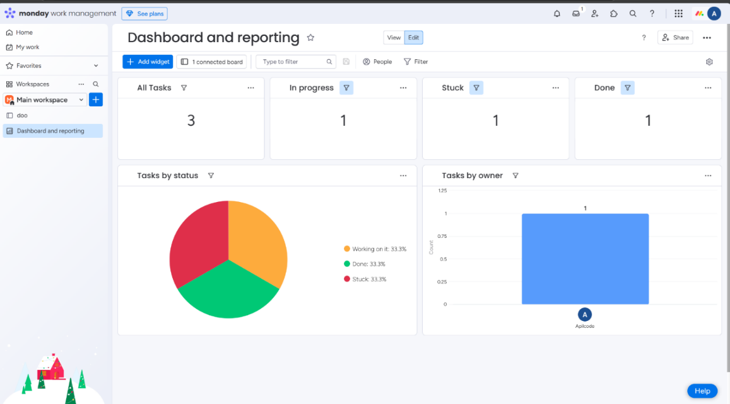

Figure 1 monday.com similar system

***Below are the similarities between Monday.com and my AI based employee system:***

|  |  |  |
| --- | --- | --- |
| **Features** | **Monday.com** | **AI EMS** |
| |  | | --- | |  |   *Task Assignment* | *Allows managers to assign and track tasks.* | *Managers can assign tasks and track employee tasks status also with posts and engagement.* |
| *Announcements* | *Enables managers to post announcements to keep teams informed.* | *Managers can post announcements with priority levels (high, medium, low).* |
| *AI Assistance* | *Uses AI for simplifying text and providing smart suggestions.* | *Incorporates AI for document summarization, meeting slide generation.* |
| *Dashboard Overview* | *Proper manager dashboard for task tracking and team management.* | *Manager dashboard which includes employee feedback analysis, sentiment insights, and task assignment features.* |
| *User-Friendly Interface* | *It is Known for its clear and good UI/UX design.* | *It is designed with a simple and intuitive interface for ease of use by both managers and employees.* |

Table 2 Similarity table of comparison with Monday.com

***Below are the Differences between Monday.com and my AI based employee system:***

|  |  |  |
| --- | --- | --- |
| **Features** | **Monday.com** | **AI EMS** |
| |  | | --- | |  |   *Employee Registration* | *Lacks a structured employee registration and onboarding process.* | *Provides structured employee onboarding by manager with all login details sent to employee through email* |
| *Sentiment Analysis* | *No sentiment analysis features for feedback evaluation.* | *Integrates sentiment analysis to evaluate employee feedback for managers.* |
| *AI Assistance* | *Uses AI for simplifying text and providing smart suggestions.* | *Incorporates AI for document summarization, meeting slide generation.* |
| *Document Handling* | *Does not support document summarization or querying.* | *Includes AI-driven document summarization and querying tools for employees.* |
| *Meeting Slide Generation* | *No capability for automatic slide generation.* | *Employees can generate meeting slides automatically from text input.* |
| *AI Assistant Features* | *Limited to basic text explanations and task assistance.* | *Offers advanced AI features such as chatbots and live real-time communication tools.* |
| *Announcement Management* | *Allows announcements but lacks priority settings.* | *Managers can prioritize announcements with high, medium, or low urgency.* |

Table 3 Differences table of comparison with monday.com

1. 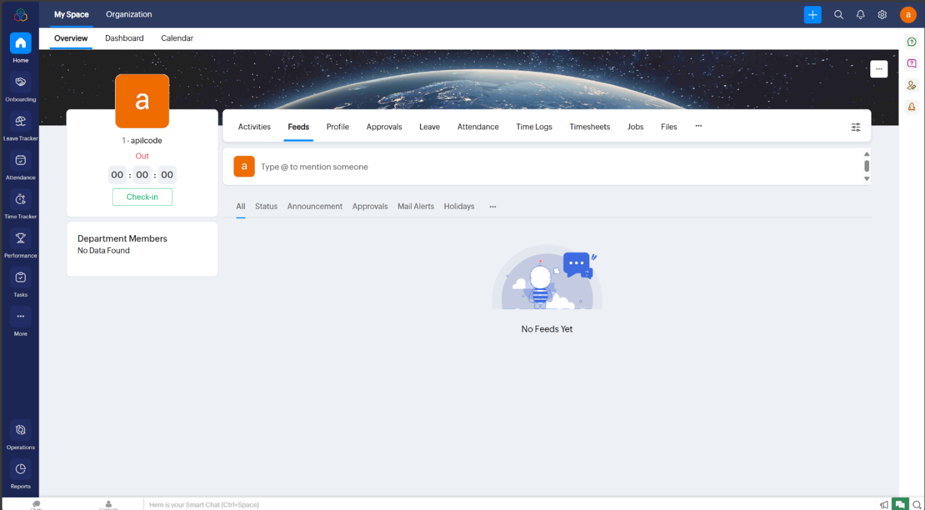**Zoho People:**

Figure 2 Zoho people similar system

Zoho People is also an employee management software (EMS) that comes with essential tools for your employee workflow management. Some of its features include check-in/check-out to mark attendance, task assignment to individual team members, announcement for any news, and time tracking to track working hours. Employees and Managers have specific dashboards to access their assigned tasks, activities, and departmental information. On the other hand, Zoho People streamline day-to-day HR operations, but it's primarily standard functionalities without the advanced AI capabilities.

***Below are the similarities between joho people and my AI based employee system:***

|  |  |  |
| --- | --- | --- |
| **Features** | **Joho People** | **AI EMS** |
| *Task Management* | *Allows task assignment and tracking for employees.* | *Managers can assign tasks and monitor employee engagement and progress.* |
| *Announcements* | *Managers can set announcements for employees.* | *Managers can post announcements with priority settings like high, medium, or low.* |
| *AI Assistance* | *Uses AI for simplifying text and providing smart suggestions.* | *Incorporates AI for document summarization, meeting slide generation.* |
| *Employee Profiles* | *Stores employee details, department, and position.* | *Employees are registered, and managers sent details to employee through email.* |
| *User Dashboard* | *Employees and managers have dashboards to access their activities and feeds.* | *Employees and managers have dedicated dashboards for task management, and feedback.* |

Table 4 Similarity table of comparison with Zoho People

***Below are the Differences between joho people and my AI based employee system:***

|  |  |  |
| --- | --- | --- |
| **Features** | **Joho People** | **AI EMS** |
| |  | | --- | |  |   *AI Integration* | *No AI features available.* | *AI-based facial recognition, document summarization, and chatbot capabilities.* |
| *Task Management* | *Standard task assignment and tracking.* | *Enhanced task management with AI-based recommendations.* |
| *Document Management* | *Upload and access documents.* | *AI-powered document summarization and querying features.* |
| *Meeting Support* | *No automated slide generation.* | *AI-based meeting slide generation from text input.* |
| *Engagement Features* | *Standard announcements and feeds.* | *Priority-based announcements with high, medium, and low settings.* |

Table 5 Differences table of comparison with Zoho People

1. 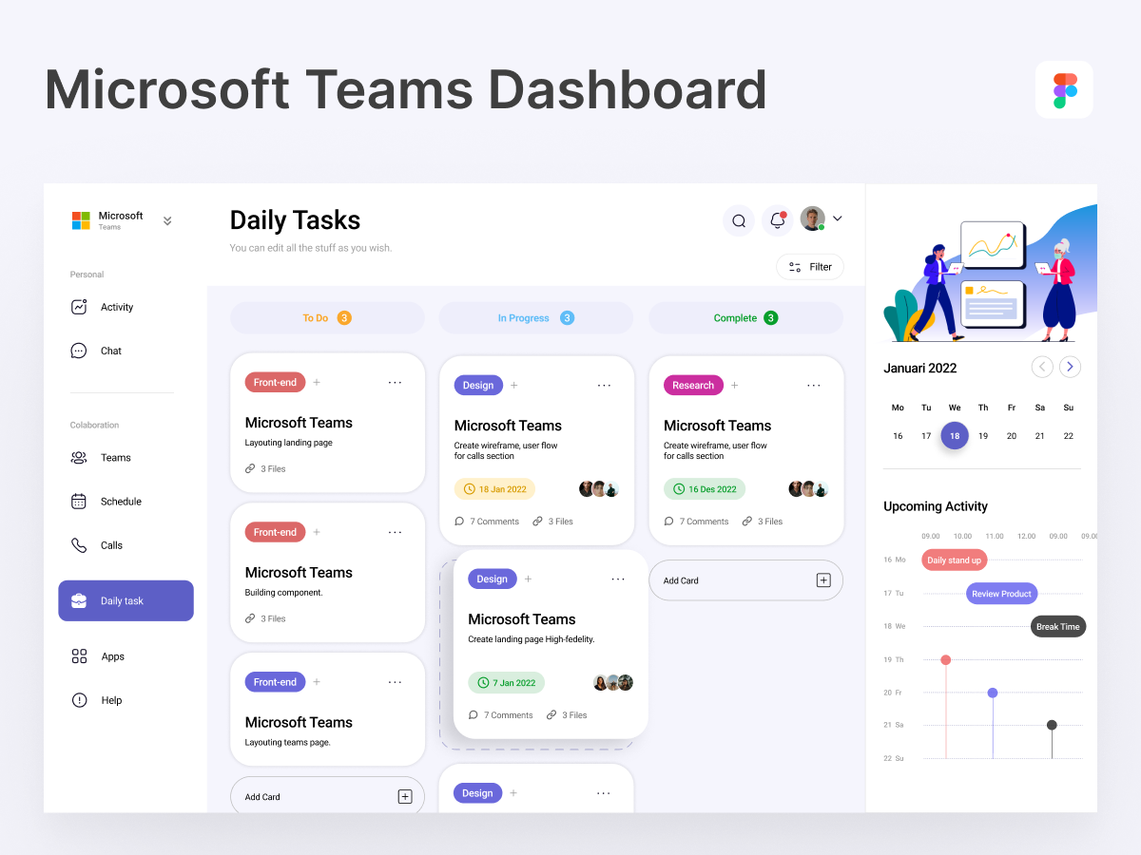**Microsoft Teams:**

Figure 3 Microsoft teams similar system

Microsoft Teams is a team collaboration communication tool typically used for the organization to set up and coordinate tasks and projects. It utilized software which allowed one-on-one chat and group chat consoles and even allowed video conferencing. It can share documents, tie meetings to Outlook, and permit access to various Microsoft tools. Employees can also manage the different projects and collaborate on channels and hold virtual meetings with the team, being the best solution for in-office and remote. (Ilag and Sabale)

***Below are the similarities between Microsoft Teams and my AI based employee system:***

|  |  |  |
| --- | --- | --- |
| **Features** | **Microsoft Teams** | **AI EMS** |
| |  | | --- | |  |   *Team Collaboration* | *Allows teams to collaborate via channels, chats, and file sharing.* | *Employees collaborate through tasks and engagement posts.* |
| *Task Management* | *Tasks can be assigned, tracked, and updated within Teams.* | *Managers assign tasks and monitor task progress for employees.* |
| *Announcements* | *Provides the ability to post announcements to teams and channels.* | *Managers can post announcements with priority levels (High, Medium, Low).* |
| *Meetings and Slides* | *Supports virtual meetings and content sharing during calls.* | *Employees can generate meeting slides automatically using AI.* |

Table 6 Similarity table of comparison with Teams

***Below are the Differences between Microsoft Teams and my AI based employee system:***

|  |  |  |
| --- | --- | --- |
| **Features** | **Joho People** | **AI EMS** |
| |  | | --- | |  |   *AI Integration* | *Limited AI, focuses on file sharing, chat, and meetings.* | *Advanced AI features like sentiment analysis, and document summarization.* |
| *Sentiment Analysis* | *No sentiment analysis feature for employee feedback.* | *Built-in AI sentiment analysis provides insights on employee feedback.* |
| *Task Management* | *Primarily task and project collaboration for teams.* | *Task assignments, tracking, and employee performance monitoring are available.* |
| *Document Handling* | *File sharing is supported, but no summarization or querying.* | *Employees can summarize and query documents using AI-powered tools.* |
| *Meeting Features* | *Manual creation of meeting slides and notes.* | *AI auto-generates meeting slides from text input for efficient preparation.* |
| *Engagement Monitoring* | *No built-in tools for employee engagement or feedback tracking.* | *Comprehensive employee engagement features like post management and feedback tracking.* |

Table 7 Differences table of comparison with Teams

# **3. DEVELOPMENT:**

## **3.1 CONSIDERED METHODOLOGY:**

In developing the AI Based Employee Management System (Work Sphere), various methodologies for developing the software were considered to ensure the process is structured, improvable, and efficient. All methods were considered based on factors such as flexibility, their approach to managing risks, ease of use, and their ability to support AI and cloud computing. Some of these methods which were considered are:

|  |  |
| --- | --- |
| **Methodology** | **Description** |
| **Iterative Waterfall Model** | A structured approach that allows revisiting previous stages, offering clarity in the development lifecycle while incorporating some flexibility for feedback. |
| **Spiral Model** | Combines iterative development with continuous risk assessment, making it suitable for large, complex projects involving emerging technologies like AI. |
| **Prototype Model** | Attempt to build initial prototypes of the system to get feedback and enhance requirements. This is an excellent method to refine user interface components and AI functionality. |
| **references (Agile)** | A team approach that breaks work in small segments named sprints. It aids in providing work frequently and adapting to varying requirements. |
| **RAD (Rapid Application Development)** | Emphasizes rapid growth and development through building blocks and user feedback, which is perfect to rapidly produce functional prototypes. |

Table 8 Considered methodology table

## **3.2 SELECTED METHODOLOGY:**

I have selected scrum methodology because it is a flexible and collaborative approach to managing software development projects. It focuses on breaking down work into small, manageable chunks called sprints, which are typically 1 to 4 weeks long. During each sprint, a specific part of the project is completed, and the team can gather feedback from stakeholders to make improvements for the next sprint. This makes it easy to adjust the project as needs change, which is ideal for developing an employee management system where requirements might evolve over time. (Srivastava et al.)

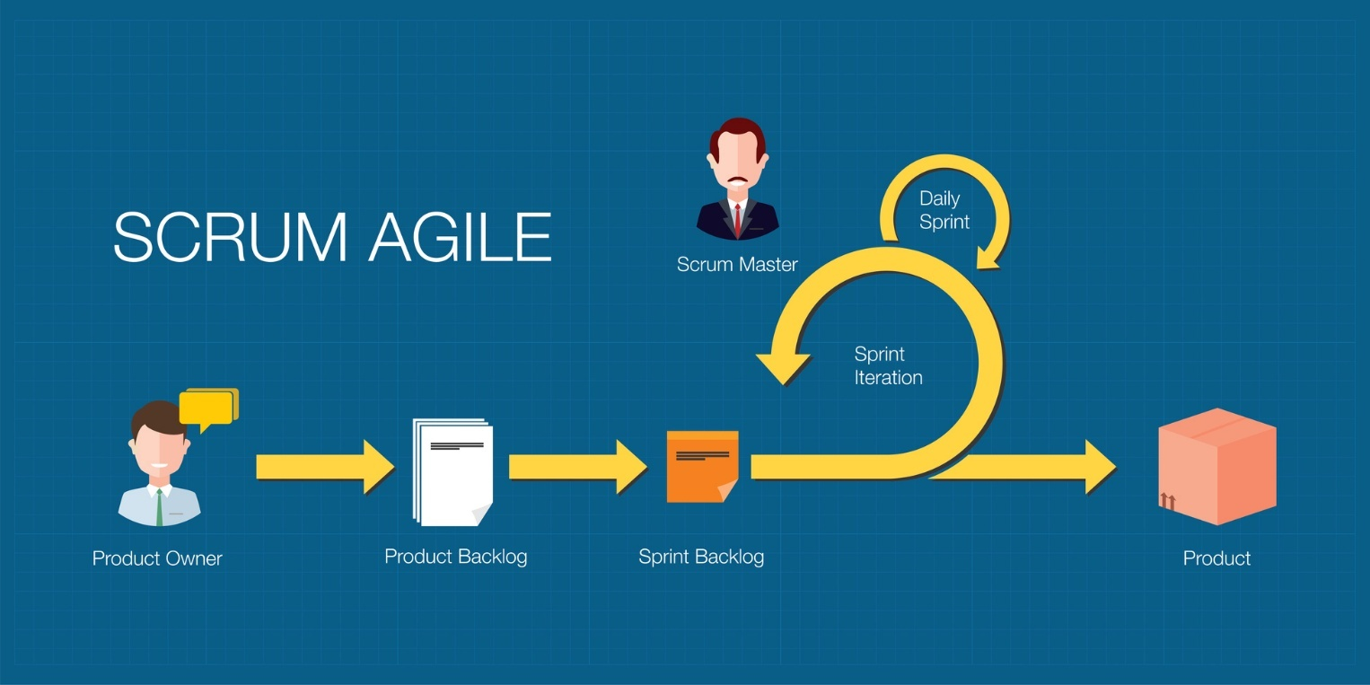**Key Elements:**

Figure 4 Scrum Methodology Process

**Roles:**

● **Product Owner:** Defines vision, managing backlog and prioritizing features.

● **Scrum Master:** Facilitates Scrum and which ensures principles.

● **Development Team:** Cross-functional, self-organizing, the team delivers increment.

**Artifacts:**

● **Product Backlog:** Product features, requirements in a prioritized manner.

● **Sprint Backlog:** All tasks selected for the current Sprint

● **Increment:** Potentially shippable, usable, value-adding product.

**Ceremonies:**

● **Sprint Planning:** Defining Sprint Goal, choosing tasks.

● **Daily Scrum:** Daily 15-minute Meeting to discuss what was done, what is being worked on, and what impediments obstructed it.

**● Sprint Review:** Show work done, collect feedback.

● **Sprint Retrospective:** Reflect and adjust processes.

**● Duration:** Typically, 2-4 weeks for product increments.

***Here is the table comparing three methodologies scrum, spiral and prototype based on features relevant to my AI based employee management system along with the reason for choosing scrum among three:***

|  |  |  |  |
| --- | --- | --- | --- |
| **Feature** | **Scrum (chosen)** | **Prototype** | **Spiral** |
| **Flexibility of changes** | High flexibility; supports iterative and adaptive changes. | Moderate; allows changes during prototyping but less iterative. | High; allows iterative changes but involves complex risk analysis. |
| **Risk Management** | Risk is addressed incrementally through sprints. | Low; risk not systematically addressed. | High; detailed risk analysis at each stage. |
| **User Feedback Integration** | Continuous feedback in every sprint cycle. | Focused on initial prototyping; feedback later limited. | Iterative feedback but delayed due to phased development. |
| **AI Feature Development** | Supports iterative delivery of AI features like chatbots and sentiment analysis. | Limited; focuses on prototype-specific features, not full system. | Supports AI features, but slower due to risk-focused phases. |
| **Team Collaboration** | High; promotes cross-functional collaboration and communication. | Moderate; team collaboration often limited to prototyping stages. | Moderate; collaboration occurs at defined phases. |
| **Time to Deliver Functional System** | Short; delivers working increments quickly. | Long; requires multiple iterations of prototypes before delivery. | Longer; due to iterative risk assessments and phased delivery. |
| **Suitability for AI Projects** | Excellent; aligns well with iterative development of AI modules. | Low; prototyping can’t handle AI’s complex evolving requirements. | Moderate; can support AI but involves higher overhead. |

Table 9 Feasible methodology comparison table

***Reasons why scrum was chosen:***

Scrum methodology is high adaptability which also follows iterative approach and continuous user feedback makes it ideal for handling complex features and which ensures seamless integration of AI technologies and allows rapid developments for meeting dynamics requirements.

***The importance of choosing Agile scrum Framework for my AI based EMS project is:***

● **Flexibility in AI Development and Design:** Iterative approach in scrum methodology provides flexibility for incremental updates which we are bringing to AI model development and architecture whenever necessary.

● **Rapid Development and Feedback Cycle:** Developers sit side-by-side with AI people and end-users enabling them to quickly modify features like chatbot assistance or document queries.

● **Accelerated Prototyping and Testing:** Sprint cycles allow to quickly build and test AI parts, such as task features or even an automated generator of meeting slides to make sure it works properly.

● **Continuous Improvement:** Regular sprint reviews allow refining the AI system’s design and functionality, ensuring optimal performance and user satisfaction.

● **Web and AI Integration:** Scrum enables smooth integration of AI models with web components (e.g., automated meeting slides, task management), ensuring real time functionality and minimal lag.

## **3.3 PHASES OF METHODOLOGY:**

Scrum project management was employed to develop the AI-Based Employee Management System. Scrum is a development approach that emphasizes incrementally building things, collectively with a team, receiving feedback from users, and releasing working software quickly. These are the major phases of Scrum and what occurs in each one: (Carvalho and Mello, 2011)

|  |  |
| --- | --- |
| **Phase** | **Activities** |
| **Requirement Gathering & Analysis** | A list of key features, enhancements, and requirements for the EMS system was prepared. It featured features such as user registration, document summarization based on AI, role-based access, and views on dashboards. It was regularly updated. |
| **Sprint Planning** | This would decide on each sprint, which was generally between 1 to 2 weeks. They would choose certain tasks from the backlog to accomplish in that sprint, such as developing a login system, utilizing LLMs, or configuring AWS services |
| **Sprint Execution** | During every sprint, the development team executed the items they planned. Daily meetings were held where they discussed how things progressed, issues, and what to do next. They coded, integrated, and tested features incrementally. |
| **Daily Scrum (Stand-up)** | They had a 15-minute team meeting each day. During the meeting, all members discussed what they did yesterday, what they would do today, and what issues arose. It kept everyone in line and everything in order. |
| **Sprint Review** | There was a meeting towards the end of every sprint to demo any work that had been completed, such as a functional AI module or a secure login system, to stakeholders to gather their feedback for future development. |
| **Sprint Retrospective** | The team considered what worked in the sprint, what could improve, and how it could be made simpler. This feedback was then applied to make the subsequent sprint better. |
| **Increment Delivery** | We delivered and deployed a functional product increment after every sprint (such as a functional dashboard or a document summarizer integrated). |

Table 10 Phases of scrum methodology

## **3.4 SURVEY RESULTS**

### **3.4.1 PRE-SURVEY RESULTS:**

A survey was conducted to gather information on the issues and probable solutions in the AI Based Employee Management System development, including even end-users, namely employees and managers. Their response showed that there are major issues present in the available systems and that intelligent solutions using AI were needed to help with better organizational management.

Major serious issues were identified through the survey in the employee management system such as manual handling of tasks, lack of transparency in observing the performance of the employees, and less effective communication between employees and employers. This system should be used for improving the efficiency of business operation, management of tasks, and effectiveness of employees.

**Key takeaways from the Survey:**

1. Automation needs:

Majority of people say that most of the features like performance management and task tracking need automated features for reducing human work and efforts.

2. AI-powered Features:

Features with AI included are sentiment analysis to measure the feedback of employees, smart rag to handle their queries, and automated changes in the status of tasks that were important to enhance efficiency and engagement.

3. More Interaction with Employees:

This highlighted the need for interaction platforms where employees can post, like, comment, and share in their departments and across the organization with a view to building a sense of community that would improve teamwork among staff.

4. Task and Performance Management:

This system is important because it enables tracking of task status and allows employees to edit tasks and enables managers to review and approve the same, all effectively.

5. Supporting Employee Feedback:

One of the main issues was the problem of supporting employee feedback. Sentiment analysis through AI, according to the respondents, would help understand employee morale and reach informed managerial decisions.

6. The survey collected perspectives from various participants, including supervisors and managers, employees and freelancers.

7. A response from around 45 participants was critically important in understanding their experience and expectations.

8. The question form is based on user satisfaction, system performance and request features in the new system.

**Access the Survey Questions:**

[*Access Here*](https://docs.google.com/forms/d/e/1FAIpQLScLVBUwu_71OPuBfNHBxDdvBYQNK9T7Zb-I_01qAyiLPgHLeA/viewform?pli=1) to view the full list of survey questions.

**Focusing Area:**

* Efficiency in workflow and task management.
* Ideas for improvements or new features.

**Documentation**: The survey includes a full listing of questions and answers.

**Outcome:**

The information that will be collected through this survey is very specific and will be used to build a better and more user-friendly system directly focused on the needs of all stakeholders.

It means that, according to the respondents, their operations had to be secured and organized through the development of secret PINs while employees were safely registered with task records and employee data all organized and easy to access.

These survey responses have Provided well in designing an effective response through the AI-Based Employee Management System. The best in the field of AI technologies, like natural language processing, sentimental analysis, would fall under one comprehensive solution. It would be one smarter and more effective way of managing the workforce by streamlining core processes, improving engagement, and making decision-making based on data.

### **3.4.2 POST-SURVEY RESULTS:**

**1. About the Survey**  
It is a questionnaire regarding how individuals utilize the **Worksphere** App. The app simplifies employees beginning work and document handling using AI. The system supports activities such as uploading of meeting slides, document summarization, responding to questions from PDF (RAG system), analysis of the feeling of feedback, and establishing a channel for communication within the app (post & comment).

**2. Principal Findings of the Survey**

* **Easy Document Organization**

Users were able to easily upload and view slides/documents for meetings.

* **Effective Summarizing:**

Most users mentioned that the document summarization capability was useful and accurate for quick file understanding.

* **RAG (Ask your PDF) Performance:**  
  Majority found the RAG system intuitive to use.  
  It returned relevant answers most of the time, and some use it weekly or occasionally.
* **Popular Features (User Choice):**  
  The top liked feature was:  
  RAG Query with PDF, followed by Document Summarization.
* **Understanding sentiments:**  
  Users found the sentiment analysis of feedback useful, and the sentiment graph allowed them to view the overall sentiment easily.
* **Communication Tools:**  
  I was able to use the posting and commenting features with ease.  
  Users found it useful for workplace interaction.  
  Suggestions for Improvement:  
  Users suggested improvements in:  
  RAG Q&A System  
  App Speed  
  Post/Comment Section
* **General Happiness:**  
  All reviewers considered that the AI capabilities of **Worksphere** were Good or Excellent.
* **Suggestion rating:**  
  Most are likely to advise their colleagues on the use of the **Worksphere** App.

**3. Summary of Survey Results**

* The users are utilizing the AI features extensively.
* Document Summarization and RAG are valuable features.
* Feedback is interpreted through sentiment analysis. Tools for communication are helpful but can always improve. Users are generally pleased and wish to recommend the app to others.

## **3.5 SOFTWARE REQUIREMENT SPECIFICATION (SRS):**

This is the Software Requirement Document of the AI Based Employee Management System **(Work Sphere)** that improves organizational efficiency by facilitating easy employee registration, task tracking, posting, feedback analysis and more. The core functionalities of this system under development will include task management, and document interactions like summarizing and querying, integrated with the AI powered features of facial recognition and sentiment analysis. (Handoyo et al.)

The system is designed to equip employees and managers with the tools necessary for the handling of collaborative task management, effective communication, and intelligent decision-making in a harmonious and productive work environment.

### **3.5.1 DOCUMENT CONVENTIONS:**

* **Font Style and Size:** Arial, size 12 for the body, bold for headings.
* **Requirement Priorities:** The requirements will be set as High, Medium, or Low in terms of priority.
* **Terms:** "Manager" is administered for admins, and "Employee" is used for regular users.

### **3.5.2 INTENDED AUDIENCES AND READING SUGGESTIONS:**

**INTENDED AUDIENCES:**

* **Developers Use:** For understanding system functionalities.
* **Testers Use:** For validating system behavior.
* **Project Managers Use:** For monitoring scope and goals.

### **3.5.3 PRODUCT SCOPE:**

The AI-Based Employee Management System handles automation for employee registration, tasks, attendance, and documents handling. It will be integrated with AI features, including face recognition and sentiment analysis.

**Goals:**

* It enhances efficiency which automatically reduces manual work.
* Enhancing Communication and Collaboration between departments.
* Use AI to make wiser decisions and track tasks.

### **3.5.4 PRODUCT PERSPECTIVE:**

The AI based employee management system is a self-made product which is designed to automate the process in employee management system. In future it might be integrated with tools for HR, tools for proper employee onboarding and management and with also various task management platforms like **Trello** which improves task tracking and collaboration.

### **3.5.5 PRODUCT FUNCTIONS:**

* **User Registration & Management:** Employees sign up, and managers approve or reject registrations, assigning departments and positions.
* **Task Management:** Employees view, submit, and track tasks; managers review, approve, or reject them.
* **Document Management:** Employees upload, query, and generate summaries from documents.
* **Interdepartmental Collaboration:** Employees create, like, and comment on posts from other departments.
* **Manager Dashboard:** Managers review employee activities, tasks, and feedback.  
  Employee Dashboard: Employees view their departments, tasks, and posts.

### **3.5.6 USER CLASSES AND CHARACTERSTICS:**

**Employee:** Frequently interacts with the system to manage all tasks, attendance mechanisms and documents.

**Manager:** It has administrative access which tracks things overall and manages employees.

### **3.5.7 OPERATING ENVIRONMENT:**

**Hardware:** The system requires a **GPU** Enabled computer with medium processing power.

**Operating System:** Developed and tested on **Windows OS**.

**External Systems:** Email services for notifications and a **FastAPI** server for backend services.

### **3.5.8 DESIGN AND IMPLEMENTATION CONSTRAINTS:**

* **Security Related:** The system shall follow all the **GDPR** regulations concerning data privacy.
* **Performance Constraints:** Face recognition shall respond in less than 2 seconds
* **Description of Technologies Used:** Python as development language, OpenCV face recognition, and MySQL database management, this narrows down the scope of freedom of technology choice.

### **3.5.9 USER DOCUMENTATION:**

* **User Manuals:** Employee and Manager manuals in PDF format
* **Online Help:** In-application context-sensitive help
* **Tutorials:** Video tutorials on major features like face recognition and tasks tracking.

### **3.5.10 ASSUMPTIONS AND DEPENDENCIES:**

**Assumptions:**

* Employees and managers should have basic technical knowledge to handle the system.
* The system will be majorly deployed on **Windows OS** but can be extended to other operating systems later.
* Employees give their valid personal data during the sign-up process.
* Email services are reliable in sending notifications and secret pins.

**Dependencies:**

The project depends upon the following third-party components for its operation:

* **FastAPI** for developing the backend.
* Email services for sending notifications.
* **MySQL** for database operations.
* System requires a GPU-enabled computer with medium-range processing powers for smooth running of the system.
* Changes to external libraries/dependencies may affect how the system behaves.

### **3.5.11 EXTERNAL INTERFACES REQUIRED:**

#### **3.5.11.1 USER INTERFACES:**

* **Login Pages:**
* Input form for employee and manager login/signup.
* PIN Based Login.

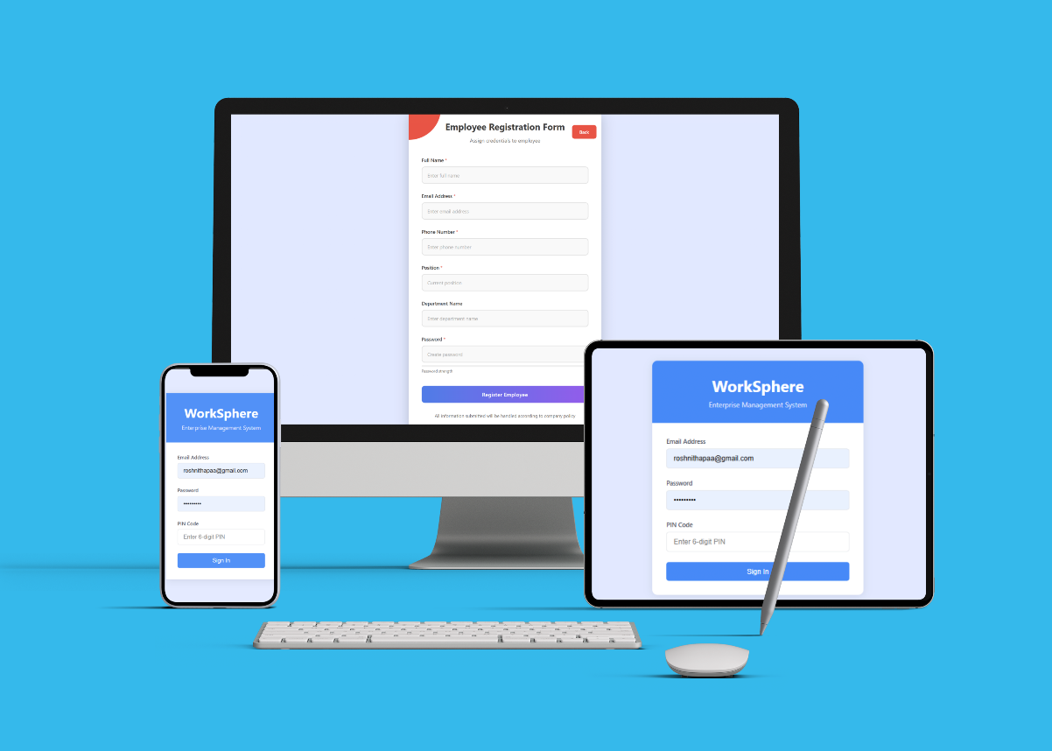

Figure 5 Login signup page responsive

* **Manager Dashboard**
* **Employee Management:** Employee Profiles, Approve/Reject Sign-ups, Department/Position Assignment.
* **Task Management:** Create, Track, and Review Employee Tasks.
* **Announcements:** Create and post announcements with the view of employees.
* **Feedback Analysis:** Sentiment Analysis of Employee Feedback.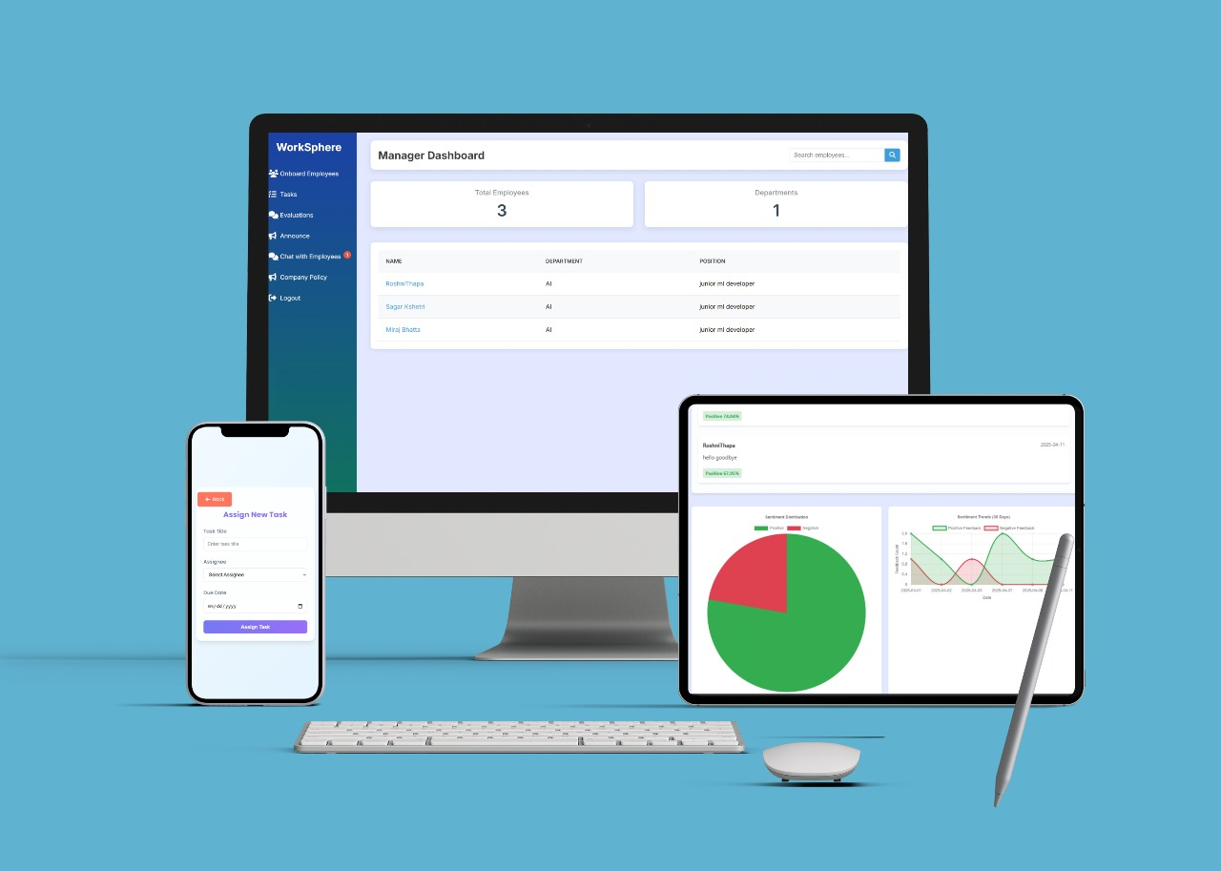

Figure 6 Manager Dashboard responsive page

* **Employee Dashboard**
* **Task Overview:** View Tasks Assigned, Submit Updates, Track Status.
* **Department Interaction:** Sharing posts, Likes posts and comment opinions.
* **Announcements:** See the announcements that are published by the manager.
* **Document Features:**
  + - * Upload documents.
      * Run queries in your documents.
      * Summarize your uploaded documents
      * 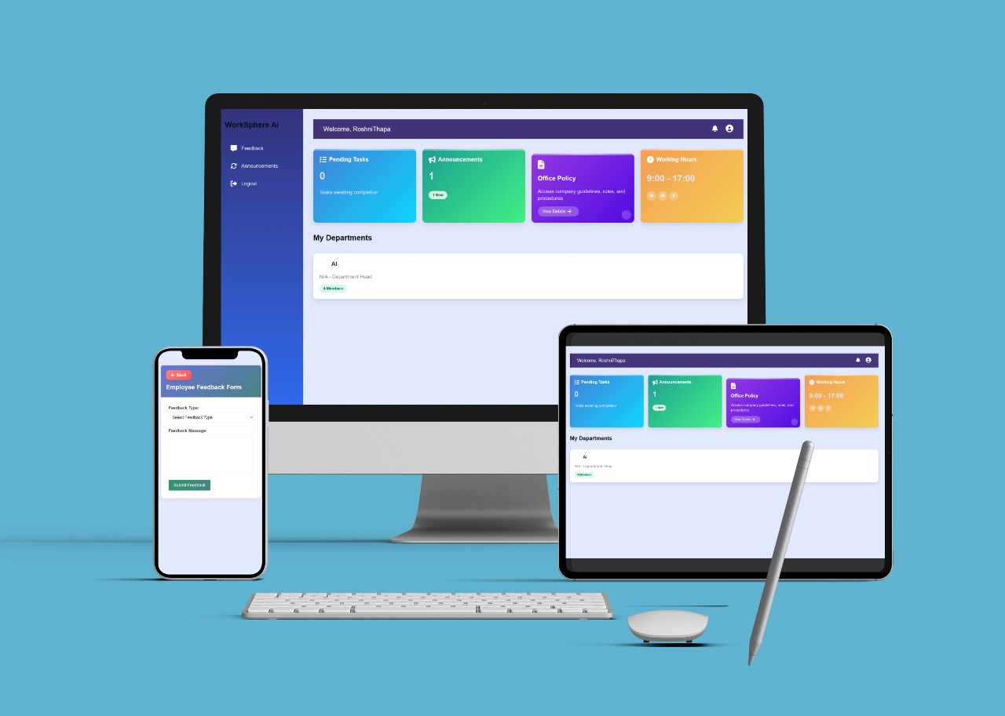Create presentation slides from any text input

Figure 7 Employee Dashboard responsive page

**Common UI Features**

* **Navigation Bar:** Quick access to dashboard sections.
* **Standard Buttons:** "Submit," "Cancel," "Edit," "Delete."
* **Error Messages:** Red for invalid input.
* **Responsiveness:** Desktop and Mobile Compatibility
* **Styling:**
  + Font: Arial 12 pt for content, bold headers.
  + Proper layout for easy navigation.

#### **3.5.11.2 HARDWARE REQUIREMENTS:**

|  |  |
| --- | --- |
| **Component** | **Details** |
| **Development Machine** | Medium Processor laptop or device for running this application or system.  Laptop devices with Windows OS.  Web Cam or Camera for facial attendance. |
| **Additional Hardware** | External SSDs for backups, storing datasets, and models |

Table 11 Hardware Requirements

#### **3.5.11.3 SOFTWARE REQUIREMENTS:**

|  |  |
| --- | --- |
| **Category** | **Details** |
| **Frontend Development** | Any frontend technologies like html, CSS bootstrap, react and tailwind. |
| **Backend and API Development** | Python (Fast API): Used for developing RESTful APIs with high performance, scalability, and integration with AI/ML models and databases. |
| **LLM Models & Frameworks** | Pre-trained models (e.g., GPT, BERT) fine-tuned for tasks like document handling and chatbot interface.  Hugging Face Transformers, PyTorch |
| **Cloud Services (AWS)** | Cloud services like EC2, S3, and Aurora for deployment. |
| **Data Science Libraries** | Pandas, NumPy, Scikit-Learn: For data preprocessing and manipulation |
| **Additional Tools** | API Testing: Postman or curl for testing API endpoints. |

Table 12 Software requirements table

#### **3.5.11.4 COMMUNICATION INTERFACES:**

**Protocols:**

**HTTP/HTTPS:** Protocols for UI and middleware communications.

**SMTP:** For email deliveries, such as secret PIN notifications.

**Data Formats:**

**MySQL Database:** It is for storing all details in the systems.

**RESTful APIs:** For organized communication between the frontend and the backend.

**Security:**

* Passwords and pins would be transmitted securely.

**Additional Features:**

**In the future:** connections with tools like Trello to provide a more advanced task management system.

### **3.5.12 REQUIREMENTS SPECIFICATIONS OF AN SRS:**

This project proposes an AI Based Employee Management System for organizations in Nepal and abroad with a vision of changing the way employee management systems work using AI driven tools and technologies. Communication gaps and lack of task management, traditional systems are not enough to counter the rising demands of contemporary workplaces. Such an innovative system aims to address these issues by fostering collaboration, increasing engagement among employees. From automating task assignments and allowing employees to build meeting slides in less than 2 minutes and keeping a feedback culture alive and securing sensitive organizational data, this system strives to make your workplace smarter and more connected. Additionally, the platform will enable employees and managers to work faster, make better decisions and increase productivity to an unprecedented level with tools such as AI powered RAG document querying and summarization tools, advanced sentiment analysis etc.

**For detailed requirements, please refer to the Appendix section:**

Click_here_for_Functional_Requirements

Click_here_for_Non_Functional

### **3.5.13 REQUIREMENTS ANALYSIS:**

#### **3.5.13.1 DATA FLOW DIAGRAM:**

*The Level 0 DFD gives a high-level view of the AI-based Employee Management System. It shows how different parts interact:* *(Li and Chen, “Data* Flow *Diagram”)*

**Entities:**

**Employee:** Employee performsSigns up, logs in, sends tasks, and engages with posts and announcements.

**Manager:** Manager performs Looks at registrations, gives roles, manages tasks, and shares announcements.

**HR:** HR sends recruited employees list to manager through form.

**Processes:**

Registration, logging in, managing tasks, announcements, and analyzing feedback.

**Data Flows:**

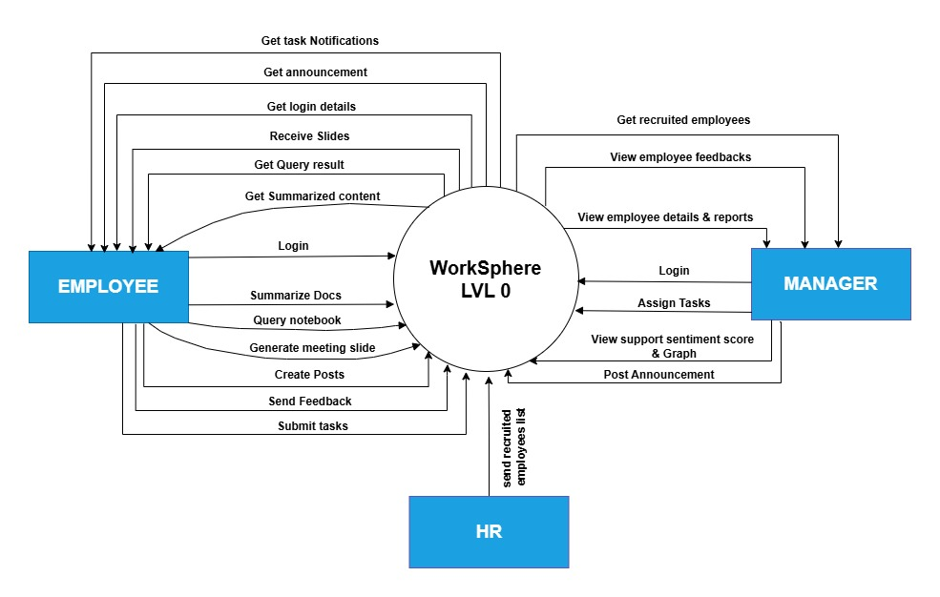Employee information, task assignments, approvals, and feedback move between the system, employees, and managers.

Figure 8 context level diagram level 0

**DATA FLOW DIAGRAM (LEVEL 1):**

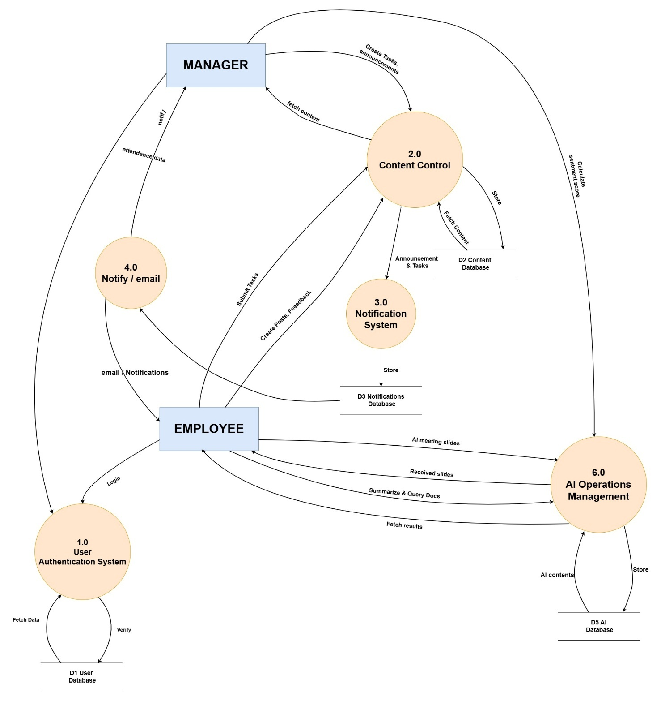A Data Flow Diagram (DFD) Level 1 is simply an elaboration of the Level 0 DFD, also known as a context diagram. It provides more detail about the processes within the system but still maintains the big picture. The single process is now broken down into smaller, subprocesses that illustrate how data moves between them, the outside entities, and data stores.

Figure 9 Level 1 Data flow diagram

#### **3.5.13.2 USE CASE DIAGRAM:**

A Use Case Diagram is a graphical representation of the interactions between actors and the system. It highlights the functional requirements of the system by showing what the system does and who interacts with it. (Fauzan et al.)

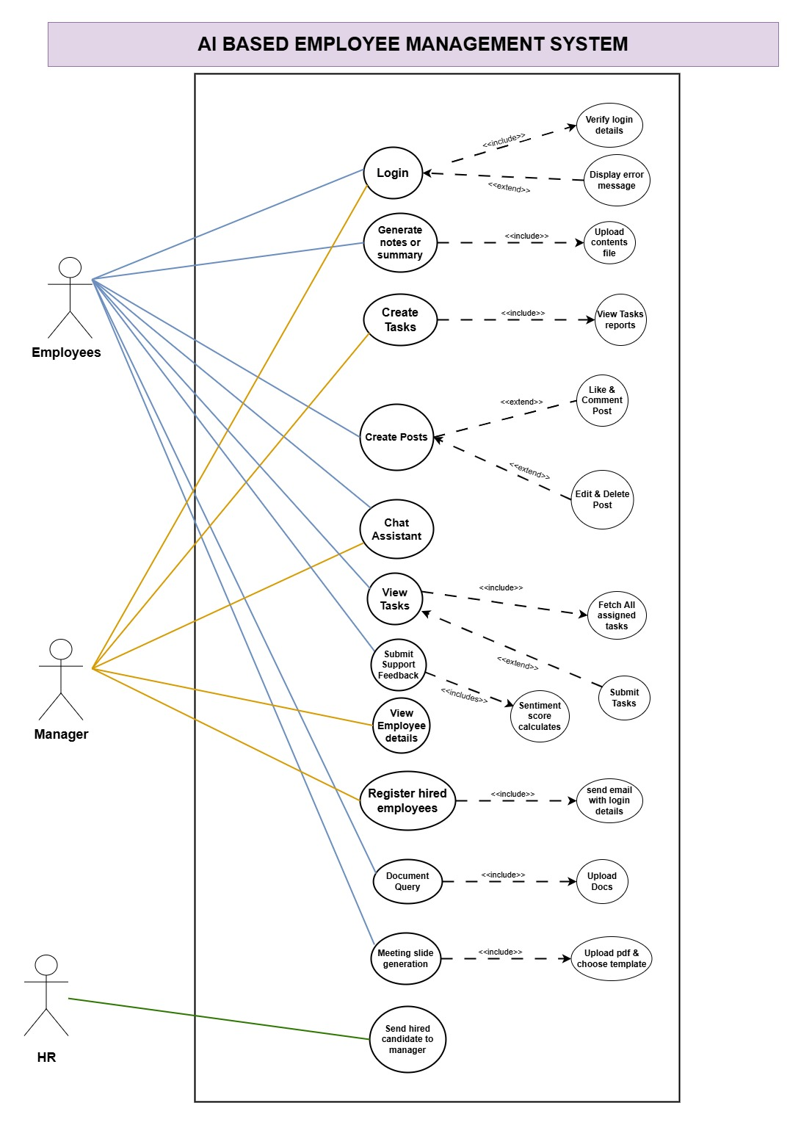

Figure 10 Use Case Diagram of system

#### **3.5.13.3 HIGH LEVEL DIAGRAM:**

A Use Case Diagram gives an overall view of the functionality the system is supposed to provide through the identification of the interactions of its actors with use cases. It explains how different kinds of users will interact with the system to achieve their objective. This diagram helps in describing visually what the system requirement and the interactions of the users are.  
  
The following is the link to get the Appendix Section, which provides detailed descriptions of all the high-level use cases identified:  
Appendix: **High-Level Use Cases**

#### **3.5.13.4 EXTENDED LEVEL DIAGRAM:**

The extended-level use case diagram is basically a diagram showing an in-depth view of the details of the system, whereby high-level use cases are then broken down into smaller, finer subtasks or scenarios. This elaborates on how the system works for each use case described and defines the relations between actors, use cases, and whatever dependencies.

See the next section for the detailed use cases expanded in the Appendix Section below:

Appendix: **Expanded Use Cases**

#### **3.5.13.3 SEQUENCE DIAGRAM:**

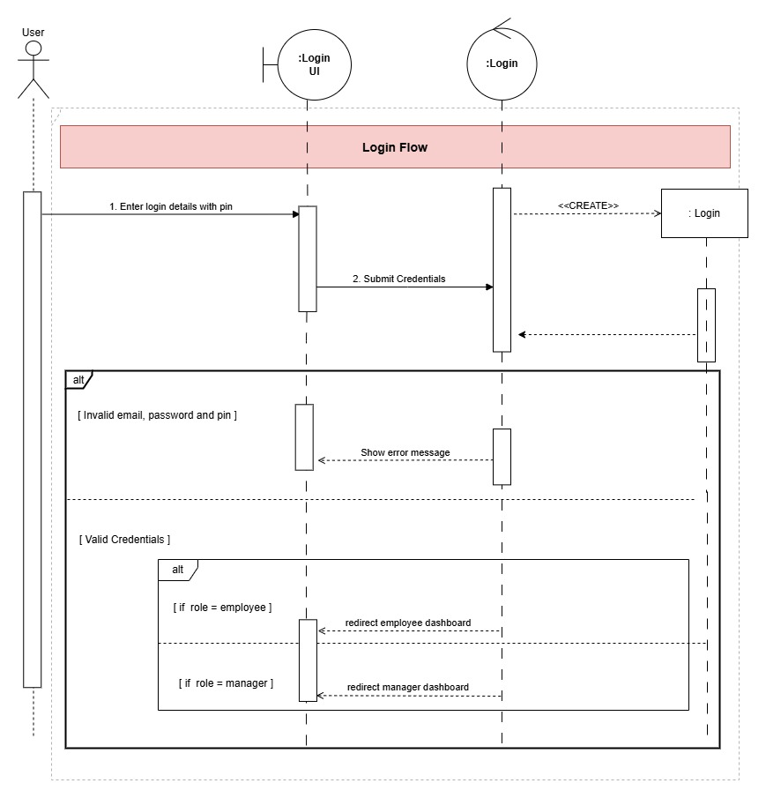The sequence diagram shows the object or component involved in an interaction, emphasizing sequences of the interactions through messages in time. It shows the order of the messages exchanged between actors, systems and objects processes to carry out some task or process. (“A Formal Semantics of UML Sequence Diagram | IEEE Conference Publication | IEEE Xplore”)

Figure 11 Login sequence diagram

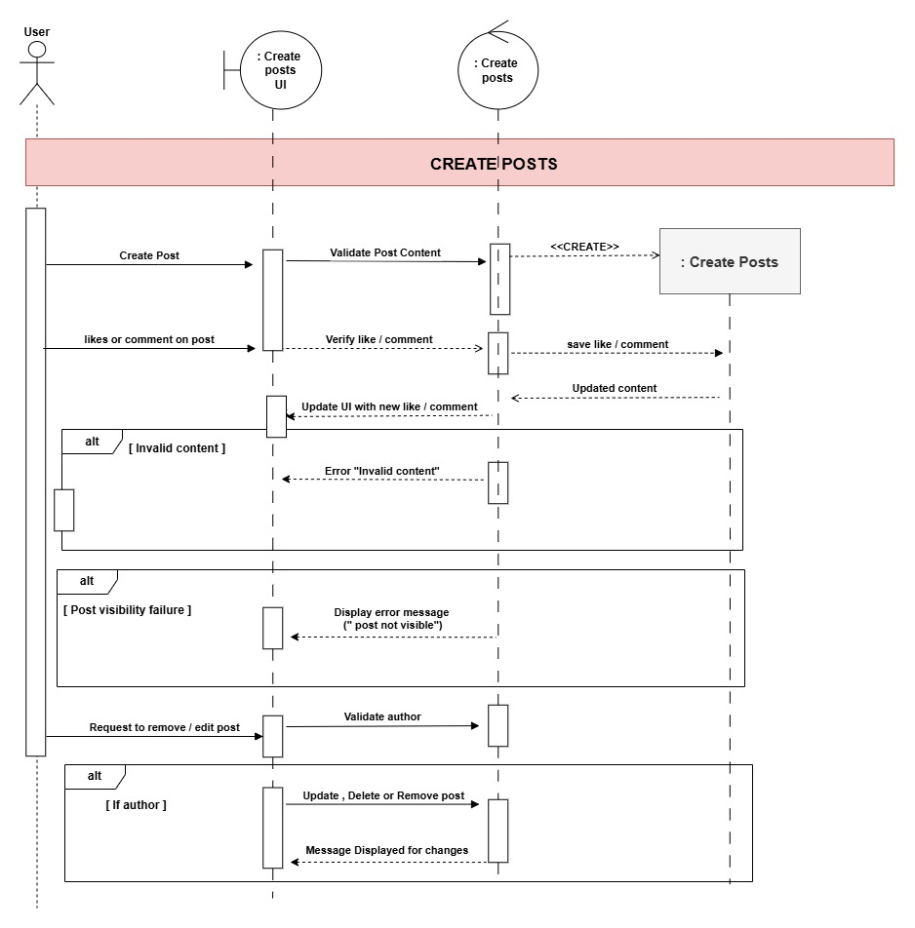

Figure 12 Post Creating sequence diagram

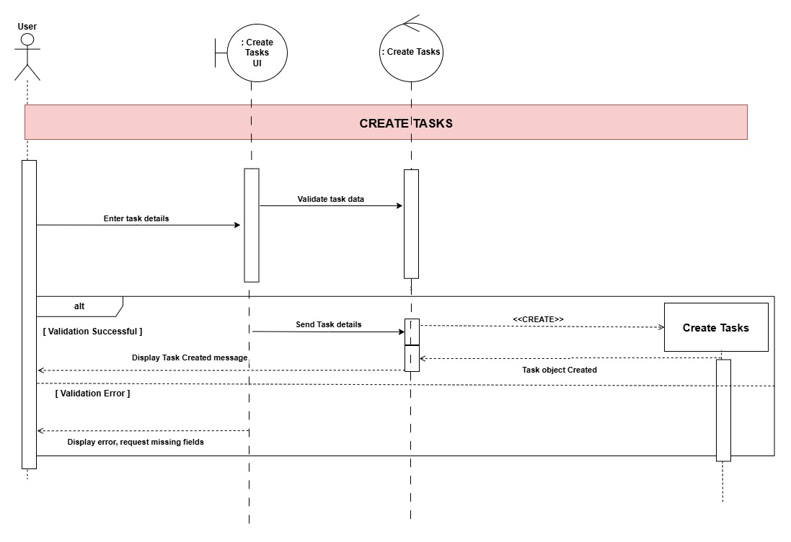

Figure 13 Creating Tasks sequence diagram

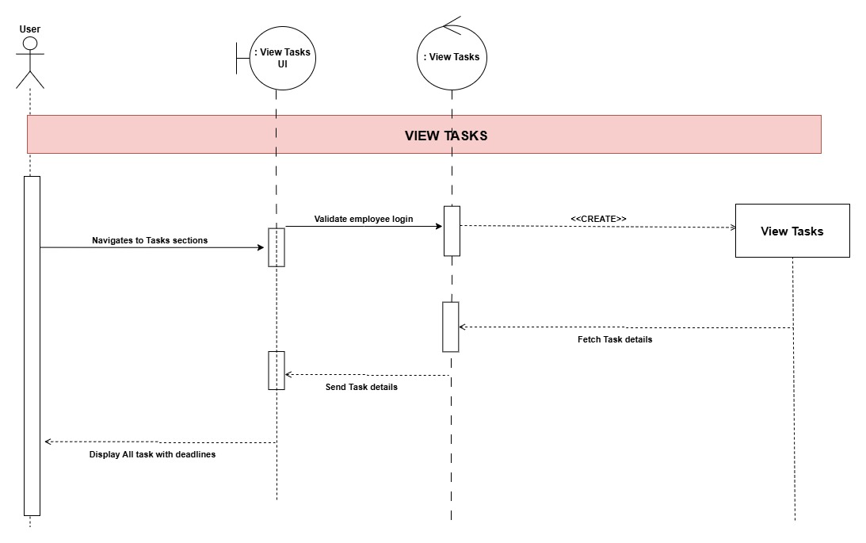

Figure 14 View Tasks sequence diagram

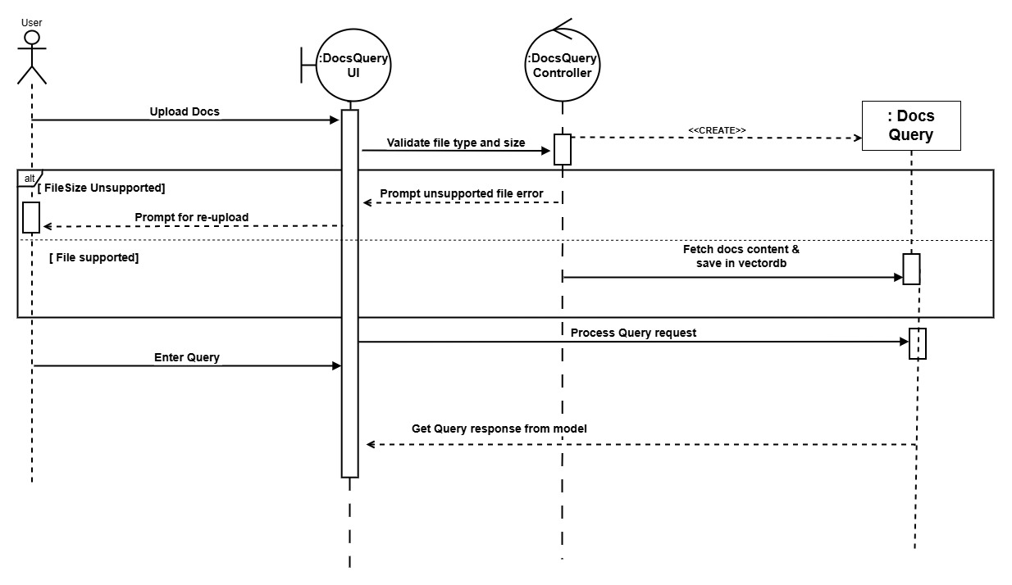

Figure 15 DocsQuery sequence diagram

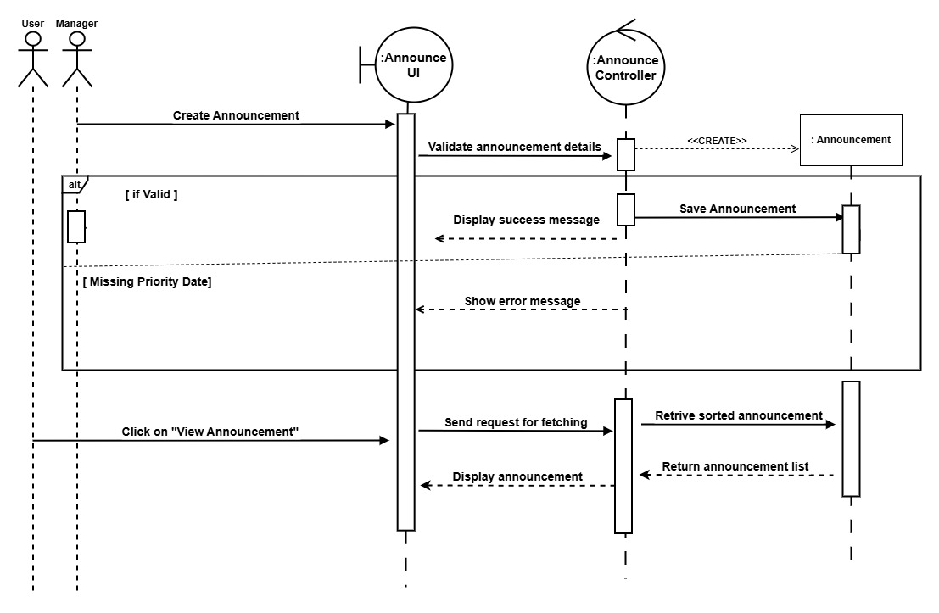

Figure 16 Announcement sequence diagram

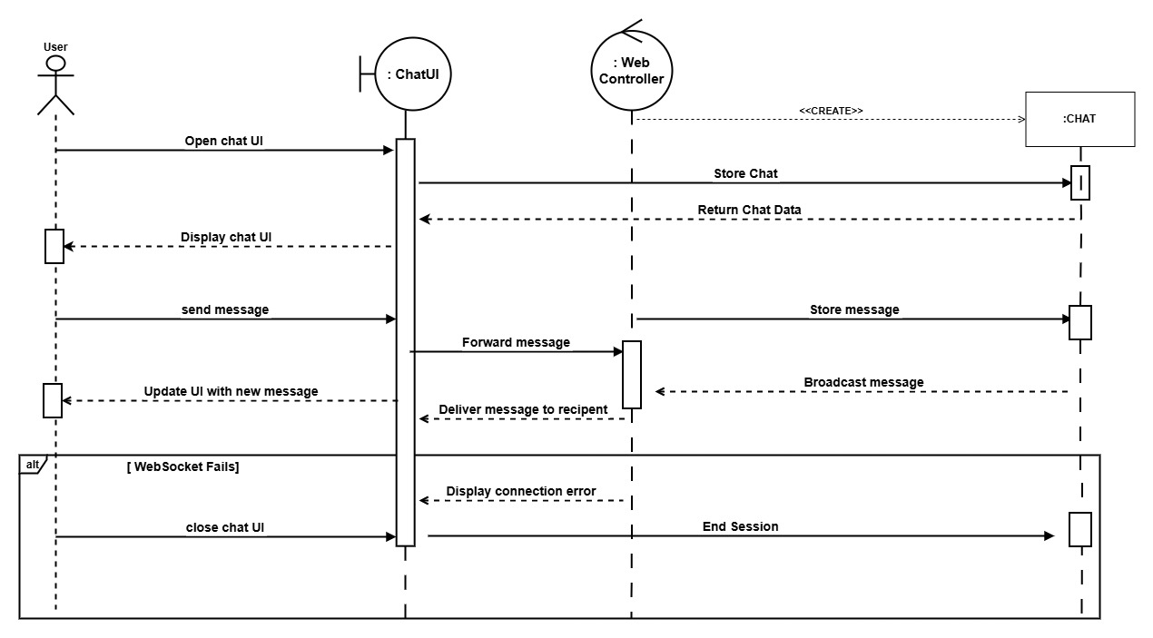

Figure 17 Chat System sequence diagram

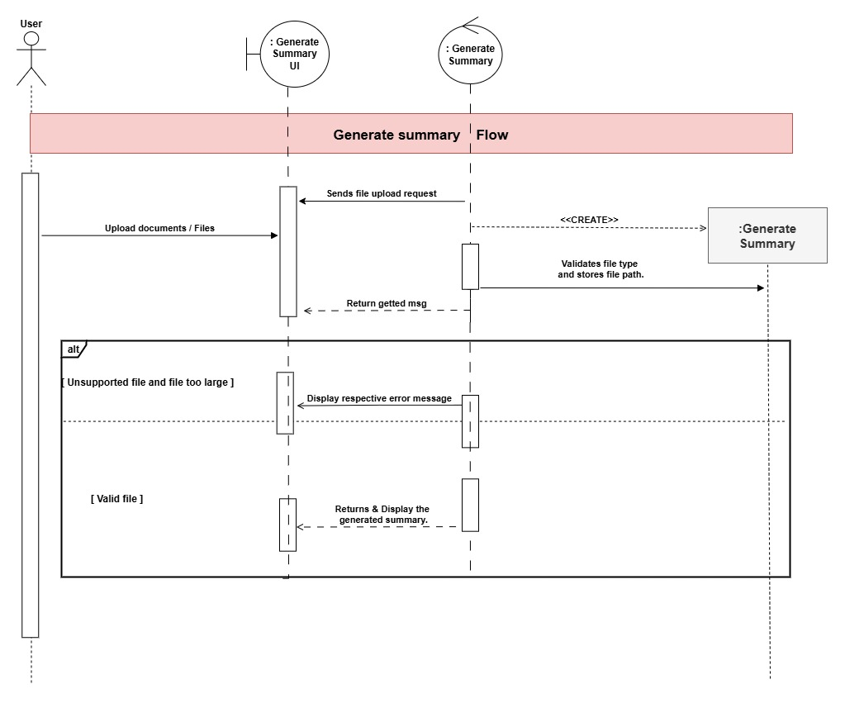

Figure 18 Generate Summary sequence diagram

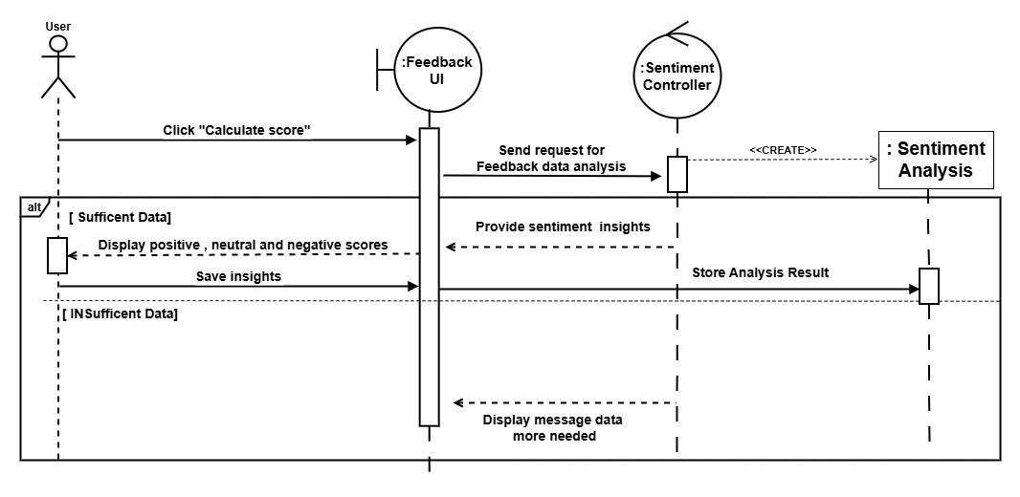

Figure 19 Feedback sequence diagram

#### **3.5.13.4 DATA DICTIONARY:**

**User Table:**

|  |  |  |
| --- | --- | --- |
| S. N | ATTRIBUTES | DATATYPES |
| 1. | User id | VARCHAR (30) |
|  | full name | VARCHAR (30) |
|  | Email | VARCHAR (70) |
|  | Phone | VARCHAR (30) |
|  | Password | VARCHAR (30) |
|  | role | ENUM (EMPLOYEE, MANAGER) |
|  | department name | VARCHAR (30) |
|  | Position | VARCHAR (30) |
|  | OTP Code | VARCHAR (30) |
|  | Is deleted | VARCHAR (30) |
|  | Isannouncement_read | VARCHAR (30) |
|  | Istask_read | VARCHAR (30) |
|  | Isnotification_read | VARCHAR (30) |

Table 13 User Table Description

**Task Table:**

|  |  |  |
| --- | --- | --- |
| S. N | ATTRIBUTES | DATATYPES |
| 1. | Task id | VARCHAR (30) |
| 2 | title | VARCHAR (30) |
| 3 | Description | VARCHAR (250) |
| 4 | Due Date | DATE |
| 5 | Docs Path | VARCHAR (30) |
| 6 | Status | ENUM (PENDING, COMPLETED, SUBMITTED) |
| 7 | Assigned to id | VARCHAR (30) |
| 8 | Assigned by id | VARCHAR (30) |
| 9 | Deleted at | VARCHAR (30) |

Table 14 Task Table Description

**Announcement Table:**

|  |  |  |
| --- | --- | --- |
| S. N | ATTRIBUTES | DATATYPES |
| 1. | Announcement id | VARCHAR (30) |
| 2 | title | VARCHAR (30) |
| 3 | Date | DATE |
| 4 | Content | VARCHAR (30) |
| 5 | Priority Level | ENUM (HIGH, MEDIUM, LOW) |
| 7 | Manager ID | VARCHAR (30) |

Table 15 Announcement Table Description

**Feedback Table:**

|  |  |  |
| --- | --- | --- |
| S. N | ATTRIBUTES | DATATYPES |
| 1. | Feedback id | VARCHAR (30) |
| 2 | Type | VARCHAR (30) |
| 3 | Message | VARCHAR (30) |
| 4 | UserID | VARCHAR (30) |
| 5 | Created_at | VARCHAR (30) |
| 6 | Feedback summary | VARCHAR (30) |
| 7 | Is_deleted | VARCHAR (30) |

Table 16 Feedback Table Description

**Comment Table:**

|  |  |  |
| --- | --- | --- |
| S. N | ATTRIBUTES | DATATYPES |
| 1. | Comment ID | VARCHAR (30) |
| 2 | Content | VARCHAR (30) |
| 3 | Date | Date |
| 4 | Post ID | VARCHAR (30) |
| 5 | User ID | VARCHAR (30) |
| 6 | Is deleted | VARCHAR (30) |

Table 17 Comment Table Description

**Post Table:**

|  |  |  |
| --- | --- | --- |
| S. N | ATTRIBUTES | DATATYPES |
| 1. | Post ID | VARCHAR (30) |
| 2 | title | VARCHAR (30) |
| 3 | Content | VARCHAR (30) |
| 4 | Likes | VARCHAR (30) |
| 5 | Created Date | Date |
| 6. | User ID | VARCHAR (30) |
| 7 | Is deleted | VARCHAR (30) |

Table 18 Post Table Description

**Likes Table:**

|  |  |  |
| --- | --- | --- |
| S. N | ATTRIBUTES | DATATYPES |
| 1. | Like ID | VARCHAR (30) |
| 2 | Post ID | VARCHAR (30) |
| 3 | User ID | VARCHAR (30) |
| 4 | Is deleted | VARCHAR (30) |

Table 19 Likes Table Description

**Message Table:**

|  |  |  |
| --- | --- | --- |
| S. N | ATTRIBUTES | DATATYPES |
| 1. | Msg id | VARCHAR (30) |
| 2 | Status | VARCHAR (30) |
| 3 | Content | VARCHAR (30) |
| 4 | Likes | VARCHAR (30) |
| 5 | Chat ID | VARCHAR (30) |
| 6. | Sender ID | VARCHAR (30) |
| 7. | Receiver ID | VARCHAR (30) |
| 8. | Is read | VARCHAR (30) |
| 9. | Status | VARCHAR (30) |
| 10. | Is_deleted | VARCHAR (30) |

Table 20 Message Table Description

**Notification Table:**

|  |  |  |
| --- | --- | --- |
| S. N | ATTRIBUTES | DATATYPES |
| 1. | Notification Id | VARCHAR (30) |
| 2 | Content | VARCHAR (30) |
| 3 | Date | VARCHAR (30) |
| 4 | User ID | VARCHAR (30) |
| 5 | Task ID | VARCHAR (30) |

Table 21 Notification Table Description

**Chatroom Table:**

|  |  |  |
| --- | --- | --- |
| S. N | ATTRIBUTES | DATATYPES |
| 1. | Chat id | VARCHAR (30) |
| 2 | Created ID | VARCHAR (30) |
| 3 | Emp1 ID | VARCHAR (30) |
| 4 | Emp2 ID | VARCHAR (30) |
| 5. | Is_Deleted | VARCHAR (30) |

Table 22 Chatroom Table Description

**Chat history Table:**

|  |  |  |
| --- | --- | --- |
| S. N | ATTRIBUTES | DATATYPES |
| 1. | User id | VARCHAR (30) |
| 2. | ID | VARCHAR (30) |
| 2 | User Query | VARCHAR (30) |
| 3 | Response | VARCHAR (30) |
| 4 | timestamp | VARCHAR (30) |
| 5. | filepath | VARCHAR (30) |

Table 23 Chat History Table Description

**Policy Table:**

|  |  |  |
| --- | --- | --- |
| S. N | ATTRIBUTES | DATATYPES |
| 1. | ID | VARCHAR (30) |
| 2 | General guidelines | VARCHAR (30) |
| 3 | Attendence_policy | VARCHAR (30) |
| 4 | Leave Policy | VARCHAR (30) |
| 5. | Working Hours | VARCHAR (30) |

Table 24 Policy Table Description

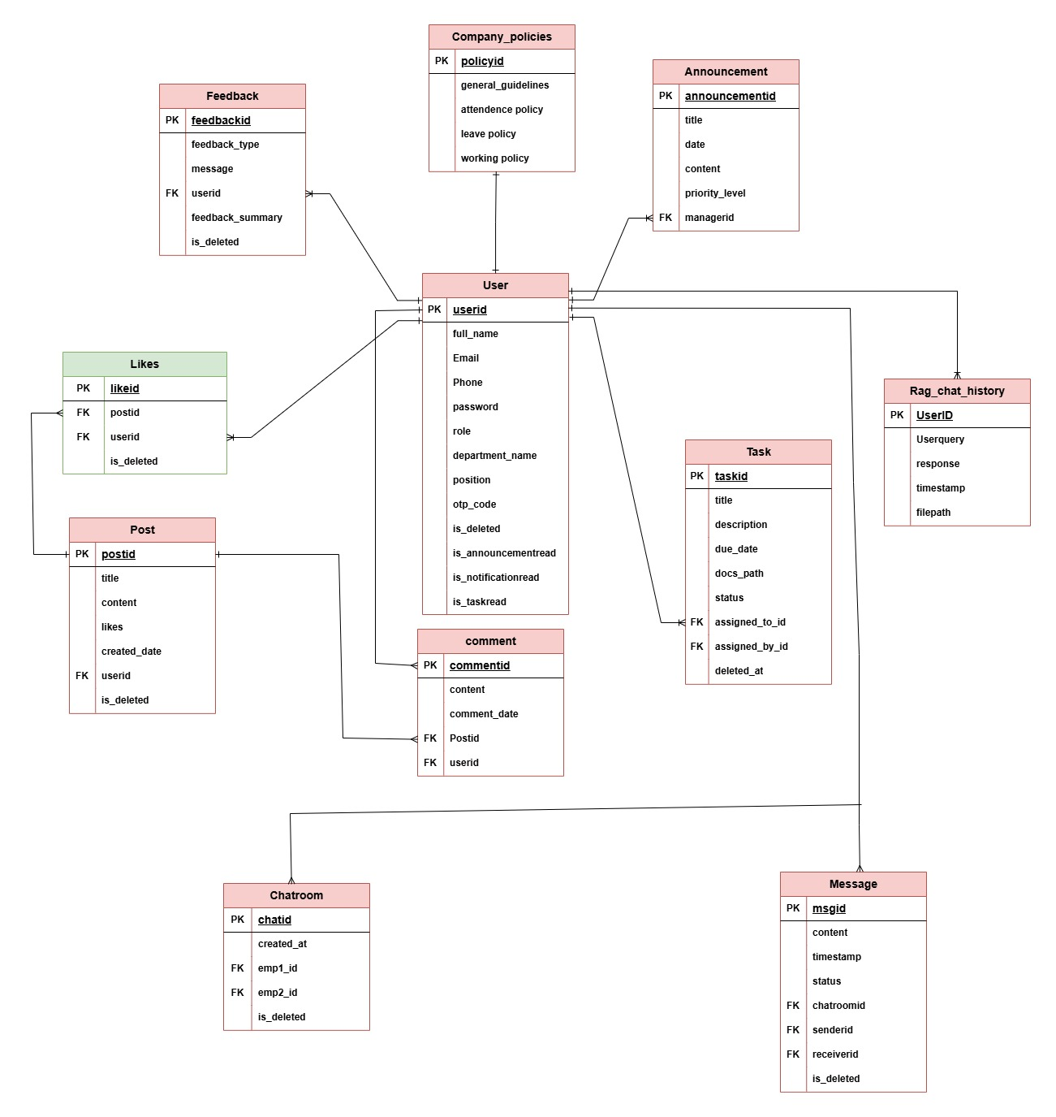**3.5.13.5 DATABASE DESIGN:**

Figure 20 Entity relationship diagram

## **3.5 DESIGN:**

With Scrum, EMS was built step by step and in individual components. The components of the system were revealed, refined, and revised with each new need that arose in each sprint.

To ensure that everyone comprehended how system setup, key features, and everything interacted with each other, we applied these UML design practices:

**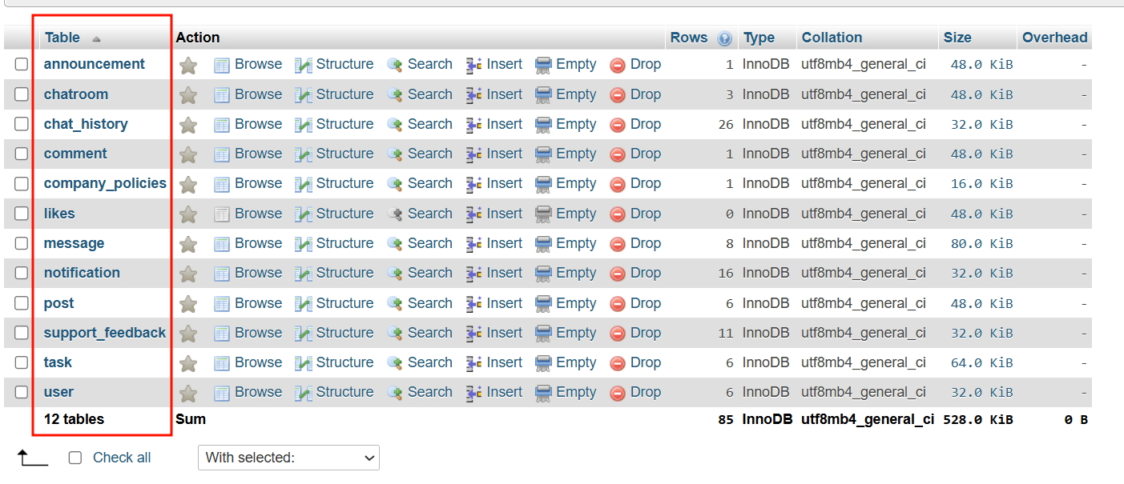****3.5.1 DATABASE DESIGN:**

Figure 21 Database design

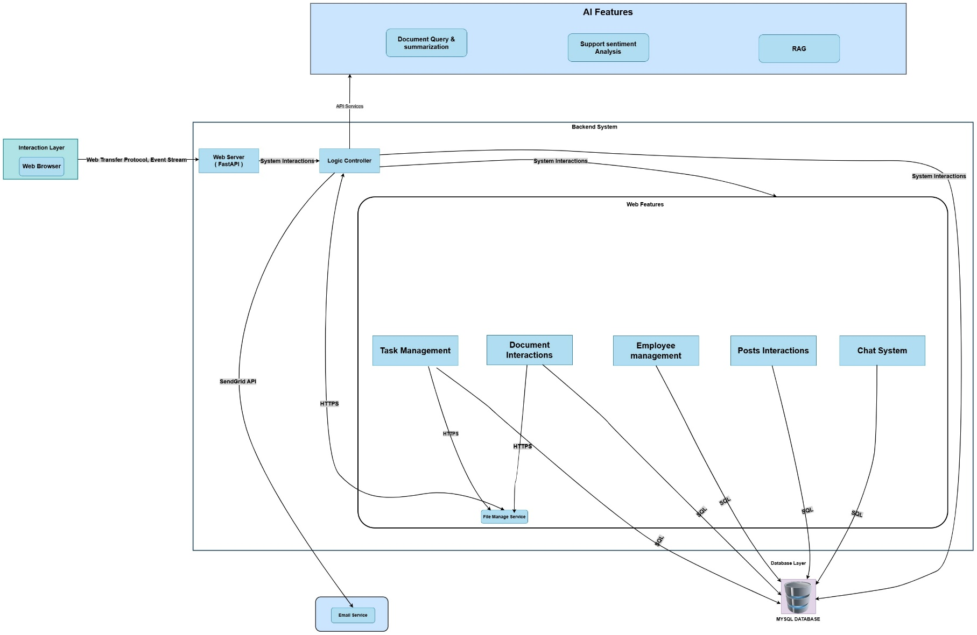**3.5.2 ARCHITECTURE DIAGRAM:**

Figure 22 Architecture Diagram

**3.5.3 CLASS DIAGRAM**

A class diagram is a structure diagram that defines classes, attributes, methods, and relationships within a system.

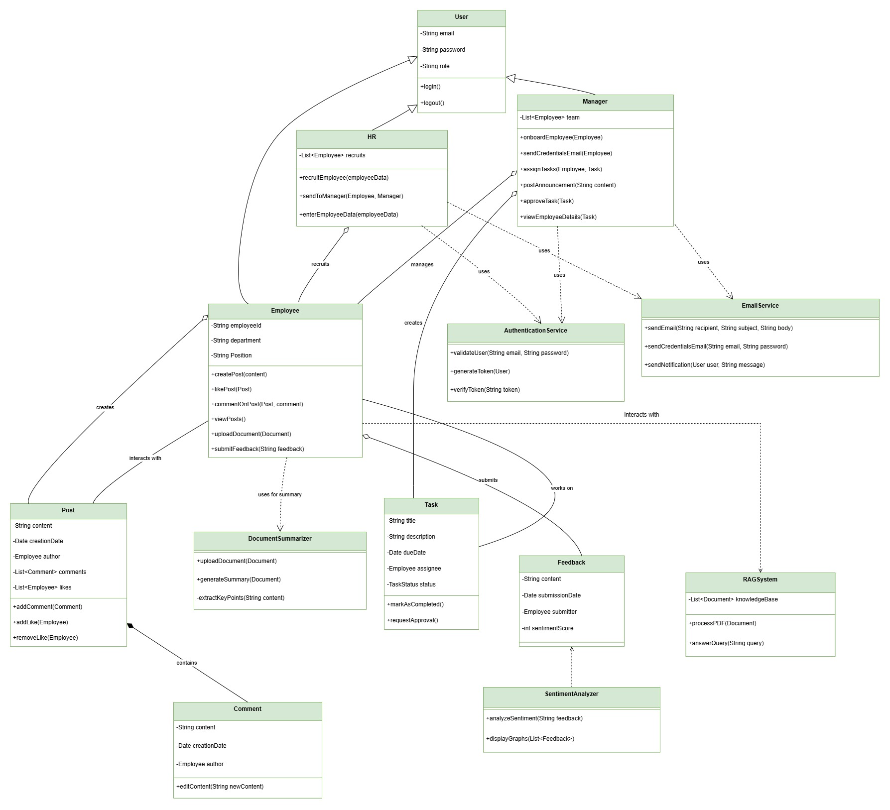

Figure 23 Class Diagram

## **3.6 IMPLEMENTATION:**

The Employee Management System based on AI is designed with a clear vision for integrating its essential components, employing new technology so that it can scale up, is secure, and is convenient for its users. In this part, we are describing how the system is designed, its structure, as well as its essential features, with example codes of how it is developed and functions. The model, view, and controller structure are shown below, along with screenshot of code for major core features on how the system is developed and operates.

**Implementation Overview:**  
This system follows a Model-View-Controller (**MVC**) pattern. This keeps things structured and makes maintenance easier.   
Here are the steps to implement it:

* **Model:** Manages storage by utilizing AWS MySQL Aurora in cloud and mysql databases in local for relational databases.
* **View:** Uses HTML, CSS, Bootstrap, Tailwind CSS, and Jinja Templates for developing flexible, interactive, and customizable dashboards.
* **Controller:** Facilitates business rules and calls for API through FastAPI. Connects the view and model, with Uvicorn serving as the ASGI server.

To illustrate the architecture and functionality, screenshots of the model, view, and controller paths, along with code for major features, are included below.

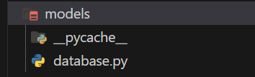

Figure 24 Model of MVC Pattern

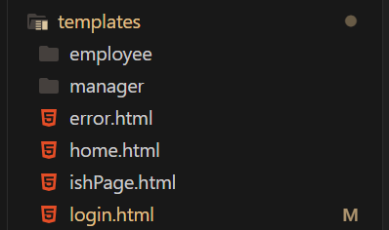

Figure 25 View of MVC Pattern

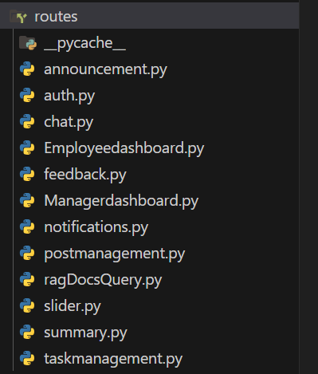

Figure 26 Controller of MVC Pattern

These are all my models views and controllers.

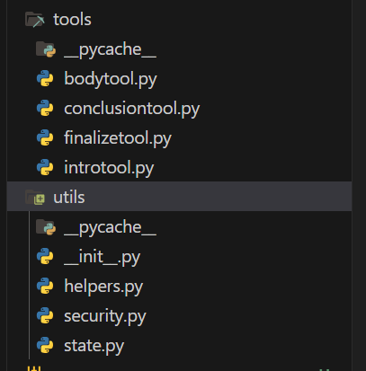

Figure 27 Tools And helper function

The utils and tools directories contain additional helper functions and service logics employed elsewhere within the system.

### **3.6.1 DEVELOPMENT OF CORE FEATURES:**

**1. Meeting Slide Generation:**

**a) kickoff:**

The main objective of these features is to simplify the process of making presentations out of meeting notes. Employees can upload the PDF version of the meeting notes and pick any of the offered slide templates that can be customized. It intends to minimize manual labor and produce high-quality slides based on powerful language models.

**b) Research:**

I researched how employees can upload the PDFs of meetings and select customized slide templates to automatically generate presentations. Proper LLM models such as Gemini, the platform identifies key points and presents them neatly arranged into slides in PPTX or PDF format.  
I researched PDF parsing, experimented with various summarization models, and utilized libraries such as python-pptx to generate slides. Users can upload files through a simple interface and immediately obtain a nice, presentation-ready deck.  
This feature improves productivity by automating slide creation, and I’ve suggested future improvements like multilingual support and live editing.  
View the Appendix – Complete Research

**c) Build:**

The system allows the user to upload the PDF with ease, select one of the customized slide templates and create a complete presentation. This is an agentic approach-based system where AI agents split down pdf context using LLM into different structured format for presentation library. The backend processes the document, processes it with LLM model and return proper meeting slides.

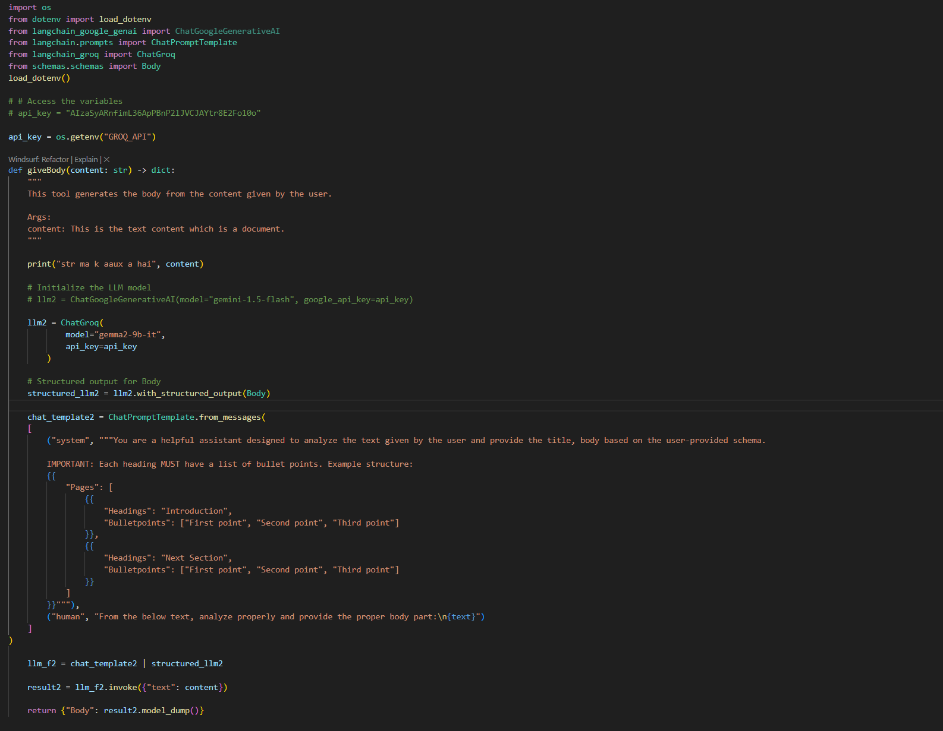

Figure 28 screenshot of body tool

**This is a body tool which splits body content using LLM model.**

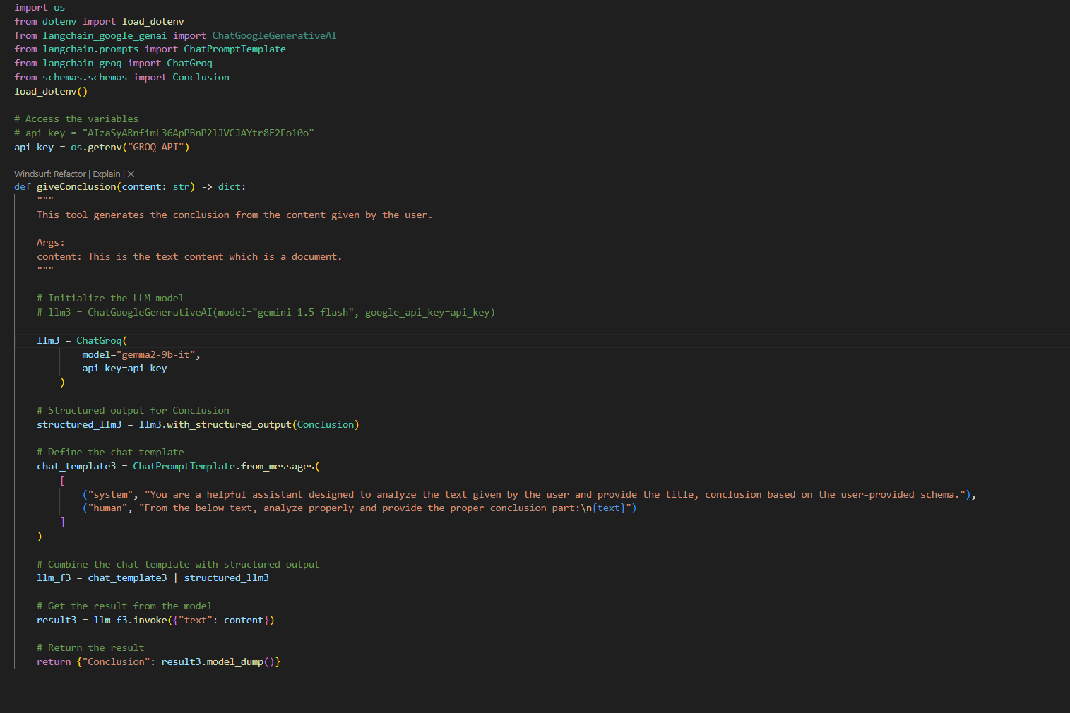

Figure 29 screenshot of conclusion tool

**This is a Conclusion tool which splits conclusion content using LLM model.**

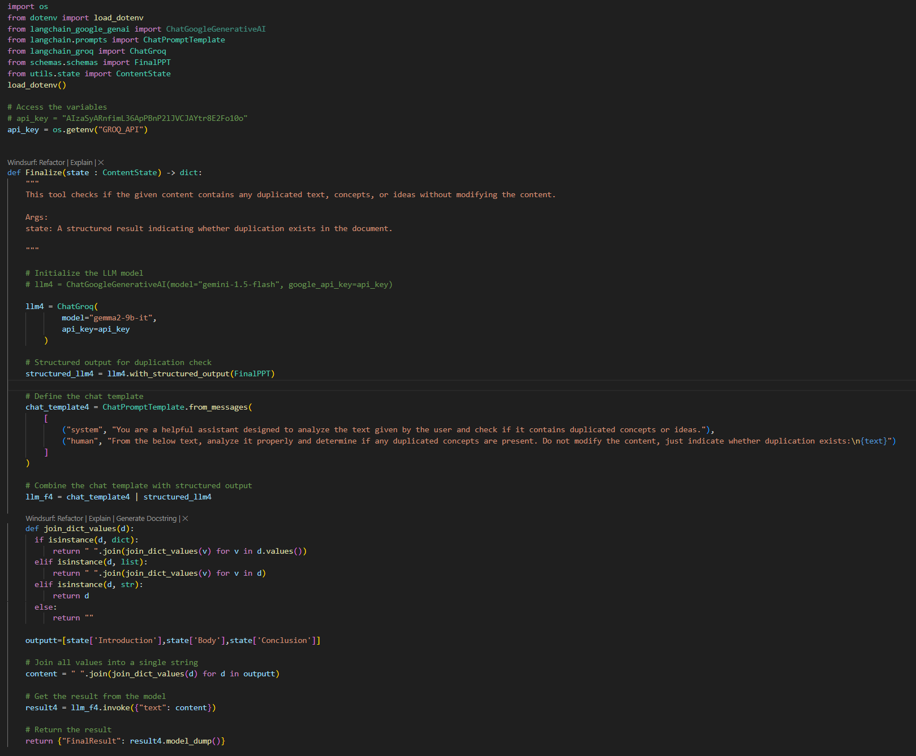

Figure 30 screenshot of finalize tool

**This is a Finalize tool which splits final content using LLM model.**

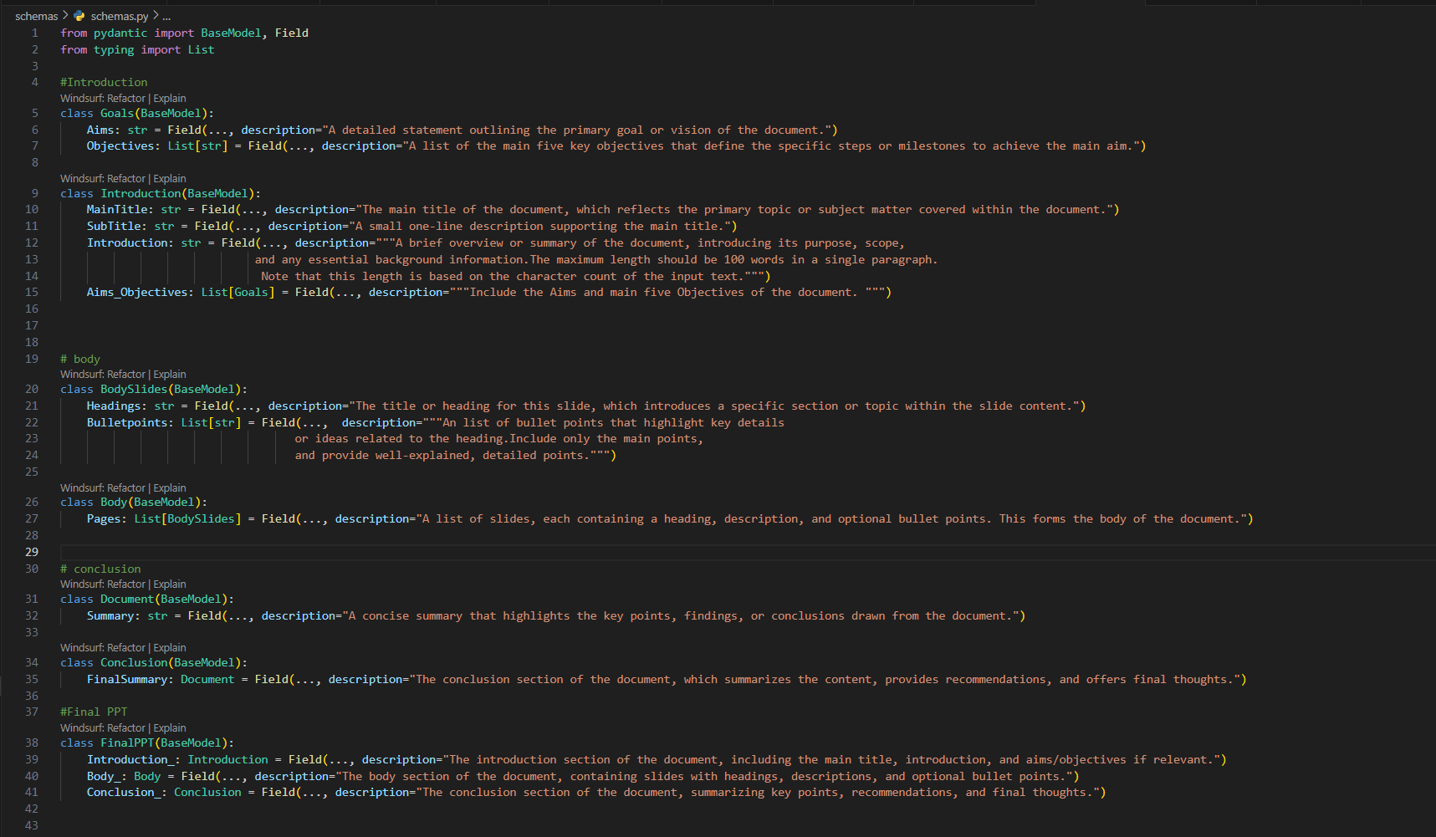

Figure 31 screenshot of pydantic schemas

This file contains all the Pydantic schemas required to parse inputs and

outputs, structured specifically for LLM tool integration.

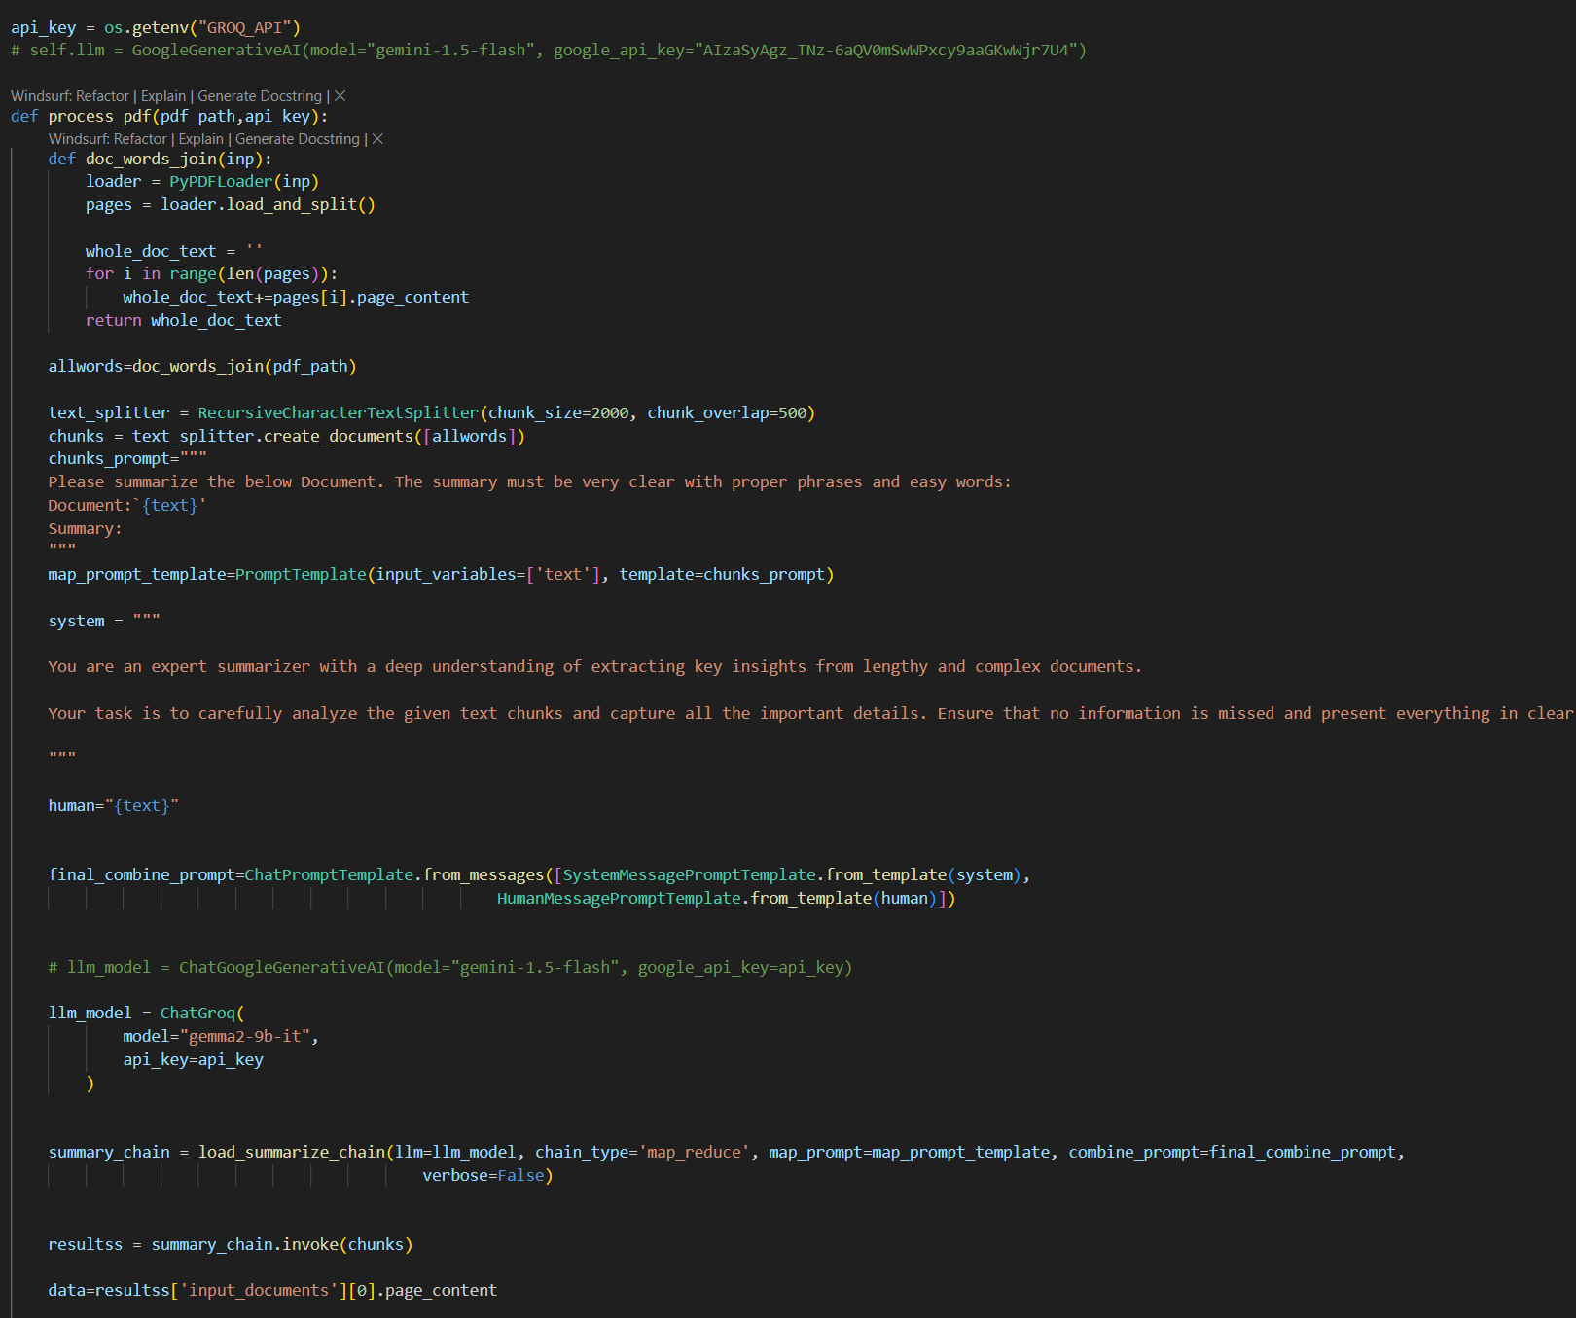

Figure 32 screenshot of core function of meeting slide

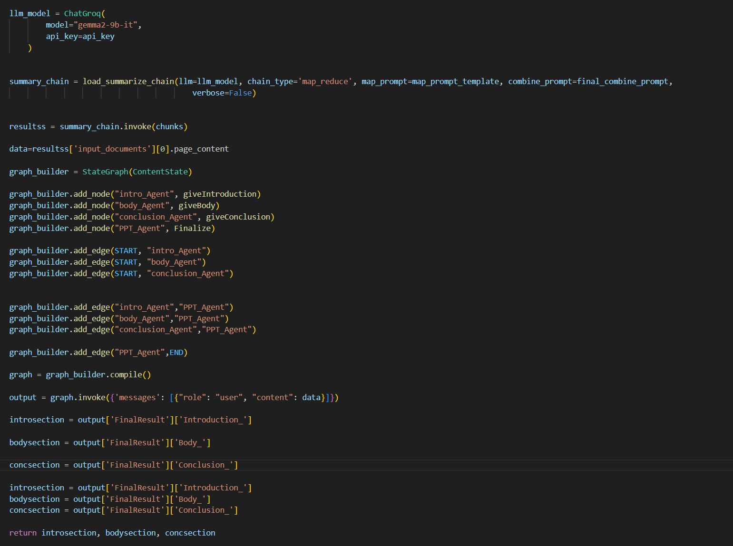

Figure 33 screenshot of graph state part

This is an agentic workflow where pdf file is loaded then chain is invoked after that Lang graph graph state which calls tools as nodes and then return proper results.

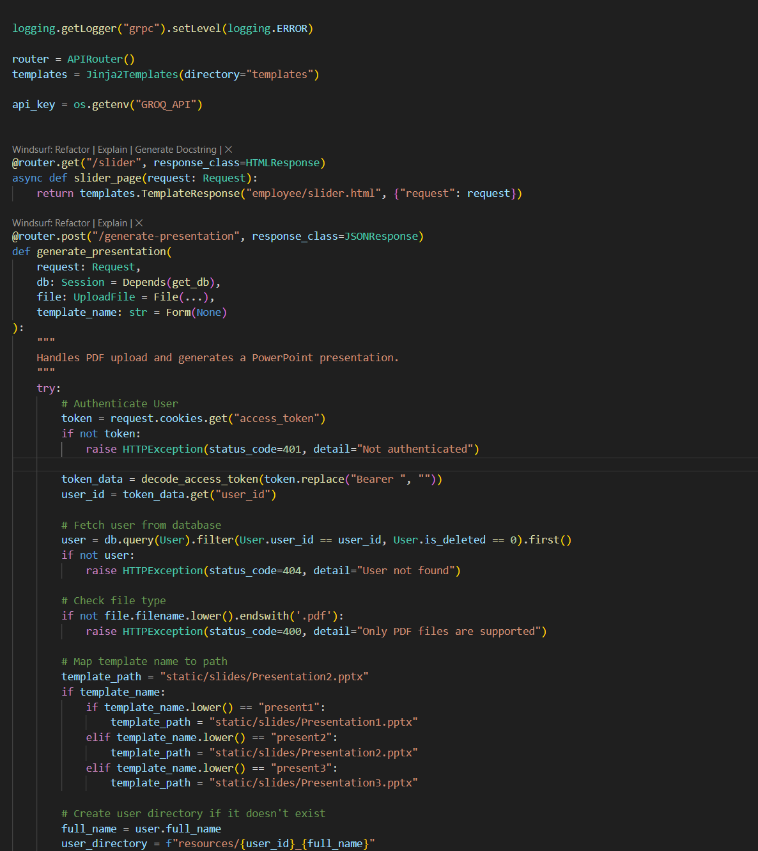

Figure 34 screenshot of post API routes

**This is API route which sends file and customized templates to backend and saved into database and performs slide generation actions.**

1. from imports import *

2.

3. from AIServices.slideAI import process_pdf

4. load_dotenv()

5. api_key = os.getenv("GROQ_API")

6.

7. def new_presentation(pdf_path, api_key, template_path, output_path):

8.     """

9.     Generate a PowerPoint presentation from a PDF document

10.

11.     Args:

12.         pdf_path (str): Path to the PDF file to process

13.         api_key (str): Google API key for accessing Gemini model

14.         template_path (str): Path to the template presentation

15.         output_path (str): Path where the output presentation will be saved

16.     """

17.     introsection, bodysection, concsection = process_pdf(pdf_path, api_key)

18.

19.     prs = Presentation(template_path)

20.

21.     def add_paginated_text(slide_title, heading_desc, bullet_points):

22.         """

23.         Adds text content dynamically, splitting into new slides if necessary.

24.         - If heading paragraph > 100 words → New slide.

25.         - If bullet points > 3 → New slide.

26.         """

27.         slide_layout = prs.slide_layouts[1]

28.         slide = prs.slides.add_slide(slide_layout)

29.         title = slide.shapes.title

30.         title.text = slide_title

31.

32.         content = slide.shapes.placeholders[1]

33.         text_frame = content.text_frame

34.         text_frame.word_wrap = True

35.

36.         if heading_desc:

37.             word_count = len(heading_desc.split())

38.

39.             if word_count > 100:

40.

41.                 words = heading_desc.split()

42.                 chunks = []

43.                 current_chunk = []

44.                 current_count = 0

45.

46.                 for word in words:

47.                     current_chunk.append(word)

48.                     current_count += 1

49.                     if current_count >= 100:

50.                         chunks.append(' '.join(current_chunk))

51.                         current_chunk = []

52.                         current_count = 0

53.

54.                 if current_chunk:

55.                     chunks.append(' '.join(current_chunk))

56.

57.                 p = text_frame.add_paragraph()

58.                 p.text = chunks[0]

59.                 p.font.size = Pt(16)

60.                 p.alignment = PP_ALIGN.JUSTIFY

61.                 p.level = 0

62.                 p.space_after = Pt(15)

63.

64.                 for i in range(1, len(chunks)):

65.                     slide = prs.slides.add_slide(slide_layout)

66.                     title = slide.shapes.title

67.                     title.text = slide_title + " (Continued)"

68.                     content = slide.shapes.placeholders[1]

69.                     text_frame = content.text_frame

70.                     text_frame.word_wrap = True

71.

72.                     p = text_frame.add_paragraph()

73.                     p.text = chunks[i]

74.                     p.font.size = Pt(16)

75.                     p.alignment = PP_ALIGN.JUSTIFY

76.                     p.level = 0

77.                     p.space_after = Pt(15)

78.             else:

79.                 p = text_frame.add_paragraph()

80.                 p.text = heading_desc

81.                 p.font.size = Pt(16)

82.                 p.alignment = PP_ALIGN.JUSTIFY

83.                 p.level = 0

84.                 p.space_after = Pt(15)

85.

86.         bullet_count = 0  # Track number of bullets

87.         for bullet in bullet_points:

88.             if bullet_count >= 4:

89.                 slide = prs.slides.add_slide(slide_layout)

90.                 title = slide.shapes.title

91.                 title.text = slide_title + " (Continued)"

92.                 content = slide.shapes.placeholders[1]

93.                 text_frame = content.text_frame

94.                 text_frame.word_wrap = True

95.                 bullet_count = 0  # Reset bullet count

96.

97.             # Add bullet point

98.             p = text_frame.add_paragraph()

99.             p.text = bullet

100.             p.font.size = Pt(16)

101.             p.alignment = PP_ALIGN.JUSTIFY

102.             p.level = 1  # This makes it a bullet point

103.             p.space_after = Pt(10)

104.

105.             bullet_count += 1  # Increment bullet count

106.

107.     # Add a title slide

108.     slide_layout = prs.slide_layouts[0]  # Title slide layout

109.     slide = prs.slides.add_slide(slide_layout)

110.     title = slide.shapes.title

111.     subtitle = slide.placeholders[1]

112.

113.     title.text_frame.text = introsection["MainTitle"]

114.     title.text_frame.paragraphs[0].font.size = Pt(32)

115.     title.text_frame.auto_size = MSO_AUTO_SIZE.SHAPE_TO_FIT_TEXT

116.     title.text_frame.paragraphs[0].alignment = PP_ALIGN.JUSTIFY

117.

118.     subtitle.text_frame.text = introsection["SubTitle"]

119.     subtitle.text_frame.paragraphs[0].font.size = Pt(18)

120.     subtitle.text_frame.auto_size = MSO_AUTO_SIZE.SHAPE_TO_FIT_TEXT

121.     subtitle.text_frame.paragraphs[0].alignment = PP_ALIGN.JUSTIFY

122.

123.     # Add Introduction Slide

124.     add_paginated_text("Introduction", introsection["Introduction"], [])

125.

126.     # For Aims

127.     add_paginated_text("Aims", "", [introsection['Aims_Objectives'][0]['Aims']])

128.

129.     # For Objectives

130.     add_paginated_text("Objectives", "", introsection['Aims_Objectives'][0]['Objectives'])

131.

132.     # Add body content dynamically from bodysection['Pages']

133.     for page in bodysection['Pages']:

134.         add_paginated_text(page['Headings'], page.get('Description', ''), page['Bulletpoints'])

135.

136.     # Add Conclusion

137.     add_paginated_text("Conclusion", concsection['FinalSummary']['Summary'], [])

138.

139.     # Save the presentation

140.     prs.save(output_path)

141.

142.     return output_path

143.

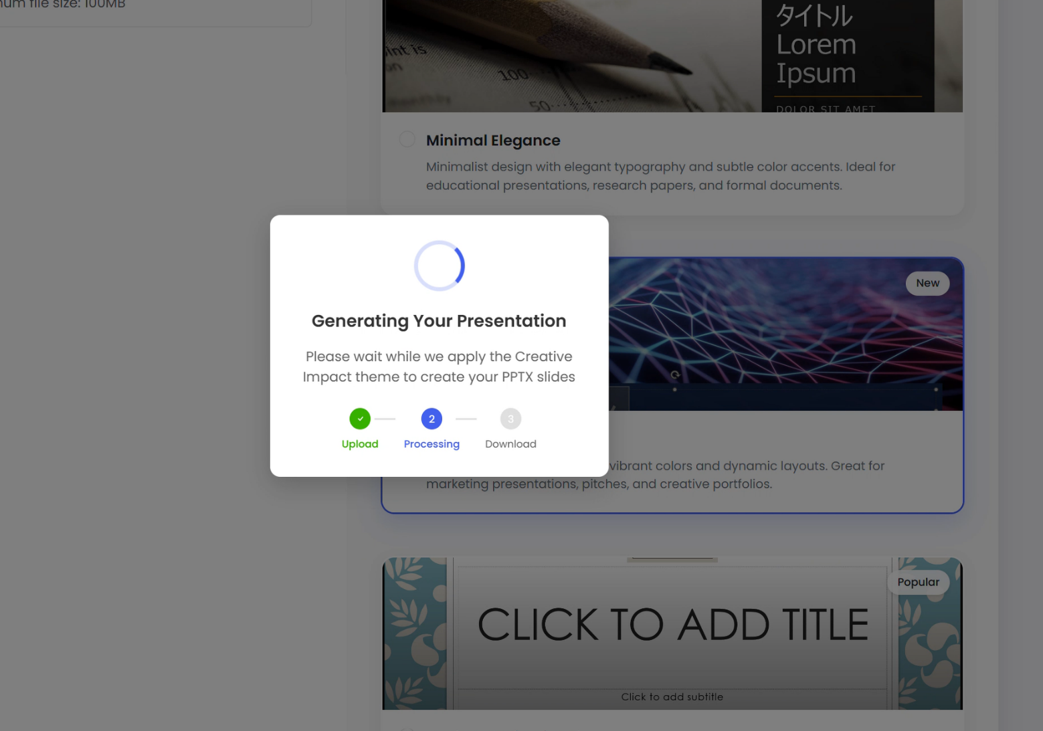**D) Testing:**

Figure 35 screenshot of displaying processing part of meeting slide

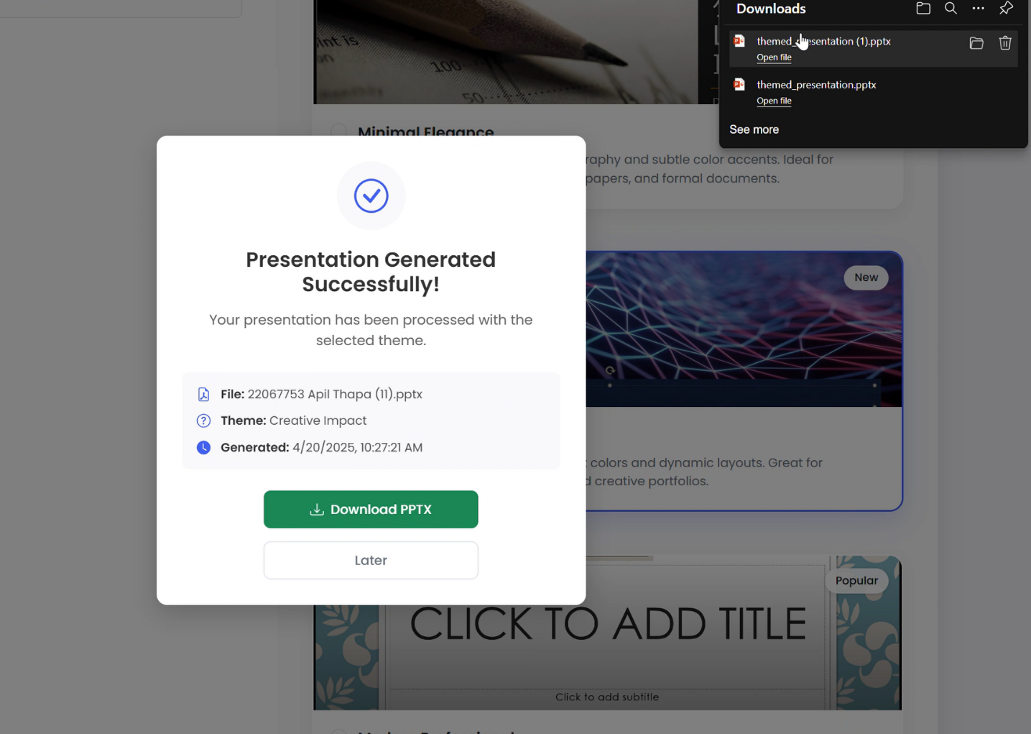

Figure 36 screenshot of displaying meeting slide has been generated successfully

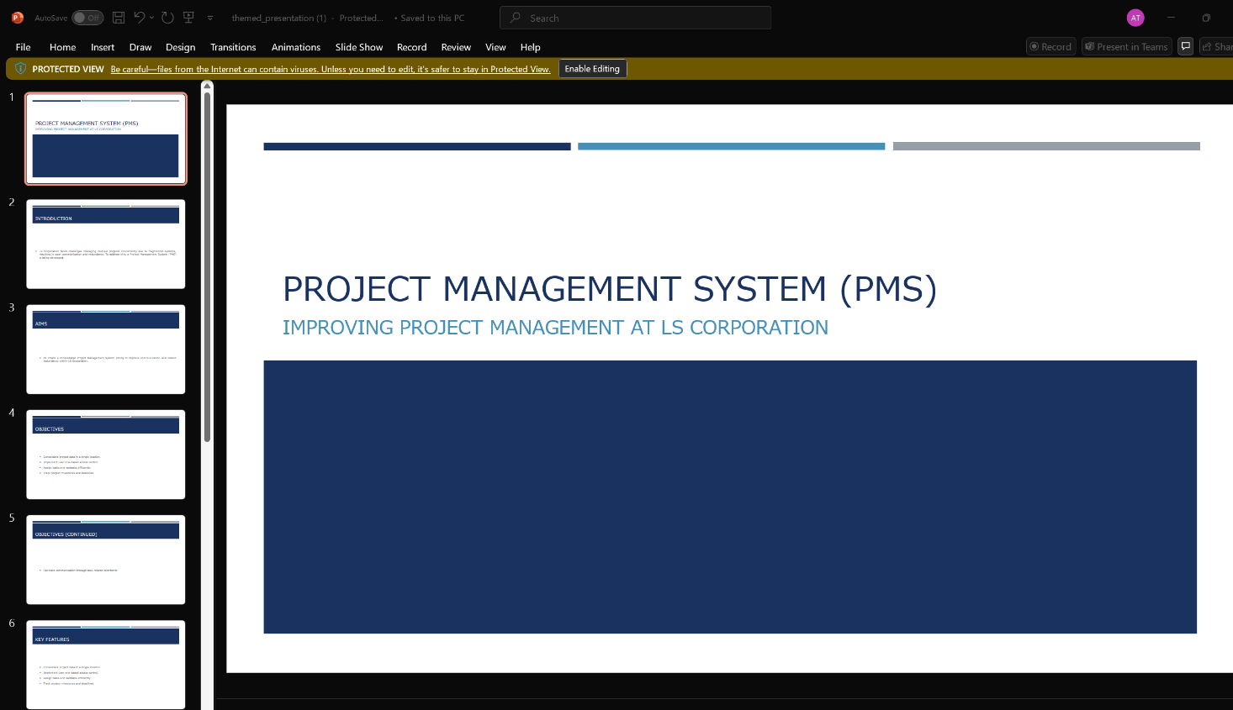

Figure 37 Displaying generated slide after downloading

This is a manual test where presentation slides are generated successfully and downloaded.

**e) Conclusion:**

In summary, this feature has the potential to simplify presentation tasks for teams by enabling them to generate proper simple meeting slides from routine meetings pdf files.

**2. Document Summary:**

**a) kickoff:**

The initial objective is to design an easier document processing system to assist employees. The system allows the user to upload PDF documents to an intuitive website, which processes the documents immediately. Once the files are uploaded, the text from the PDF is extracted and sent to the language model, which generates a concise yet readable summary of the document. The user then views the summary, which can be accessed where it is displayed and downloaded as a text document to be accessed later. It aims to be time-saving, easier to access, and to assist with leveraging the power of the new AI capabilities using technologies such as Python to read PDFs, an LLM API to summarize, and modern web design to be easy to access through an approachable interface.

**b) Research:**

The research phase for the PDF summarization system focused on key components. I have evaluated PyPDF2 for PDF text extraction, LLM models for real-time LLM summarization, and bootstrap for a user-friendly upload and summary display interface. **Fast Api** for backend processing.

Visit this research – Click here

**c) Build:**

The application was designed to accept PDF uploads, extract the text, and pass that along to one of the large language models to summarize immediately. A method to work with files, generate summaries, and arrange them was established in the back end. Eventually, an interface was created that would allow the user to upload documents and download the summaries quite straightforwardly.

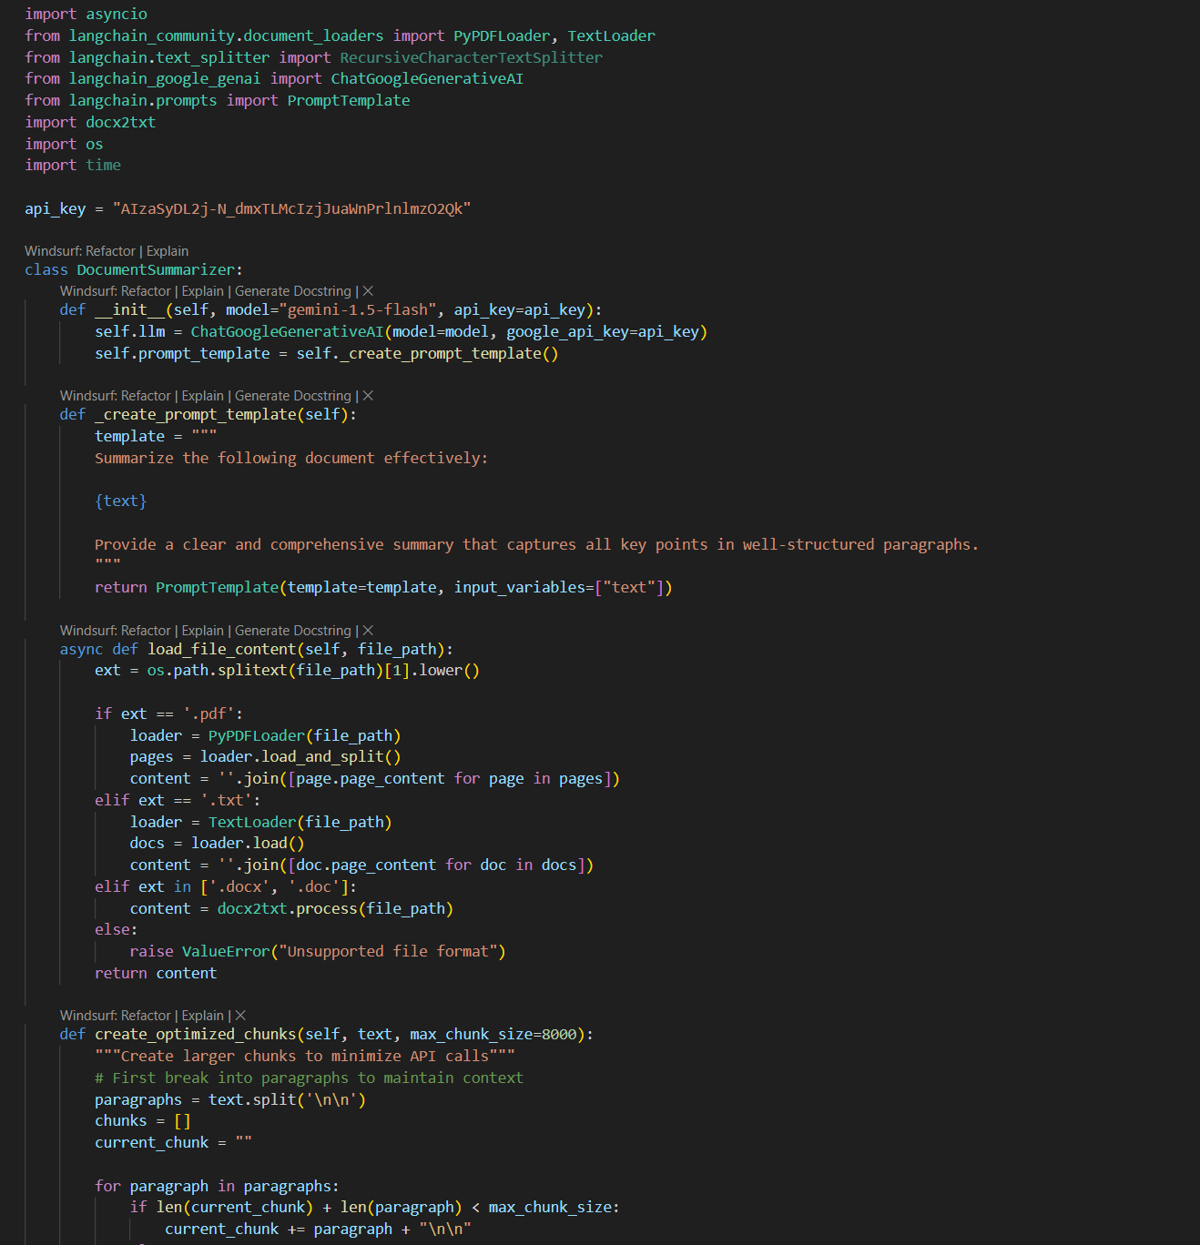

Figure 38 screenshot of summary generation class AI code

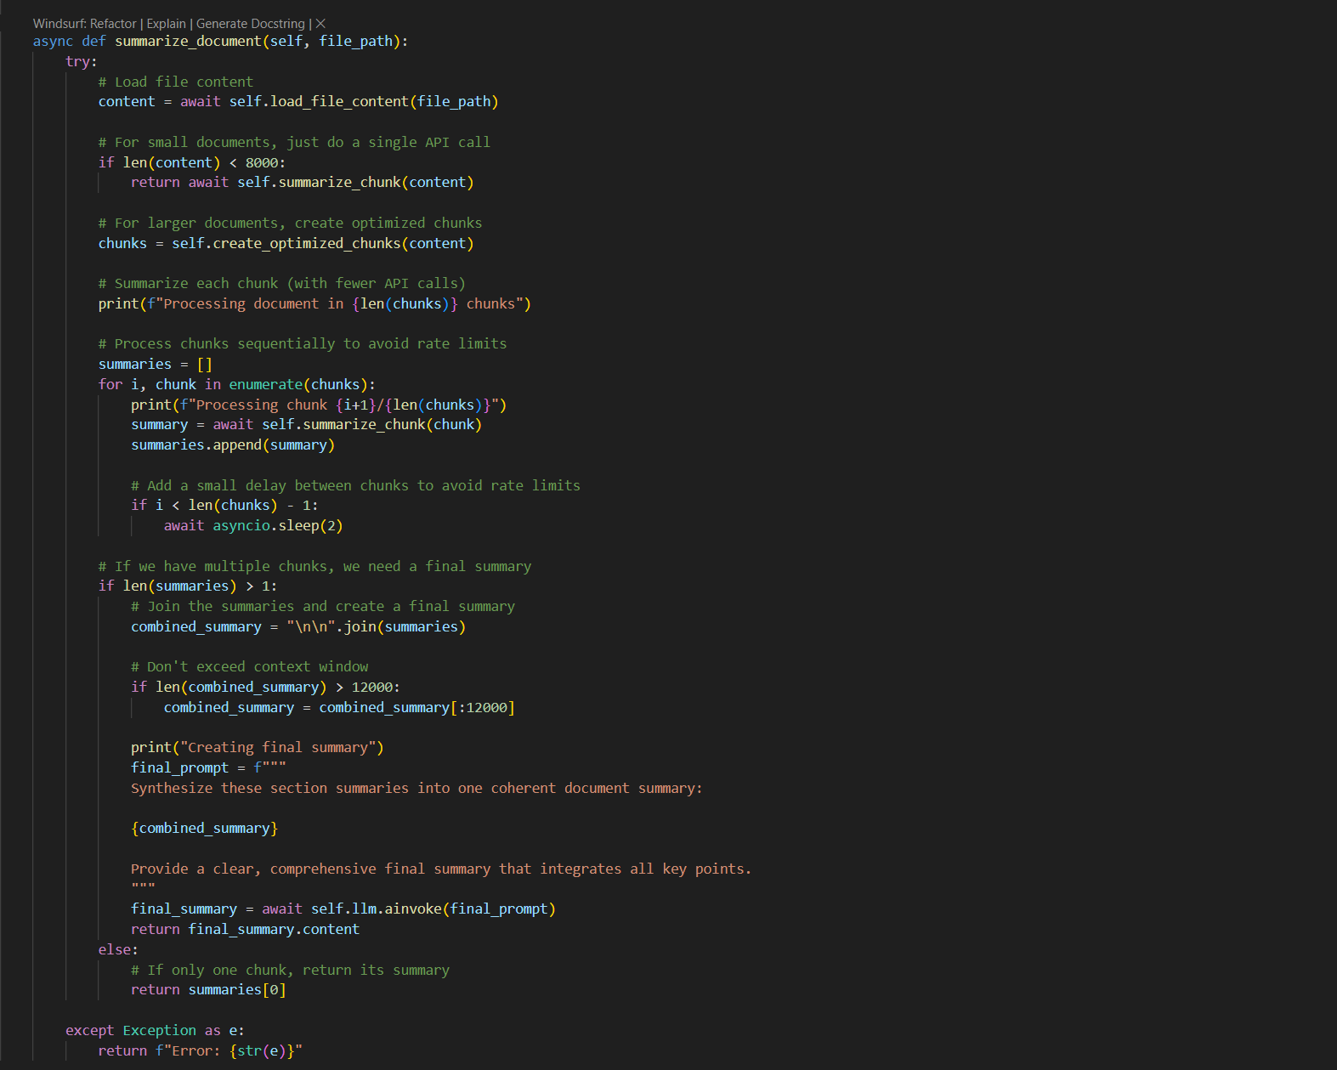

Figure 39 screenshot of core function in summarization which return values

This is a document summarization class which helps to summarize the documents content using LLM model.

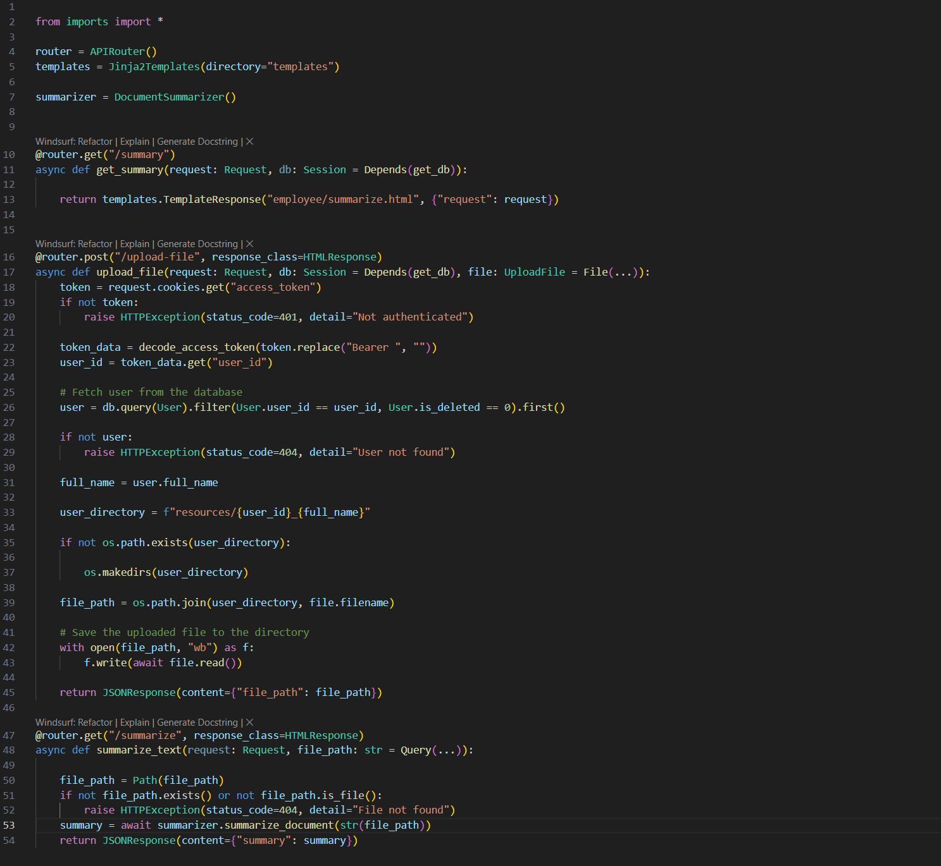

Figure 40 screenshot of post API routes

This is an API code which sends document pdf file to backend AI module and generate summary.

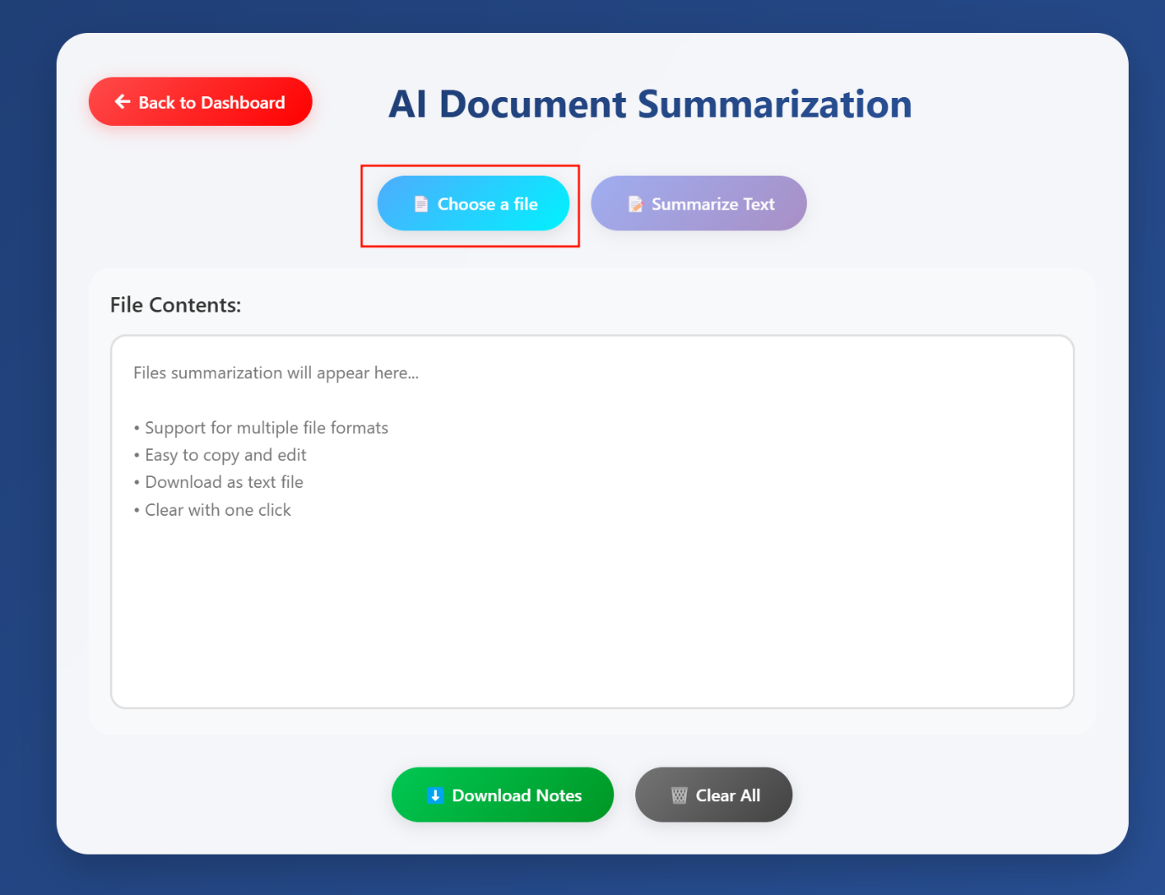**d) Testing:**

Figure 41 screenshot of summarization UI for uploading file

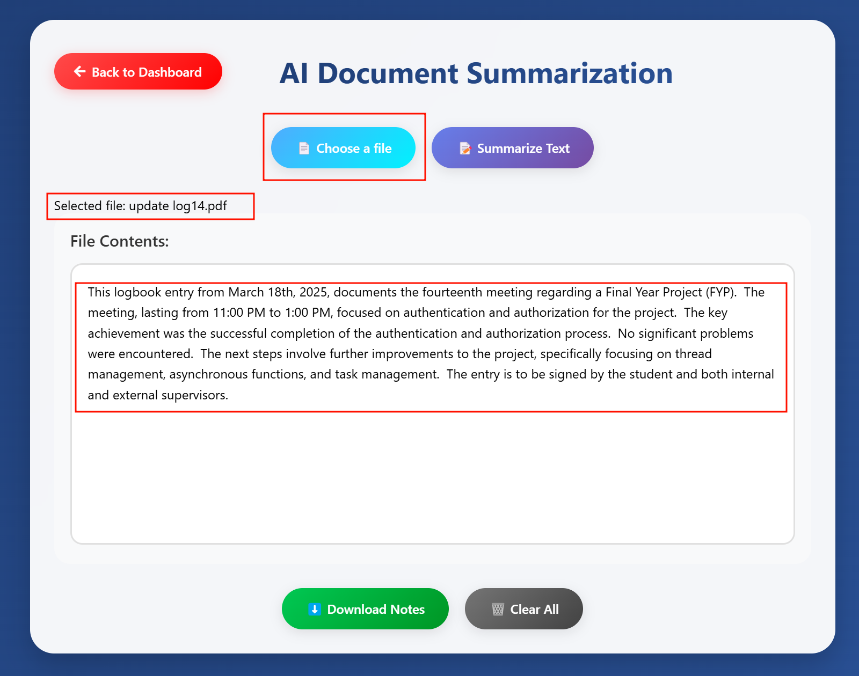

Figure 42 screenshot of displaying content after file uploading

Here, first we choose files for upload pdf then LLM will generate summary for that pdf files.

**e) Conclusion:**

The PDF summarization tool allows you to upload PDFs, summarize them using a language model immediately, and download the summaries into text files. It is simple to use and performs well, offering an approach that can evolve and adapt with user input.

**3 Feedback Sentiment analysis:**

**a) kickoff:**

A sentiment analysis feedback system begins by establishing locations for users to provide feedback. A dedicated BERT model will provide real-time feeling scores (negative, positive). The solution employs language processing to provide useful information in the form of an intuitive interface where users can provide feedback and export the results. The project will scale rapidly by tapping into BERT’s capabilities in sentiment classification and generation.

**b) Research:**

I have researched all possible sentiment models and decided that BERT is suitable for sentiment understanding in text due to its preciseness in NLP. We utilize Hugging Face Transformers and **PyTorch** to fine-tune BERT on different variations of datasets. I have investigated text preprocessing techniques, such as tokenization, to process feedback.  
Visit this research – Click here

**c) Build:**

To build the feedback sentiment analysis system, fine-tune a BERT model with Hugging Face Transformers to classify feedback as positive, negative, or neutral. Develop a Python app to preprocess feedback and compute sentiment scores using BERT. Create a web interface for feedback submission and result downloads. Link the app and interface via APIs. Test with sample feedback for accuracy, deploy on EC2, and refined based on user feedback.

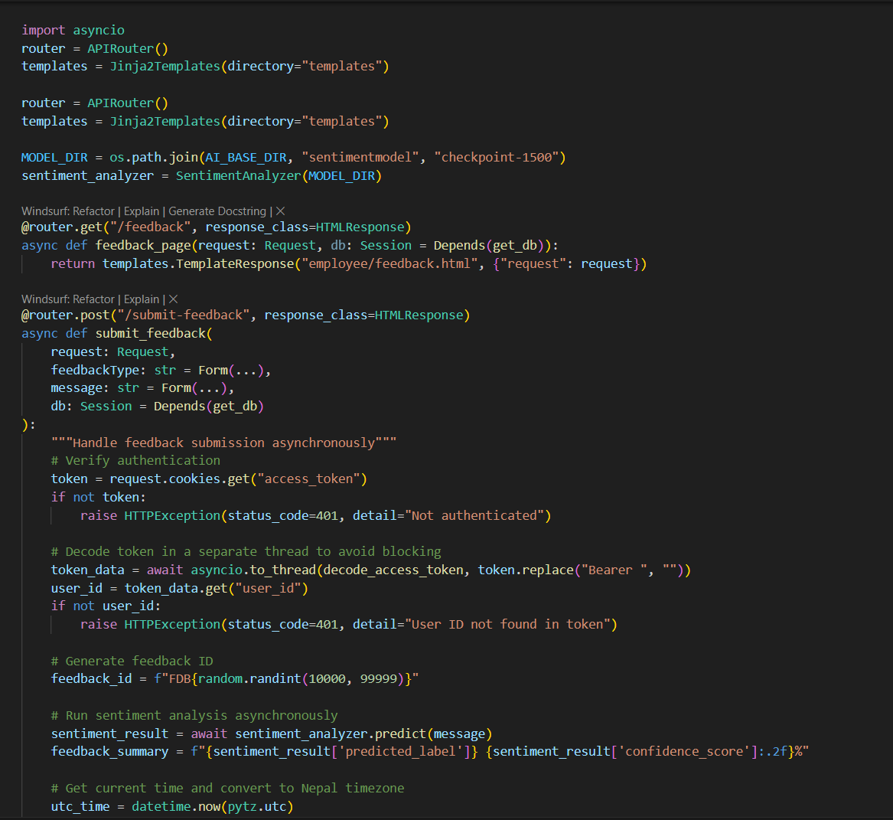

Figure 43 screenshot of submitting feedback post API

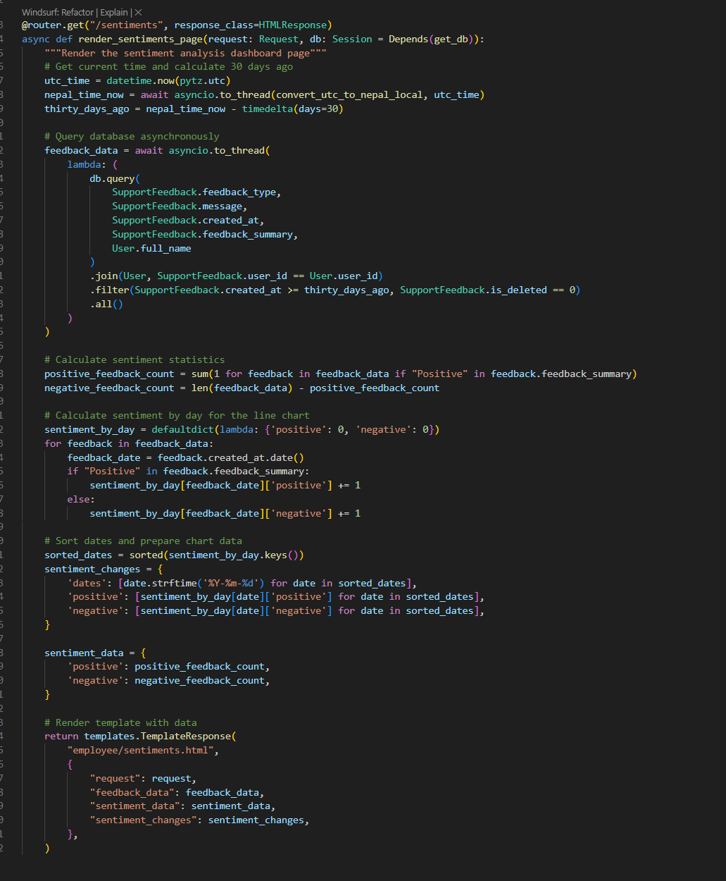

Figure 44 screenshot of GET API request for feedback

This is feedback sentiment where user submits feedback then that feedback is passed into sentiment model which is transformers-based **BERT** which provides proper sentiment score with binary class predictions.

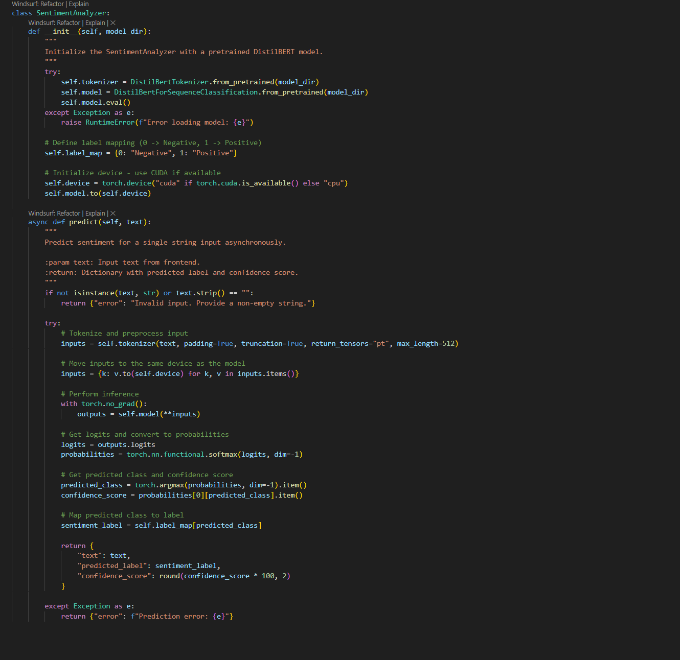

Figure 45 screenshot of sentiment AI class

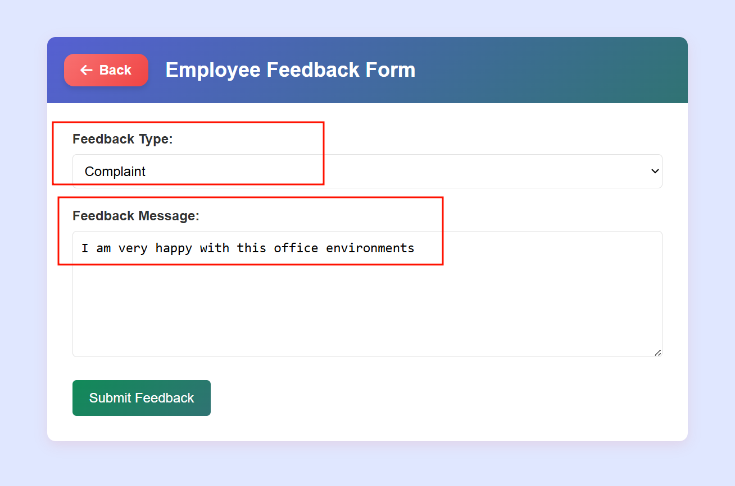**d) Testing:**

Figure 46 screenshot of adding feedback

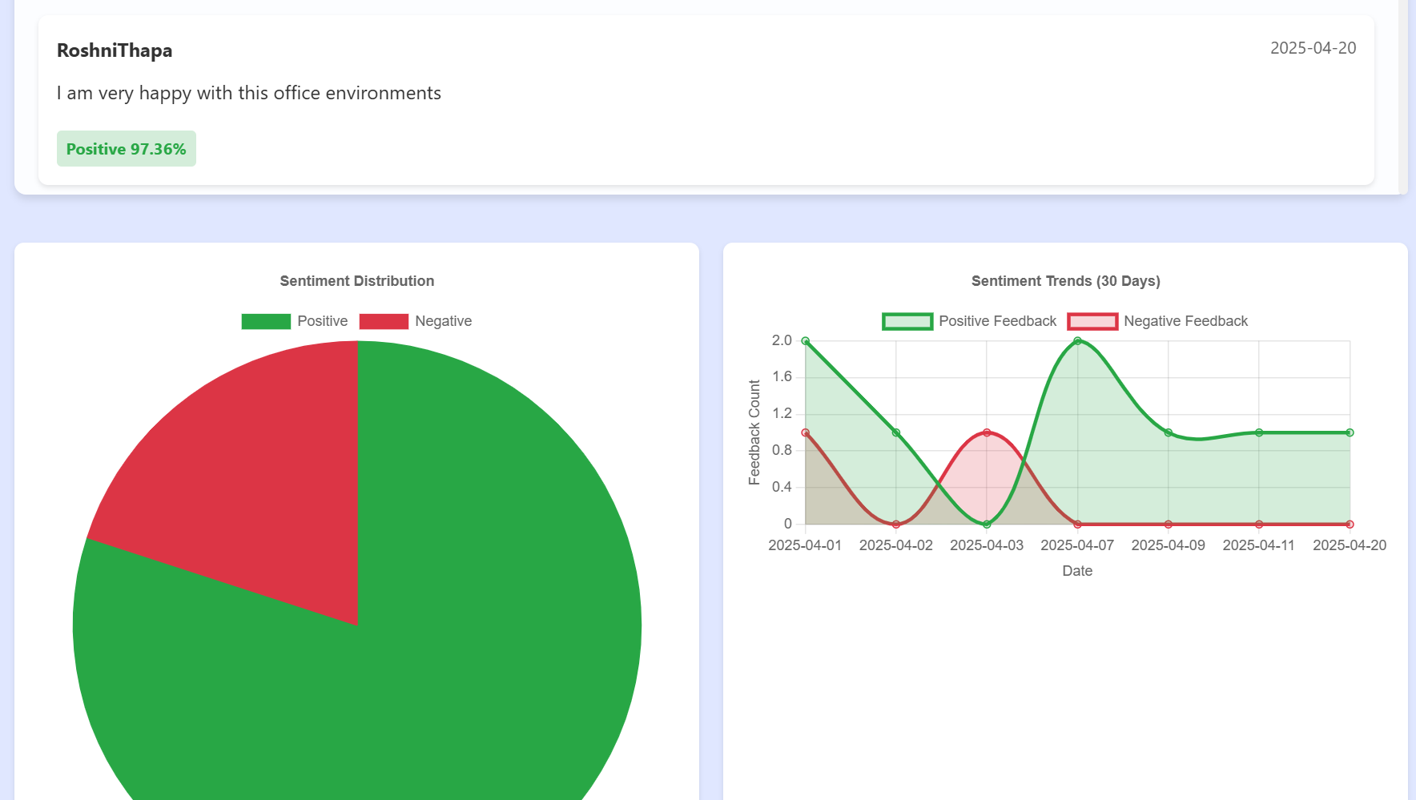

Figure 47 screenshot of displaying graph and sentiment with score for feedback message

This is testing where employees submit their feedback and then sentiment score is calculated and saved into database properly.

**e) Conclusion:**

In conclusion, sentiment analysis for feedback submitted by an employee is gone to BERT model and then score is generated with binary class.

**4 Create Tasks:**

**a) kickoff:**

The main purpose of these features is to allow managers to create tasks with a deadline, assignee, and title. The system will enhance teamwork and accountability among teams, with easy task assignment and update. The solution will be an easy-to-use design to input and store tasks, with easy task assignments and discovery. The project is designed with rapid development in mind, utilizing new web technologies to develop an easy-to-use system with the ability to scale as required.

**b) Research:**

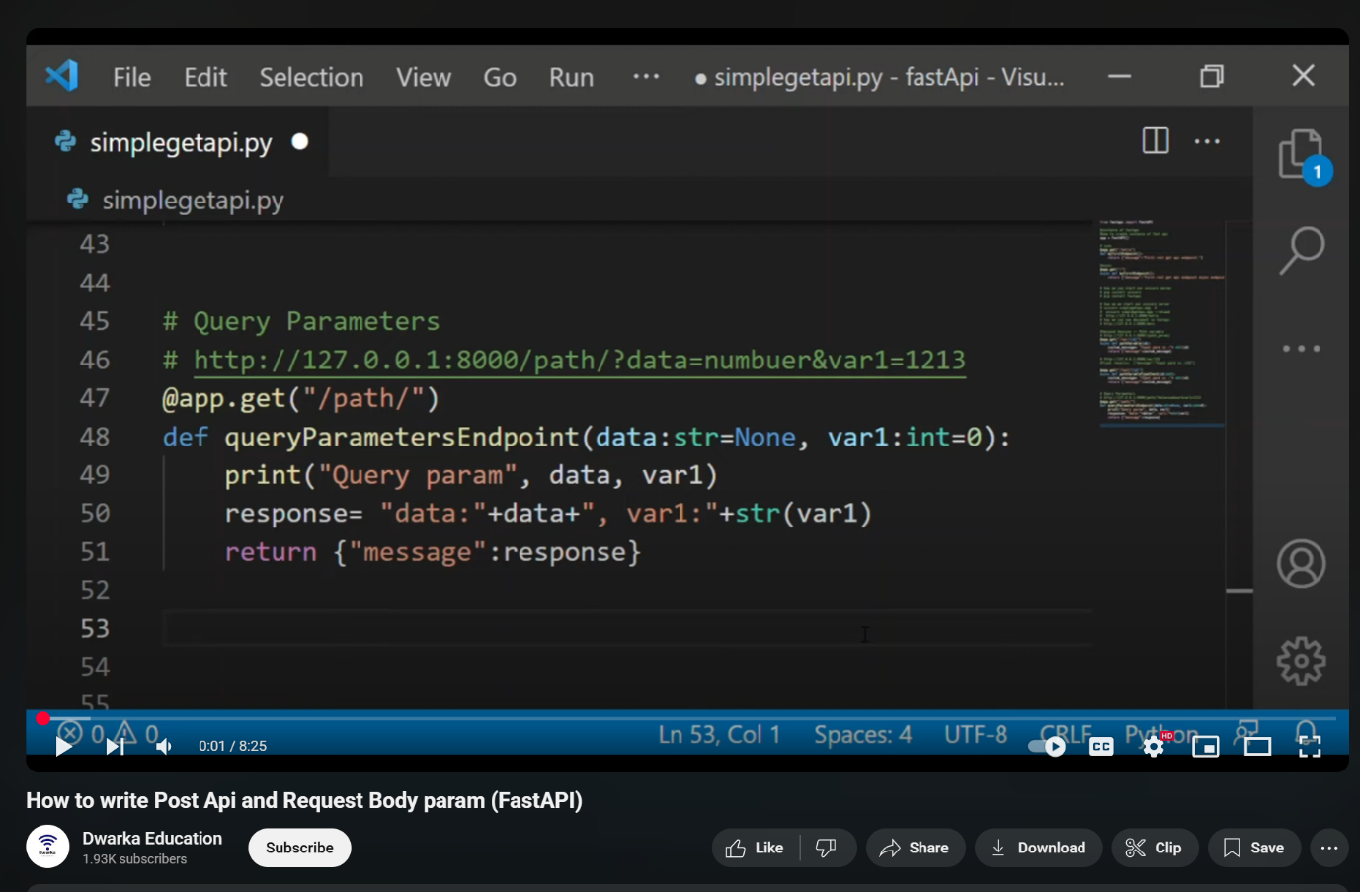I have done research on how **fastapi** handles different types of API requests. Some from YouTube videos and others through the internet.

Figure 48 screenshot of research part for API from youtube

**c) Build:**

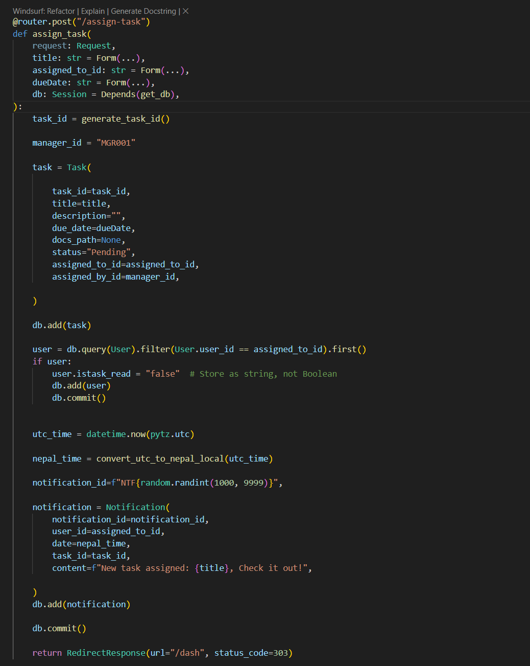For the building process in task creation, I have created API request which accepts title, date and assignee for tasks then which is sent to backend through API from frontend.

Figure 49 screenshot of POST request API for task creation

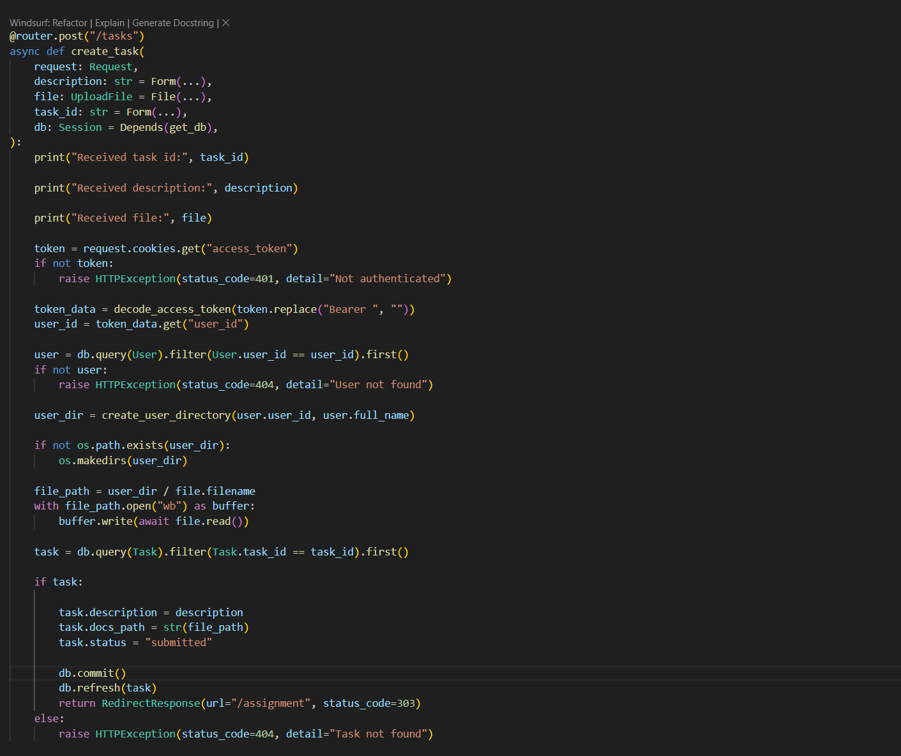

Figure 50 screenshot of GET API for task

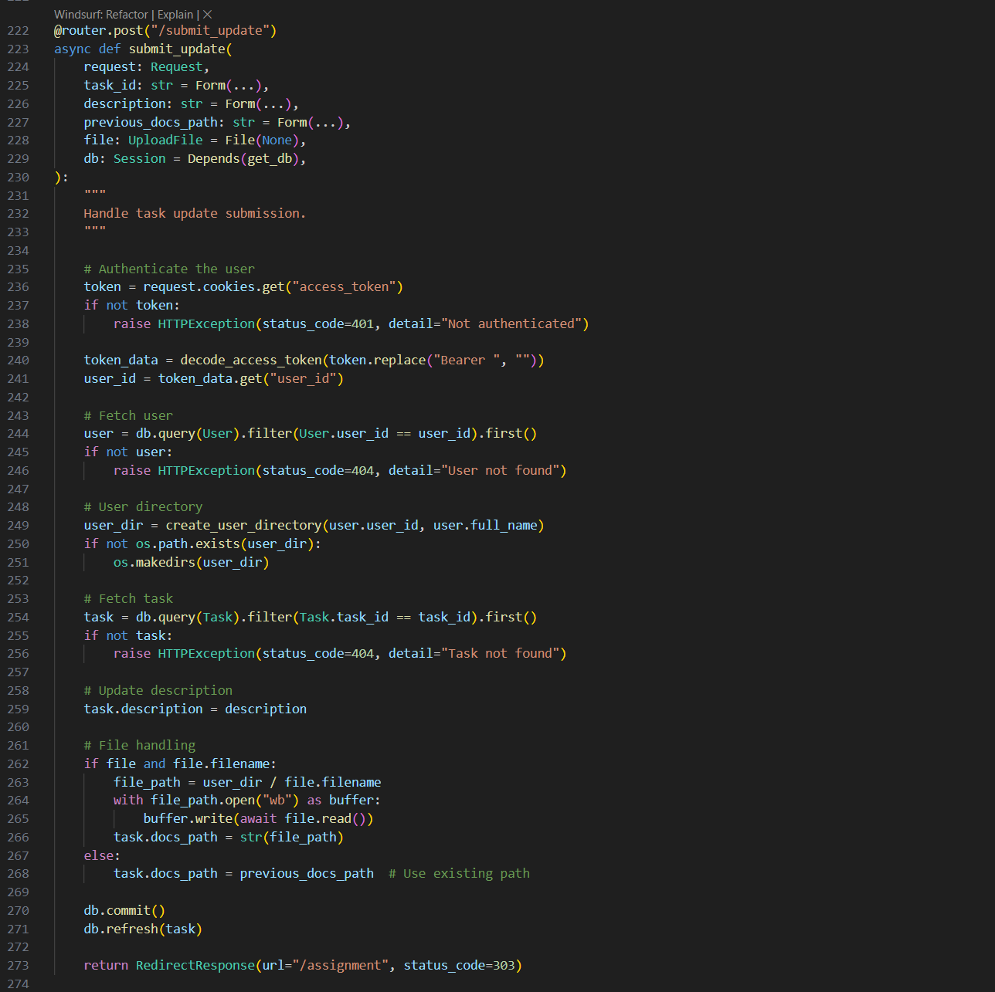

Figure 51 screenshot of task update

**d) Testing:**

I have tested this task creating with proper manager assigning tasks to employees properly and employee can get those tasks and then they can submit and update tasks until approved.

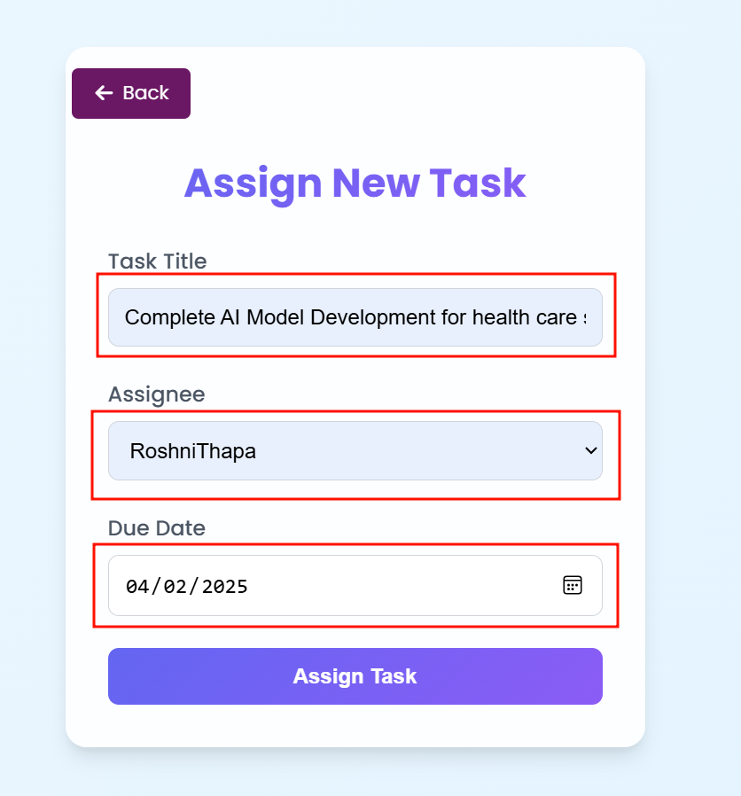

Figure 52 screenshot of task assigning with values

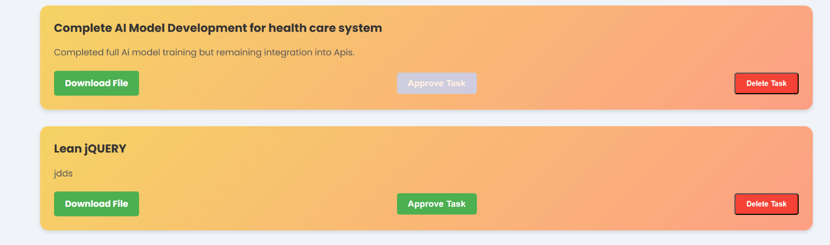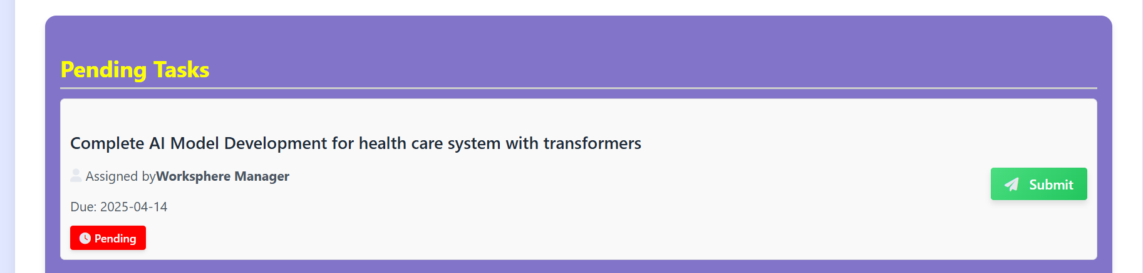

Figure 53 screenshot for displaying approved task

Figure 54 screenshot of displaying pending tasks for employee

**e) Conclusion:**

To conclude, each task is assigned properly to employees and employees also can view all assigned tasks at real time then they can submit tasks and update tasks also till approved by manager.

**5 Create Posts:**

**a) kickoff:**

The main purpose of these features is to allow employees to create posts where every employee from that author department can view all those posts then they can interact also on that post with like comments and all in real time.

**b) Research:**

I have done research on how **fastapi** handles different types of API requests. Some from Docs through the internet.

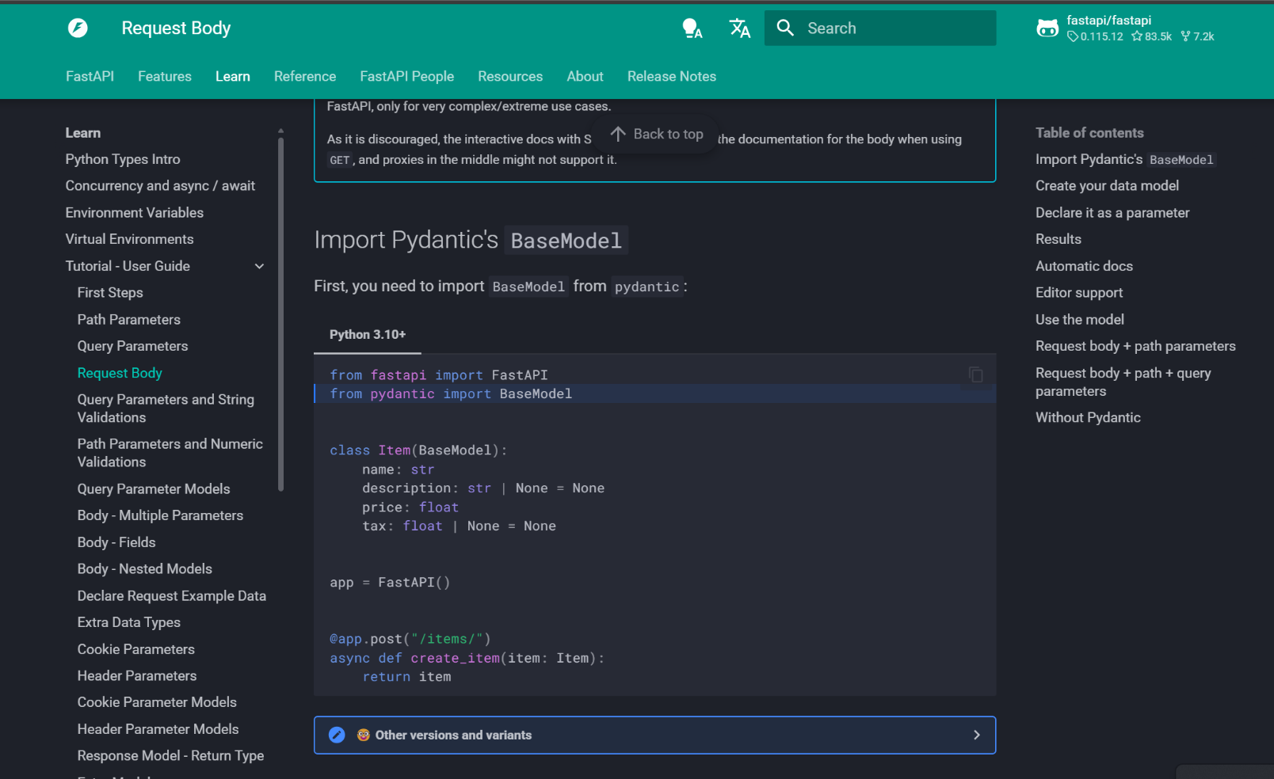

Figure 55 screenshot for research part of API request from official fast Api docs

**c) Build:**

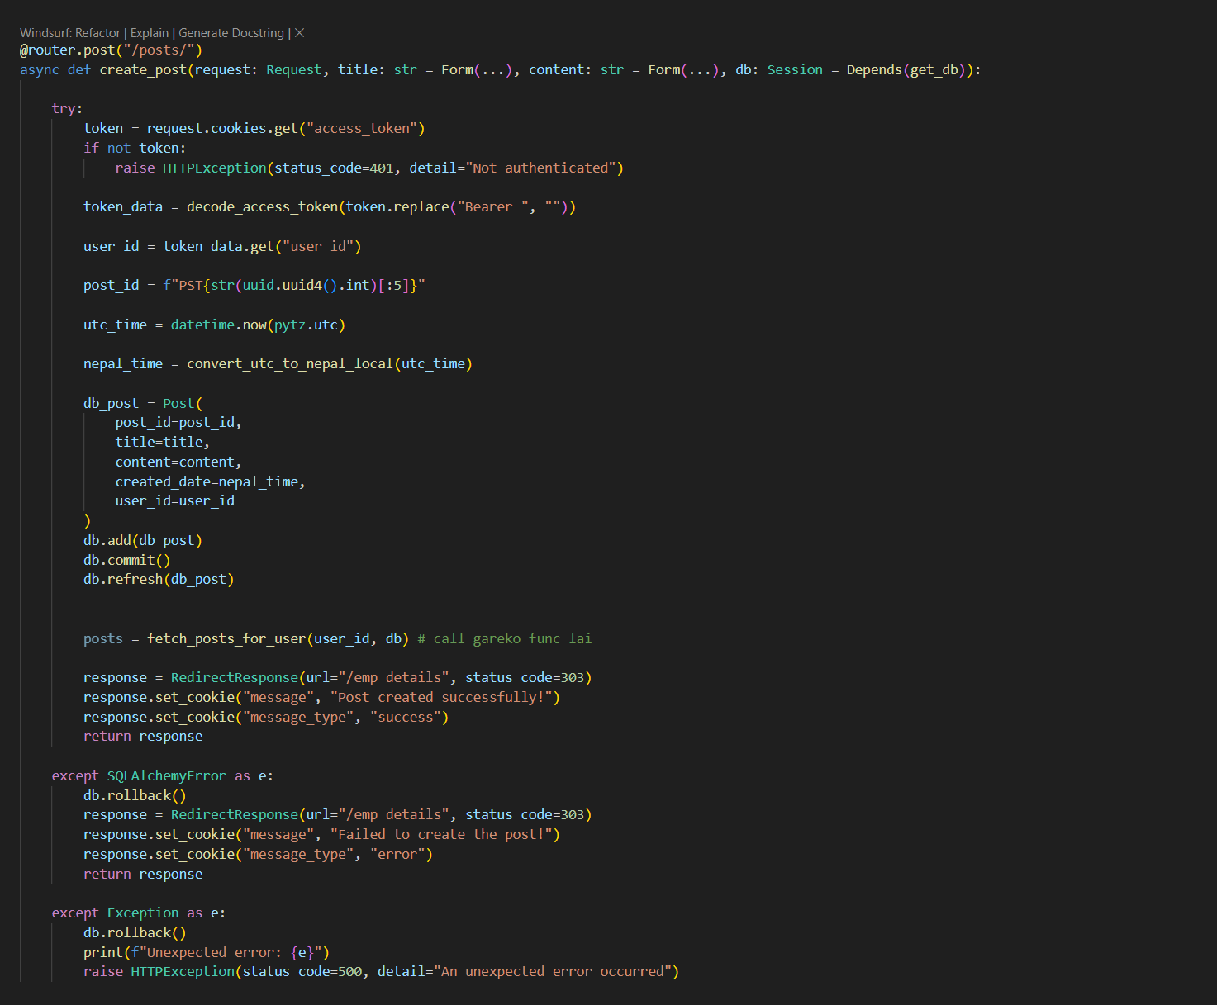For the building process in Post creation, I have created API request which accepts title and description for posts then which is sent to backend through API from frontend to backend.

Figure 56 screenshot of post request API

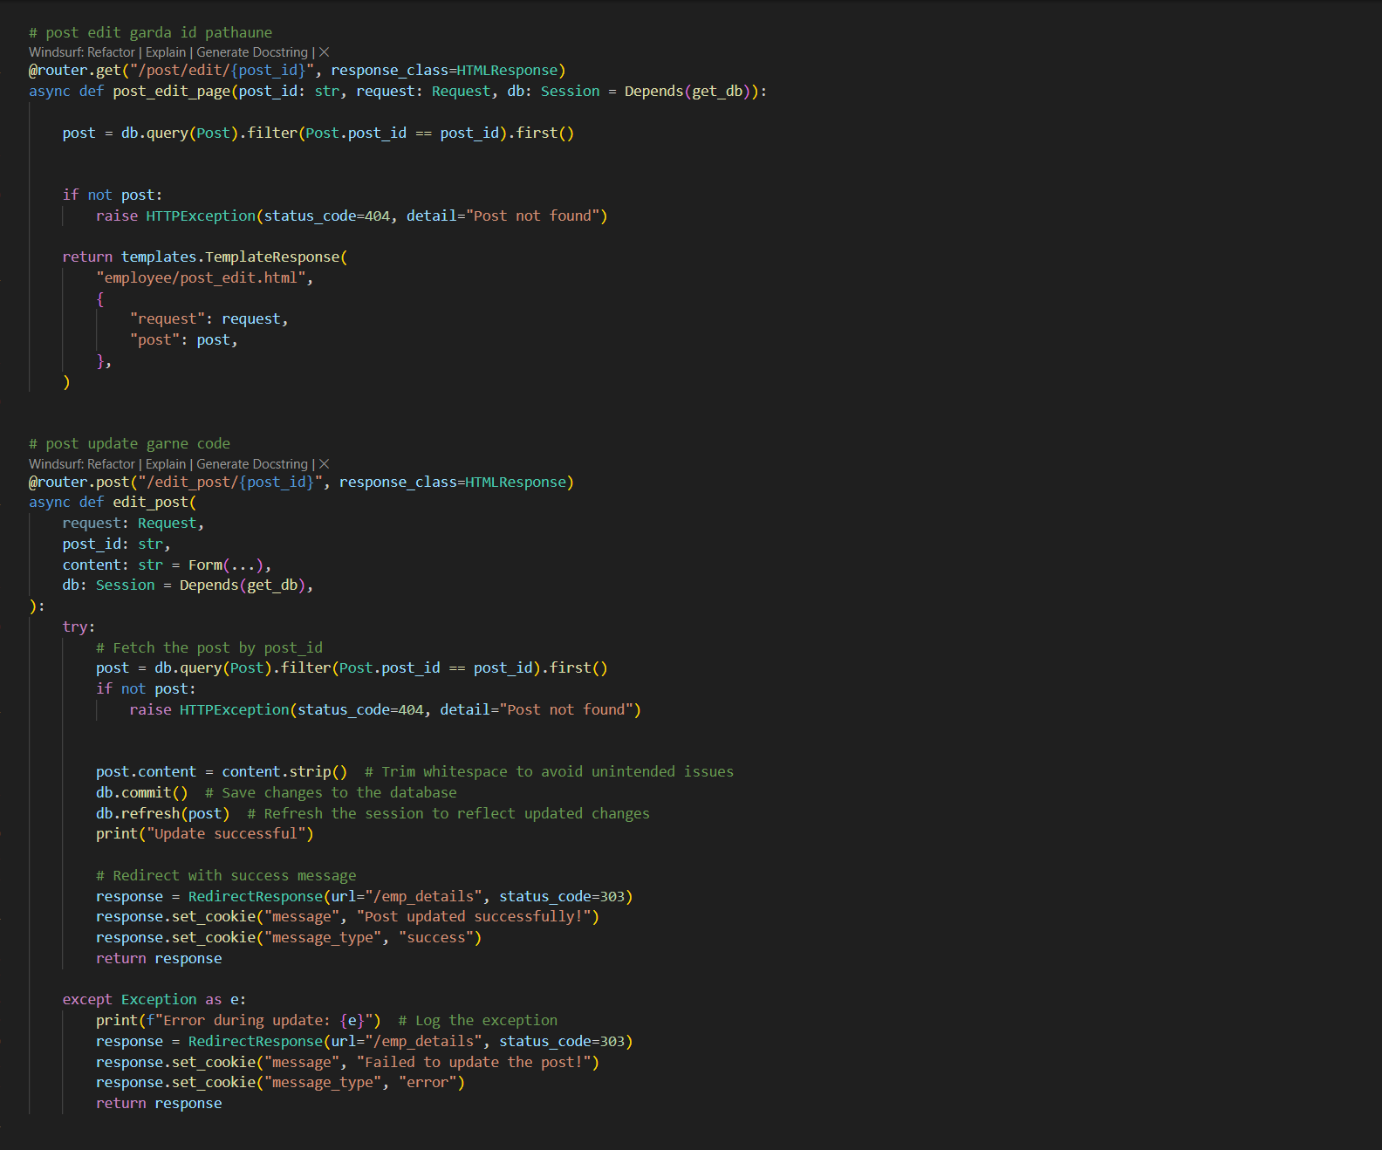

Figure 57 screenshot of post edit with POST API request

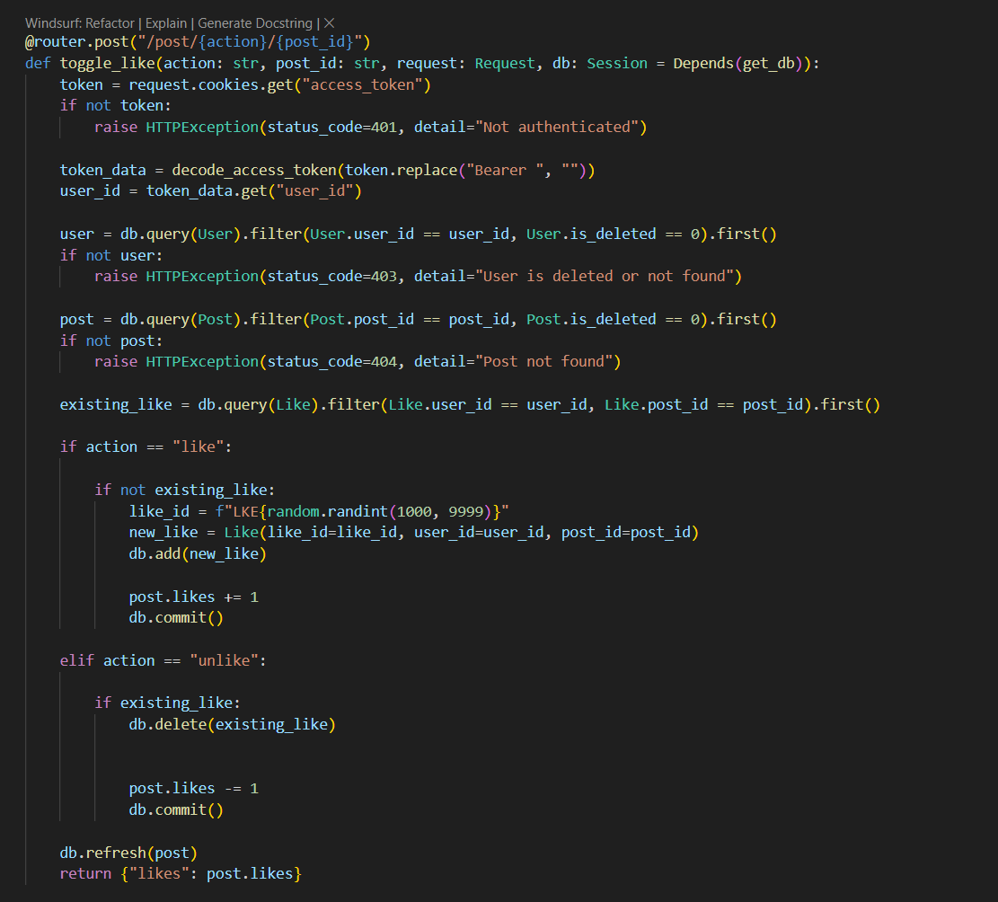

Figure 58 screenshot of post like part

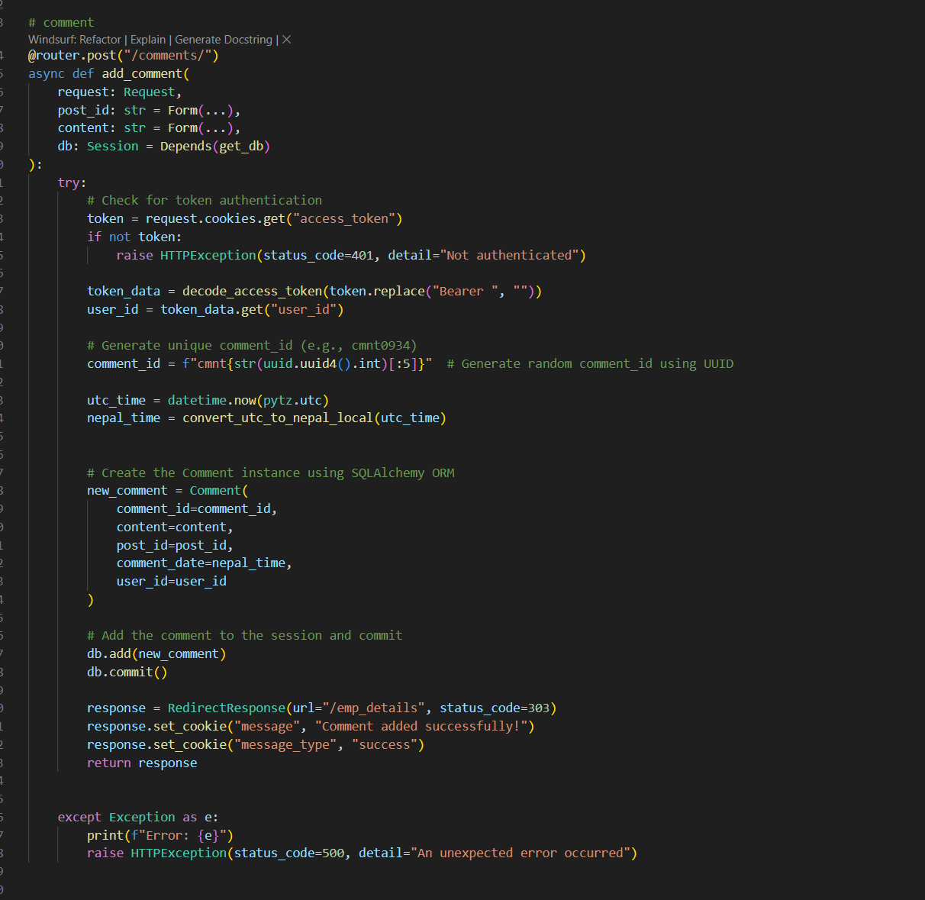

Figure 59 screenshot of comment part on posts through API request

**d) Testing:**

For testing phase, I have done like creating posts and successfully then other departments members can interact with those posts.

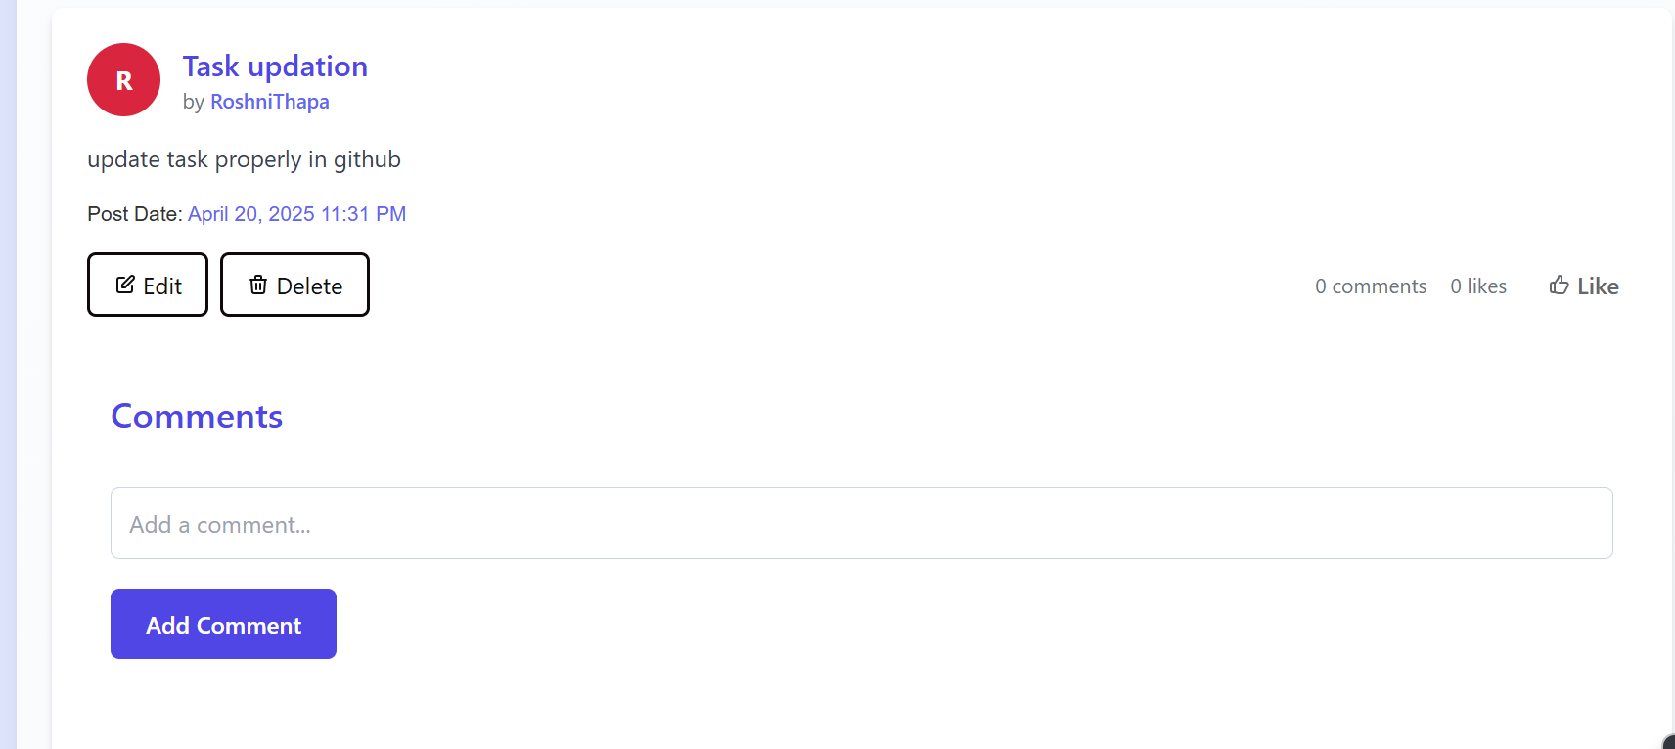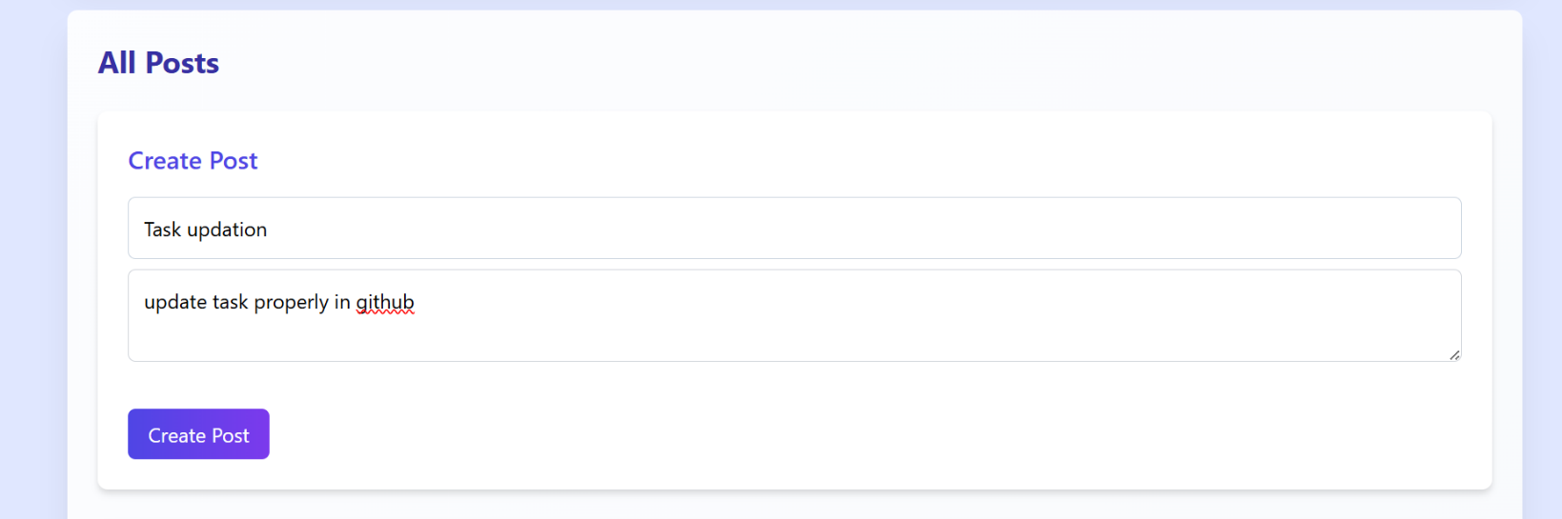

Figure 60 Displaying that newly created posts

Figure 61 Creating new posts

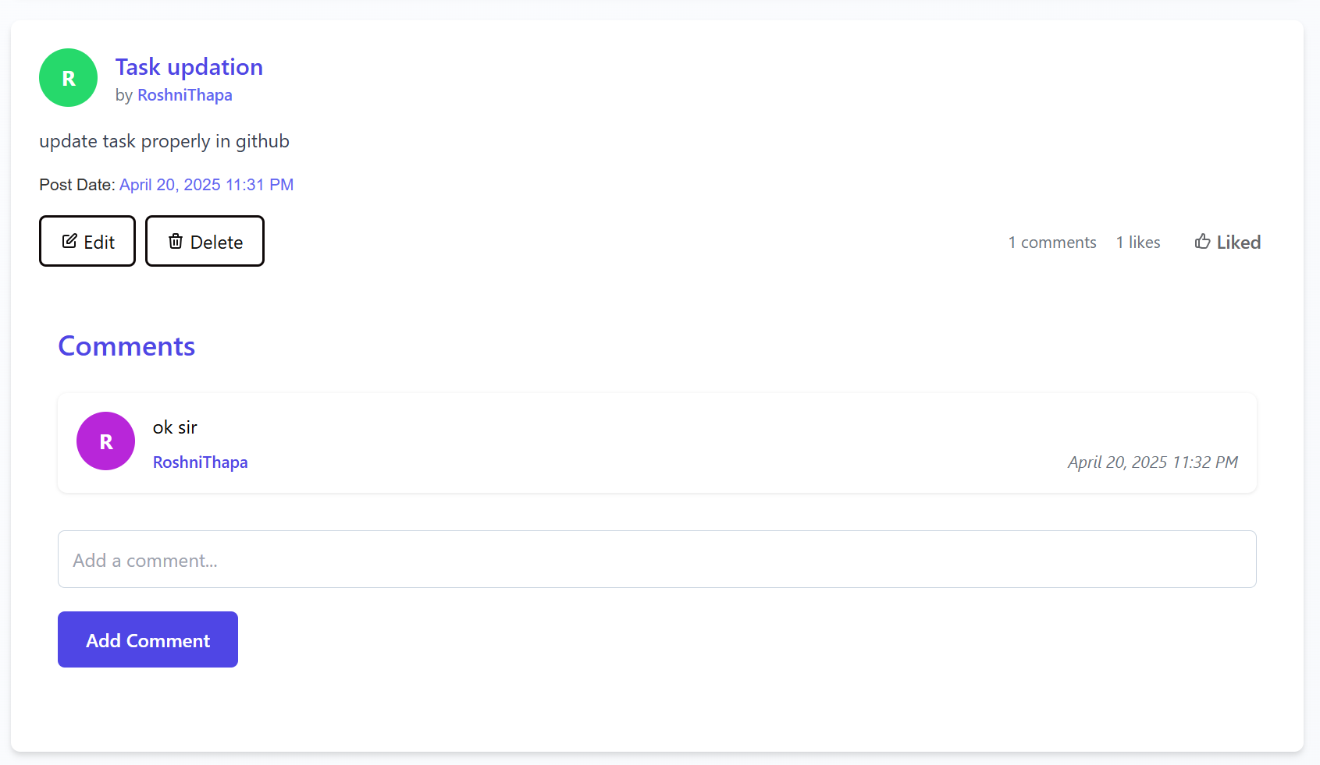

Figure 62 Added likes and comments

**e) Conclusion:**

The process of creating a post enables users to easily create and post their entries with the help of a user-friendly interface. Through a simplified content input and management platform, it ensures smooth posting and accessibility. Refined and enriched based on users' reviews, the process provides an interactive and scalable platform to post content.

**6 Announcement:**

**a) Kickoff:**

The announcement system will allow managers to make announcements with a subject, date, priority, and message so that the users can view announcements at the right time. Announcements will enhance the flow of information at the company, ensuring the updates are understandable, prioritized, and accessible. The announcements will be simple to post and read, with an emphasis on growth and efficiency, using APIs to implement data management quickly, resulting in a solid solution to ensure good communication.

**b) Research:**

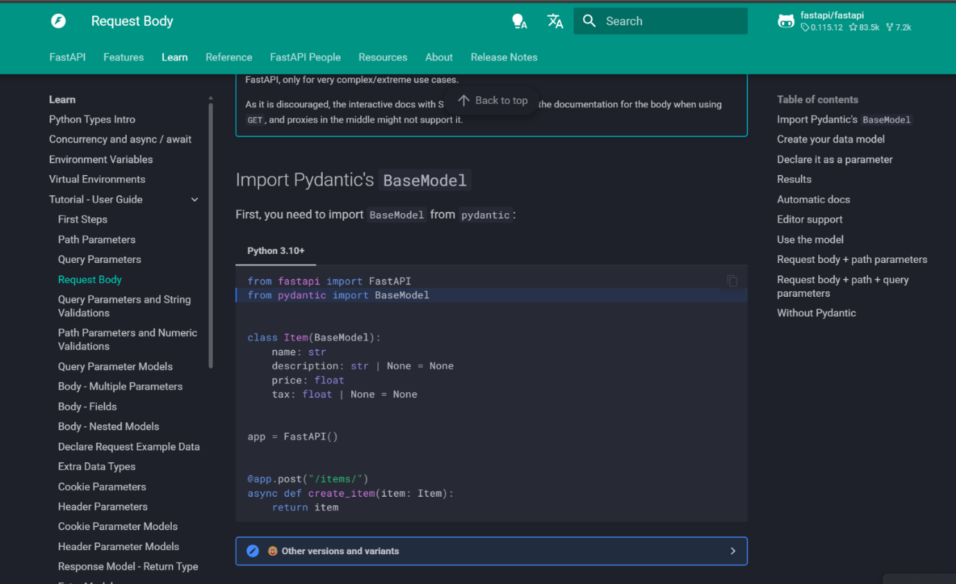I have done research on how **fastapi** handles different types of API requests. Some from Docs through the internet.

Figure 63 screenshot for announcement request handling from Official Docs

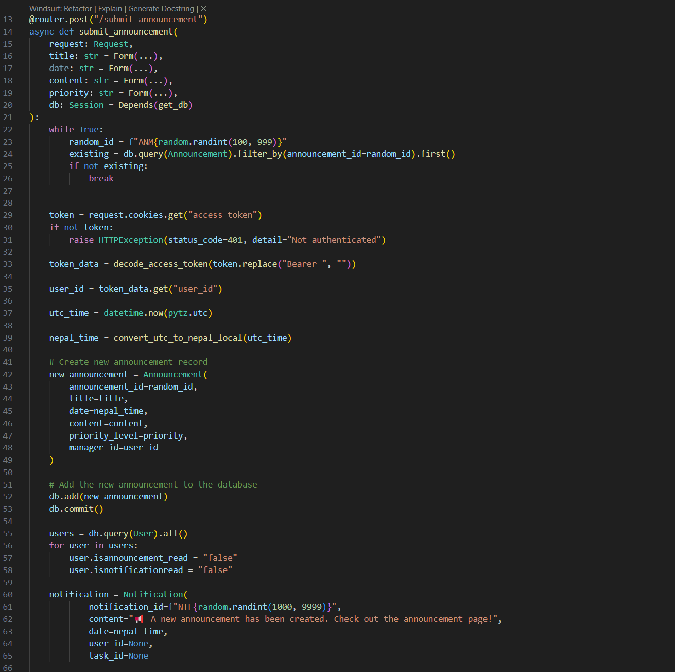**c) Build:**

Figure 64 screenshot of submitting announcement

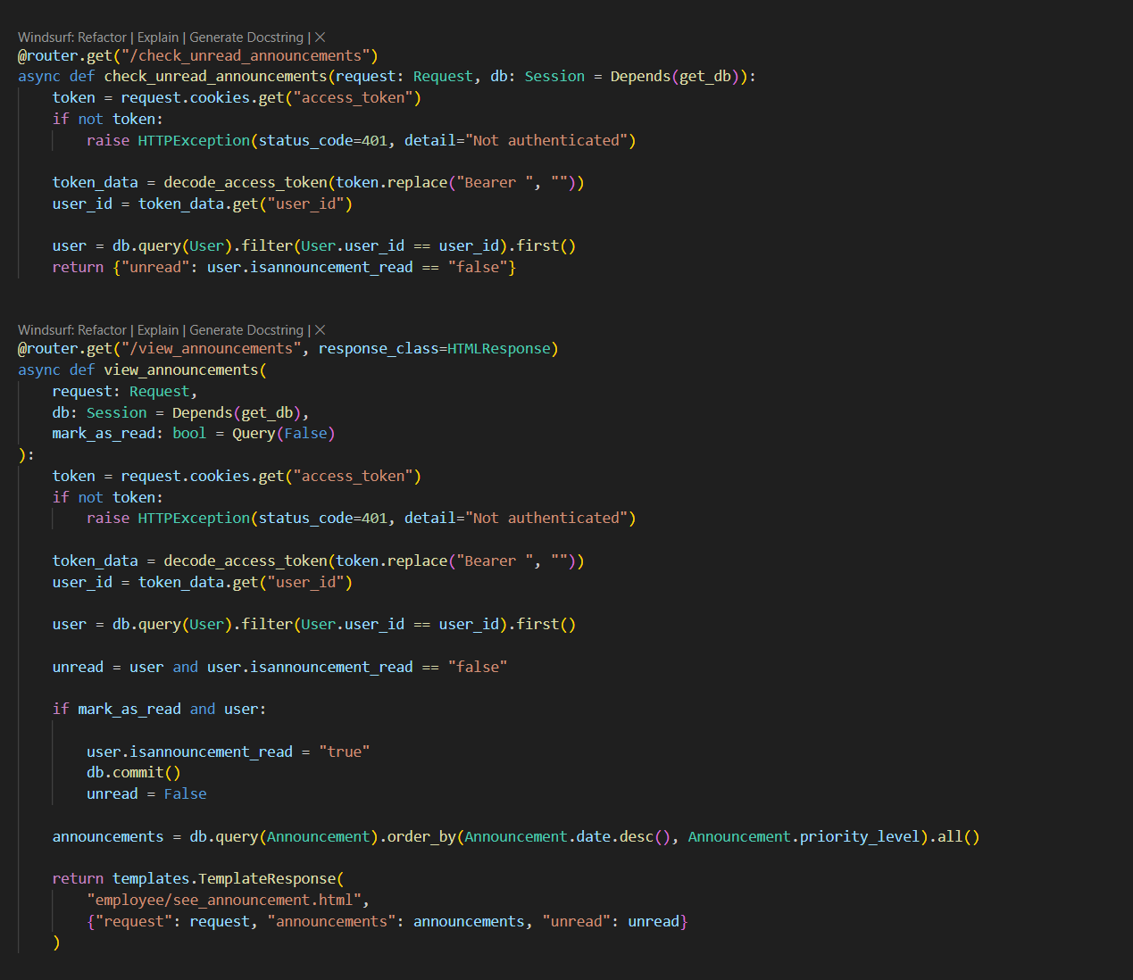

Figure 65 screenshot of seeing announcement by employee

**d) Testing:**

For the testing phase, I have done like announcement and successfully then announcements can be seen by all employees with notifications seen as well.

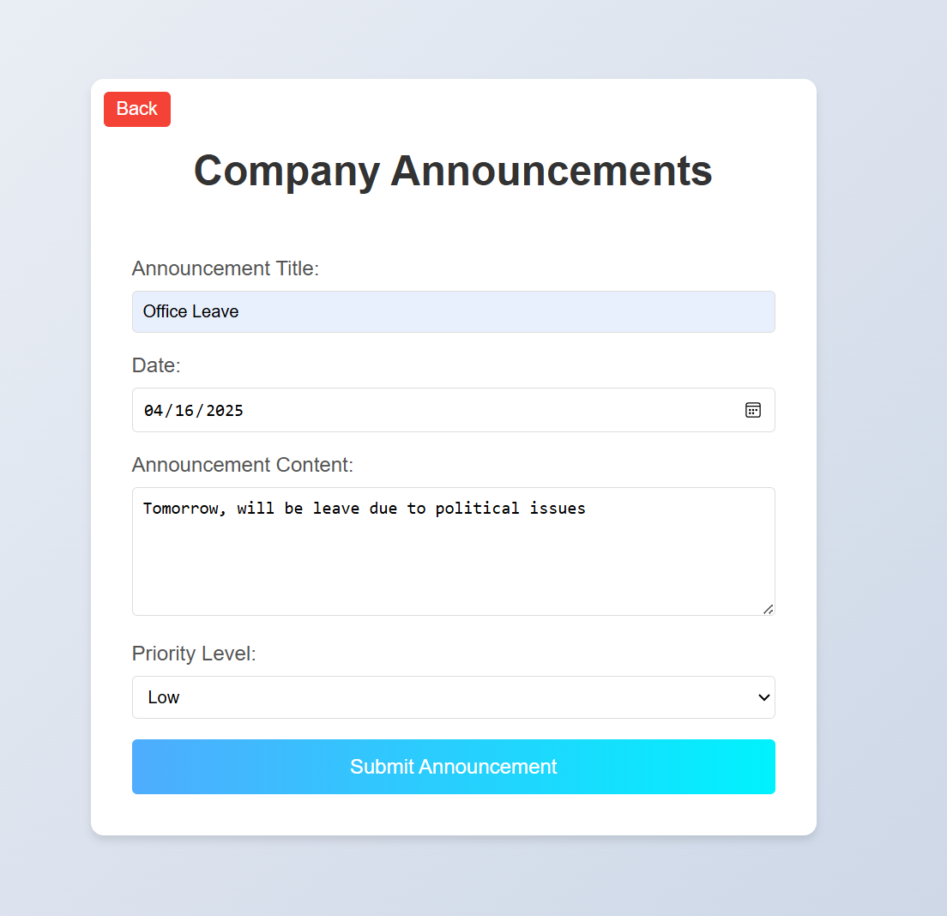

Figure 66 screenshot of adding new announcement

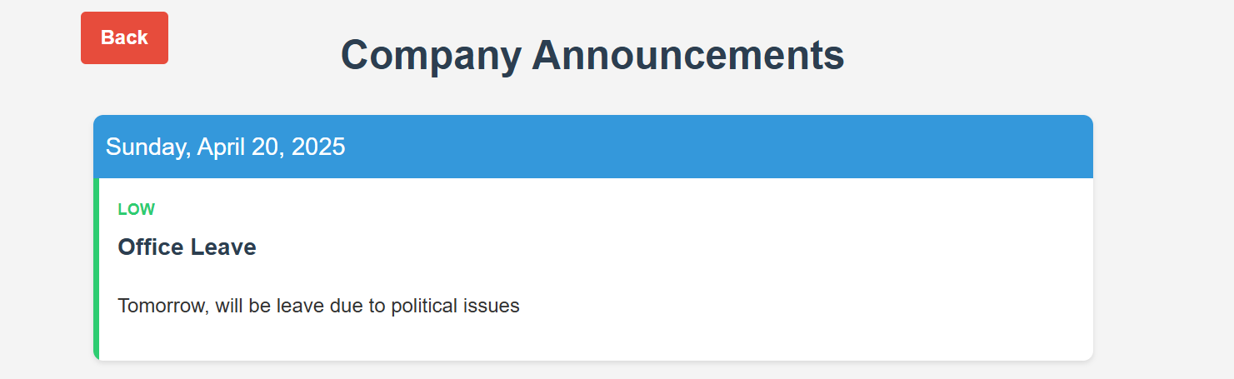

Figure 67 Displayed announcement created by employee

**e) Conclusion:**

In conclusion, the announcement system enables managers to create announcements with title, date, priority, and content, while users can easily view them.

# **4. TESTING AND ANALYSIS:**

## **4.1 TEST PLAN:**

### **4.1.1 UNIT TESTING, TEST PLAN**

Unit testing focuses on testing individual components or modules of a system, making certain that each one works appropriately by itself.

**Purpose:**

* Verify all methods or functions work exactly as expected.
* Detect bugs early during the development process.

**Key Takeaways:** Performed by developers either while coding or afterwards.

* Uses synthetic data to assess inputs and outputs.
* Typically automated using frameworks like **pytest**, **unittest**, etc.
* Fast feedback, easier debugging.

**The test plan includes:**

* Test Scope: Individual functions, classes, or modules.
* Test Cases: Input validation, boundary testing, expected output.

Tools: Python **unittest**, **pytest**, etc. Frequency: This happens after each module is finished or at Sprints.

### **4.1.2 SYSTEM TESTING, TEST PLAN**

System testing verifies an entire and integrated system to ensure that it satisfies all stated requirements.

**Purpose:**

* Test the behavior of the entire application.
* Ensure that all things go well together.

Key points:

* By developers or by QA/testers in small groups.
* Emphasizes full functionality and user scenarios.
* Can be manual or automated.
* Functional testing and non-functional testing.

**The test plan includes:**

* Test Scope: Entire system (user interface, backend, database, links).
* Test cases: Login, data transfer, form sending, report generation, etc.

Selenium for UI testing, Postman for API testing, and manual testing. Frequency: After major sprint releases or feature completion.

## **4.2 UNIT TESTING:**

**All Possible Test cases for unit testing:**

|  |  |  |
| --- | --- | --- |
| **Test Case ID** | **Objectives** | **Test Case Description** |
| **1.1** | Managers enter employee details with valid name, email, phone position, department name and password | Verify system accepts all valid employee details and submits successfully |
| **1.2** | Manager enters details with missing name | Verify system rejects submission when name is missing |
| **1.3** | Manager enters details with invalid email | Verify system rejects submission with incorrect email format |
| **1.4** | Manager enters details with invalid phone (too short) | Verify system rejects phone numbers shorter than allowed range |
| **1.5** | Manager enters details with phone containing non-digits | Verify system rejects phone numbers with non-digit characters |
| **1.6** | Manager enters weak password | Verify system denies weak password |
| **1.7** | Employee logs in with valid email, phone, and PIN | Verify system allows login with correct credentials |
| **1.8** | Employee logs in with incorrect password | Verify system rejects login with invalid password |
| **1.9** | Employee logs in with incorrect PIN | Verify system rejects login when PIN is incorrect |
| **1.10** | Employee logs in with invalid email address | Verify system rejects login when email is not valid. |
| **1.11** | Employee tries to access manager-specific endpoint | Verify system denies employee access to manager-only endpoints |
| **1.12** | Manager accesses employee-specific endpoint | verify system denied employee access to designated endpoints |
| **1.13** | Employee creates a post with valid title and description | Verify system allows post creation with valid data |
| **1.14** | Employee adds a comment to a department post | Verify system allows comments on posts visible to the department |
| **1.15** | Employees from the same department view the post | Verify post is visible to all users in the same department |
| **1.16** | Non-author employees don’t see edit delete button | Verify system prevents non-authors from seeing edit and delete button |
| **1.17** | Author edits their own post | Verify system allows the author to edit their own post |
| **1.18** | Author deletes their own post | Verify system allows the author to delete their own post |
| **1.19** | Employees like a post | Verify system allows a user to like a post once |
| **1.20** | Employees try to like the same post again | Verify system prevents a user from liking a post more than once |
| **1.21** | Manager enters and assigns a task with valid task title, assignee name, and due date | Verify system allows manager to assign a task to an active employee with valid details |
| **1.22** | Manager sees a deleted employee in the assignee list while assigning a task (failure case) | Verify system does not display deleted employees in the assignee list when assigning tasks |
| **1.23** | User views the assigned task | Verify user can see task details assigned to them |
| **1.24** | User submits task with description but no file (failure case) | Verify system requires a file for submission and shows an error if missing |
| **1.25** | User submits task with description and file successfully | Verify system allows successful submission with description and file |
| **1.26** | User re-submits task with new file after successful submission | Verify re-submission with a new file replaces the previous file |
| **1.27** | User re-submits task without new file after successful submission | Verify re-submission without a new file keeps the previous file, no error |
| **1.28** | User submits task with file but no description | Verify system requires a description for submission |
| **1.29** | Employee submits feedback with valid feedback type and message | Verify system allows employees to submit feedback with valid details |
| **1.30** | Manager viewing feedback with sentiment analysis and graph | Verify manager can access feedback and see sentiment analysis visualized in a graph |
| **1.31** | Manager creates announcements with title, content date and priority level | Verify system allows manager to create an announcement with valid details |
| **1.32** | User sees all announcements with notifications seen | Verify employee can view all announcements and their notification status |
| **1.33** | User uploads file, generates summary, and downloads it as a text file | Verify file upload enables summary button, AI generates summary, and download works |
| **1.34** | User uploads file, generates summaries, and clears the output | Verify summary generation works, and clear function resets the output |
| **1.35** | One person sends a chat message and another receives it in real time | Verify real-time chat messaging works between two users |

Table 25 Possible unit testing cases

|  |  |
| --- | --- |
| **Field** | **Details** |
| **Test Case** | Test Case 1.1 |
| **Objective** | Managers enter employee details with valid name, email, phone position, department name and password |
| **Test Type** | Manual |
| **Action** | **Example Data for 1.1 (Valid Case):**   * **Name**: "Apil Thapa" * **Email**:"[apil.thapa@example.com](mailto:apil.thapa@example.com)" * **Phone**: "9876543210" (10 digits) * **Position**: "Software Engineer" * **Department Name**: "IT" * **Password**: "Apil123!" |
| **Expected result** | Manager sends data to employees, data registered in database, and employee get result into email also success message displayed |
| **Actual result** | The user was registered in the system, and a success message is displayed with proper email to user. |
| **Conclusion** | ✅ Test passed successfully. |

Table 26 Test case 1.1

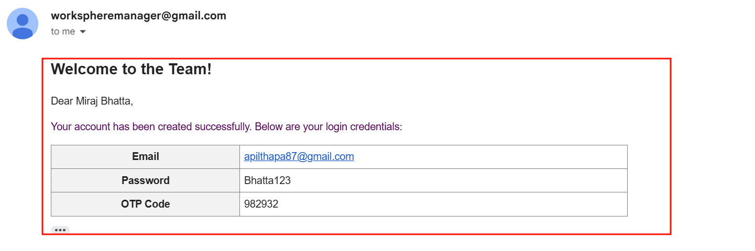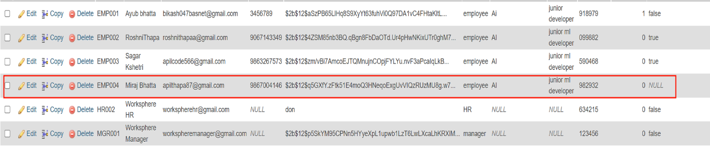

Figure 68 Employee receiving mail

Figure 69 Database showing employee data added

|  |  |
| --- | --- |
| **Field** | **Details** |
| **Test Case** | Test Case 1.2 |
| **Objective** | Manager enters details with missing name |
| **Test Type** | Manual |
| **Action** | **Example Data for 1.2 (Valid Case):**   * **Name**: "" * **Email**:"[apil.thapa@example.com](mailto:apil.thapa@example.com)" * **Phone**: "9876543210" (10 digits) * **Position**: "Software Engineer" * **Department Name**: "IT" * **Password**: "Apil123!" |
| **Expected result** | The system should prevent the data from being sent to the employee or stored in the database and display an error message indicating that all required fields (in this case, the name) must be provided. |
| **Actual result** | The error message is displayed saying all fields need to be filled with values. |
| **Conclusion** | ✅ Test passed successfully. |

Table 27 Test cases 1.2

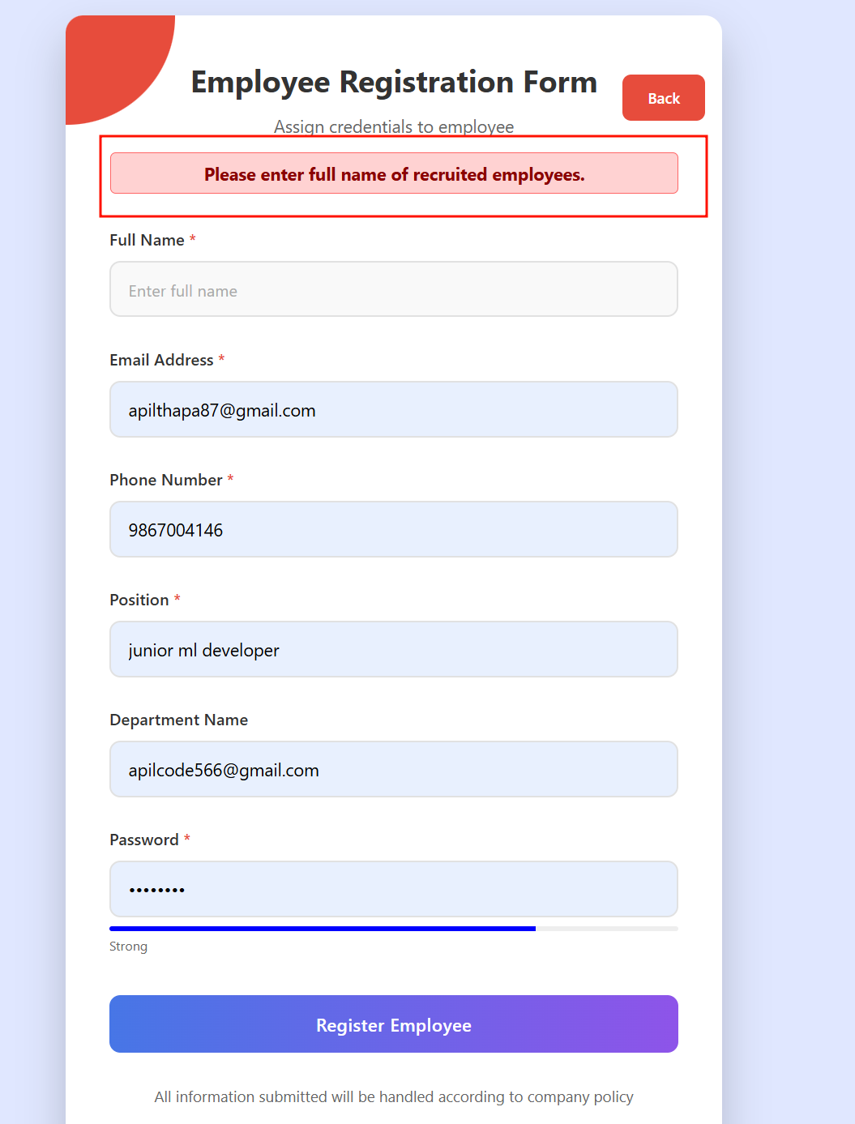

Figure 70 Screenshot of data adding into fields

|  |  |
| --- | --- |
| **Field** | **Details** |
| **Test Case** | Test Case 1.3 |
| **Objective** | Manager enters details with invalid email |
| **Test Type** | Manual |
| **Action** | **Example Data for 1.3 (Valid Case):**   * **Name**: "John Kc" * **Email**:"[apil.thapaexample.com](mailto:apil.thapa@example.com)" * **Phone**: "9876543210" (10 digits) * **Position**: "Software Engineer" * **Department Name**: "IT" * **Password**: "Apil123!" |
| **Expected result** | The system should reject the submission due to the invalid email format, prevent the data from being sent to the employee or stored in the database, and display an error message like "Invalid email format." |
| **Actual result** | The error message is displayed saying "Invalid email format." |
| **Conclusion** | ✅ Test passed successfully. |

Table 28 Test cases 1.3

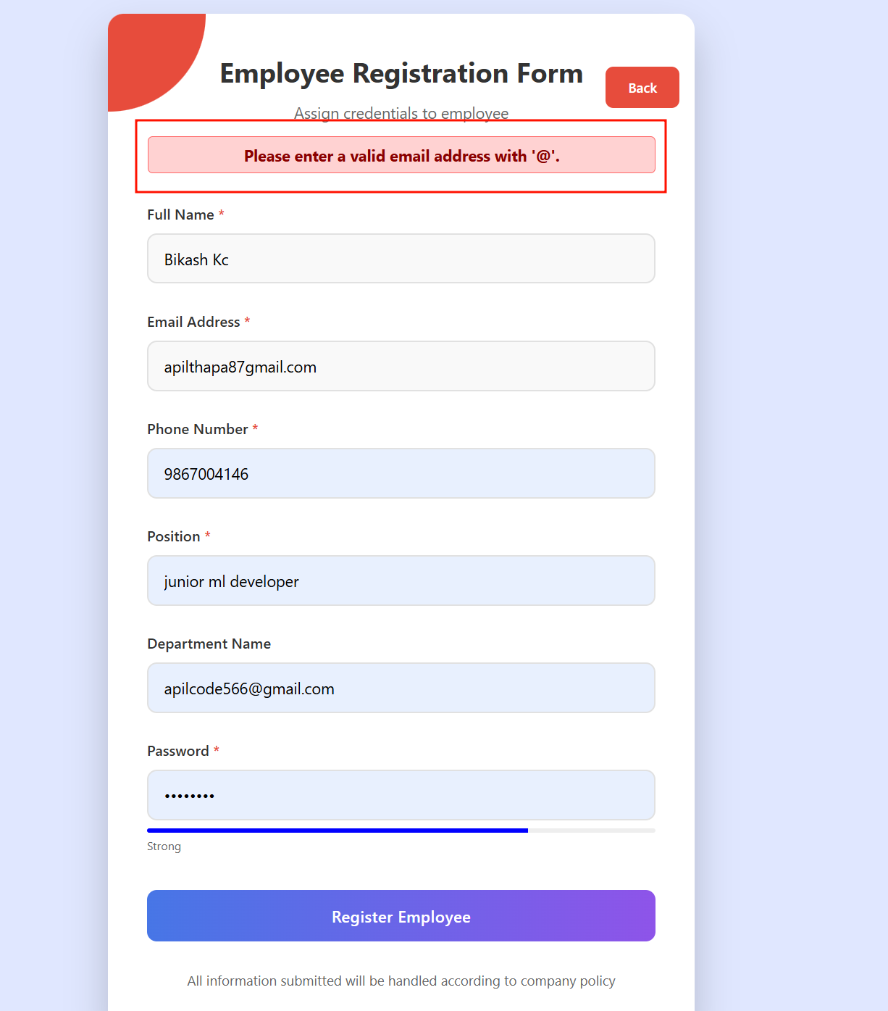

Figure 71 Error email message displayed screenshpt

|  |  |
| --- | --- |
| **Field** | **Details** |
| **Test Case** | Test Case 1.4 |
| **Objective** | Manager enters details with invalid phone (too long) |
| **Test Type** | Manual |
| **Action** | **Example Data for 1.4 (Valid Case):**   * **Name**: "John Kc" * **Email**:"[apil.thapa@example.com](mailto:apil.thapa@example.com)" * **Phone**: "987654323210" (12 digits) * **Position**: "Software Engineer" * **Department Name**: "IT" * **Password**: "Apil123!" |
| **Expected result** | The system should reject the submission because the phone number is longer than the required length (10 digits), prevent the data from being sent or stored, and display an error message like "Phone number must be 10 digits." |
| **Actual result** | The error message is displayed saying "Phone number must be of 10 digits" |
| **Conclusion** | ✅ Test passed successfully. |

Table 29 Test cases 1.4

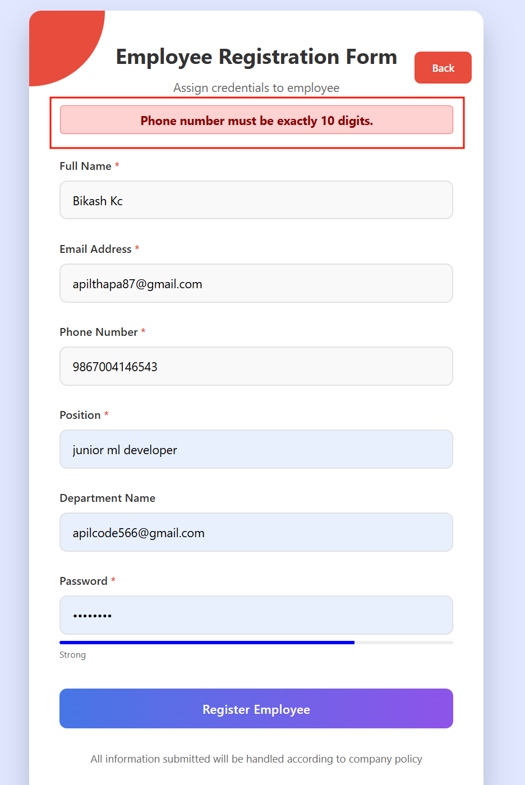

Figure 72 Phone number error message displayed

|  |  |
| --- | --- |
| **Field** | **Details** |
| **Test Case** | Test Case 1.5 |
| **Objective** | Manager enters details with phone containing non-digits |
| **Test Type** | Manual |
| **Action** | **Example Data for 1.5 (Valid Case):**   * **Name**: "John Kc" * **Email**:"[apil.thapa@example.com](mailto:apil.thapa@example.com)" * **Phone**: "nondigitsentered" * **Position**: "Software Engineer" * **Department Name**: "IT" * **Password**: "Apil123!" |
| **Expected result** | The system should reject the submission because the phone number includes non-digit characters, prevent the data from being sent or stored, and display an error message like "Phone number must contain only digits." |
| **Actual result** | The error message is displayed saying "Phone number must contain only digits" |
| **Conclusion** | ✅ Test passed successfully. |

Table 30 Test cases 1.5

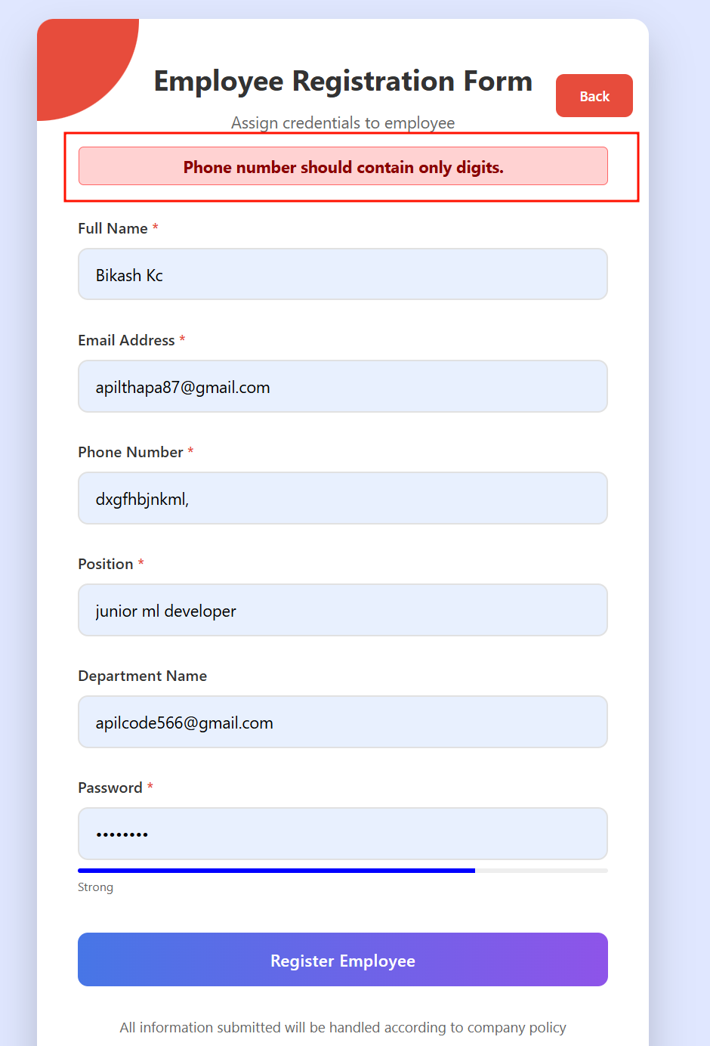

Figure 73 Phone number error message displayed

|  |  |
| --- | --- |
| **Field** | **Details** |
| **Test Case** | Test Case 1.6 |
| **Objective** | Manager enters password with at least 8 characters long and contain a letter and a number |
| **Test Type** | Manual |
| **Action** | **Example Data for 1.6 (Valid Case):**   * **Name**: "John Kc" * **Email**:"[apil.thapa@example.com](mailto:apil.thapa@example.com)" * **Phone**: "9866004146" * **Position**: "Software Engineer" * **Department Name**: "IT" * **Password**: "apil" |
| **Expected result** | The system should display weak password message below form |
| **Actual result** | Weak passwords is displayed |
| **Conclusion** | ✅ Test passed successfully. |

Table 31 Test cases 1.6

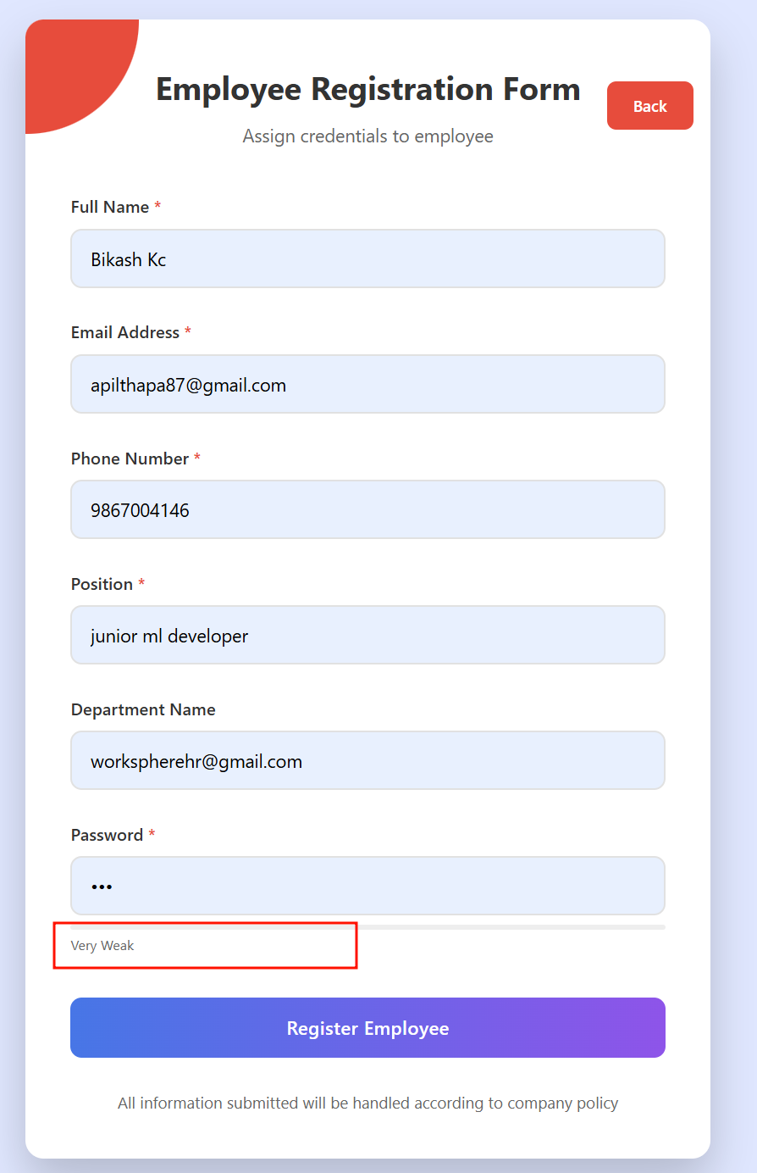

Figure 74 Password strength displayed

|  |  |
| --- | --- |
| **Field** | **Details** |
| **Test Case** | Test Case 1.7 |
| **Objective** | Employee logs in with valid email, phone, and PIN |
| **Test Type** | Manual |
| **Action** | **Example Data for 1.7 (Valid Case):**   * **Email**:"[apil.thapa@gmail.com](mailto:apil.thapa@gmail.com)" * **password**: " **Apil1234**#" * **pin**: "123456" (6 digits) |
| **Expected result** | Employee successfully logs in, access granted to employee dashboard or authorized endpoints |
| **Actual result** | Employees logged in successfully and redirected to dashboards. |
| **Conclusion** | ✅ Test passed successfully. |

Table 32 Test cases 1.7

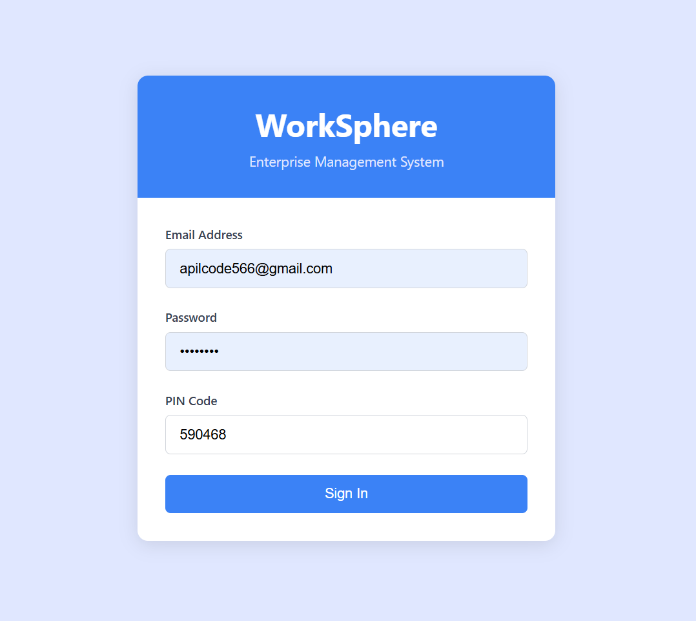

Figure 75 Screenshot of Employee with valid login details



Figure 76 Redirection routes displayed

|  |  |
| --- | --- |
| **Field** | **Details** |
| **Test Case** | Test Case 1.8 |
| **Objective** | Employee logs in with incorrect password |
| **Test Type** | Automated |
| **Action** | **Example Data for 1.7 (Valid Case):**   * **Email**:"[apil.thapa@gmail.com](mailto:apil.thapa@gmail.com)" * **Correct Password (registered): " Apil1234**#**"** * **Incorrect Password (entered): "WrongPass99"** * **pin**: "123456" (6 digits) |
| **Expected result** | Login denied, error message displayed: "Incorrect password" or "Invalid login credentials" |
| **Actual result** | Employees logged in denied and wrong password message get displayed |
| **Conclusion** | ✅ Test passed successfully. |

Table 33 Test cases 1.8

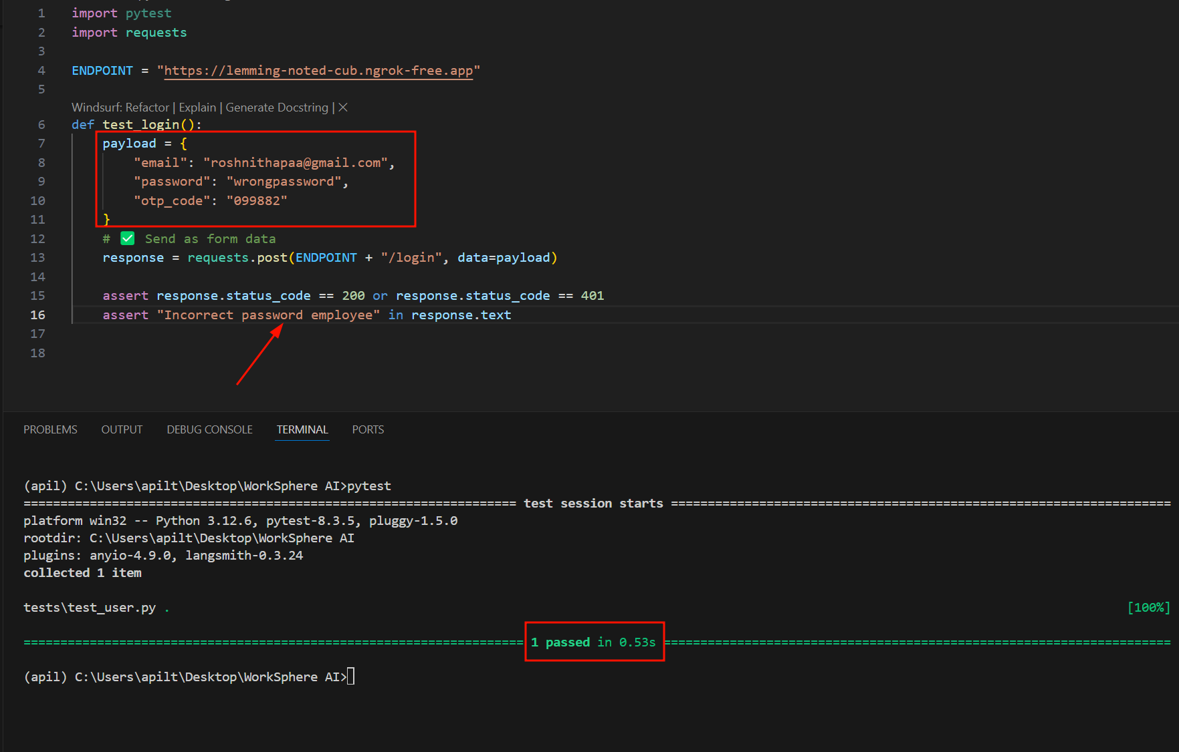

Figure 77 Screenshot of valid login details test with pytest

Table 34 Test cases 1.9

|  |  |
| --- | --- |
| **Field** | **Details** |
| **Test Case** | Test Case 1.9 |
| **Objective** | Employee logs in with incorrect Pin |
| **Test Type** | Automated |
| **Action** | **Example Data for 1.7 (Valid Case):**   * **Email**:"[apil.thapa@gmail.com](mailto:apil.thapa@gmail.com)" * **Correct Password (registered): " Apil1234**#**"** * **Incorrect Password (entered): "WrongPass99"** * **Correct pin: “123456”** * **Wrong pin**: "345245" (6 digits) |
| **Expected result** | Login denied, error message displayed: "Incorrect pin" or "Invalid login credentials" |
| **Actual result** | Employees logged in denied and wrong pin message get displayed |
| **Conclusion** | ✅ Test passed successfully. |

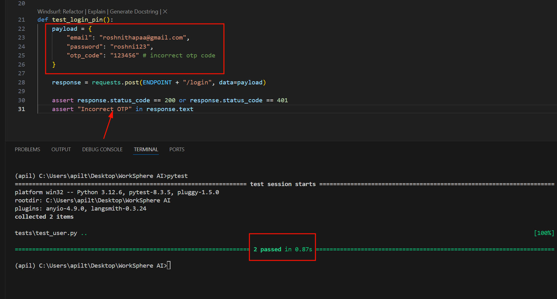

Figure 78 Testing api routes with invalid otp code with pytest

|  |  |
| --- | --- |
| **Field** | **Details** |
| **Test Case** | Test Case 1.10 |
| **Objective** | Employee logs in with invalid email address |
| **Test Type** | Manual |
| **Action** | **Example Data for 1.7 (Valid Case):**   * **Email**:"[apil.thapagmail.com](mailto:apil.thapa@gmail.com)" * **Correct Password (registered): " Apil1234**#**"** * **Correct pin: “123456”** |
| **Expected result** | Login denied, error message displayed: "Invalid email format" or "Invalid login credentials" |
| **Actual result** | Employees logged in denied and error messages got displayed |
| **Conclusion** | ✅ Test passed successfully. |

Table 35 Test cases 1.10

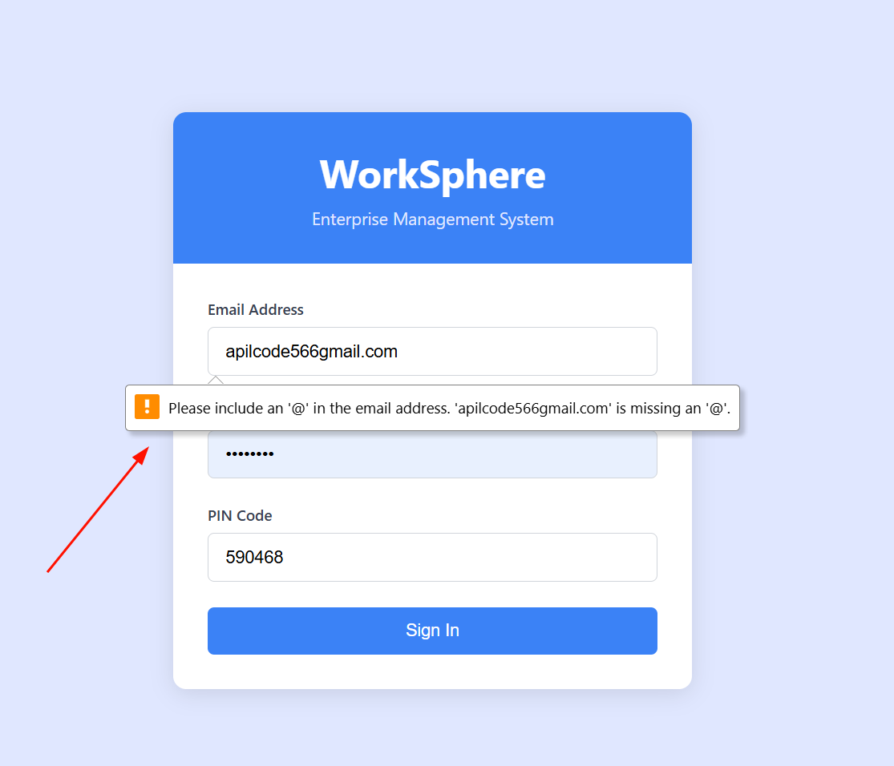

Figure 79 Screenshot of invalid email format

|  |  |
| --- | --- |
| **Field** | **Details** |
| **Test Case** | Test Case 1.11 |
| **Objective** | Employee tries to access manager-specific endpoint |
| **Test Type** | Manual |
| **Action** | Verify system denies employee access to manager-only endpoints |
| **Expected result** | Access denied, employee redirected to same current page |
| **Actual result** | Employees got redirected to same current page. |
| **Conclusion** | ✅ Test passed successfully. |

Table 36 Test cases 1.11

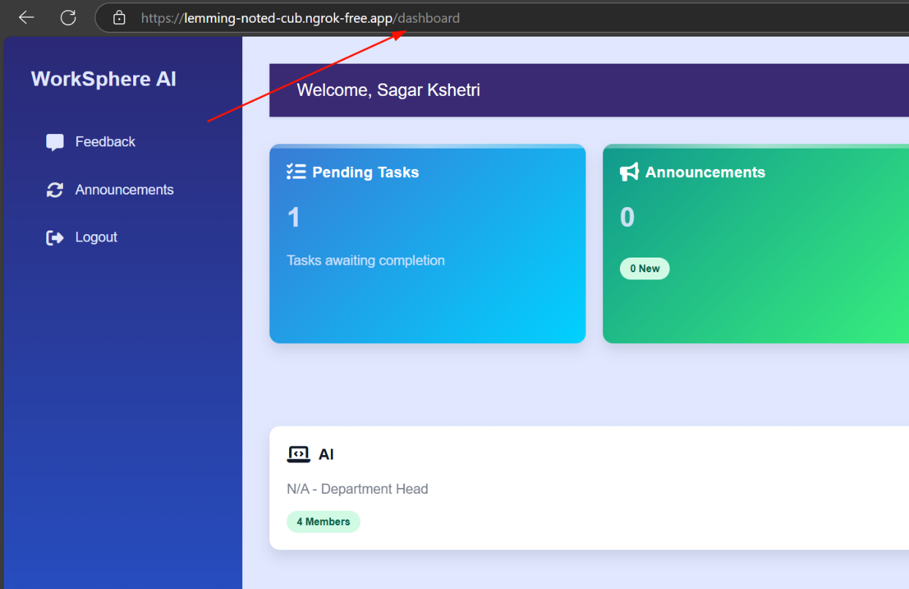

Figure 80 Screenshot of employee accessing dashboard

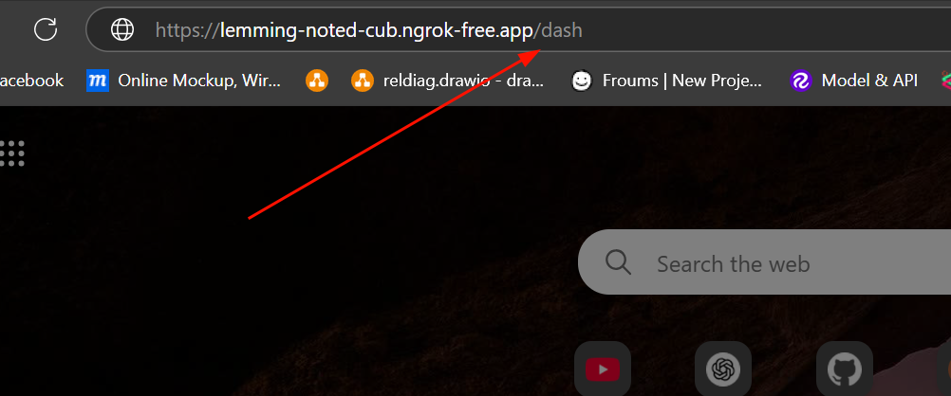

Figure 81 Screenshot of employee try to access manager dashboard

|  |  |
| --- | --- |
| **Field** | **Details** |
| **Test Case** | Test Case 1.12 |
| **Objective** | Manager tries to access employee-specific endpoint |
| **Test Type** | Manual |
| **Action** | Verify system denies manager access to employee-only endpoints |
| **Expected result** | Access denied, manager redirected to same current page |
| **Actual result** | manager got redirected to same current page. |
| **Conclusion** | ✅ Test passed successfully. |

Table 37 Test cases 1.12

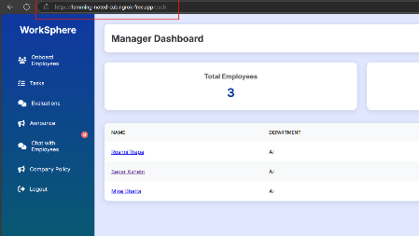

Figure 82 Manager access their own dashboard

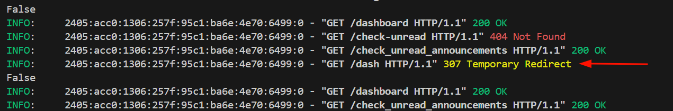

Figure 83 Temporary redirection shown

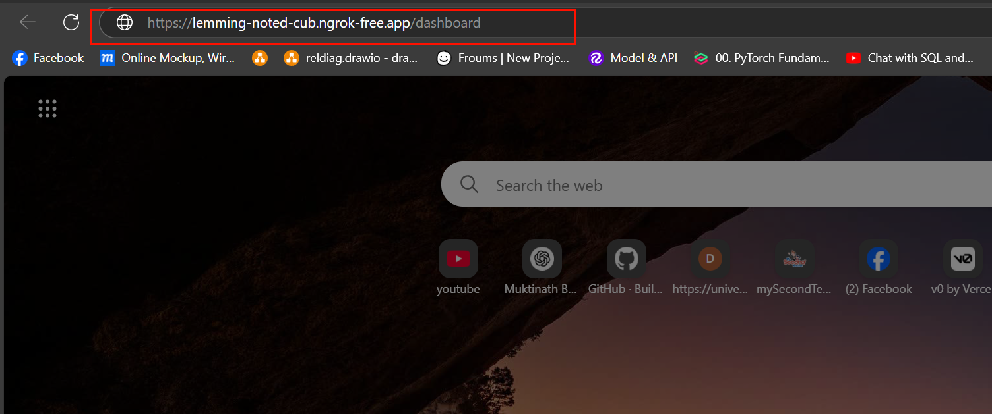

Figure 84 Manager access employee dashboard

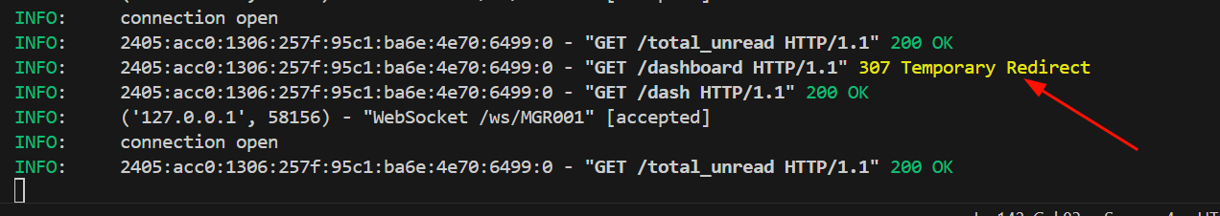

Figure 85 Temporary redirect shows

**POSTS:**

|  |  |
| --- | --- |
| **Field** | **Details** |
| **Test Case** | **Test Case 1.13** |
| **Objective** | Employee creates a post with valid title and description |
| **Test Type** | Manual |
| **Action** | **Title**: "Project Update"  **Description**: "Completed phase 1 of the project."  **Department**: AI |
| **Expected result** | Posts are created successfully,  saved in the database, and visible to the department success message displayed (e.g., "Post created successfully") |
| **Actual result** | Post is created and saved into database successfully. |
| **Conclusion** | ✅ Test passed successfully. |

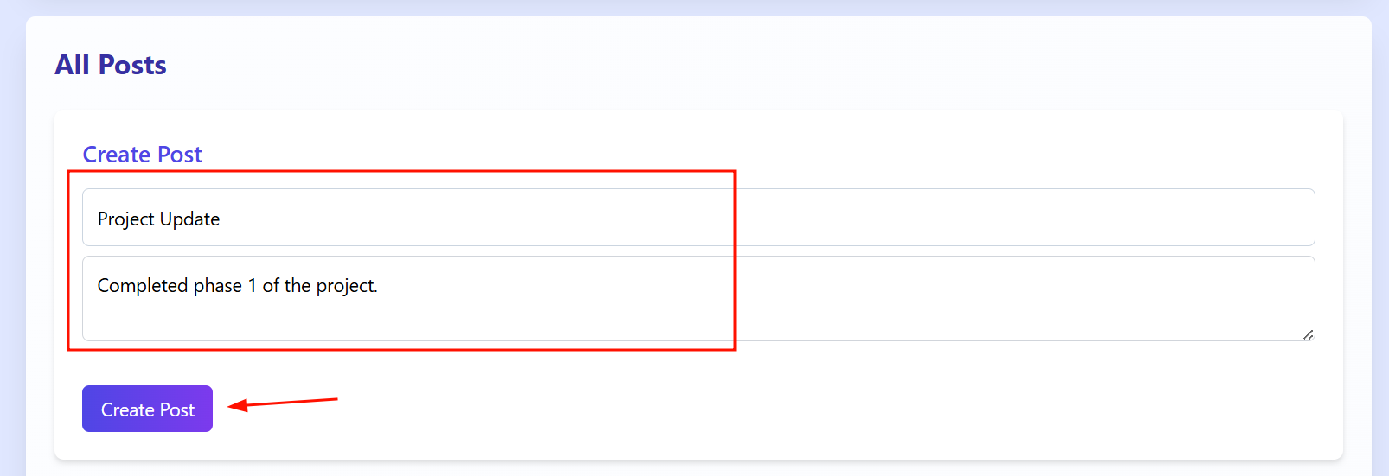

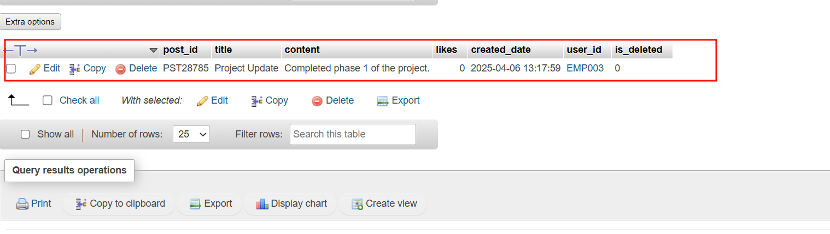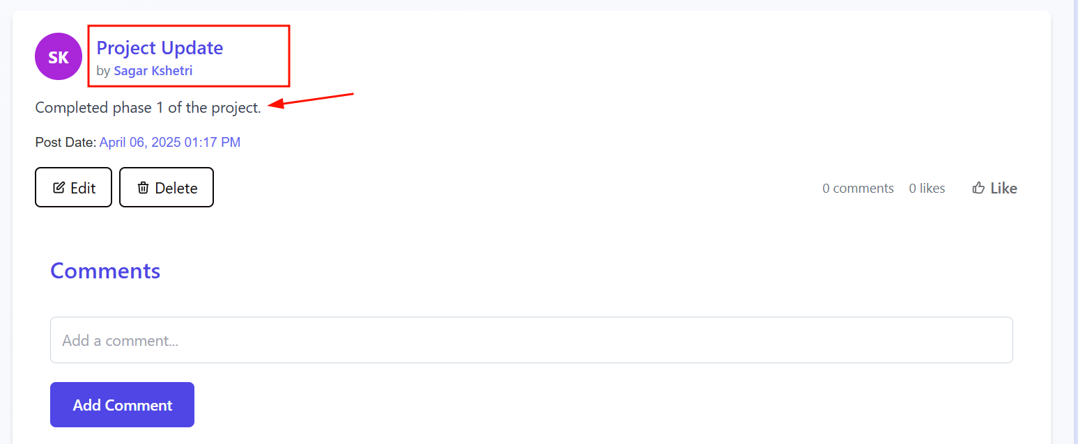

|  |  |
| --- | --- |
| **Field** | **Details** |
| **Test Case** | **Test Case 1.14** |
| **Objective** | Employee adds a comment to a department post |
| **Test Type** | Manual |
| **Action** | **Title**: "Project Update"  **Description**: "Completed phase 1 of the project."  **Department**: AI  **Comment:** "Great work on phase 1!" |
| **Expected result** | Comment is successfully added to the post, saved in the database, and visible to the department |
| **Actual result** | Comment is added to the post and saved into database successfully. |
| **Conclusion** | ✅ Test passed successfully. |

Table 38 Test cases 1.14

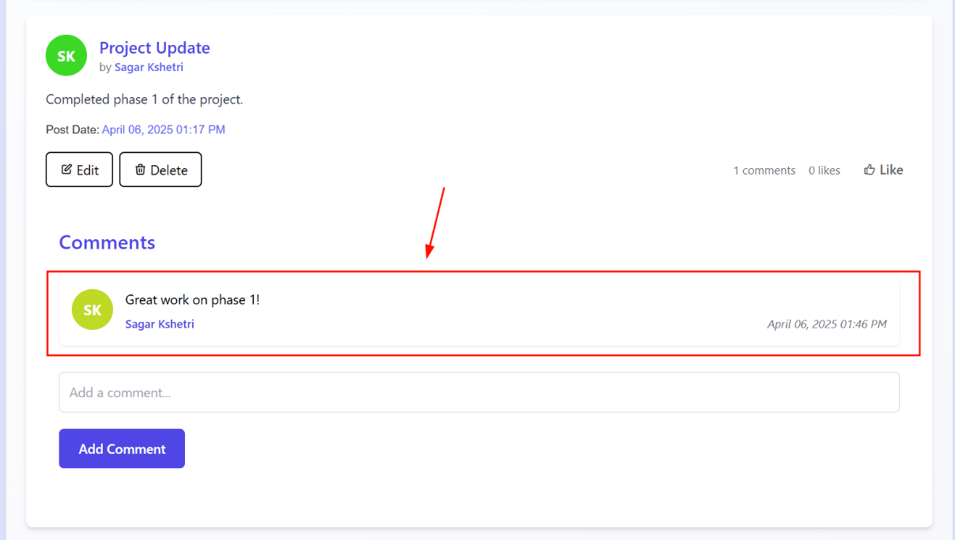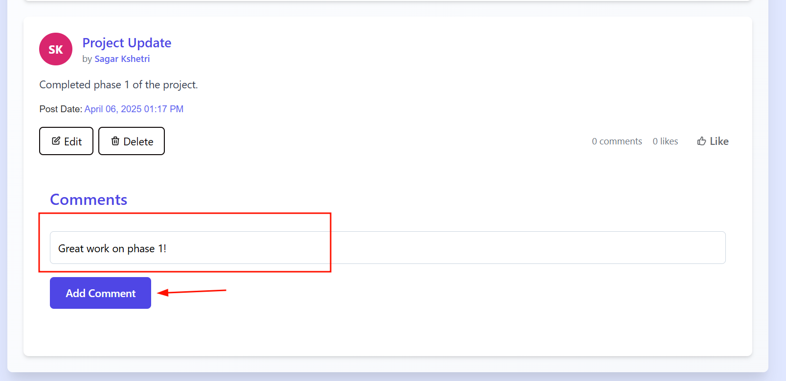

Figure 86 Screenshot of comment added successfully

Figure 87 Screenshot of adding comment on post

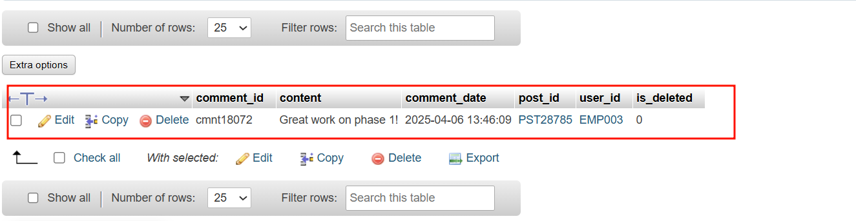

Figure 88 Screenshot of database added

|  |  |
| --- | --- |
| **Field** | **Details** |
| **Test Case** | **Test Case 1.15** |
| **Objective** | Employees from the same department view the post |
| **Test Type** | Manual |
| **Action** | 1. Log in as Roshni thapa with email "[roshnithapaa@gmail.com](mailto:roshnithapaa@gmail.com)" and password "roshni1234" which belongs to same department.  2. Navigate to the posts section  3. Locate and select the post titled "Project Update" created by Sagar Kshetri.  4. Observe the post content displayed on the screen. |
| **Expected result** | Post is displayed to employees in the same department with title, description, and any comments |
| **Actual result** | Post displayed successfully to all department members. |
| **Conclusion** | ✅ Test passed successfully. |

Table 39 Test cases 1.15

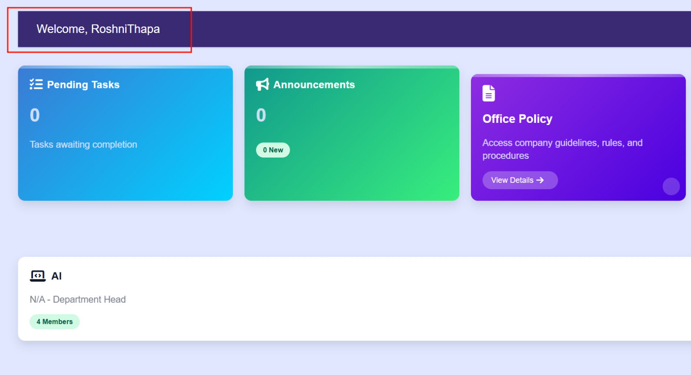

Figure 89 Screenshot of employee accessing dashboard from same department

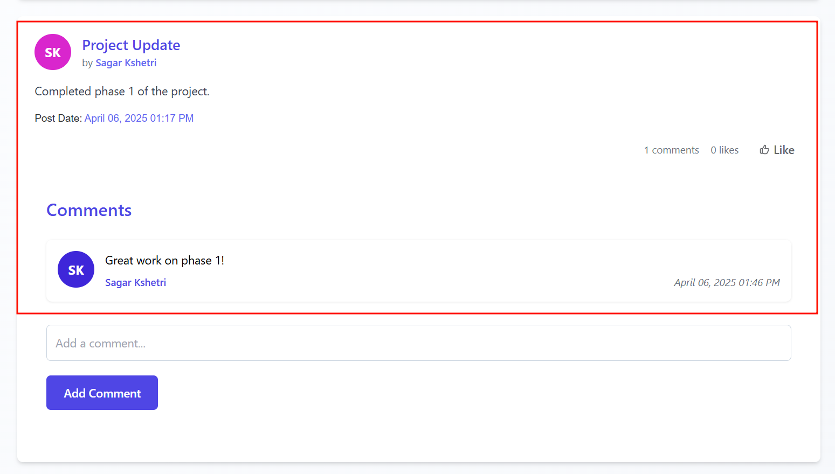

Figure 90 Post seen successfully

Table 40 Test cases 1.16

|  |  |
| --- | --- |
| **Field** | **Details** |
| **Test Case** | **Test Case 1.16** |
| **Objective** | Non-author employees don’t see edit delete button |
| **Test Type** | Manual |
| **Action** | 1. Log in as Roshni thapa with email "[roshnithapaa@gmail.com](mailto:roshnithapaa@gmail.com)" and password "roshni1234" which belongs to same department.  2. Navigate to the posts section  3. Locate and select the post titled "Project Update" created by Sagar Kshetri.  4. Inspect the UI for the presence of edit and delete buttons. |
| **Expected result** | Post is visible to the non-author, edit and delete buttons are hidden in the UI for the non-author |
| **Actual result** | Post get visible but edit and delete button are not visible to non author. |
| **Conclusion** | ✅ Test passed successfully. |

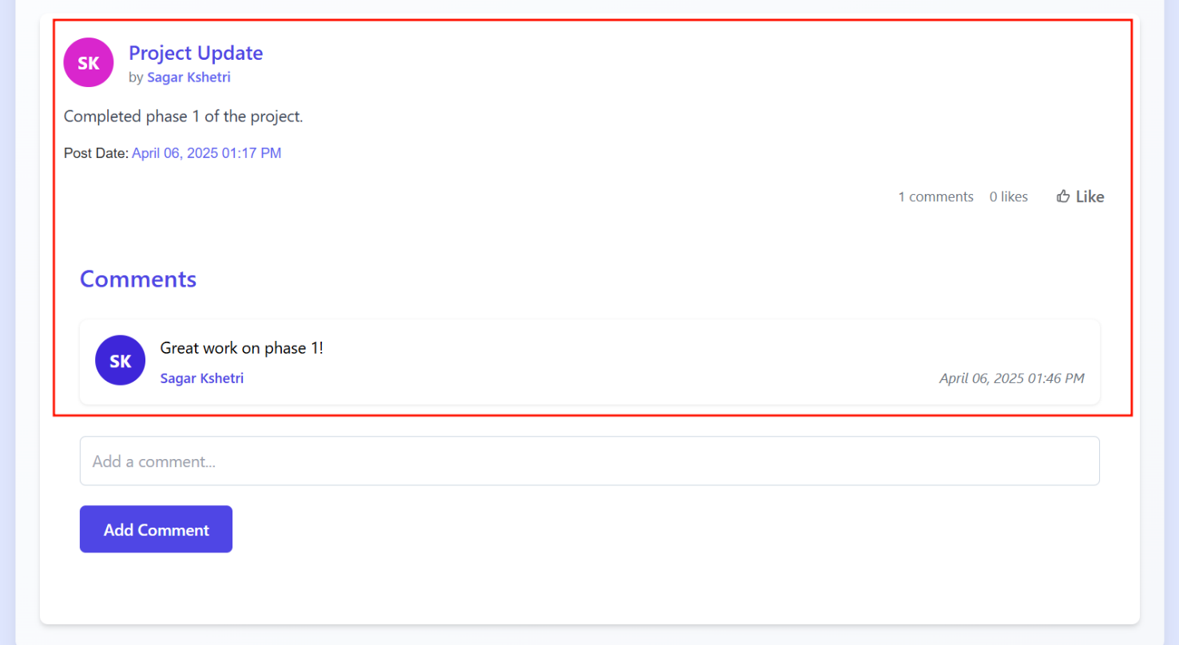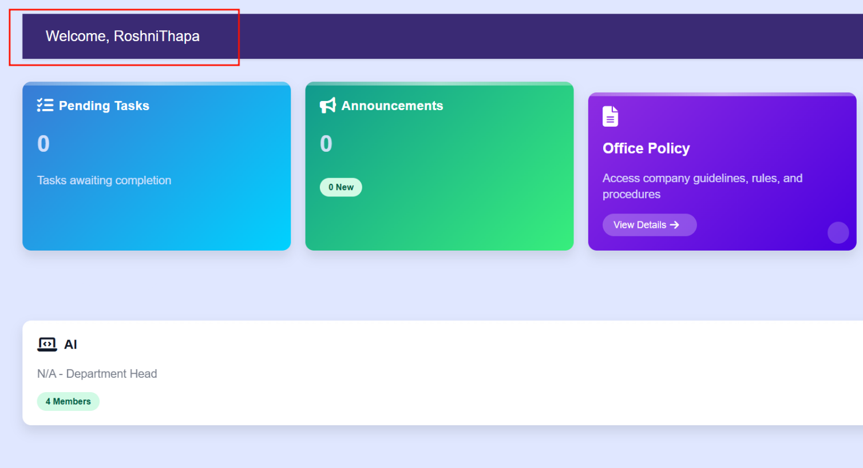

Figure 91 Screenshot of employee seeing posts but edit/delete button is not visible

Figure 92 Screenshot of employee accessing dashboard from same department

|  |  |
| --- | --- |
| **Field** | **Details** |
| **Test Case** | **Test Case 1.17** |
| **Objective** | Author edits their own post |
| **Test Type** | Manual |
| **Action** | 1. Log in as Sagar with email "[apilcode566@gmail.com](mailto:apilcode566@gmail.com)" and password "apil1234"  2. Navigate to the posts section  3. Locate and select the post titled "Project Update".  4. click the edit buttons.  5. enter completed phase 1 and started phase 2.  6. Save the changes. |
| **Expected result** | Post is updated successfully in the database, new description is visible to the department |
| **Actual result** | Post updated successfully in the database and visible to members of department. |
| **Conclusion** | ✅ Test passed successfully. |

Table 41 Test cases 1.17

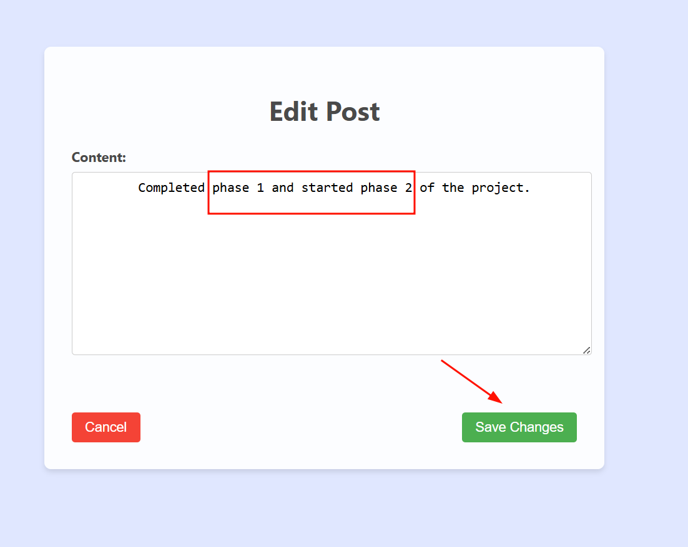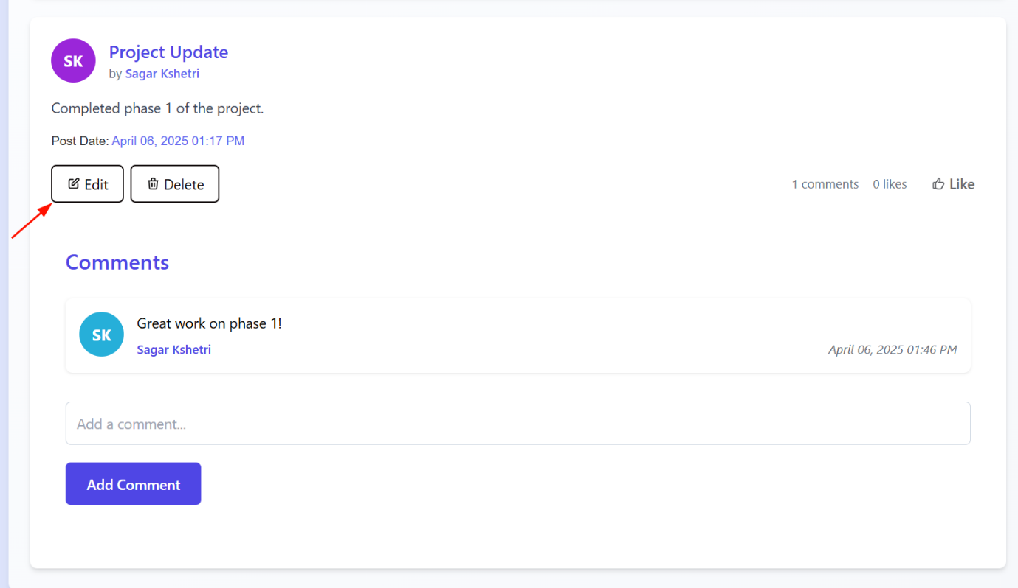

Figure 93 Screenshot of employee updating post

Figure 94 Screenshot of employee clicking edit button

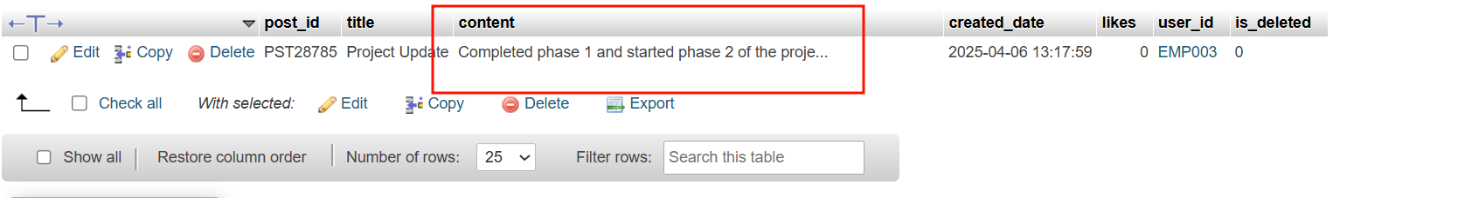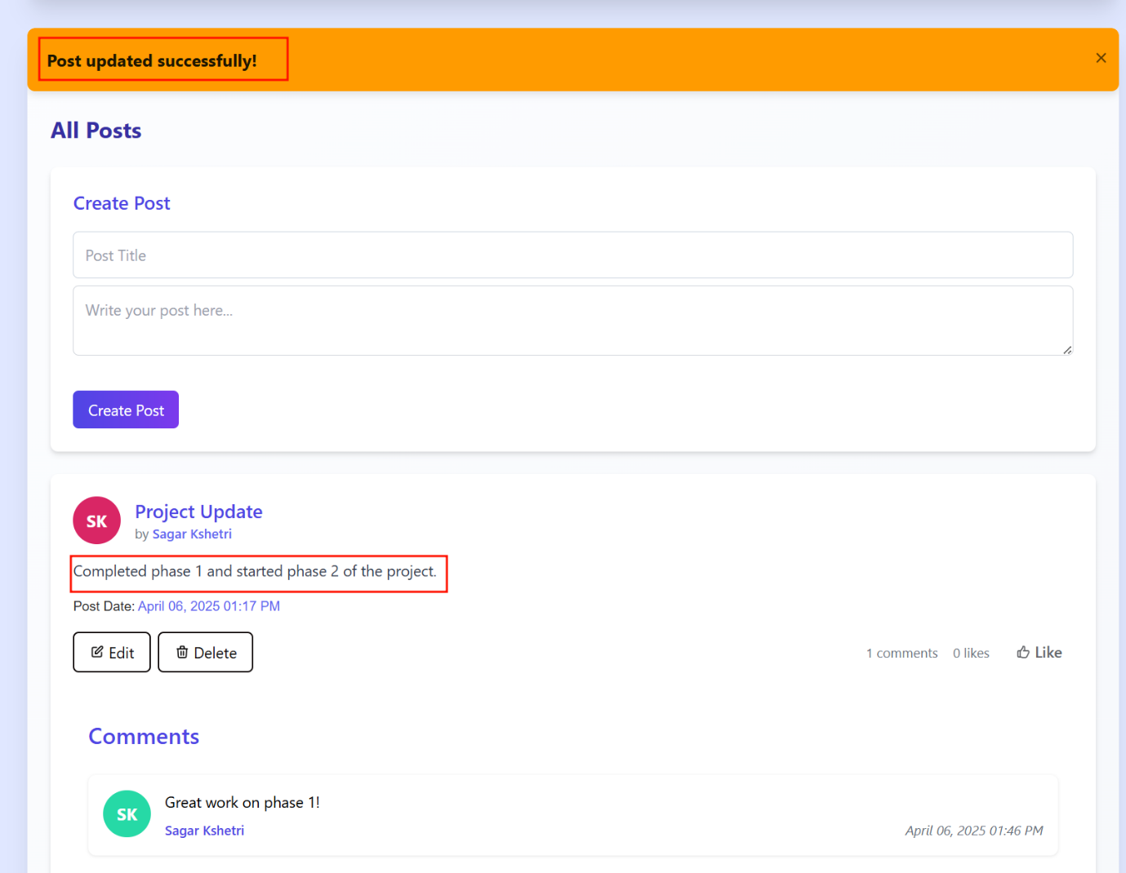

Figure 95 Screenshot of database updation

Figure 96 Successfully post success message shown and updated post is visible

|  |  |
| --- | --- |
| **Field** | **Details** |
| **Test Case** | **Test Case 1.18** |
| **Objective** | Author deletes their own post |
| **Test Type** | Manual |
| **Action** | 1. Log in as Sagar with email "[apilcode566@gmail.com](mailto:apilcode566@gmail.com)" and password "apil1234"  2. Navigate to the posts section  3. Locate and select the post titled "Project Update".  4. click the delete buttons which will delete the post |
| **Expected result** | Post is removed from the database, no longer visible to the department |
| **Actual result** | Post deleted successfully in the database and removed from UI. |
| **Conclusion** | ✅ Test passed successfully. |

Table 42 Test cases 1.18

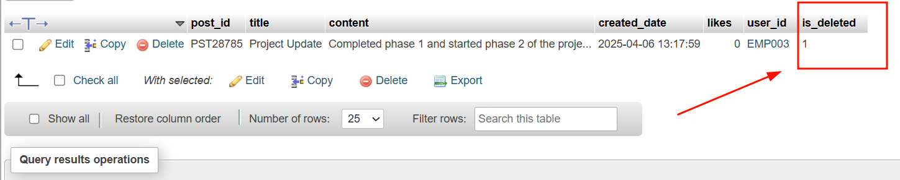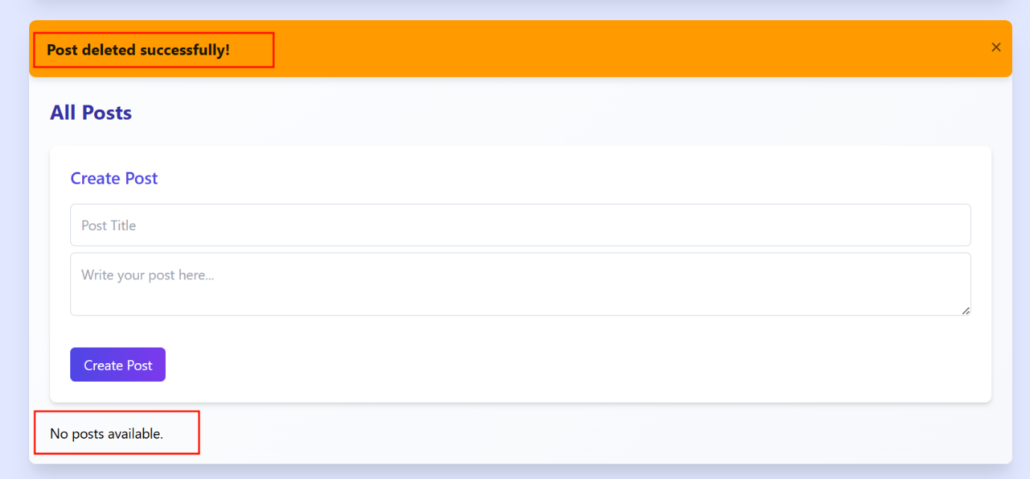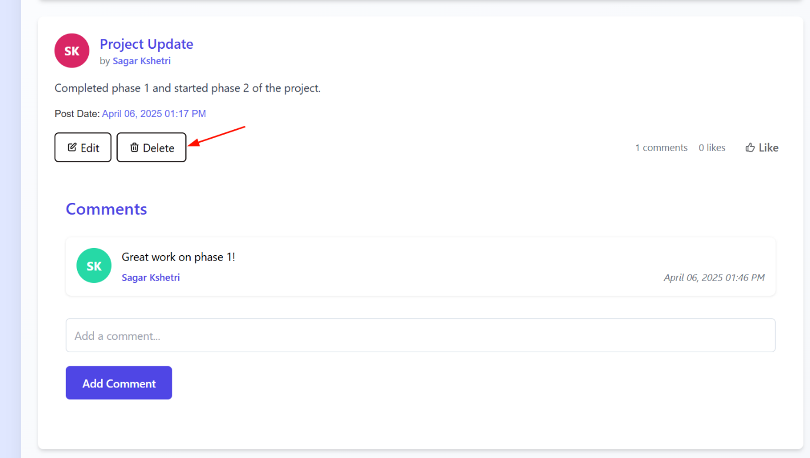

Figure 97 screenshot of showing is_deleted flag columns updates to 1 which indicates deletion of post

Figure 98 Post deleted and success message dispalyed

Figure 99 Screenshot of author clicking delete button

Table 43 Test Case 1.19

|  |  |
| --- | --- |
| **Field** | **Details** |
| **Test Case** | **Test Case 1.19** |
| **Objective** | Employees like a post |
| **Test Type** | Manual |
| **Action** | 1. Log in as Sagar with email "[apilcode566@gmail.com](mailto:apilcode566@gmail.com)" and password "apil1234"  2. Navigate to the posts section  3. Locate and select the post titled "Project Update".  4. click the Like buttons which will like the post |
| **Expected result** | Like is recorded in the database, like count increases by 1, UI updates to reflect the like |
| **Actual result** | Post Liked successfully in the database and reflect in UI. |
| **Conclusion** | ✅ Test passed successfully. |

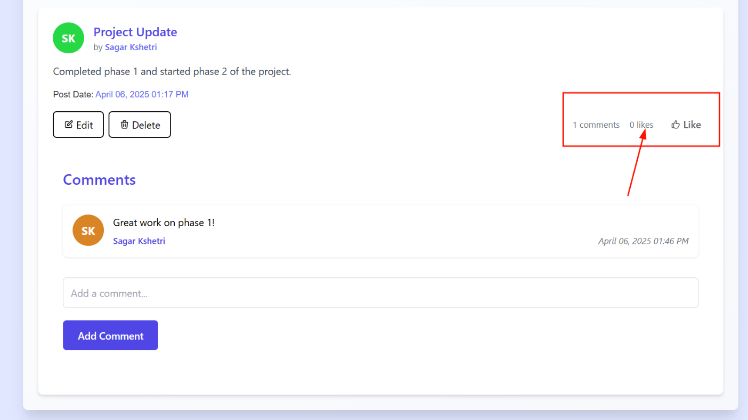**Before**:

Figure 100 Screenshot of before image of like count in post

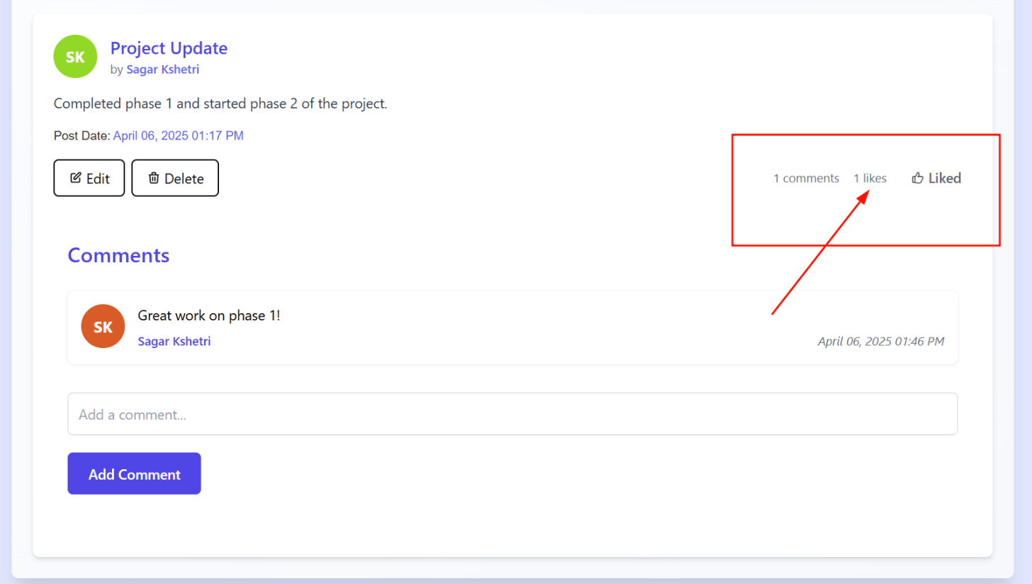After: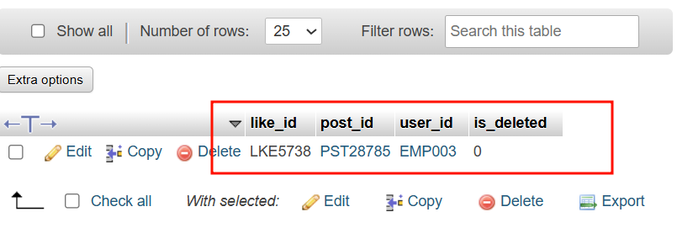

Figure 101 Screenshot of after image of like count increased in post

Figure 102 Screenshot of showing like details shown in database

Table 44 Test Case 1.20

|  |  |
| --- | --- |
| **Field** | **Details** |
| **Test Case** | **Test Case 1.20** |
| **Objective** | Employees try to like the same post again |
| **Test Type** | Manual |
| **Action** | 1. Log in as Sagar with email "[apilcode566@gmail.com](mailto:apilcode566@gmail.com)" and password "apil1234"  2. Navigate to the posts section  3. Locate and select the post titled "Project Update".  4. click on the Like buttons which will dislike the post |
| **Expected result** | Like count removed in the database, like count increases by 1, UI updates to reflect the like |
| **Actual result** | Post Liked successfully in the database and reflect in UI. |
| **Conclusion** | ✅ Test passed successfully. |

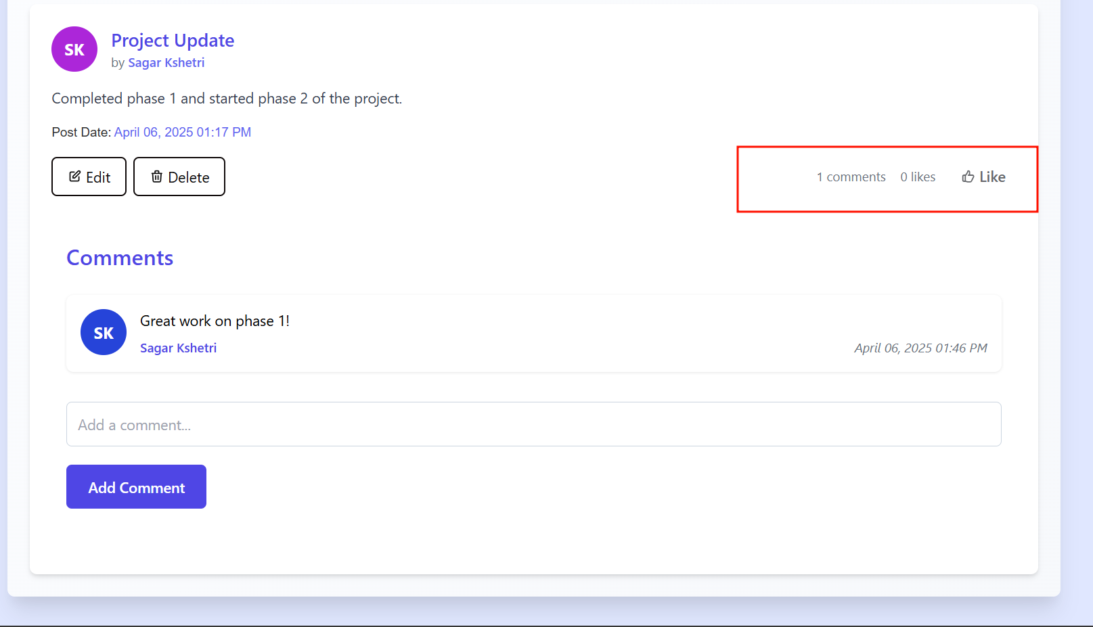

Figure 103 Screenshot of displaying total likes count in a post after like button clicked

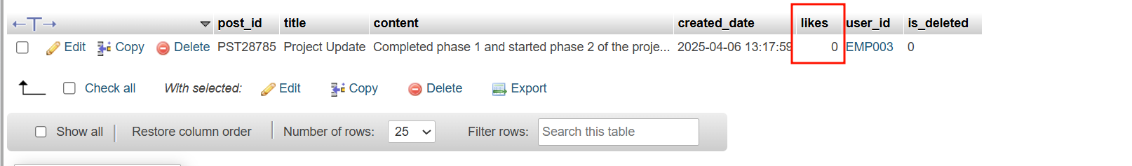

Figure 104 Screenshot of displaying like count decreases to 0 in a particular post

Table 45 Test Case 1.21

|  |  |
| --- | --- |
| **Field** | **Details** |
| **Test Case** | **Test Case 1.21** |
| **Objective** | Manager enters and assigns a task with valid task title, assignee name, and due date |
| **Test Type** | Manual |
| **Action** | Manager Logins from his id and visits tasks section in his dashboard enter task title, select assignee then date and assign tasks. |
| **Expected result** | Task is assigned to employees, saved in the database, notification sent to assignee. |
| **Actual result** | Task successfully assigned to employees and notification goes to an employee |
| **Conclusion** | ✅ Test passed successfully. |

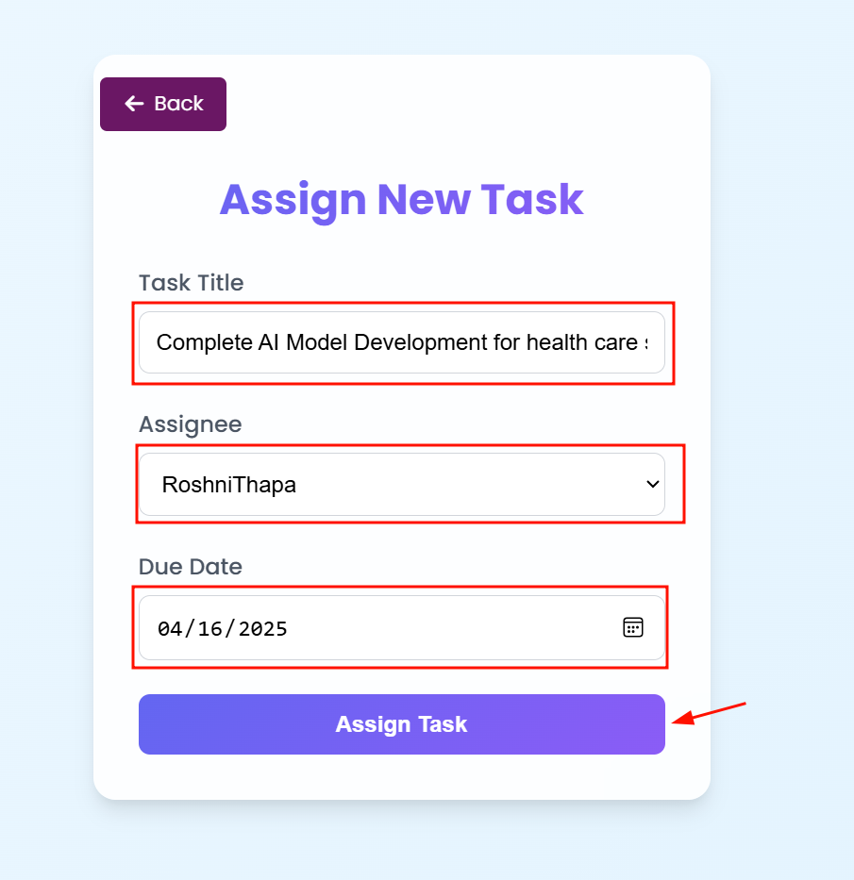

Figure 105 Screenshot of manager filling details for assigning tasks

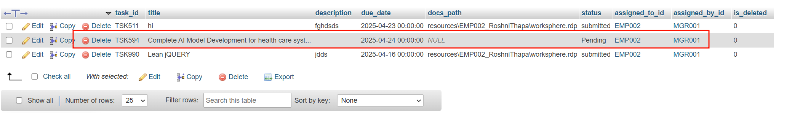

Figure 106 Screenshot of showing task saved to database

Table 46 Test Case 1.22

|  |  |
| --- | --- |
| **Field** | **Details** |
| **Test Case** | **Test Case 1.22** |
| **Objective** | Verify system does not display deleted employees in the assignee list when assigning tasks |
| **Test Type** | Manual |
| **Action** | Manager Logins from his id and visits tasks section in his dashboard enter task title and assigns task to current active employee. |
| **Expected result** | Non-deleted employees are only seen in the list of assignees. |
| **Actual result** | Deleted employees are also seen their assignees. |
| **Conclusion** | ❌ Test Failed. |

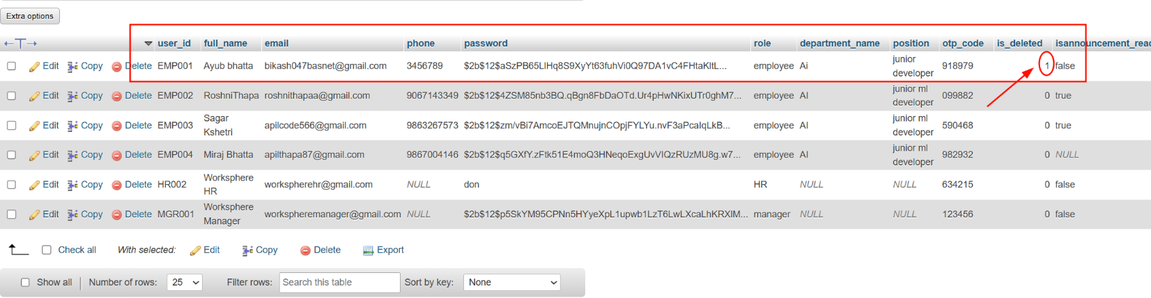

Figure 107 Displaying deleted employee named ayub in a database

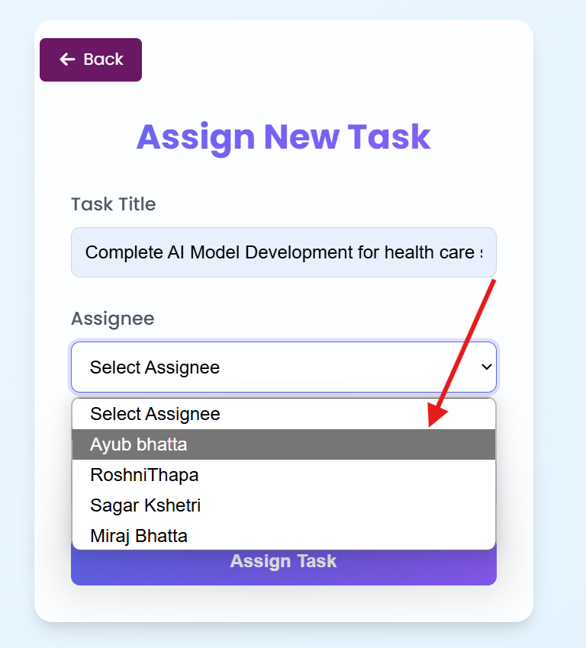

Figure 108 Screenshot of displaying assignee list showing ayub is there shown

|  |  |
| --- | --- |
| **Field** | **Details** |
| **Test Case** | **Test Case 1.23** |
| **Objective** | Verify users can get notifications and see task details assigned to them |
| **Test Type** | Manual |
| **Action** | User logged in they see notifications that new task has been created and then they visits task section to see assigned tasks. |
| **Expected result** | Task details with notifications (title "Complete Report", assignee "Ayub Bhakta", due date "2025-04-15") are displayed |
| **Actual result** | User sees notifications and task assigned to them in task sections. |
| **Conclusion** | ✅ Test Passed. |

Table 47 Test Case 1.23

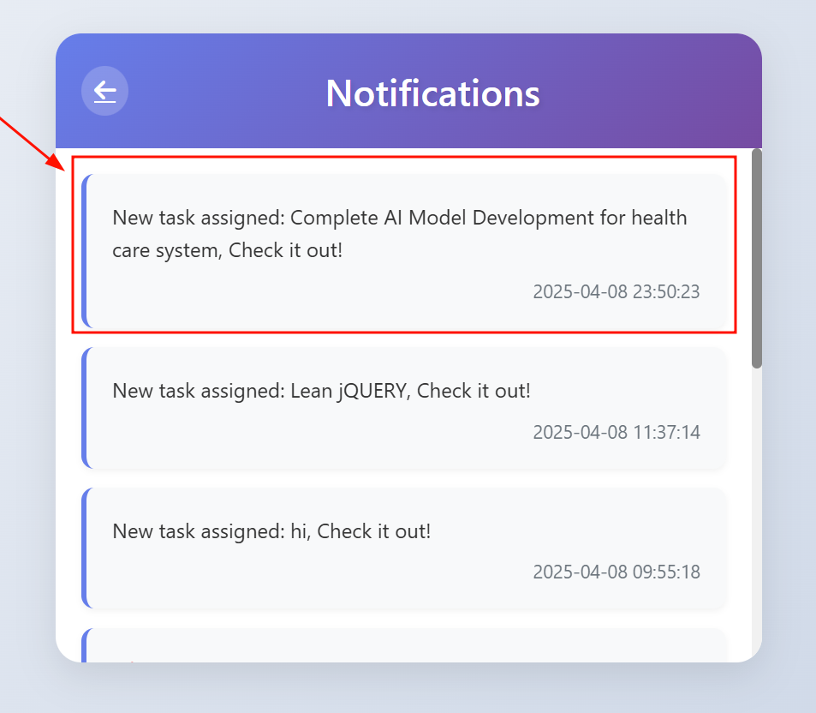

Figure 109 Screenshot of displaying notifications for tasks

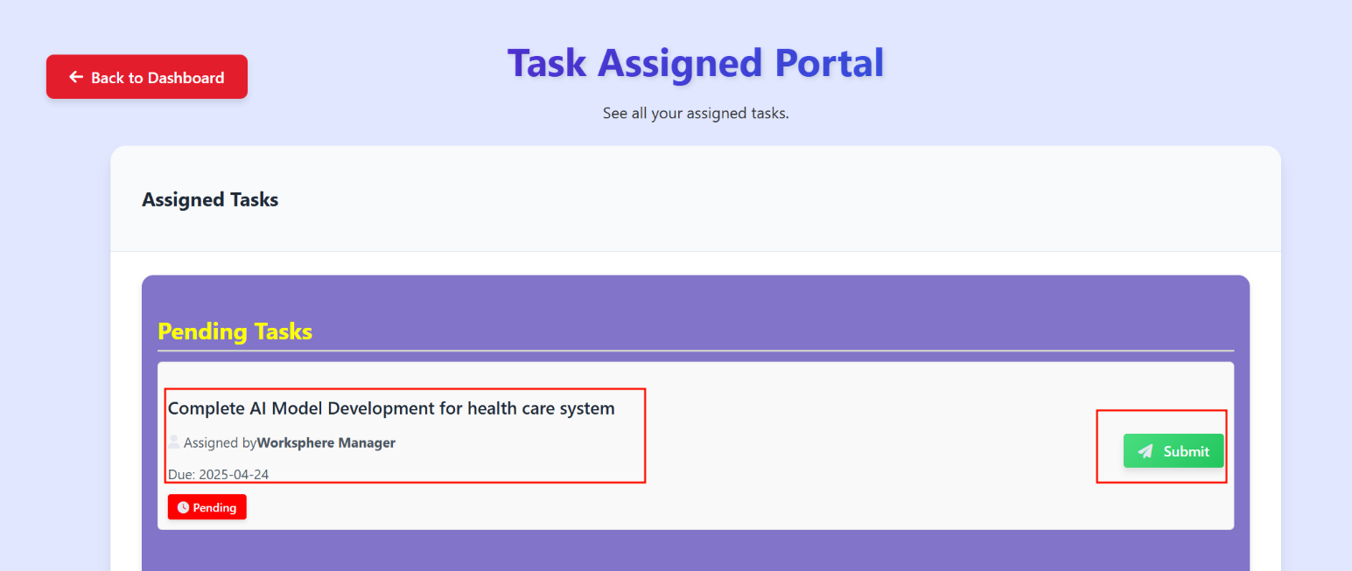

Figure 110 Screenshot of user seeing pending tasks

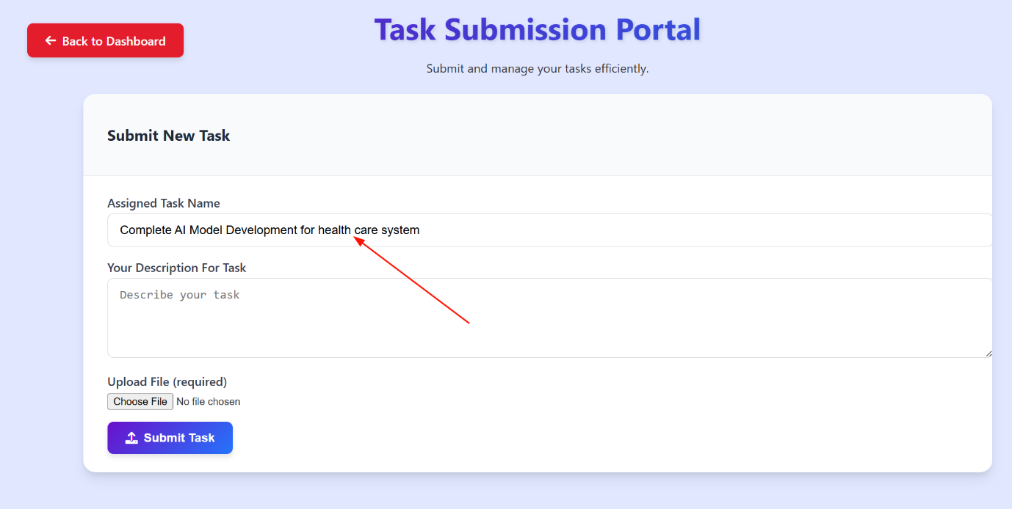

Figure 111 Screenshot of user seeing task name in submission page where user can submit those tasks

Table 48 Test Case 1.24

|  |  |
| --- | --- |
| **Field** | **Details** |
| **Test Case** | **Test Case 1.24** |
| **Objective** | Verify system shows error when submitted without uploading file |
| **Test Type** | Manual |
| **Action** | User logged in they see notifications that new task has been created and then they visit task section to see assigned tasks and he clicks button by filling descriptions for that task and clicked. |
| **Expected result** | User must get an error because without uploading file it should not get submitted. |
| **Actual result** | User sees error message related to file uploading instead of error |
| **Conclusion** | ❌ Test Failed. |

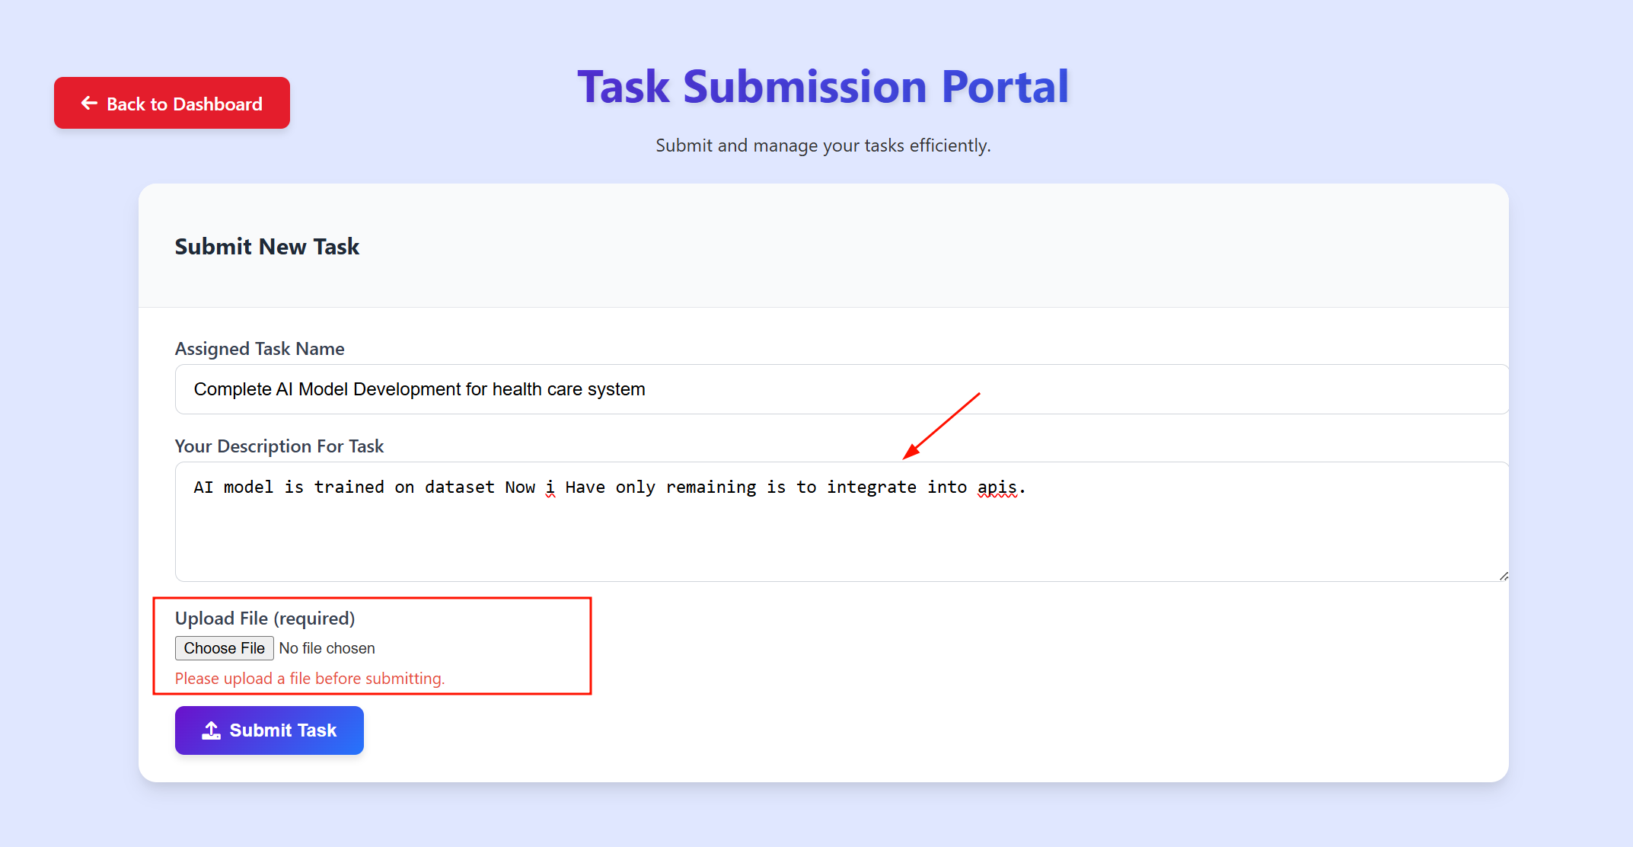

Figure 112 Screenshot of user seeing error msg for not uploading file in submission

Table 49 Test Case 1.25

|  |  |
| --- | --- |
| **Field** | **Details** |
| **Test Case** | **Test Case 1.25** |
| **Objective** | Verify system allows successful submission with description and file |
| **Test Type** | Manual |
| **Action** | User logged in they see notifications that new task has been created and then they visit task section to see assigned tasks and he write descriptions and uploaded file then submit his task. |
| **Expected result** | The user submits the task successfully and is redirected to the task detail page. |
| **Actual result** | The task is submitted, and the user is redirected to other page. |
| **Conclusion** | ✅ Test Passed. |

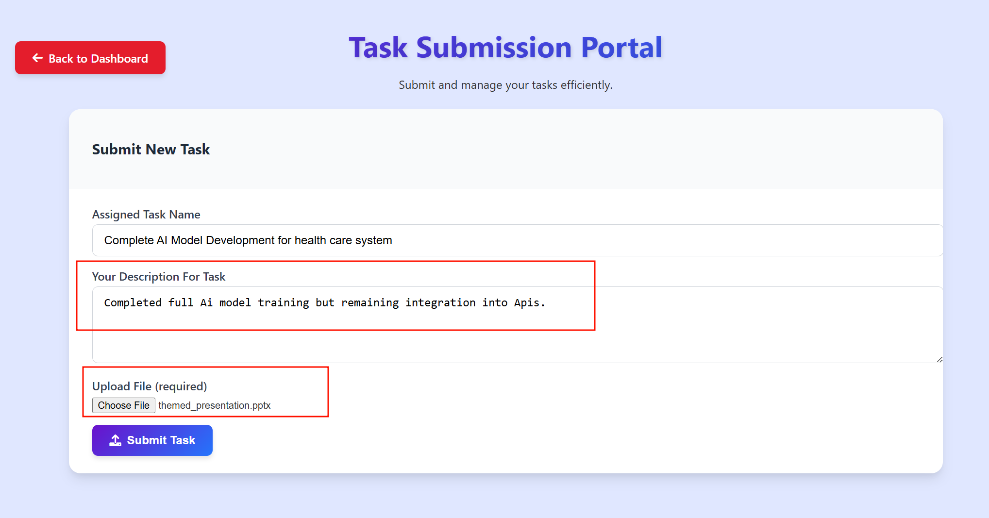

Figure 113 Screenshot of user submitting task with filling details

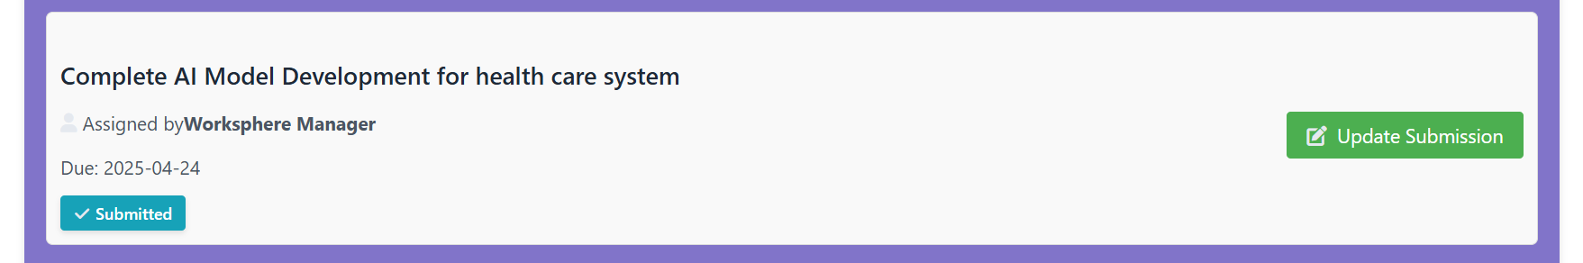

Figure 114 After submission submitted status is shown for those tasks

Table 50 Test Case 1.26

|  |  |
| --- | --- |
| **Field** | **Details** |
| **Test Case** | **Test Case 1.26** |
| **Objective** | Verify re-submission with a new file replaces the previous file |
| **Test Type** | Manual |
| **Action** | User logged in they see notifications that new task has been created and then they visit task section to see assigned tasks and he write descriptions and uploaded file then submit his task he goes back to update submission page and update again and re submit it. |
| **Expected result** | The user updates the task successfully and is redirected to the task detail page again. |
| **Actual result** | The task is re submitted, and the user is redirected to other page. |
| **Conclusion** | ✅ Test Passed. |

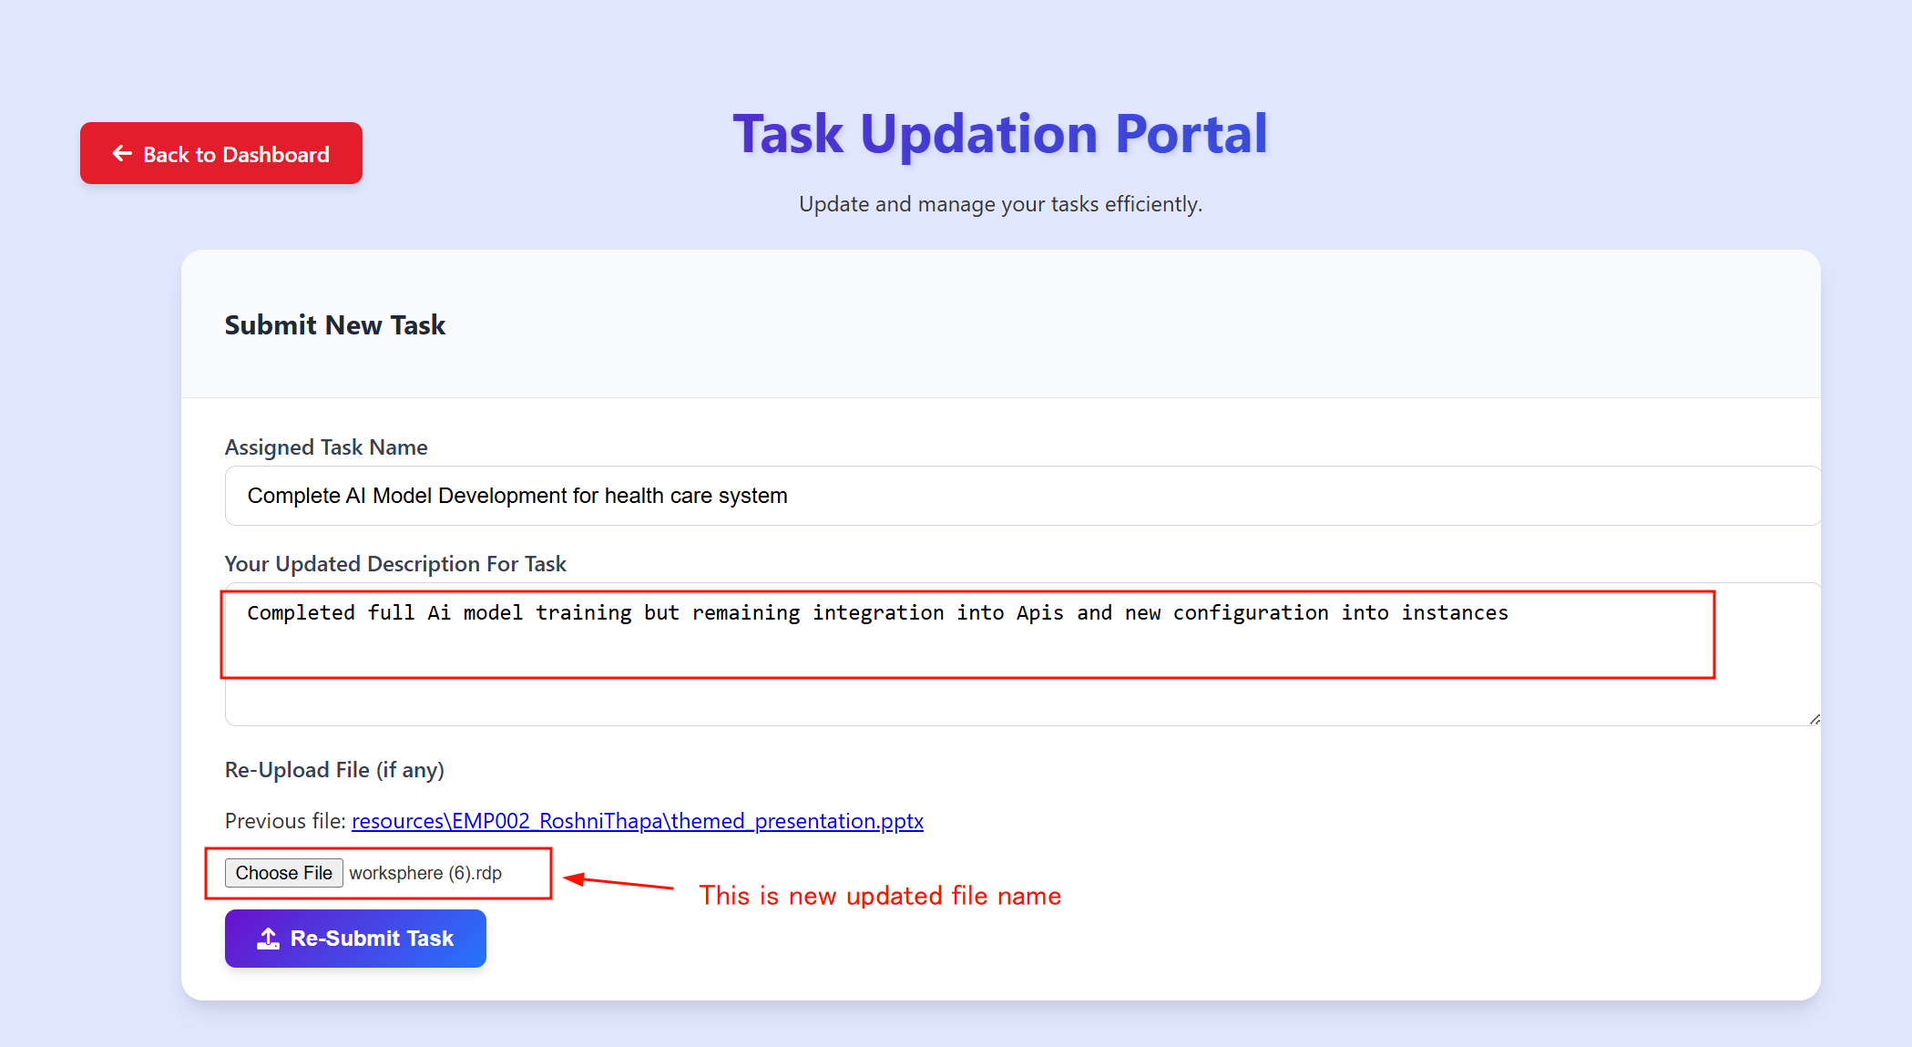

Figure 115 Screenshot of updating tasks with new updated file name

Table 51 Test Case 1.27

|  |  |
| --- | --- |
| **Field** | **Details** |
| **Test Case** | **Test Case 1.27** |
| **Objective** | Verify re-submission without a new file keeps the previous file, no error |
| **Test Type** | Manual |
| **Action** | Users logged in they see notifications that new task has been created and then they visit the task section to see assigned tasks and he writes descriptions and uploads files then submits his task he goes back to update submission page and update description only and re submit it. |
| **Expected result** | The user updates the task successfully and is redirected to the task detail page again. |
| **Actual result** | The task is re submitted, and the user is redirected to another page. |
| **Conclusion** | ✅ Test Passed. |

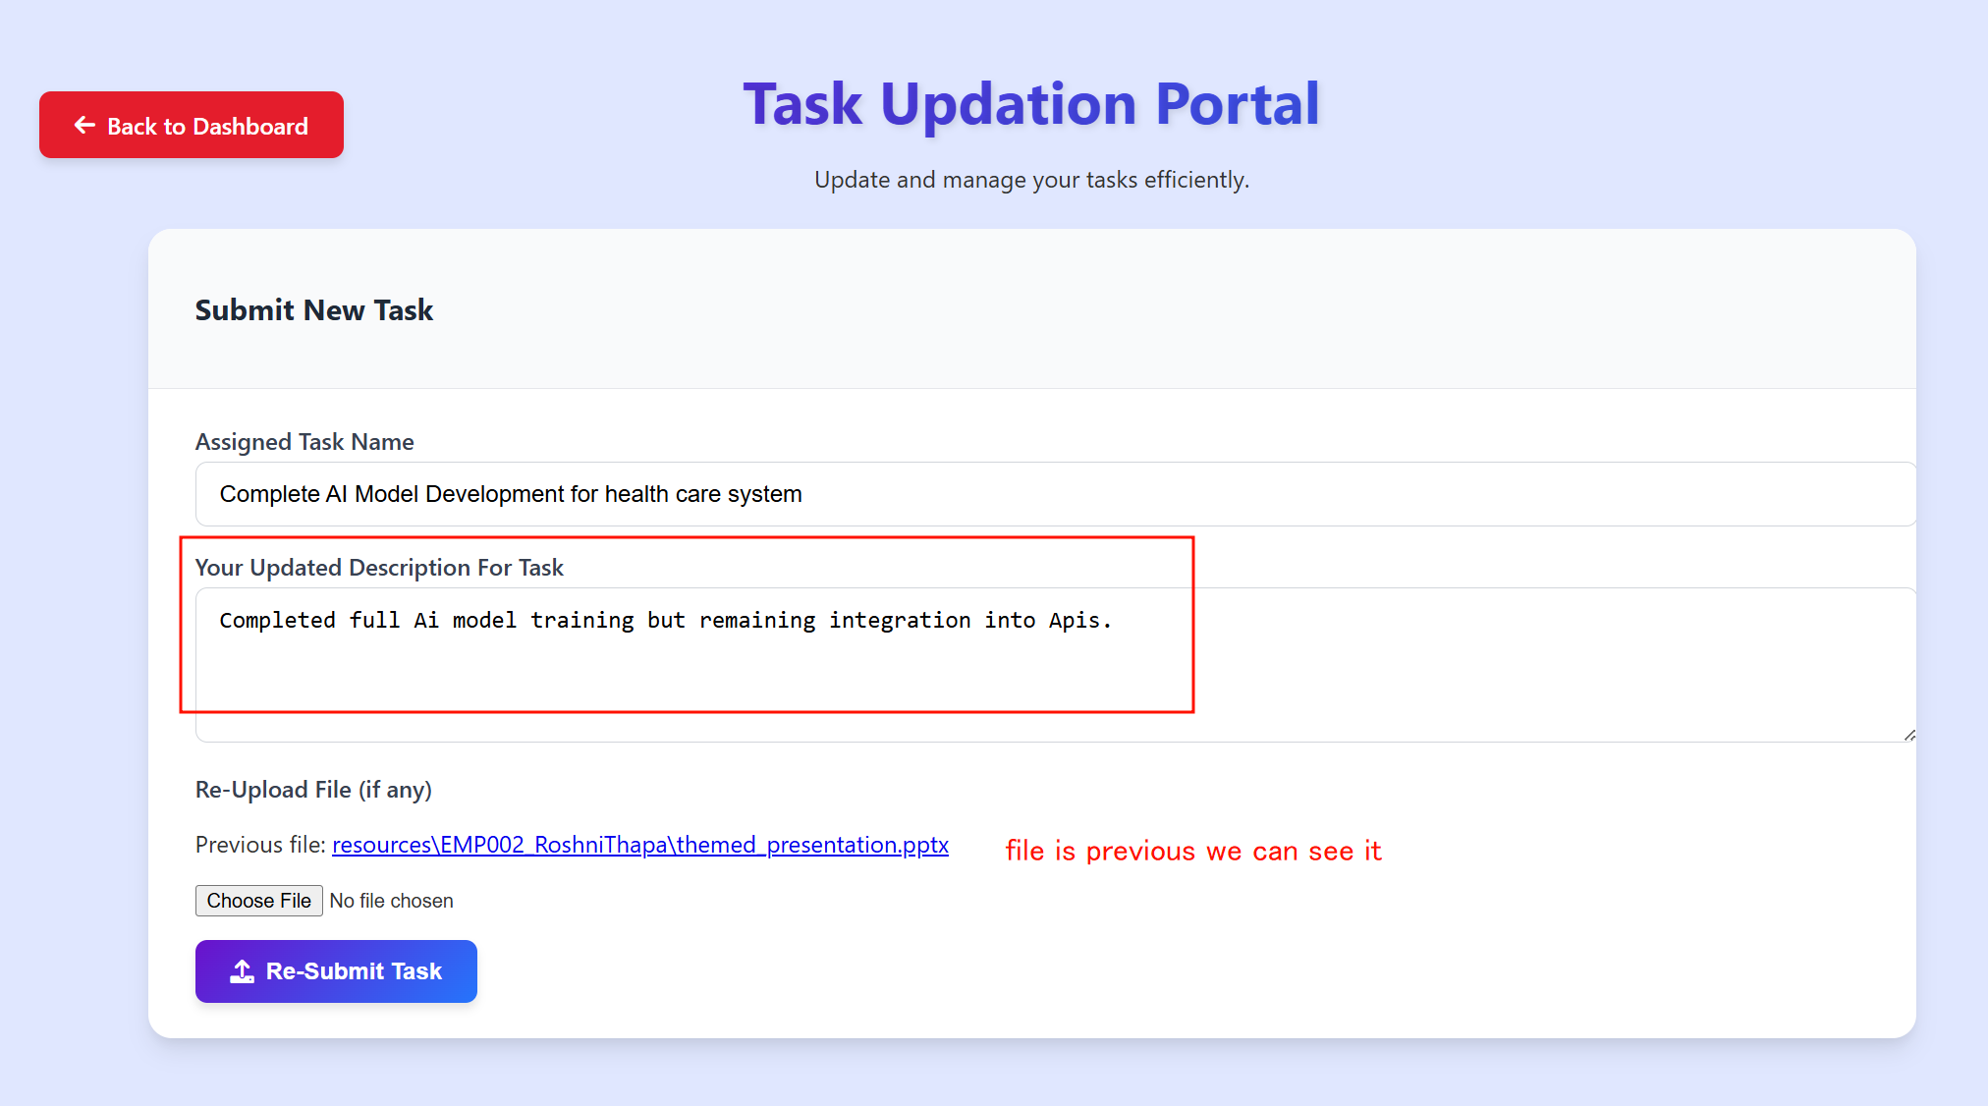

Figure 116 Screenshot of submitting task with previous file name

Table 52 Test Case 1.28

|  |  |
| --- | --- |
| **Field** | **Details** |
| **Test Case** | **Test Case 1.28** |
| **Objective** | Verify manager can approve an employee-submitted task and the employee sees the approval status |
| **Test Type** | Manual |
| **Action** | Manager sees that submitted task and he approve task then employee sees that task. |
| **Expected result** | Task status updates to "Approved" in the database and user sees approved task status |
| **Actual result** | The task is show approved, and the status is updated to approved into database |
| **Conclusion** | ✅ Test Passed. |

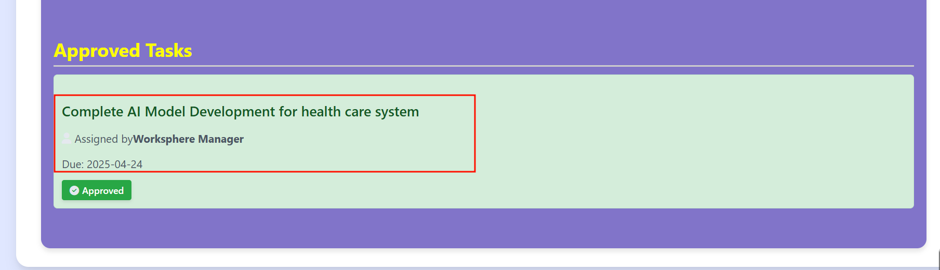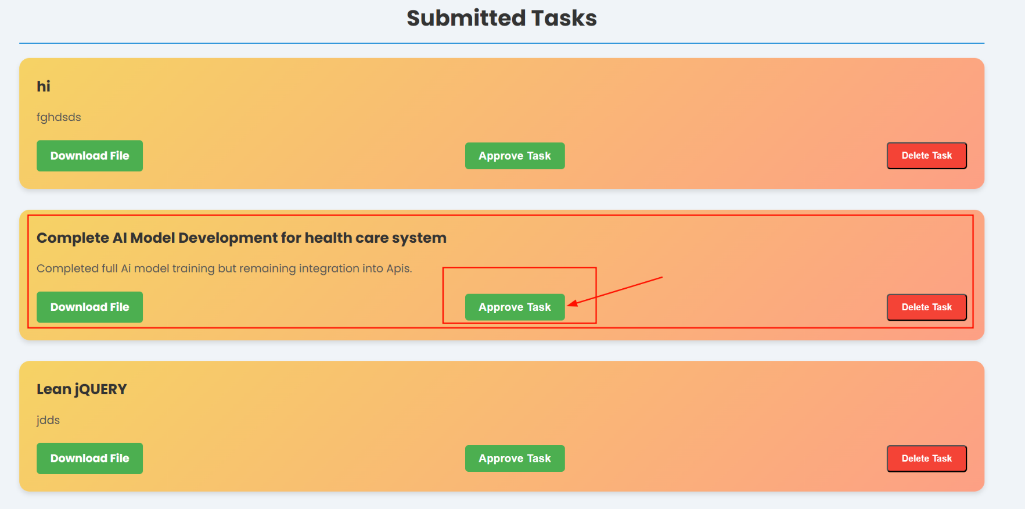

Figure 117 In database status is also settled to approved

Figure 118 After manager approved tasks user see approved in that task status

Figure 119 Submitted tasks is shown in manager dashboard with approve button

Table 53 Test Case 1.29

|  |  |
| --- | --- |
| **Field** | **Details** |
| **Test Case** | **Test Case 1.29** |
| **Objective** | Verify system allows employees to submit feedback with valid details |
| **Test Type** | Manual |
| **Action** | Employee goes to the feedback section and enter feedback type and descriptions and then sends feedback. |
| **Expected result** | Feedback is scented successfully and saved in the database, |
| **Actual result** | User sent feedback and saved into database. |
| **Conclusion** | ✅ Test Passed. |

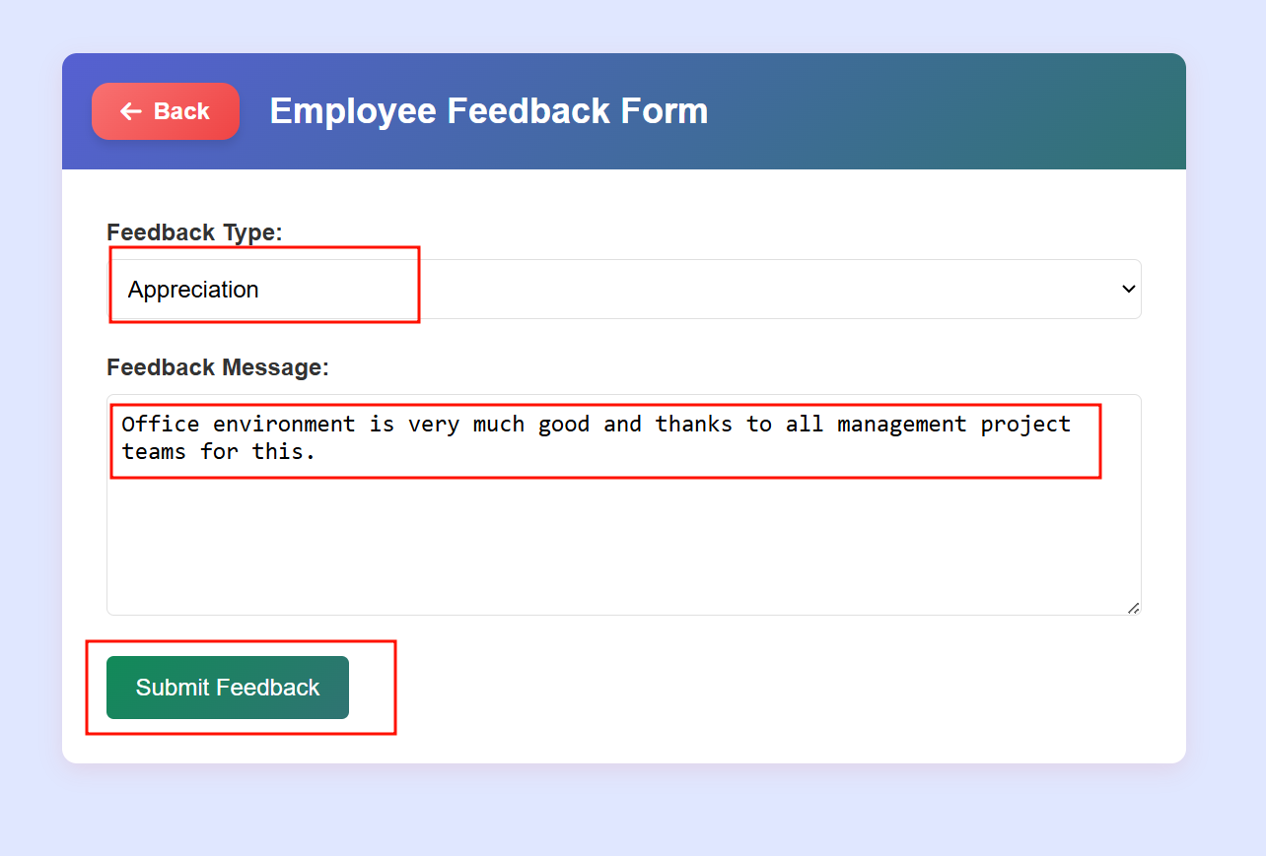

Figure 120 Screenshot of showing employee sending feedback with type

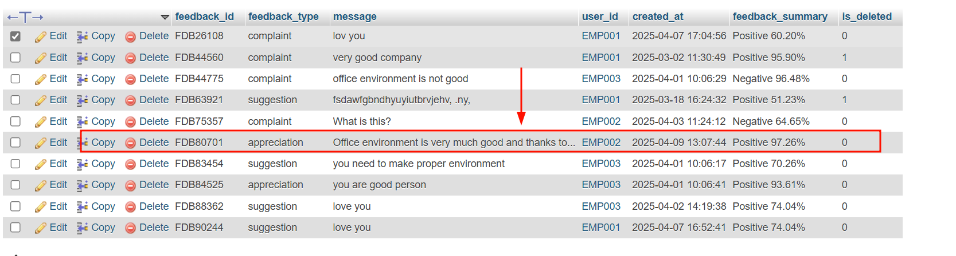

Figure 121 Screenshot of showing feedback saved into database

Table 54 Test Case 1.30

|  |  |
| --- | --- |
| **Field** | **Details** |
| **Test Case** | **Test Case 1.30** |
| **Objective** | Verify manager can access feedback and see sentiment analysis visualized in a graph |
| **Test Type** | Manual |
| **Action** | Manager login with id and then he goes to the feedback section and sees all graphs and feedback with sentiment score. |
| **Expected result** | Feedback with sentiment score and graphs are displayed successfully |
| **Actual result** | Manager viewed feedback with graph properly. |
| **Conclusion** | ✅ Test Passed. |

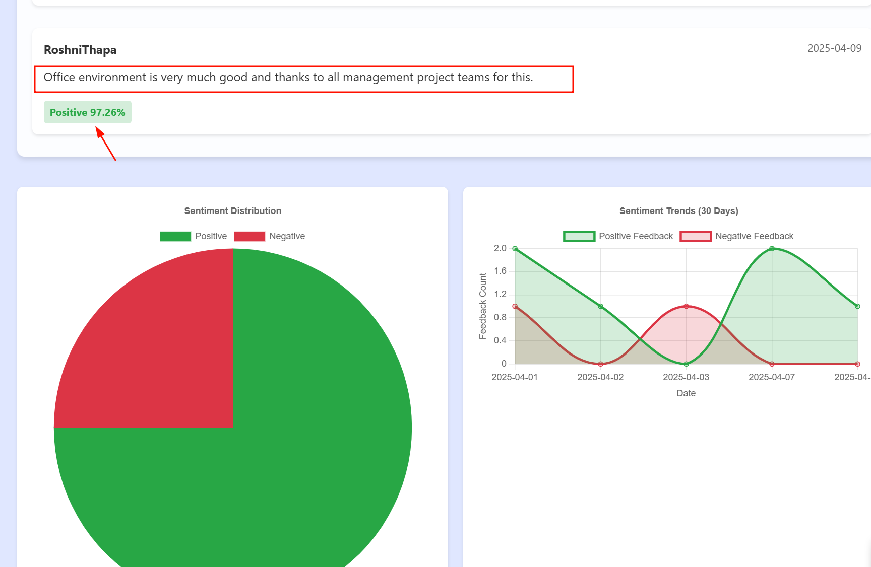

Figure 122 Manager sees all feedback with graphs

Table 55 Test Case 1.31

|  |  |
| --- | --- |
| **Field** | **Details** |
| **Test Case** | **Test Case 1.31** |
| **Objective** | Verify system allows manager to create an announcement with valid details |
| **Test Type** | Manual |
| **Action** | Manager goes to their dashboard page and then he fills all details like title, content date and priority level set and creates announcements. |
| **Expected result** | Announcements are saved in the database with success message. |
| **Actual result** | Manager enters all details and create announcements. |
| **Conclusion** | ✅ Test Passed. |

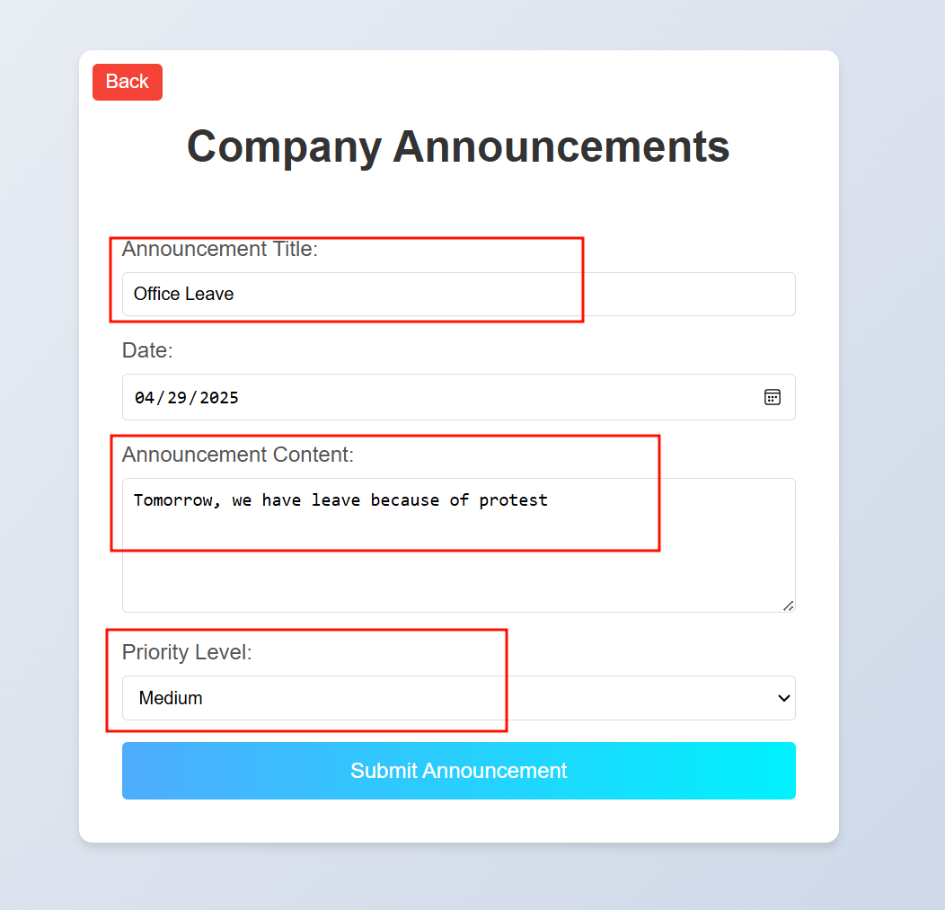

Figure 123 Screenshot of displaying manager sending announcement to all employees

Table 56 Test Case 1.32

|  |  |
| --- | --- |
| **Field** | **Details** |
| **Test Case** | **Test Case 1.32** |
| **Objective** | Verify employee can view all announcements and their notification status |
| **Test Type** | Manual |
| **Action** | Employees go to dashboards and see notifications in the announcements section, and they see all the announcements created. |
| **Expected result** | Announcements are seen by users in the announcement section and notifications also |
| **Actual result** | Users see notifications for announcement and announcement created in section. |
| **Conclusion** | ✅ Test Passed. |

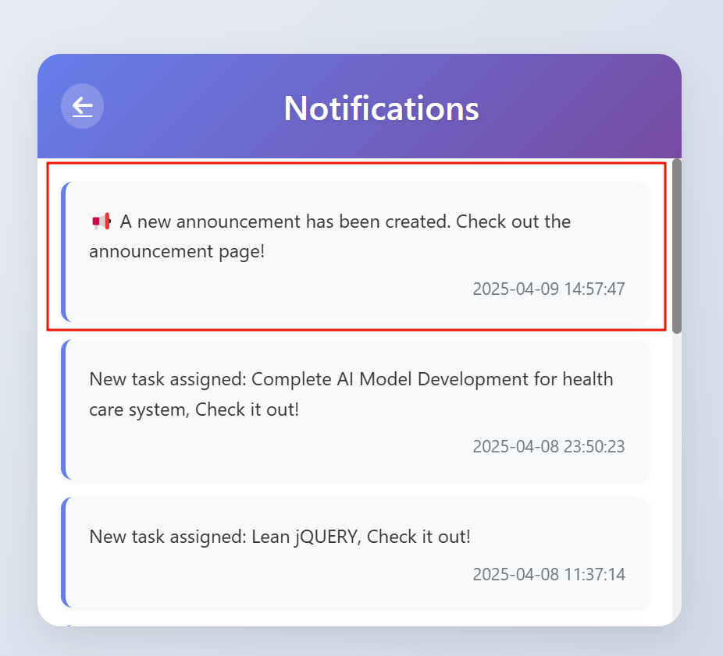

Figure 124 Screenshot of displaying notifications about announcement in employee dashboard

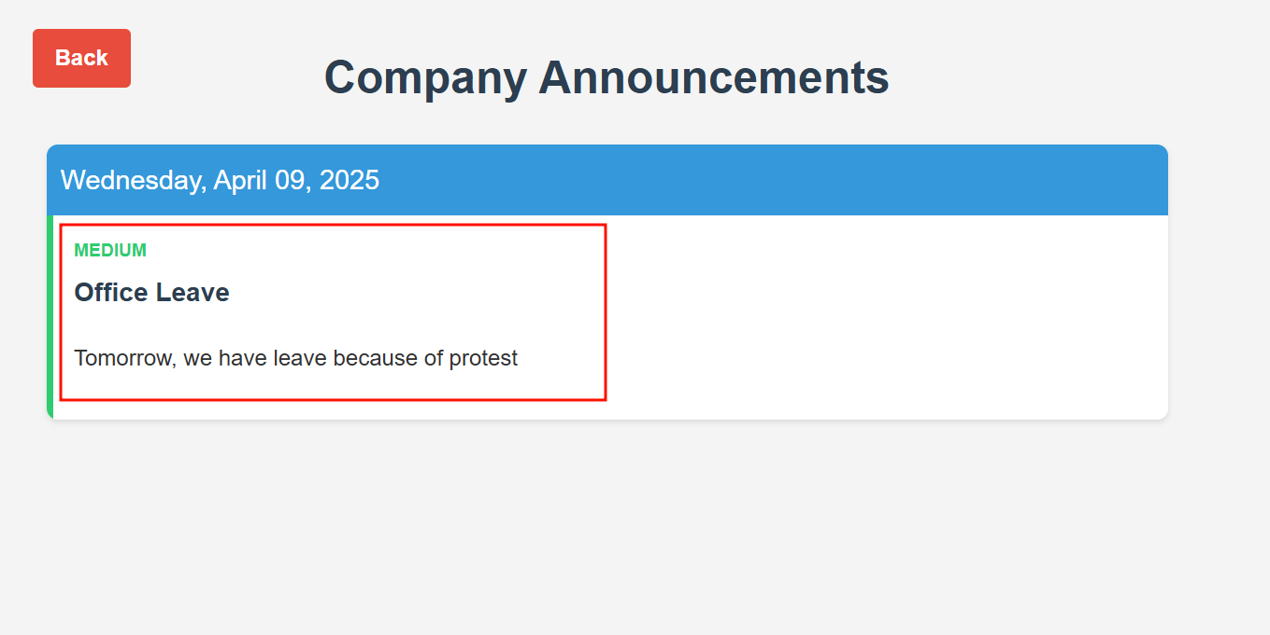

Figure 125 employee seeing announcements sends by manager

Table 57 Test Case 1.33

|  |  |
| --- | --- |
| **Field** | **Details** |
| **Test Case** | **Test Case 1.33** |
| **Objective** | Verify file upload enables summary button, AI generates summary, and download works |
| **Test Type** | Manual |
| **Action** | Employees go to dashboards and goes inside department section and goes to generate summary section upload file pdf and then button enables and click it and generated summary displayed then click download and save into .txt file. |
| **Expected result** | Summarize text button enables after pdf file upload, AI generates summary and download button is clicked. |
| **Actual result** | After file uploaded summarize, button enables then summary get generated and download it successfully. |
| **Conclusion** | ✅ Test Passed. |

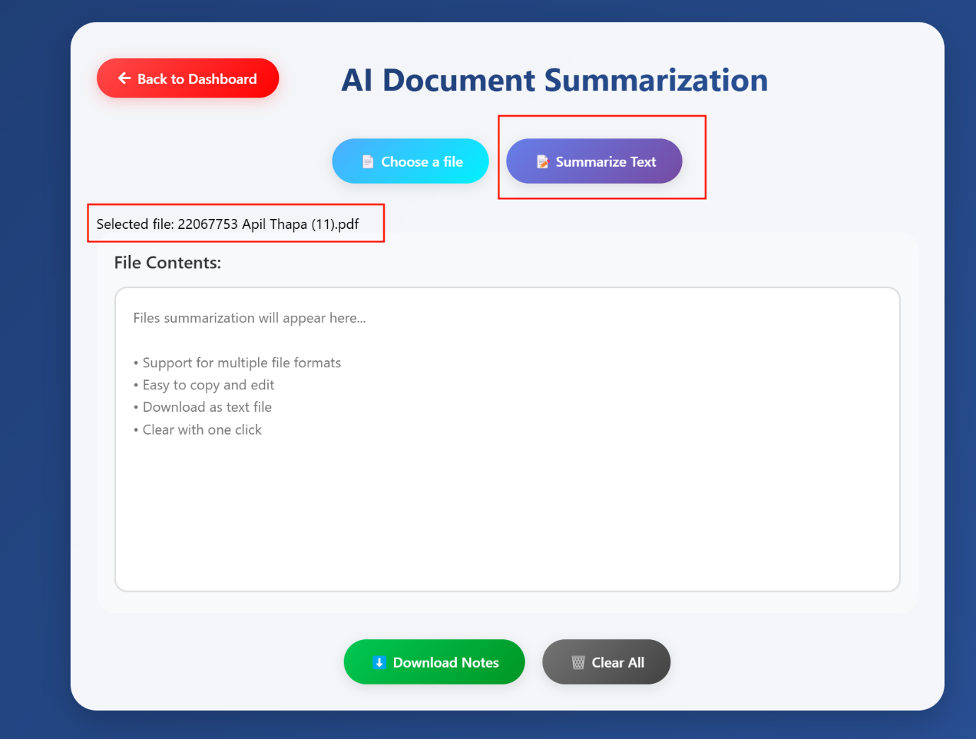

Figure 126 Screenshot of employee uploading file and generating summary

Table 58 Test Case 1.34

|  |  |
| --- | --- |
| **Field** | **Details** |
| **Test Case** | **Test Case 1.34** |
| **Objective** | Verify real-time chat messaging works between two users |
| **Test Type** | Manual |
| **Action** | One employee goes to the chat section at the same time and the other employees also goes at that time, and both can send message ta a same time. |
| **Expected result** | User A can send messages to User B and can get responses at the same time. |
| **Actual result** | Both user A and user B can send and get response at a same time |
| **Conclusion** | ✅ Test Passed. |

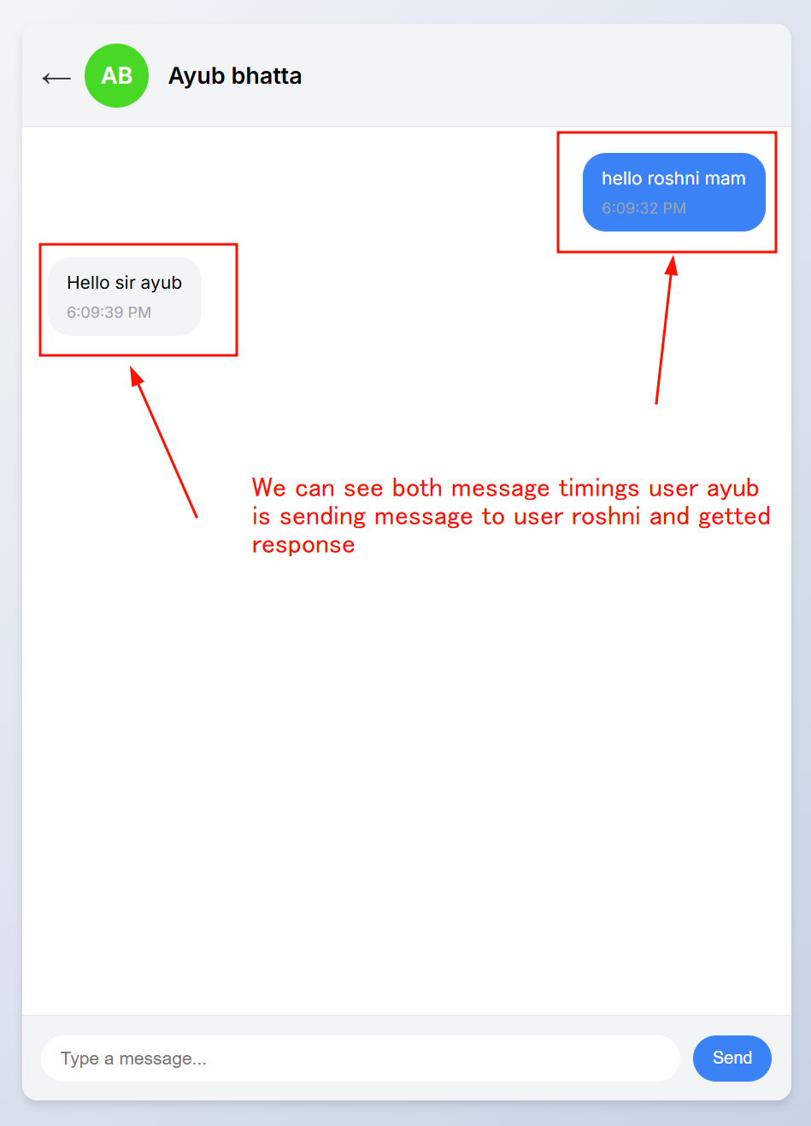

Figure 127 Screenshot of chatting both users A to B

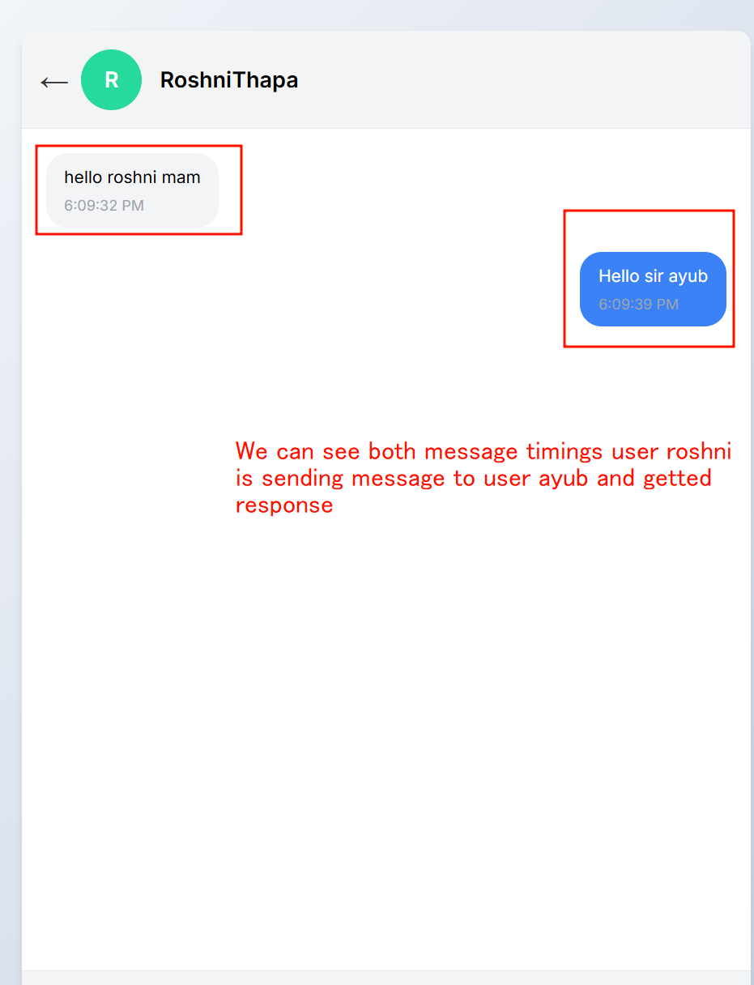

Figure 128 Screenshot of chatting both users B to A

## **4.3 SYSTEM TESTING:**

|  |  |  |
| --- | --- | --- |
| Test Case ID | Test Case Description | Objective |
| 1.1 | Manager and employee log in with role-based access, restricted pages enforced | Verify role-based login works and restricts access to unauthorized pages |
| 1.2 | JWT token is generated after user login and used for token-based authentication | Verify JWT token is generated post-login and enables secure access to authorized resources |
| 1.3 | System is responsive and functional across multiple devices | Verify system UI and functionality work consistently on various devices and screen sizes |
| 1.4 | Manager approves a task and downloads the file submitted by an employee | Verify manager can approve tasks and download associated employee-submitted files |
| 1.5 | Application runs on a Windows EC2 instance in the cloud | Verify system operates correctly when deployed on a Windows EC2 instance |
| 1.6 | Each user cannot access restricted pages without logging in | Verify users can’t access restricted pages without logging in. |
| 1.7 | System runs asynchronously, supporting multiple users simultaneously | Verify system handles concurrent user interactions without performance degradation |
| 1.8 | User interactions create data stored in MySQL Aurora, connection verified | Verify data from user actions is stored in MySQL Aurora and database connection is functional |

Table 59 Possible system test cases

Table 60 System Test cases 2.1

|  |  |
| --- | --- |
| **Field** | **Details** |
| **Test Case** | **Test Case 2.1** |
| **Objective** | Verify role-based login works and restricts access to unauthorized pages |
| **Test Type** | Manual |
| **Action** | Users whose role is manager get role-based redirection to manager dashboard and whose role is employee get access to employee dashboard and employee can’t get access to manager pages and manager can’t get access to employee pages. |
| **Expected result** | Users should get redirected based on their role and should get access to their respective pages only. |
| **Actual result** | Users get redirected to employee dashboard if he is employee and manager dashboard if he is manager respectively with other role page restrictions. |
| **Conclusion** | ✅ Test Passed. |

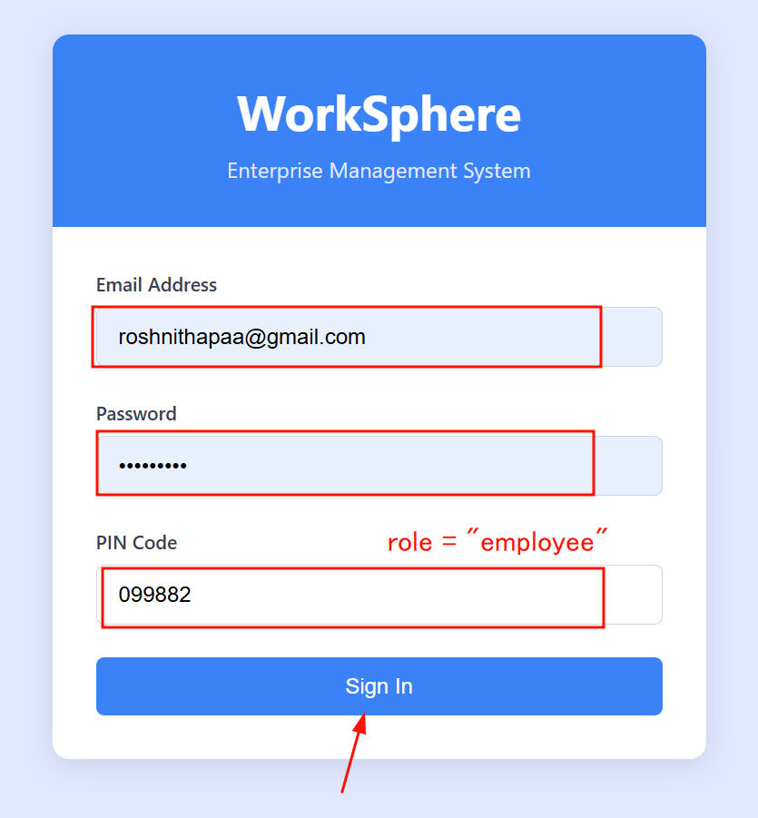

Figure 129 Entering employee details and sigining in

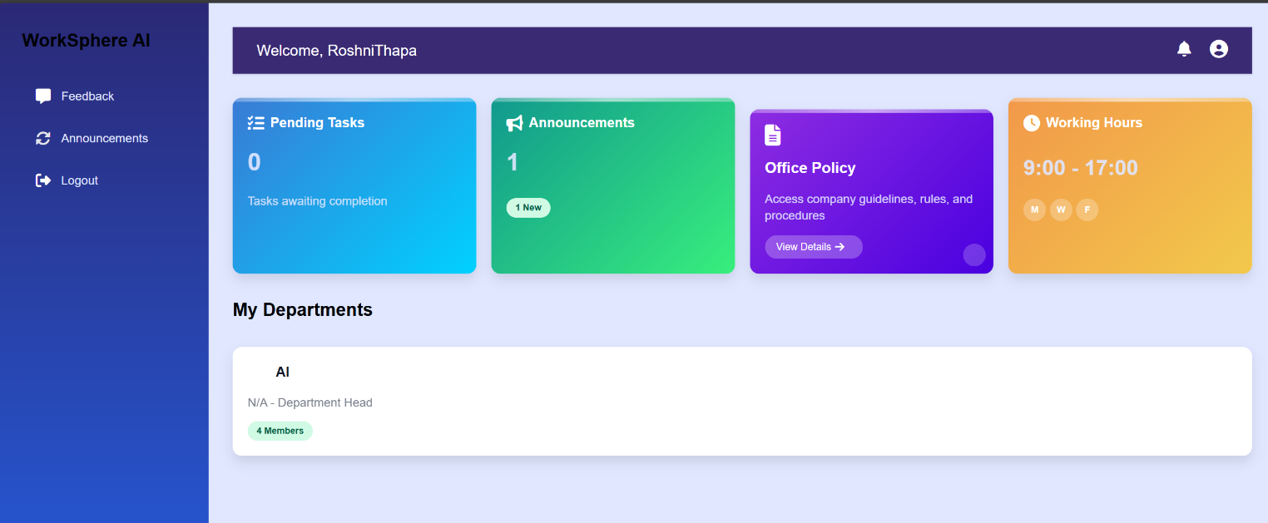

Figure 130 Screenshot of accessing employee dashboard

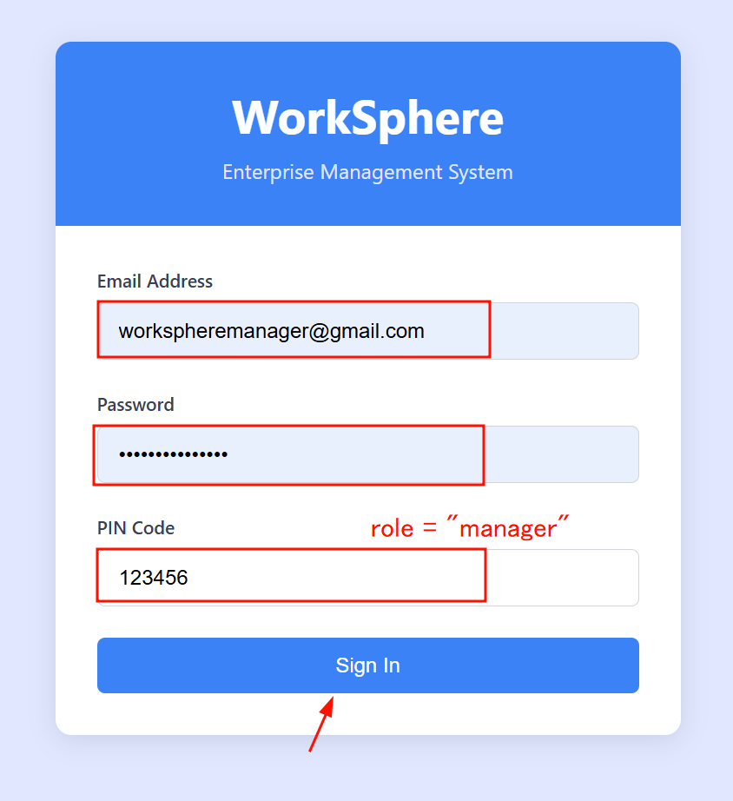

Figure 131 Entering manager details and logging in

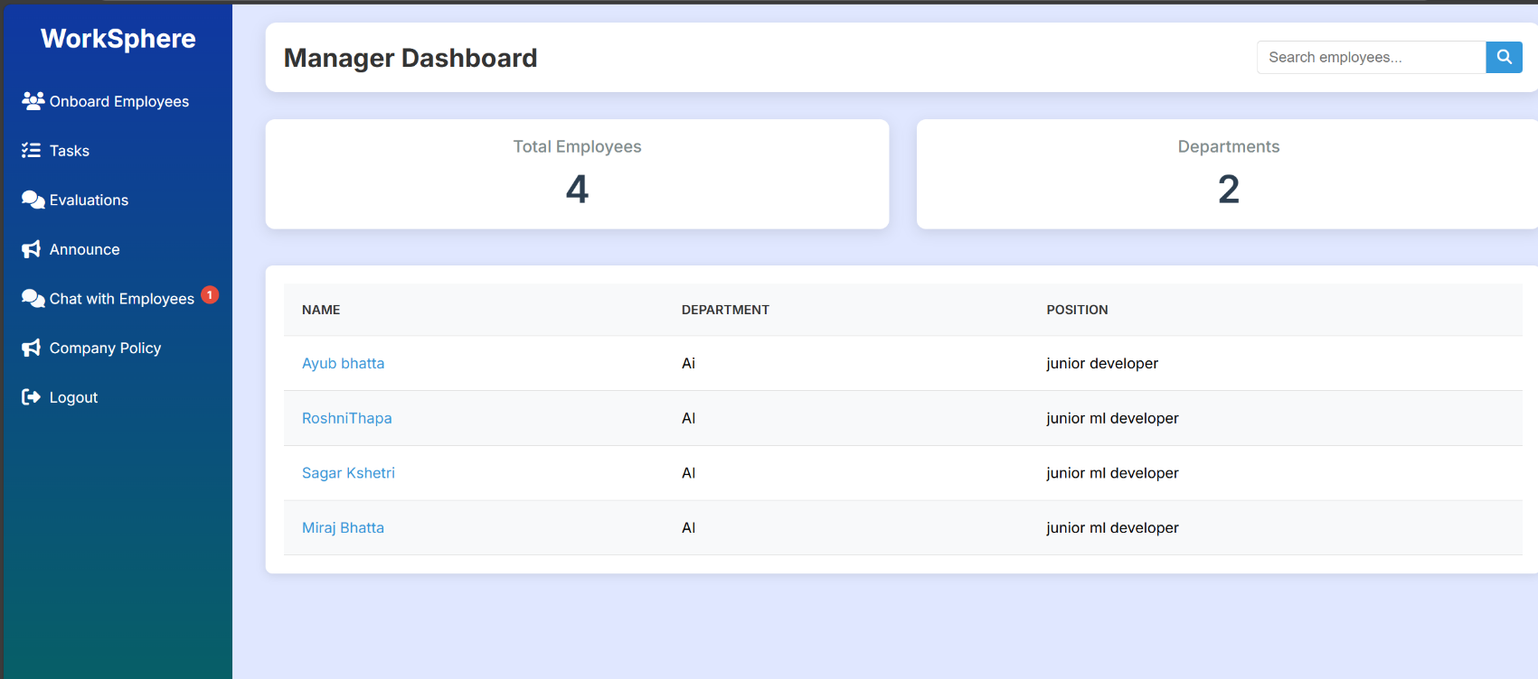

Figure 132 Screenshot of accessing manager dashboard

**Redirection:**

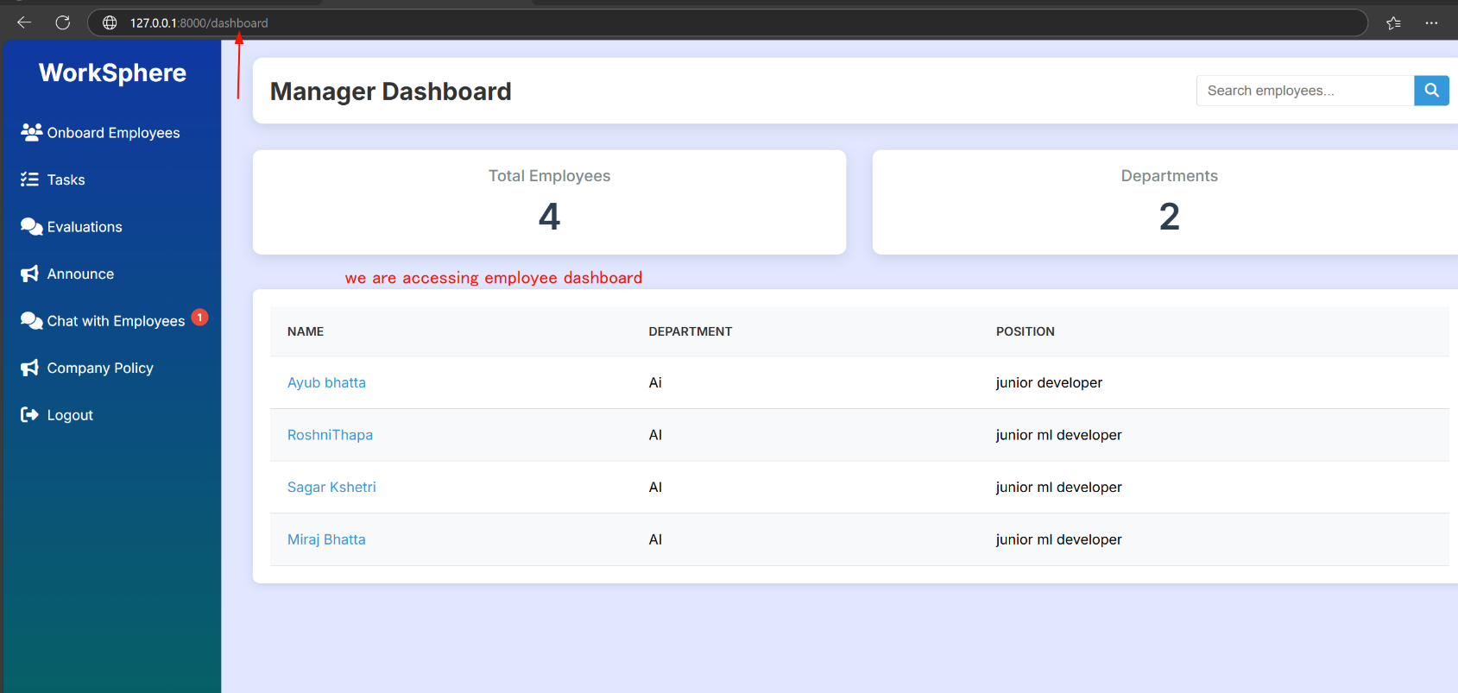

Figure 133 Manager try to access employee dashboard screenshot

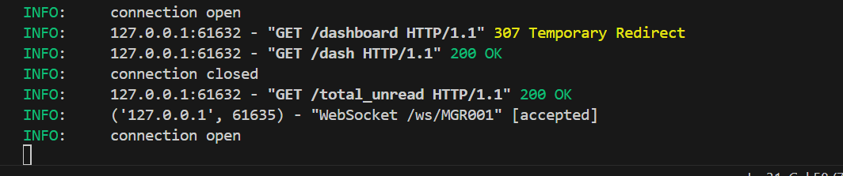

Figure 134 Temporary redirection done to send back to manager page

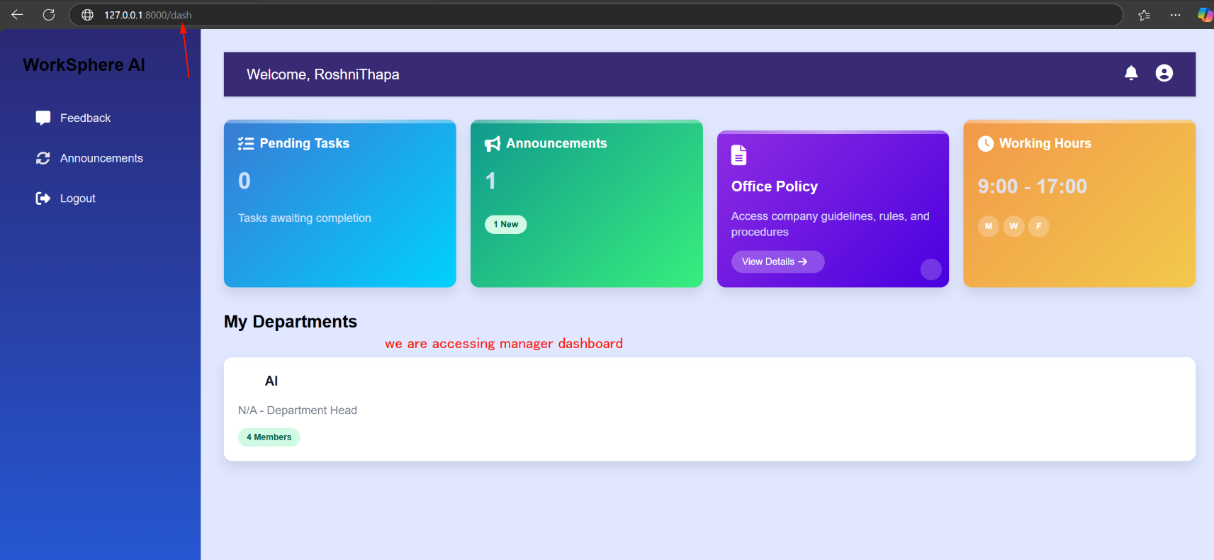

Figure 135 Employee accessing manager dashboard

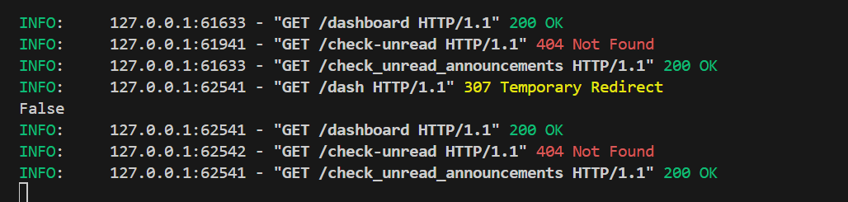

Figure 136 Temporary redirection occurs to send back employee to respective page

|  |  |
| --- | --- |
| **Field** | **Details** |
| **Test Case** | **Test Case 2.2** |
| **Objective** | Verify JWT token is generated post-login and enables secure access to authorized resources |
| **Test Type** | Manual |
| **Action** | User logs in, system generates JWT token, user attempts to access authorized resources and user attempts to access unauthorized resources. |
| **Expected result** | User logs in and system generates JWT token, user accesses authorized resources successfully using the token, and user is denied access to unauthorized resources with invalid or no token. |
| **Actual result** | User logs in and system generates JWT token, user accesses authorized resources successfully using the token, and user is denied access to unauthorized resources with invalid or no token. |
| **Conclusion** | ✅ Test Passed. |

Table 61 System Test cases 2.2

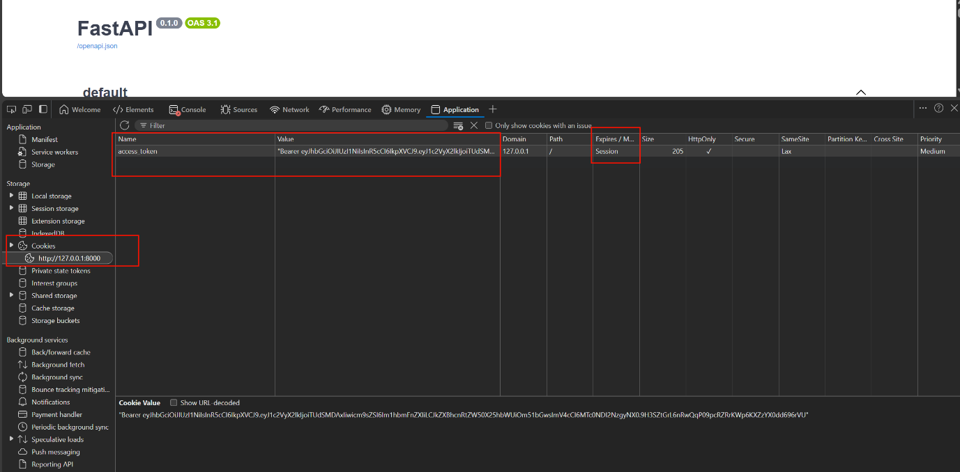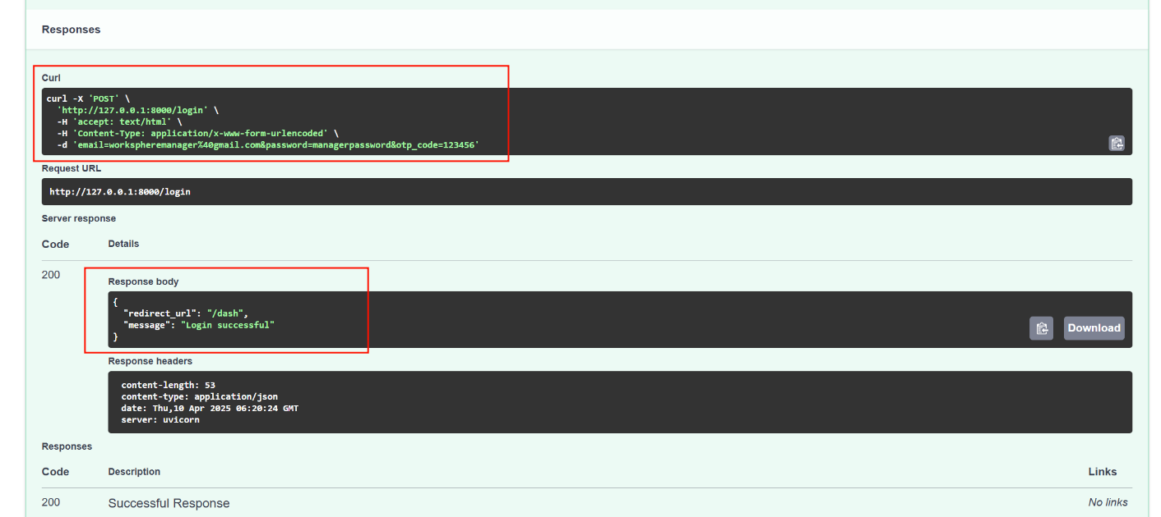

Figure 137 JWT token stored in cookies after logged in

Figure 138 Screenshot of displaying response body for successful login

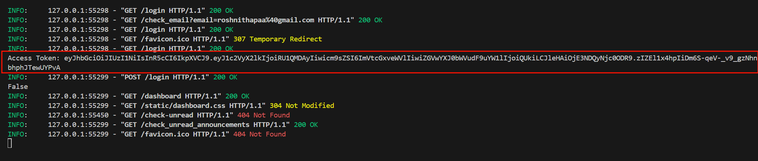

Figure 139 Screenshot of token shown in console

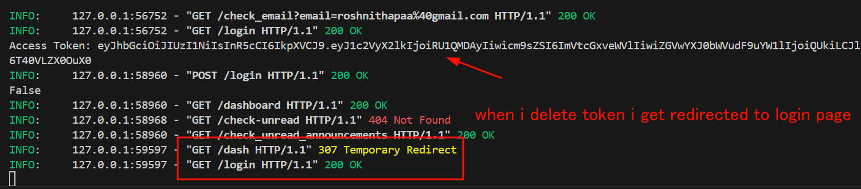

Figure 140 Tested by deleting token manually then redirected back to login page

Table 62 System Test cases 2.3

|  |  |
| --- | --- |
| **Field** | **Details** |
| **Test Case** | **Test Case 2.3** |
| **Objective** | System is responsive and functional across multiple devices |
| **Test Type** | Manual |
| **Action** | User accesses systems on desktop, iPhone, and other mobile devices, logs in, navigates to key pages, and performs core actions like task submission or viewing announcements. |
| **Expected result** | User accesses system on desktop, iPad mini, and mobile devices, UI adapts responsively to each screen size, login succeeds, navigation to key pages works, and core actions |
| **Actual result** | User accesses system on desktop, tablet, and mobile devices, UI adapts responsively to each screen size, login succeeds, navigation to key pages works, and core actions works as well |
| **Conclusion** | ✅ Test Passed. |

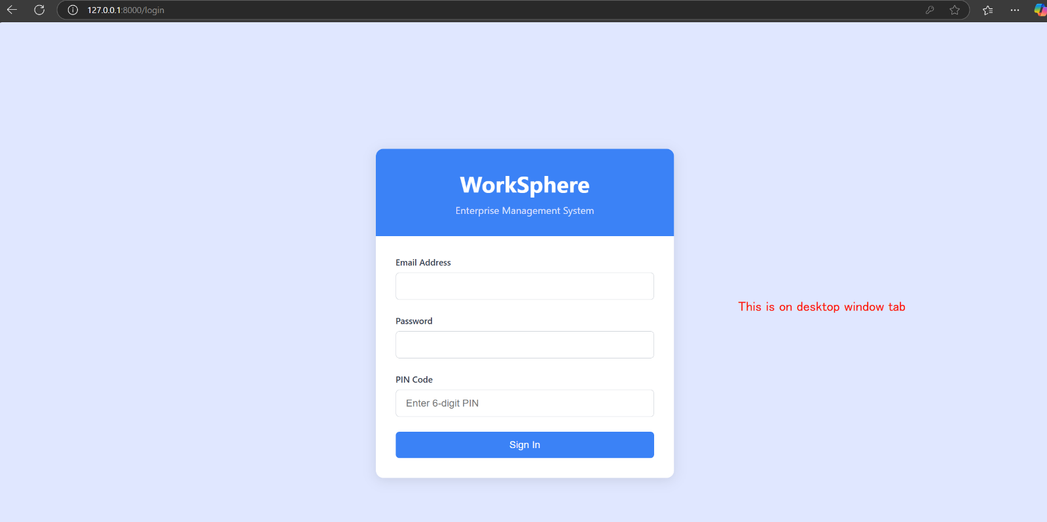

Figure 141 Tested responsive design for login page in desktop view

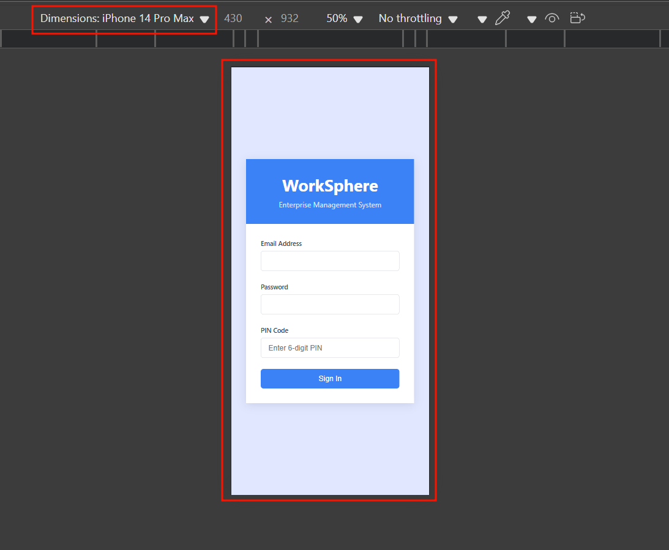

Figure 142 Tested responsive design for login page in Mobile view

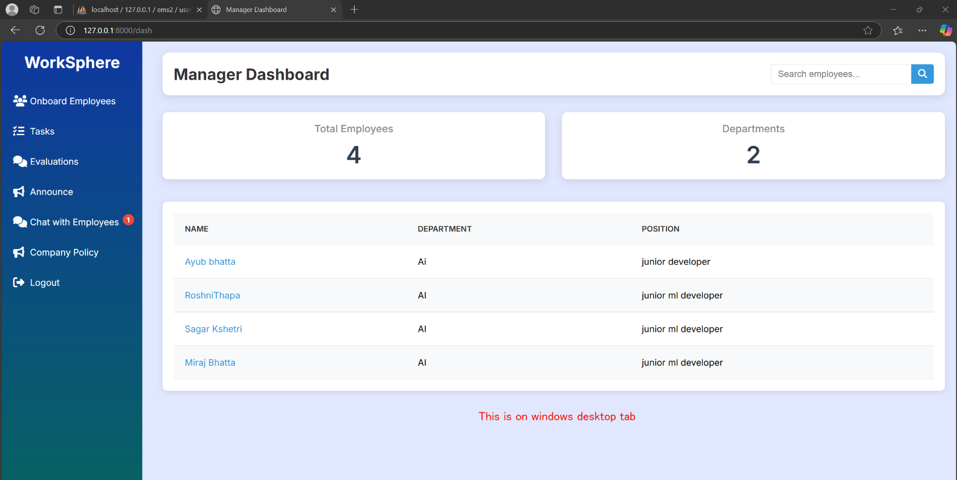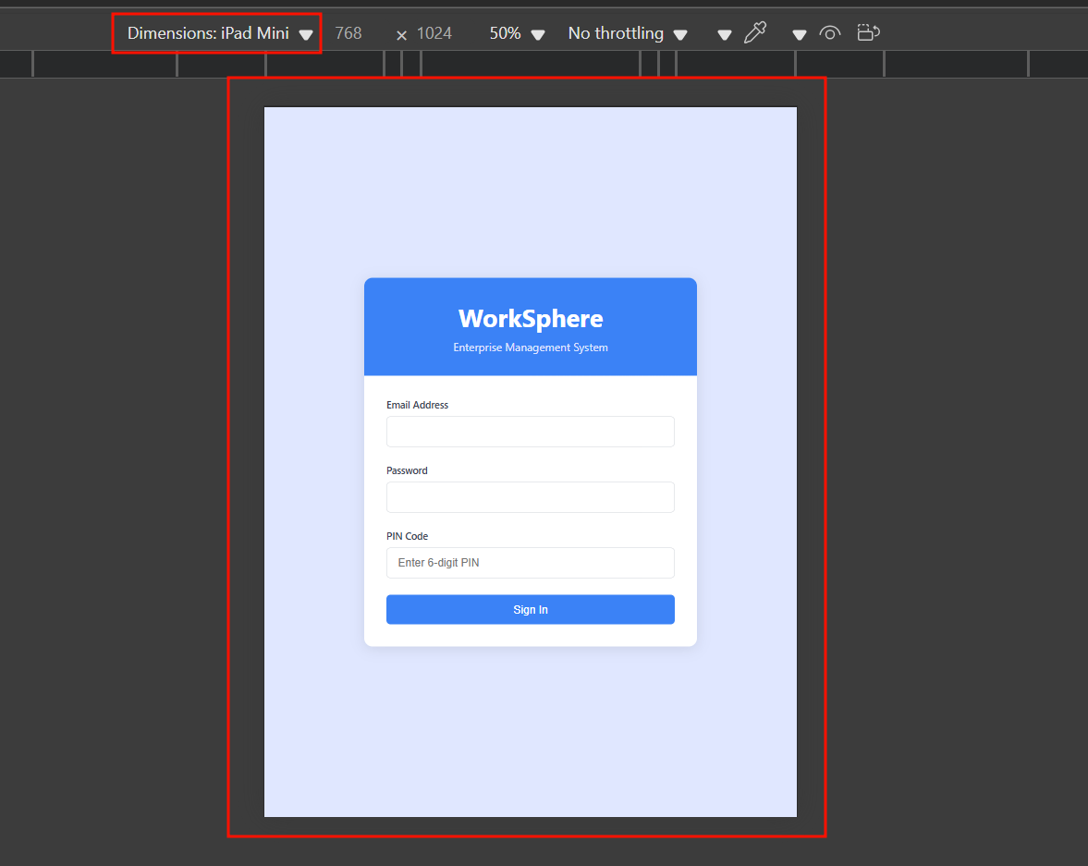

Figure 143 Tested responsive design for manager dashboard page in desktop view

Figure 144 Tested responsive design for login page in iPad view

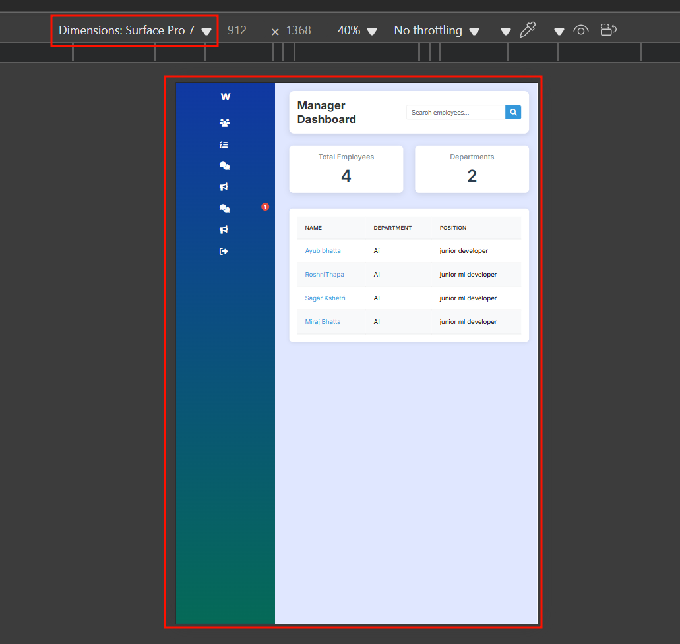

Figure 145 Tested responsive design for manager page in Surface pro view

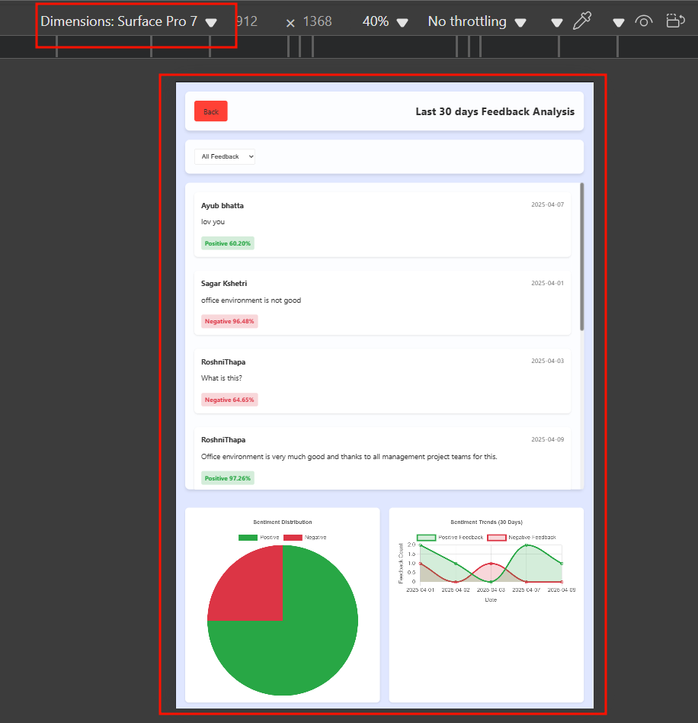

Figure 146 Tested responsive design for feedback displaying page in surface pro view

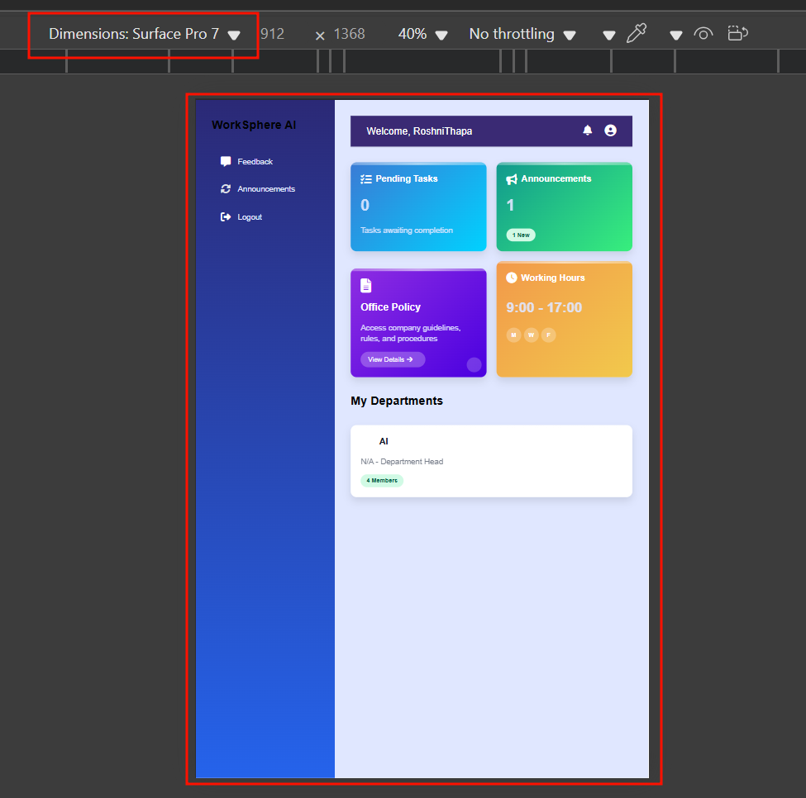

Figure 147 Tested responsive design for employee dashboard page in surface pro view

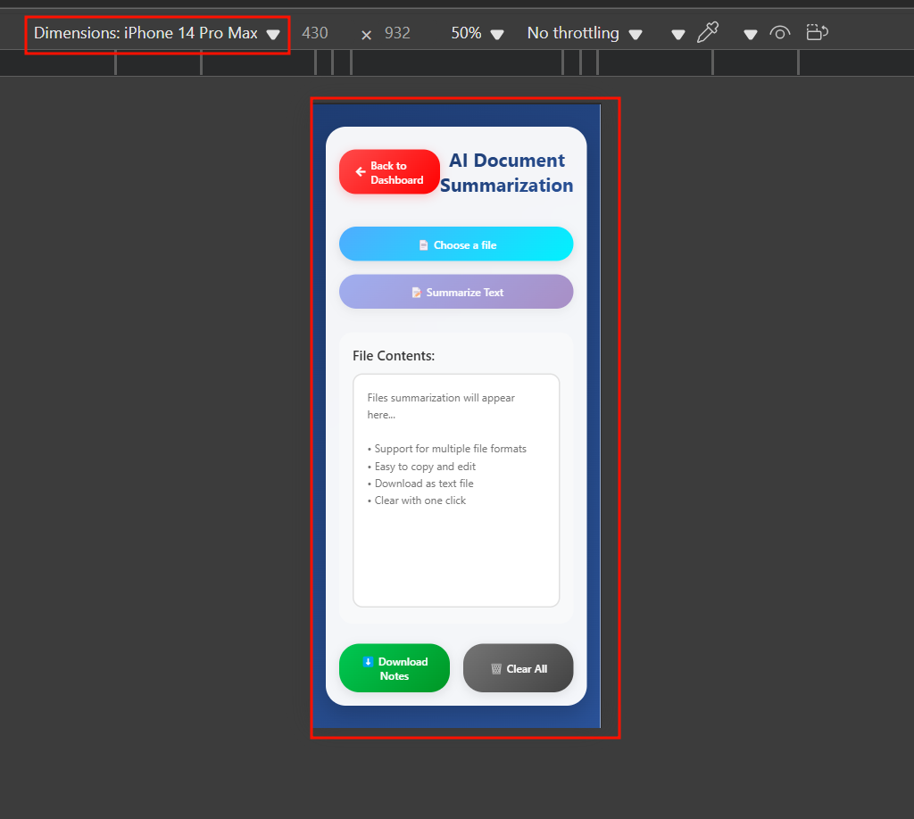

Figure 148 Tested responsive design for summary page in mobile view

Table 63 System Test cases 2.4

|  |  |
| --- | --- |
| **Field** | **Details** |
| **Test Case** | **Test Case 2.4** |
| **Objective** | Verify manager can approve tasks and download associated employee-submitted files |
| **Test Type** | Manual |
| **Action** | Employee submits a task with a file, manager logs in, navigates to task approval section, approves the task, and downloads the submitted file. |
| **Expected result** | Employee submits a task with a file, manager logs in and navigates to task approval section, approves the task successfully, downloads the submitted file |
| **Actual result** | Employee submits a task with a file, manager logs in and navigates to task approval section, approves the task successfully, downloads the submitted file |
| **Conclusion** | ✅ Test Passed. |

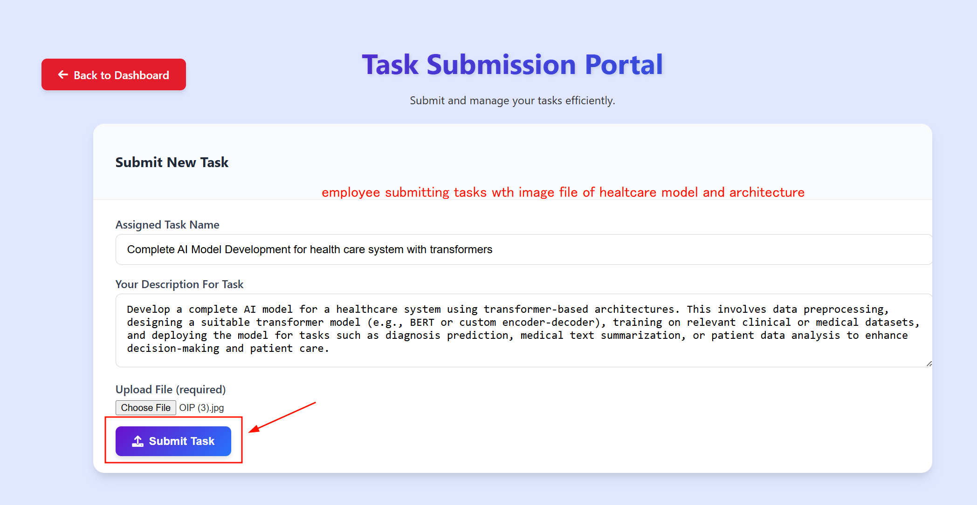

Figure 149 Employee submitting tasks with image file

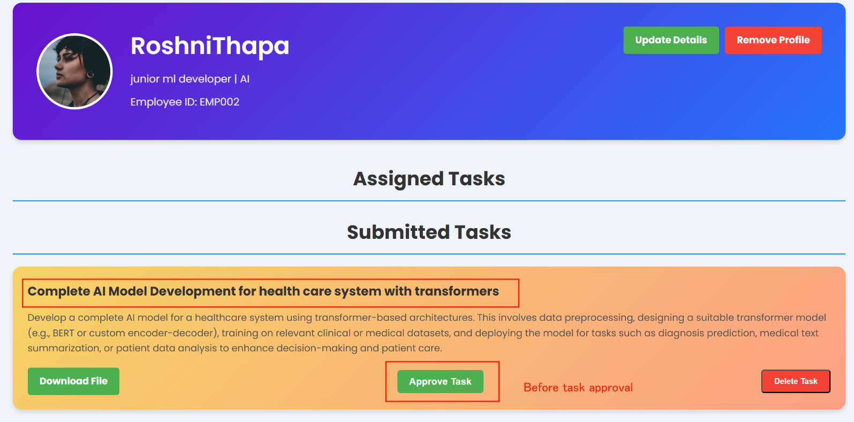**Before**:

Figure 150 Manager viewing that posts in manager page

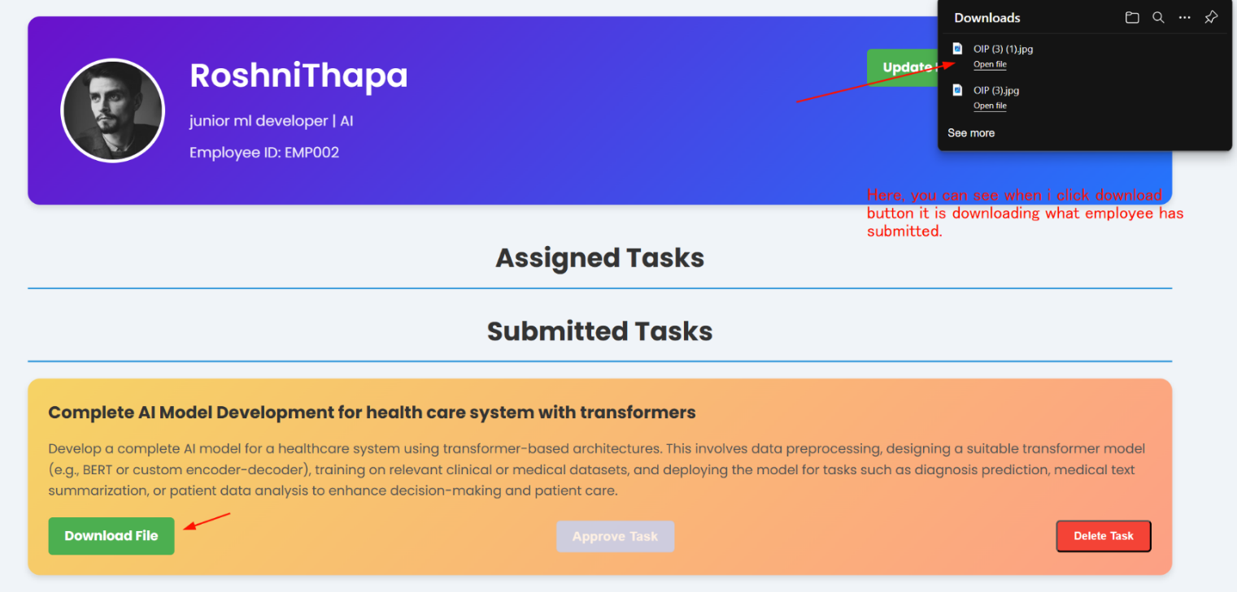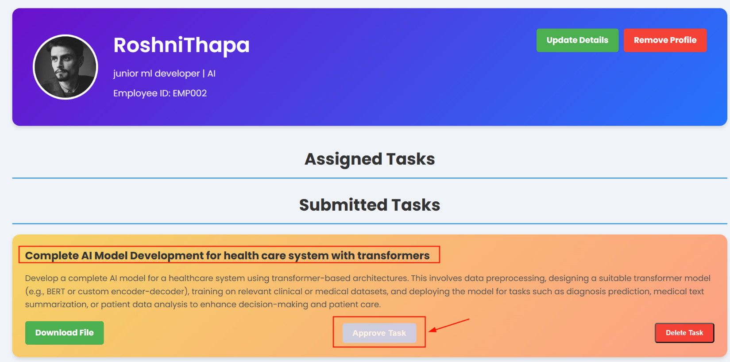**After:**

Figure 151 Screenshot of manager downloading file

Figure 152 Screenshot of manager approved tasks

Table 64 System Test cases 2.5

|  |  |
| --- | --- |
| **Field** | **Details** |
| **Test Case** | **Test Case 2.5** |
| **Objective** | Application runs on a Windows EC2 instance in the cloud |
| **Test Type** | Manual |
| **Action** | Application is deployed on a Windows EC2 instance, user accesses the application via browser, logs in, and performs key actions like navigating dashboards |
| **Expected result** | Application is deployed on a Windows EC2 instance, user accesses the application via browser, logs in successfully, navigates dashboards |
| **Actual result** | Application is deployed on a Windows EC2 instance, user accesses the application via browser, logs in successfully, navigates dashboards |
| **Conclusion** | ✅ Test Passed. |

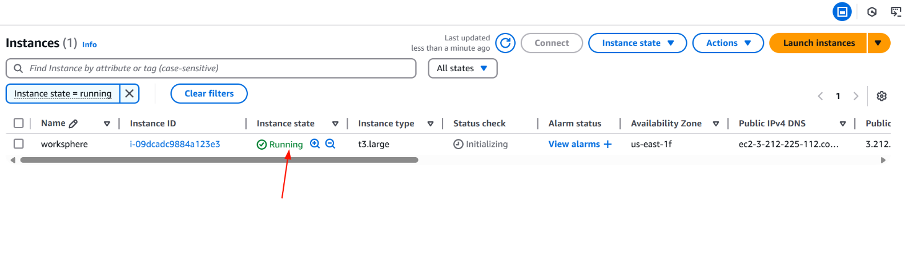

Figure 153 Screenshot of showing ec2 running

Figure 154 Accessing ec2 server

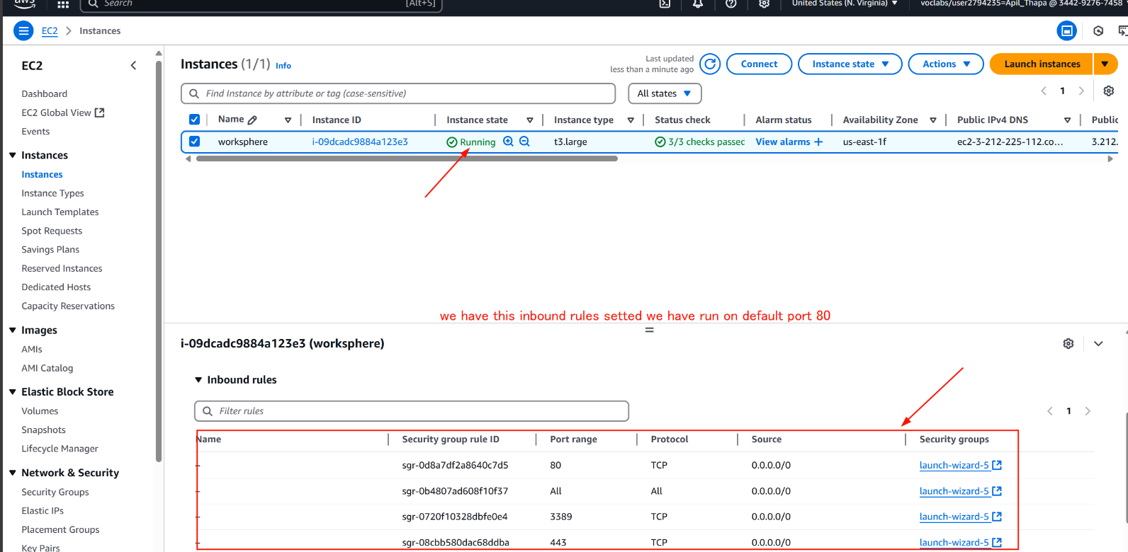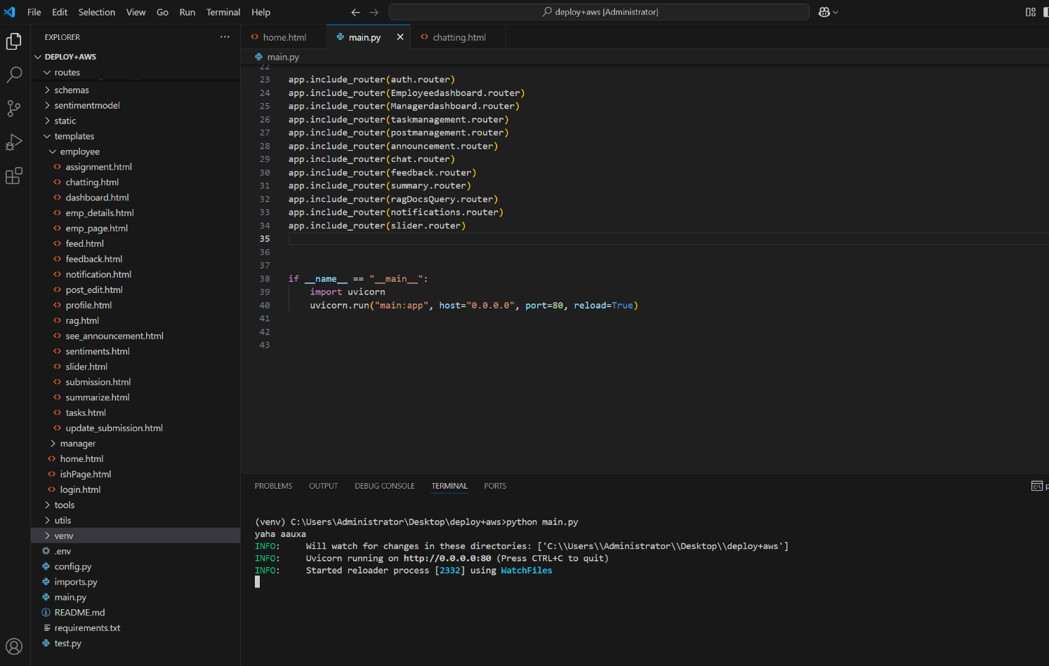

Figure 155 Screenshot of running code in server computer

Figure 156 Screenshot of showing proper inbound rules configured for ec2 and ipv4

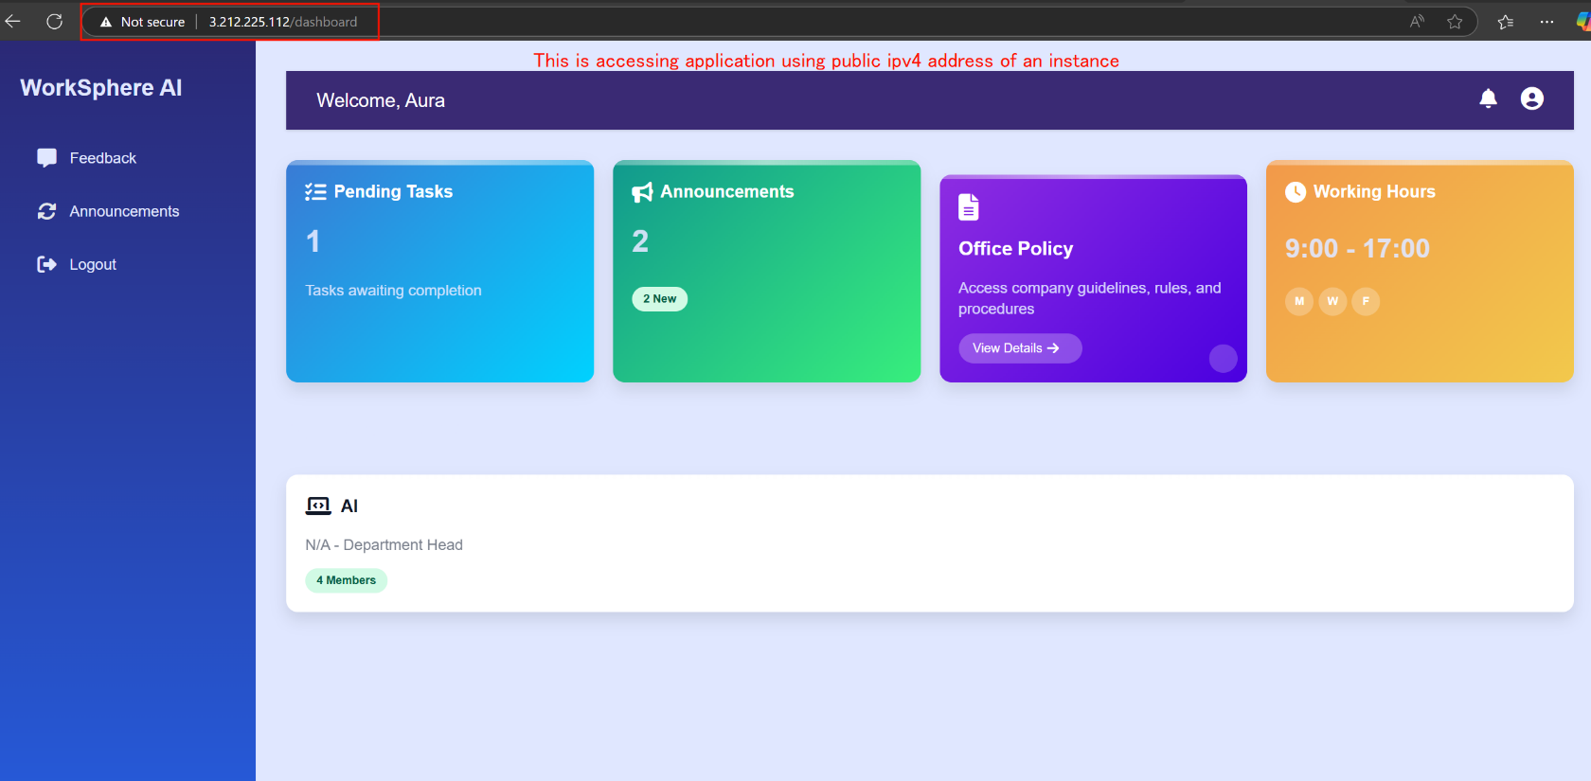

Figure 157 Screenshot of showing accessing ipv4 address inside browser

Table 65 System Test cases 2.6

|  |  |
| --- | --- |
| **Field** | **Details** |
| **Test Case** | **Test Case 2.6** |
| **Objective** | Each user cannot access restricted pages without logging in |
| **Test Type** | Manual |
| **Action** | User attempts to access restricted manager pages and employee pages without logging in by directly entering URLs or navigating via browser. |
| **Expected result** | User attempts to access restricted manager pages and employee pages without logging in, gets redirected to login page |
| **Actual result** | User attempts to access restricted manager pages and employee pages without logging in, gets redirected to login page |
| **Conclusion** | ✅ Test Passed. |

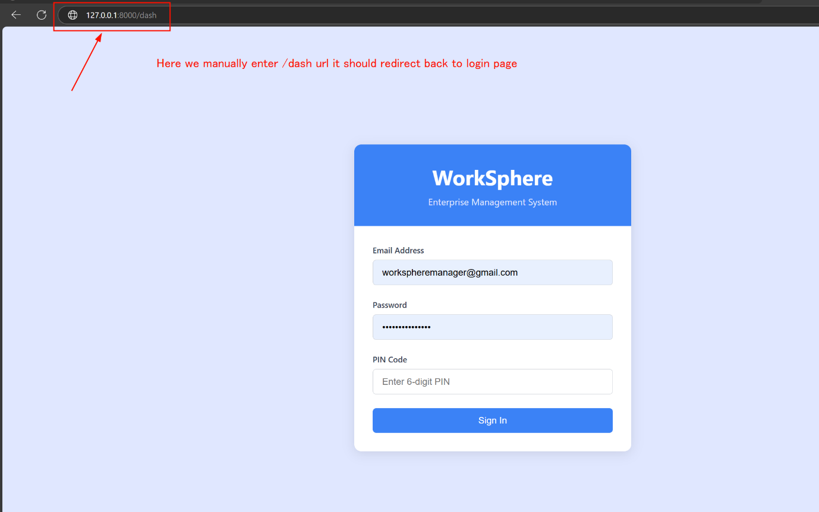

Figure 158 Screenshot of accessing /dash route directly without logged in

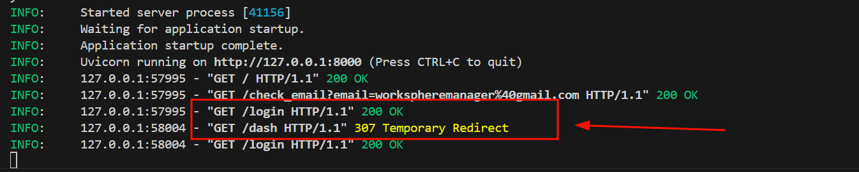

Figure 159 Screenshot of showing temporary redirection to login page

Table 66 System Test cases 2.7

|  |  |
| --- | --- |
| **Field** | **Details** |
| **Test Case** | **Test Case 2.7** |
| **Objective** | System runs asynchronously, supporting multiple users simultaneously |
| **Test Type** | Manual |
| **Action** | Multiple users log in simultaneously on different devices, perform actions like submitting tasks, sending chats, and viewing announcements at the same time |
| **Expected result** | Multiple users log in simultaneously on different devices, perform actions |
| **Actual result** | Multiple users log in simultaneously on different devices, perform actions |
| **Conclusion** | Test Failed. |

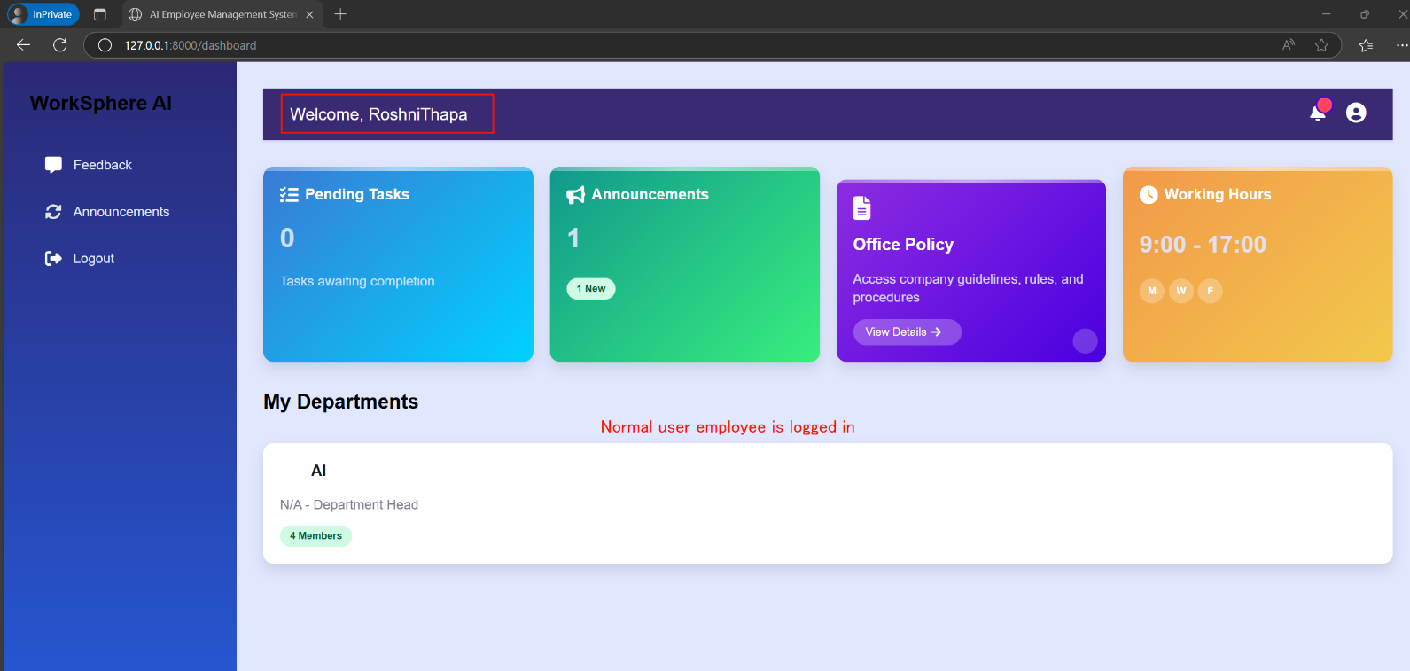

Figure 160 Normal employee logs in

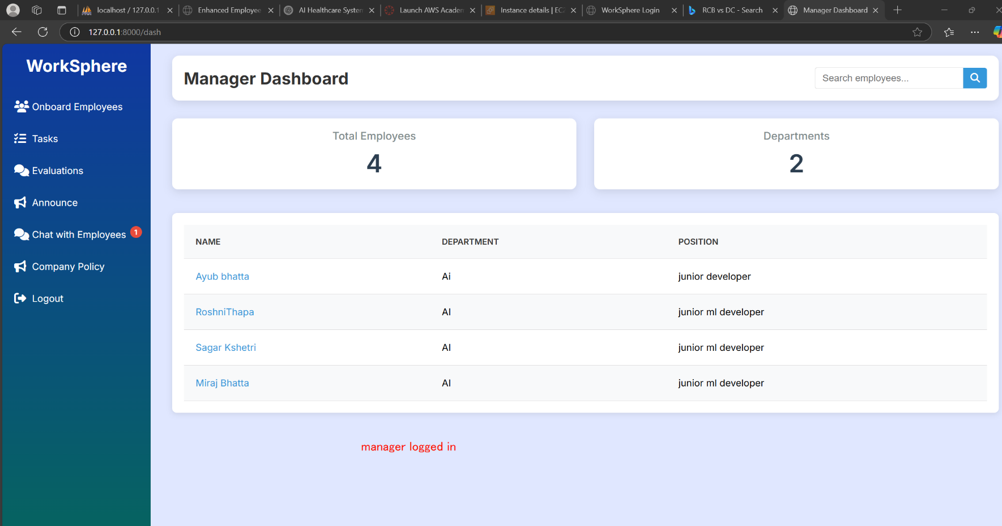

Figure 161 Manager logs in

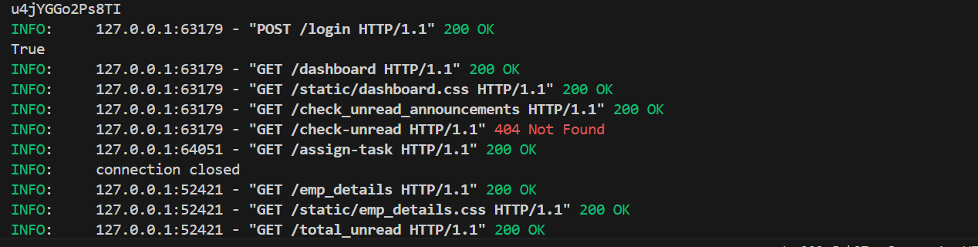

Figure 162 Screenshot of showing post request login

Table 67 System Test cases 2.8

|  |  |
| --- | --- |
| **Field** | **Details** |
| **Test Case** | **Test Case 2.8** |
| **Objective** | User interactions create data stored in MySQL Aurora; connection verified |
| **Test Type** | Manual |
| **Action** | User logs in, performs different actions systems, store the data in MySQL Aurora, and connection status is checked indirectly through successful interactions. |
| **Expected result** | User logs in, performs actions, system stores the task details and chat message in MySQL Aurora, user sees confirmation of actions |
| **Actual result** | User logs in, performs actions system stores the task details and chat message in MySQL Aurora, user sees confirmation of actions |
| **Conclusion** | ✅ Test Passed. |

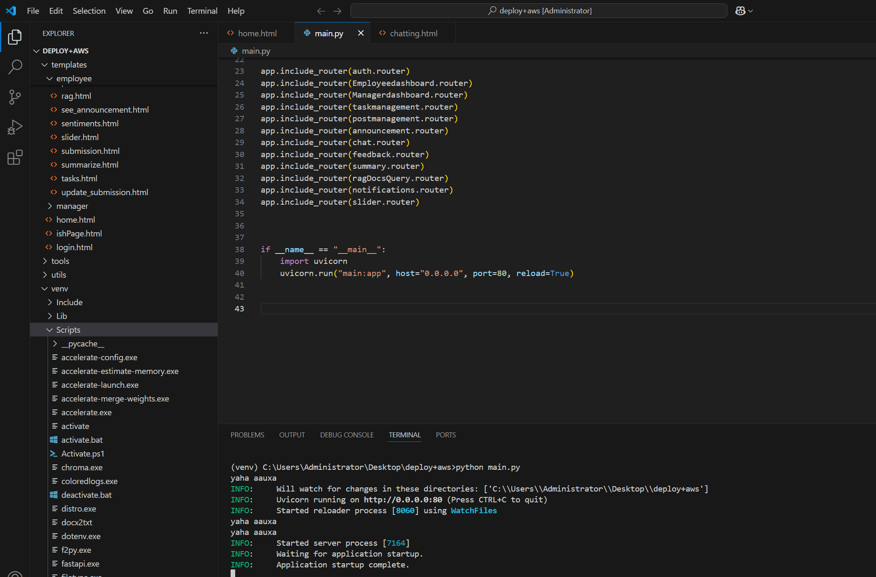

Figure 163 Screenshot of showing system running

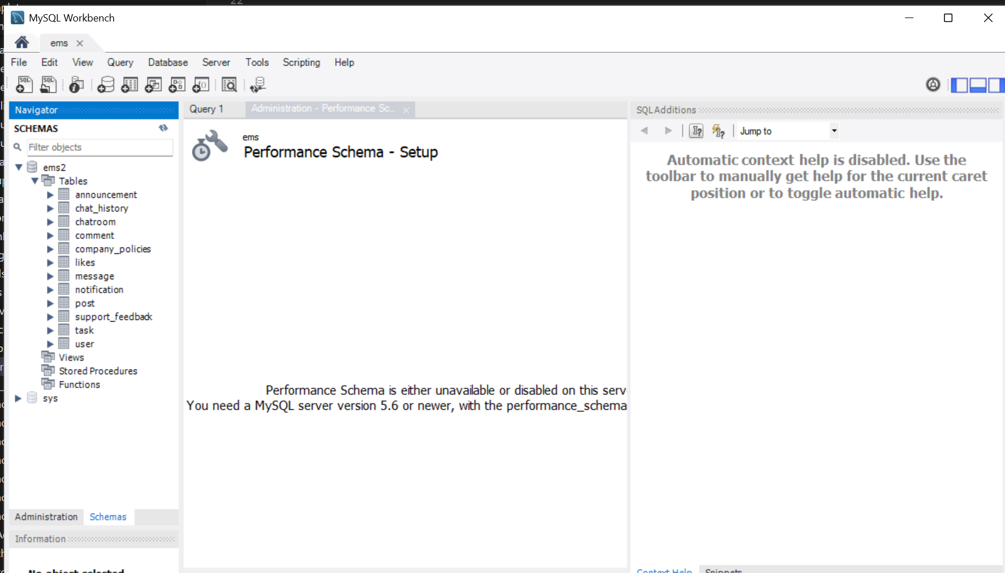

Figure 164 MySQL Aurora connected in workbench for database changes seeing

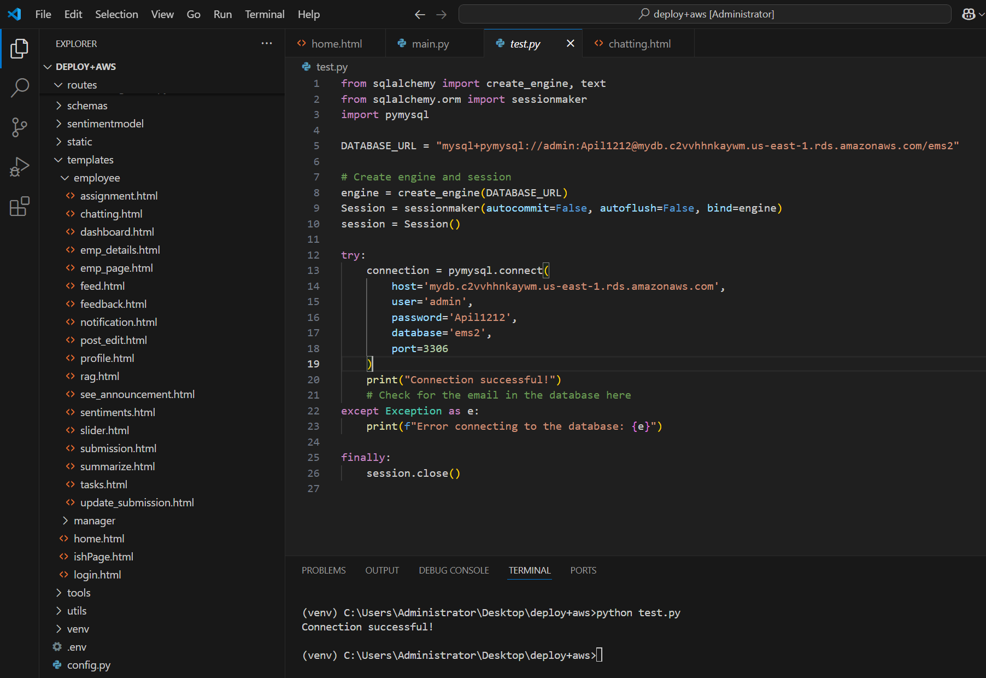

Figure 165 Testing connection for cloud aurora db connection test

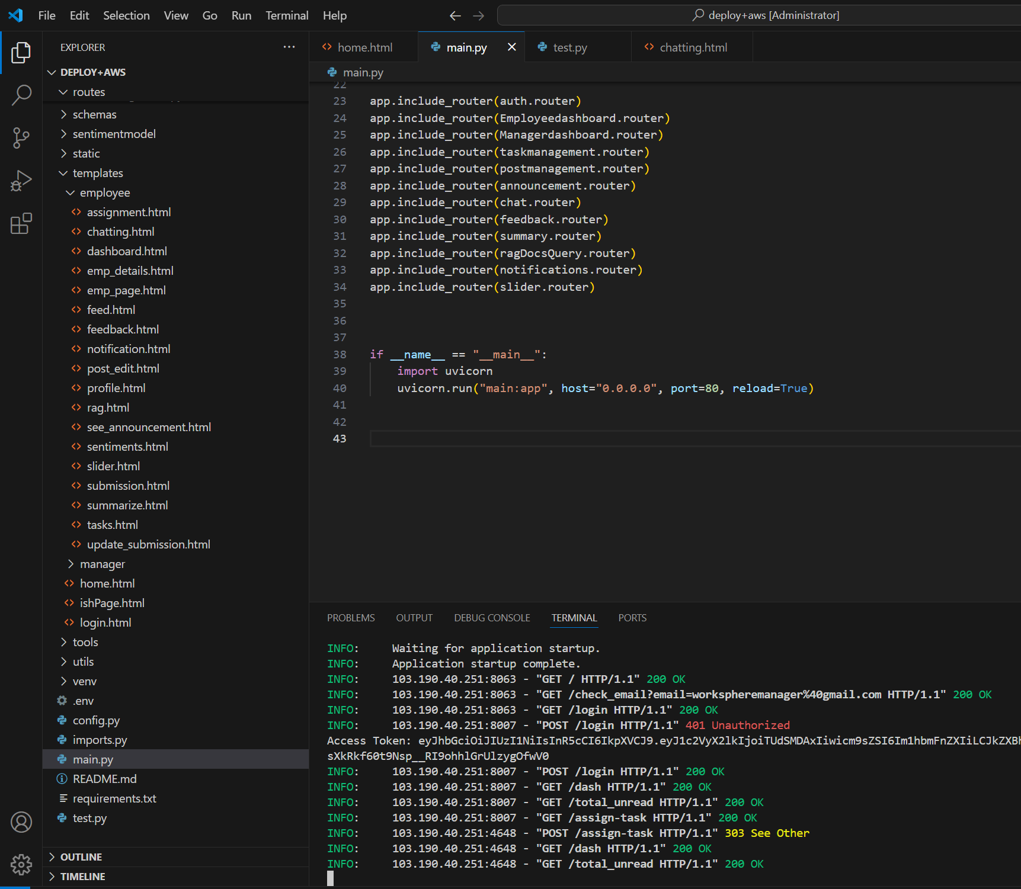

Figure 166 Screenshot of showing cloud database interaction for user

## **4.4 CRITICAL ANALYSIS:**

I have completed all the unit and system testing phases for our web application. The goal here is to critically evaluate the testing process, find proper results, and figure out if this app is ready to get into live in to real world where users will engage into this system. We tested everything from role-based logins to real-time chat, task management, and responsiveness across devices, all running on a Windows EC2 instance in the cloud with data stored in MySQL Aurora. This analysis will break down the testing outcomes, reflect on our Scrum methodology, zoom in on the failures, and sum up where we stand.  
I have carried out both testing such as unit testing and system testing. Unit testing was all about checking the building blocks like making sure the login system correctly assigns roles, JWT tokens get generated, and individual functions do what they’re supposed to whereas System testing took a broader view, testing how all these pieces work together like a manager approving a task, employees chatting in real time, or the app behaving nicely on different devices. I ran these tests manually using Chrome and edge browsers, sometimes hopping into developer tools to peek at network requests or simulate mobile screens.  
The process was automated with scripts sometimes and moreover manually testing. but it gave us a solid feeling about how the system behaves. I tested about 40 key problem scenarios, where most of the scenarios were passed but some of the scenarios failed which needed to improve into further developments.

**Analysis on selected methodology:**

I utilized **Scrum**, whereby I worked in brief cycles of 2-4 weeks in length, which are called sprints. It served the following purposes:  
I can switch tests when new features emerge.  
✔ Catch problems early à We solve problems promptly through daily check-ins.  
✔ Work as a team à Testers, developers, and managers collaborated closely.

**What I have Learned:**

* **Good:** Scrum kept us moving fast and organized.
* **Bad:** I sometimes rushed and didn't test crucial things (such as how the app performs with lots of users).

**Analyzing failed test cases:**

Here are two failure cases for our system.

**Failed Case 1: Multiple Users - Asynchronous Handling Issue**

I tested how the system behaves when several people are using the system simultaneously. It performed great with 1-2 people, but with more than that (3-10), we experienced some issues.  
• UI elements began lagging or overlapping.  
• Chat messages were delayed.

**Reason for failure:**  
The issue appears to be with how the system manages multiple users at once It appears the problem lies in how the system manages numerous users concurrently (asynchronous threading). If there are 3 or 4 users, the system runs smoothly. But too many users and the back-end will have issues. Perhaps the server receives too many requests, or the front-end does not have the capacity for real-time updating. We did not perform the test using many users initially, and thus missed this

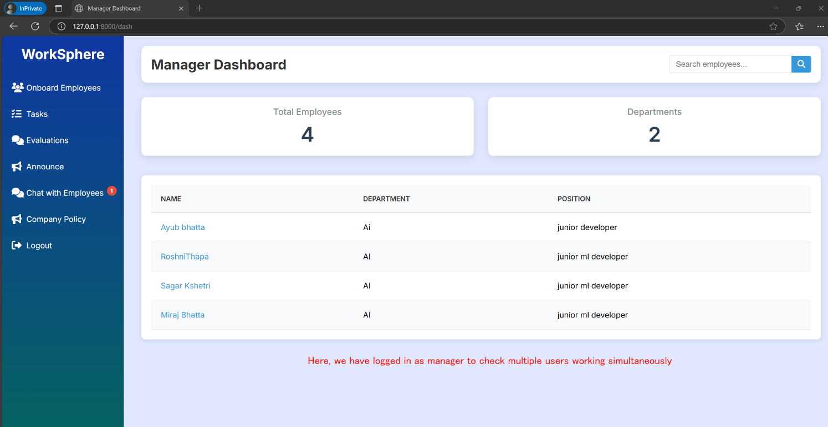**Impact:**  
This is a scalability issue. If too many people attempt to use the system simultaneously, such as 4 or more, it could slow down, experience glitches, or present errors. This will create a poor experience for users.

Figure 167 Screenshot of showing manager logged in

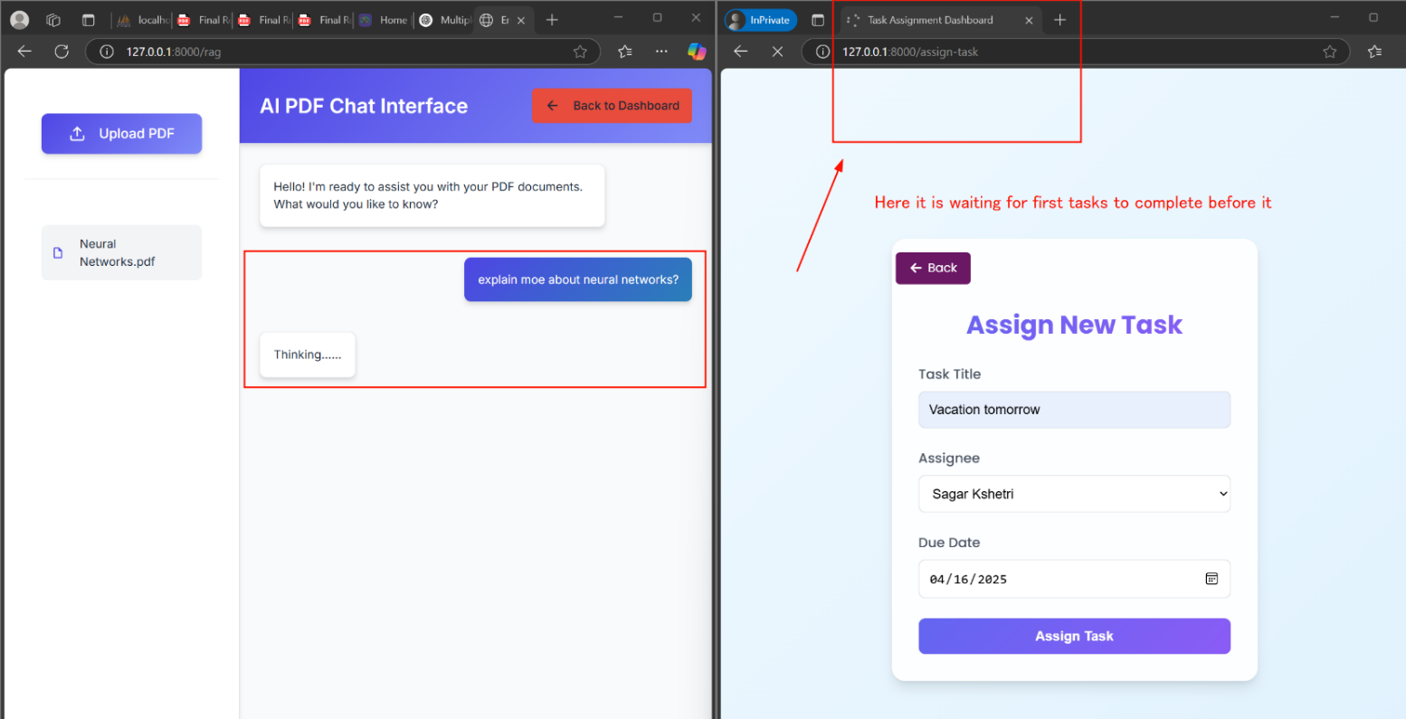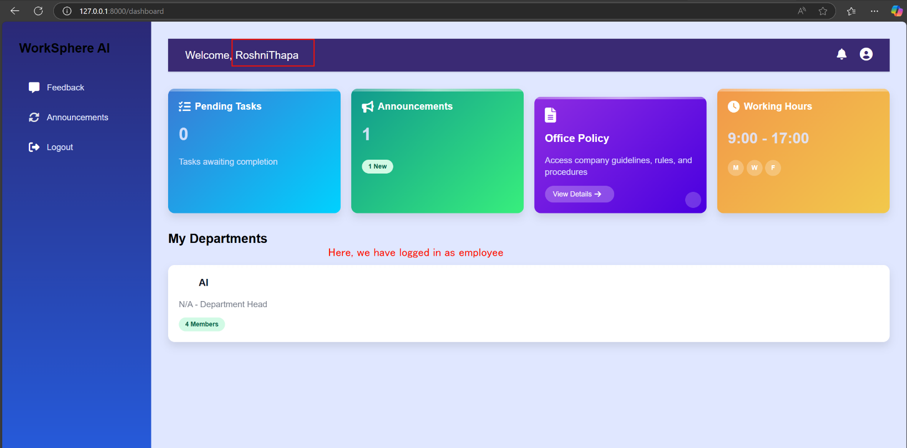

Figure 168 Performing at a time both action which takes little times

Figure 169 Screenshot of showing employee logged in

**Failed Case 2: Deleted User Seen in Assignee List (TC2)**

* When a manager tried assigning a task, the assignee dropped down including a deleted user removed from the system. The test expected only active employees to show up, but this bug let a ghost user linger. If selected, it either failed to save or caused an error downstream.
* This points to a flaw in the database query or caching. MySQL Aurora likely has a record marked "deleted", but the app’s logic didn’t filter it out.
* 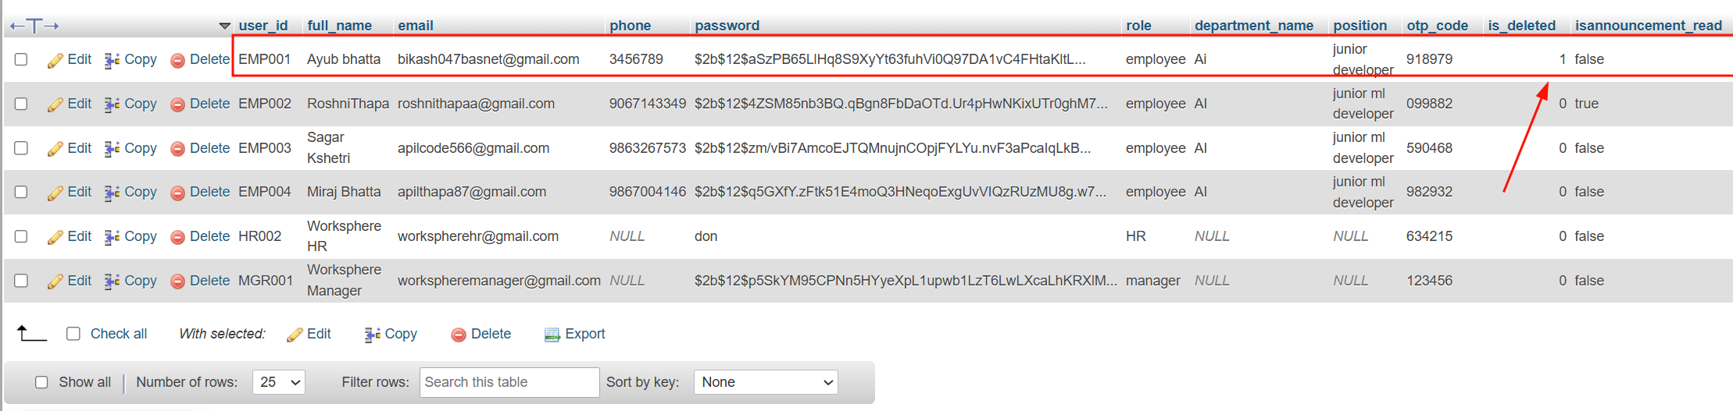**Impact**: It’s a critical bug for task management. Assigning tasks to nonexistent users could confuse workflows or break dependencies.

Figure 170 Deleted employee shown

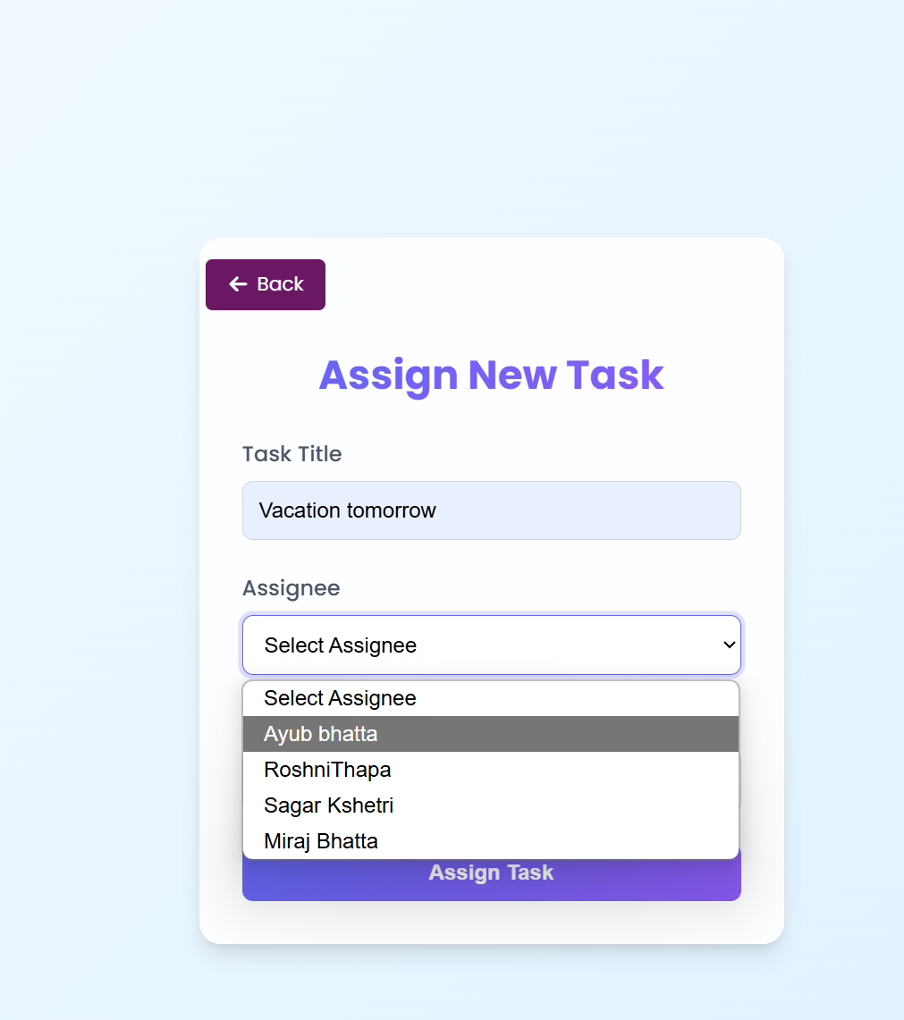

Figure 171 While manager assigning tasks that employee deleted is shown

**Test summary:**  
I tested the application extensively and it functioned well. Main things such as: role-based login, live chat and task management were working smoothly. I timely fixed all other bugs in each development stage. Automated test scripts was one of my biggest successes that was a huge time saver and will help in future tests as well! The app is good in general usage, but there is always room for improvement to plan for more users at a time and some exceptional cases. My recommendations are for Async process for multiple users doing stuff in parallel and the deployment process getting more tests for intensive usage and outlying issues.

**Key Points:**

* 95% of test cases passed
* All important features are working
* Automated testing was added
* All bugs were fixed on time

**Further Improvement:**

* Better support for more than 5 users at once
* More testing for rare/unusual situations
* Improve how the app is packaged for release

**Next Plan:**

* Make a proper release/deployment package
* Add stress and edge case testing
* Use tools to monitor the app in real-time
* Make sure it works well with many users

# **5. CONCLUSION:**

## **5.1 LEGAL, SOCIAL AND ETHICAL ISSUES:**

Employee Management System, utilizing artificial intelligence, focuses on enhancing the way workplaces globally by applying new technologies. It also comprises legal, social, and ethical problems that must be dealt with meticulously to ensure it is applied responsibly in various fields. This is a comprehensive list of the primary problems associated with this project globally.

### **5.1.1 LEGAL ISSUES:**

**Here are some of the legal issues:**

|  |  |  |
| --- | --- | --- |
| **Issue** | **Description** | **Mitigation strategy** |
| **Data Protection and Privacy** | The Work sphere stores sensitive data (such as employee information and feedback) in AWS S3 and MySQL Aurora. It is required to comply with international regulations such as GDPR (EU), CCPA (USA), PDPA (Singapore), and more. In case of breaches or non-compliance, it may be fined or prosecuted. | * Employ RBAC and AES-256 encryption to secure data. * Use HTTPS to send data. * Ensure that we obey the local regulations. * Obtain users' consent through transparent privacy notices. |
| **Email Communication Security** | PINs and the SMTP protocol login credentials should also guarantee safe forwarding to prevent interception under the cybercrime legislation such as the EU Directive on electronic privacy and the USA CAN-SPAM Act. | * Establish safe SMTP using TLS/SSL * Verify email servers to prevent phishing attacks. * Monitor any unauthorized attempts to access email. |
| **Intellectual Property (IP)** | EMS employs other organizations' tools (such as LangChain, Grok Cloud, Bootstrap) and license-based AI models. Violation of IP regulations (such as WIPO treaties) might pose problems. | * Acquire licenses of other companies' tools * Record proprietary code (such as **FastAPI** logic) to demonstrate ownership. * Collaborate with an attorney for global IP regulations. |
| **Employment Law Compliance** | Such task monitoring and reviewing of the feedback must comply with labor regulations such as the ILO conventions, the USA's FLSA, and the EU's Working Time Directive, to prevent discriminatory monitoring or dismissal. | * Establish clear guidelines on using EMS in contracts. * Avoid unwanted monitoring through AI analysis. * Ensure transparency in data use with employees. |

Table 68 Legal issues

### **5.1.2 SOCIAL ISSUES:**

**Here are some of the social issues:**

|  |  |  |
| --- | --- | --- |
| **Issue** | **Description** | **Mitigation strategy** |
| **Digital Divide and Accessibility** | Varying tech literacy levels globally (e.g., urban vs. rural areas, developed vs. developing nations) may hinder EMS adoption. Non-tech-savvy users could struggle with AI querying or WebSocket messaging, risking exclusion. | * Construct a simple and user-friendly interface using Bootstrap or Tailwind CSS. * It offer multilingual training and support. * Ensure compatibility with low-bandwidth environments. |
| **Workplace Trust and Surveillance** | Monitoring work and tracking feelings can feel like micromanaging. It can decrease trust, at least in areas that value privacy (such as the EU) or teamwork (such as in Asia). | * Allow anonymous feedback. * Clarify the advantages (for instance, productivity and teamwork). * Simply observe how they work |
| **Fear of Job Loss** | Employing AI tools (such as summary or slide tools) may cause workers to fear losing their jobs. This is a concern everywhere in the world. | * Display how AI can assist individuals and not substitute them * Provide instructions on using the new equipment. * Engage HR to explain the problems. |
| **Cultural Sensitivity** | Different cultural groups have different ways of communicating. For instance, Americans tend to talk straightforwardly, while Japanese employees prefer being more formal. This can vary the interpretation of tools such as messaging or notifications. | * Add multi-language support and region-specific settings. * Adhere to cultural norms in messages and notifications. * Enhance the features based on suggestions by users in different areas. |

Table 69 Social issues

### **5.1.3 ETHICAL ISSUES:**

**Here are some of the ethical issues:**

|  |  |  |
| --- | --- | --- |
| **Issue** | **Description** | **Mitigation strategy** |
| **Bias in AI Models** | AI models (such as LangChain RAG and LLMs) may produce biased outputs when trained on biased or incomplete data. This can affect specific groups or languages. | * Use diverse training data that includes global perspectives. * Always verify the outcome using tools such as **LangSmith**. * Let users edit or correct AI-generated results. |
| **Transparency in Data Usage** | The users may not know how their data (such as tasks or comments) is being utilized, which poses trust issues, particularly in areas of low technological knowledge. | * Formulate specific rules regarding privacy in simple language and in regional languages. * Always inform users prior to collecting personal data. * Let users opt out of non-essential data tracking. |
| **Over-Reliance on Automation** | Working on many AI tools can decrease creativity and worker decision-making at the workplace. | * Get individuals to view and okay AI-generated content. * Allow users to edit or modify AI outputs. * Instruct users to perform tasks manually as well. |
| **Equal Access for Everyone** | Not everyone possesses the same technology skills or access, and this presents differences in their utilization of EMS. | * Be simple and consequent (like Jinja Templates). * Provide easy, step-by-step directions for various job positions (HR, employee, manager). * Verify how things are utilized to identify and resolve accessibility problems. |

Table 70 Ethical issues

## **5.2 ADVANTAGES:**

The Employee Management System (EMS) is AI-based and contains numerous benefits as it employs new technology to ease work everywhere. Below are some of the primary benefits of the System, as per the project's features and its application globally.

* **Improved productivity**

Utilizes FastAPI to automatically allocate and monitor tasks, reducing manual effort and ensuring timely completion of tasks. Artificial intelligence document summarizing tools (LLM using LangChain, Grok Cloud) and slide creations (LangGraph) save time and enable faster decision-making.

* **Intelligent Data Processing:**

LangChain's RAG Framework supports exact document querying, quickly retrieving pertinent content to support sound decision-making.  
It provides real-world insights using Feedback Sentiment Analysis, allowing managers to better resolve employee concerns.

* **Scalability and reliability:**  
  Hosted on AWS EC2 with Elastic IP and MySQL Aurora, ensuring the system scales with organizational growth and maintains high availability.  
  AWS S3 offers more secure, reliable storage for documents and files which supports global access with higher performance.
* **Higher security:**  
  It protects sensitive data with RBAC, AES-256 encryption, and HTTPS, ensuring compliance with global privacy laws .  
  It secures onboarding with PIN-Based Activation and reliable email delivery via SMTP Protocols, minimizing unauthorized access risks.
* **User-Friendly Experience:** Delivers an intuitive, responsive interface with HTML, CSS, Bootstrap, and Tailwind CSS, accessible to users of varying tech proficiency worldwide. It simplifies workflows for HR, managers, and employees, driving higher adoption across multicultural workforces.
* **Cost Efficiency:**  
  It saves administrative overheads by eliminating the need to carry out similar processes repeatedly, thus reducing operational expenses.  
  Cloud-based infrastructure (AWS) minimizes the need for on-premises hardware, offering flexible, cost-effective scaling.
* **Global Adaptability:**  
  It has multilingual and culturally appropriate features, making it suitable for diverse regions and workplace cultures.  
  It supports remote and hybrid work by including real-time collaboration capabilities that mirror the global workforce trends.
* **Future proof Decisions:**  
  AI analytics, including document querying and sentiment analysis, provides managers with useful insights that both increase team motivation and the team's performance.  
  Centralized data management (MySQL Aurora) ensures accurate, accessible records for strategic planning.
* **Timeless design:**  
  Built with scalable technologies (Kubernetes-ready AWS, LangChain) to adapt to evolving business needs and technological advancements.

Regular updates and AI model improvements ensure long-term relevance and functionality.  
These benefits bring the EMS to a revolutionary status, raising efficiency, security, and teamwork to new heights while fulfilling the needs of modern workplaces globally.

## **5.3 LIMITATIONS:**

This AI-based system provides significant benefits but also has its weaknesses, which might affect its usage as well as its general functioning. These weaknesses, caused by several different technological, operational, and situational factors, are discussed below to provide a comprehensive picture of the system's potential and weaknesses: (“(PDF) Challenges of Implementing an Employee Management System for Improving Workplace Management Effectiveness”)

|  |  |  |
| --- | --- | --- |
| **Limitation** | **Description** | **Potential Impact** |
| **Dependence on Internet Connectivity** | The EMS relies on cloud infrastructure (AWS EC2, S3, MySQL Aurora) and real-time features (**WebSockets**), requiring stable, high-speed internet. In regions with poor connectivity, such as rural areas or developing countries, performance may degrade. (“What Is Amazon Aurora? - Amazon Aurora”) | End-users may experience latency when accessing functionality like task status and messaging, which could decrease both efficiency and usage. |
| **High Initial Setup Costs** | Implementing the EMS involves costs for AWS services, licensing third-party tools (LangChain, Grok Cloud), and training users on AI features. Small organizations with limited budgets may find these costs prohibitive. | May limit adoption among SMEs or resource-constrained organizations, particularly in developing economies. |
| **AI Model Limitations** | AI components (LLM, LangChain, LangGraph) may produce inaccurate summaries or queries if trained on biased or incomplete datasets. Complex or poorly formatted documents may reduce output quality. (“Quick Start”) | Artificial intelligence errors can lead to poorly informed decisions or a breakdown in trust in the system. |
| **Learning Curve for Users** | A few options such as A pdf Querying, creating slides, and using dashboards (Jinja Templates, Tailwind CSS) could be challenging for technologically poor users, particularly in other workspaces globally. | Additional training is required, and it will cause people to use it less. |
| **Scalability Constraints** | While AWS EC2 and MySQL Aurora support scalability, extremely high user loads (e.g., thousands of concurrent users) may require additional optimization or infrastructure upgrades, increasing costs. | Slow responses during peak periods annoy customers in large corporations. |
| **Data Privacy and Compliance Risks** | Following the data protection regulations of numerous locations (such as GDPR and CCPA) will be difficult when operating in numerous locations. Legal issues or data leaks can occur due to SMTP errors or RBAC. | If data security fails, it could result in legal issues or cause users to become suspicious. |
| **Maintenance and Updates** | **FastAPI**, **LangChain**, and **AWS** services require continuous maintenance to fix bugs, address security issues, and upgrade AI models. Such maintenance requires a continuous input of both time and expertise. | During the upgrade, incompatibility and downtime can cause work to not flow smoothly. |

Table 71 Limitations of the system

## **5.4 FUTURE WORK:**

The Employee Management System (EMS) built using AI can be improved, more effective, and more user-friendly. Some of the simple future plans include improved setup using AWS, time-based work functionality, and facial recognition in attendance.

* **Improved AWS configuration**  
  Migrate from EC2 to AWS Elastic Beanstalk or Fargate for easier scaling and management.  
  Utilizing AWS services like Lambda for no-server tasks, such as sending email or querying AI.  
  Utilizing CloudFormation for stable and repeatable deployments.
* **Fully Asynchronous System:**  
  Enabling async processing with FastAPI and asyncio for operations with high concurrency (e.g., WebSockets).  
  Use ThreadPoolExecutor to speed up AI jobs like LangChain RAG. Uvicorn: Enhance Uvicorn for asynchronous workers to increase real-time feature responsiveness. (“Welcome to Uptime | Better Stack Documentation”)
* **Facial recognition attendance**  
  Using the YOLO model or Amazon Rekognition, attendance can be safely recorded.  
  To provide privacy, MySQL Aurora data is also secured using the encryption feature.  
  Displaying the records on the dashboard by utilizing Jinja Templates and Tailwind CSS.
* **Multilingual support**

It supports more languages, using different frameworks to make it accessible worldwide.  
Adapt LangChain AI to process multilingual documents.  
Adapt your messages to suit local traditions.

* **Offline Features:**  
  Implement a PWA using Service Workers to enable offline access to tasks and feedback.  
  Sync data to Aurora and S3 when online.
* **Improved AI capabilities**  
  Enhance LangChain RAG by incorporating contextual memory so it responds quickly to hard questions.  
  Using LangGraph to create personal slide presentations  
  Enhancing the LLM using Grok Cloud to produce transparent and equitable summaries.
* **Analytics Dashboard:**  
  Use Chart.js to create charts illustrating the number of tasks and the feedback.  
  Utilizing with AWS QuickSight to present various engagement trends.  
  Interactive Bootstrap dashboards are user-friendly.
* **Creating Mobile Apps:**  
  Developing iOS and Android apps using Flutter that will work anywhere. Utilizing AWS SNS to deliver appropriate task notifications Ensure good alignment with mobile UI using Tailwind CSS for web design.
* **Third-party integrations:**  
  Seamlessly integrate with HR software like BambooHR using REST APIs.  
  Enable synchronization with Google Calendar.  
  Use OAuth 2.0 for secure Single Sign-On.
* **Cost and Sustainability:**Minimize costs using AWS Auto Scaling in conjunction with Cost Explorer.  
  Use **SageMaker** for cost-effective AI training.  
  Adopt efficient coding for sustainability.

These improvements will make the EMS more innovative, user-friendly, and scalable, efficiently meeting the diverse requirements of workplaces worldwide.

# **6. REFERENCES:**

* “A Formal Semantics of UML Sequence Diagram | IEEE Conference Publication | IEEE Xplore.” *Ieeexplore.ieee.org*, ieeexplore.ieee.org/abstract/document/1290469.
* Fauzan, Reza, et al. “Use Case Diagram Similarity Measurement: A New Approach.” *IEEE Xplore*, 1 July 2019, ieeexplore.ieee.org/document/8850978.
* Globerson, Shlomo. “Impact of Various Work-Breakdown Structures on Project Conceptualization.” *International Journal of Project Management*, vol. 12, no. 3, Aug. 1994, pp. 165–171, <https://doi.org/10.1016/0263-7863(94)90032-9>.
* Handoyo, Eko, et al. “SRS Document Proposal Analysis on the Design of Management Information Systems according to IEEE STD 830-1998.” *Procedia - Social and Behavioral Sciences*, vol. 67, Dec. 2012, pp. 123–134, <https://doi.org/10.1016/j.sbspro.2012.11.313>.
* Ilag, Balu N, and Arun M Sabale. “Microsoft Teams Overview.” *Troubleshooting Microsoft Teams*, 2022, pp. 17–74, link.springer.com/chapter/10.1007/978-1-4842-8622-7_2, <https://doi.org/10.1007/978-1-4842-8622-7_2>.
* Li, Qing, and Yu-Liu Chen. “Data Flow Diagram.” *Modeling and Analysis of Enterprise and Information Systems*, 2009, pp. 85–97, <https://doi.org/10.1007/978-3-540-89556-5_4>.
* Poi Wong, Ng, et al. “Operational Improvements in It-Based E-Commerce Companies Using Monday.com.” *Jurnal Teknologi Dan Sistem Informasi Bisnis*, vol. 4, no. 1, 15 Jan. 2022, pp. 102–106, <https://doi.org/10.47233/jteksis.v4i1.355>.
* Srivastava, Apoorva, et al. “SCRUM Model for Agile Methodology.” *2017 International Conference on Computing, Communication and Automation (ICCCA)*, vol. 1, no. 1, May 2017, <https://doi.org/10.1109/ccaa.2017.8229928>.
* betterstackhq. (2016). *Welcome to Uptime | Better Stack Documentation*. [online] Available at: <https://betterstack.com/docs/uptime/start/> [Accessed 21 Apr. 2025].
* docs.aws.amazon.com. (n.d.). *What Is Amazon Aurora? - Amazon Aurora*. [online] Available at: <https://docs.aws.amazon.com/AmazonRDS/latest/AuroraUserGuide/CHAP_AuroraOverview.html>.
* Github.io. (2024). *Quick Start*. [online] Available at: <https://langchain-ai.github.io/langgraph/tutorials/introduction/>.

# **7. BIBLIOGRAPHY:**

* ResearchGate. (n.d.). *(PDF) Challenges of Implementing an Employee Management System for Improving Workplace Management Effectiveness*. [online] Available at: <https://www.researchgate.net/publication/338216184_Challenges_of_Implementing_an_Employee_Management_System_for_Improving_Workplace_Management_Effectiveness>.
* Geraldi, Joana, and Thomas Lechter. “Gantt Charts Revisited: A Critical Analysis of Its Roots and Implications to the Management of Projects Today.” *International Journal of Managing Projects in Business*, vol. 5, no. 4, 2012, pp. 578–594. *Researchgate*, <https://doi.org/10.1108/17538371211268889>.
* Carvalho, B.V. de and Mello, C.H.P. (2011). Scrum agile product development method - literature review, analysis and classification. *Product Management & Development*, [online] 9(1), pp.39–49. doi:<https://doi.org/10.4322/pmd.2011.005>.
* Batra, H., Punn, N.S., Sonbhadra, S.K. and Agarwal, S. (2021). BERT-Based Sentiment Analysis: A Software Engineering Perspective. *Lecture Notes in Computer Science*, pp.138–148. doi:<https://doi.org/10.1007/978-3-030-86472-9_13>.
* Manju Appukuttan (2016). Automatic Slide Generation of Academic Paper. *Engineering, Technology and Applied Science Research*, [online] 4(5). Available at: <https://www.researchgate.net/publication/320978617_Automatic_Slide_Generation_of_Academic_Paper>.

# **8: APPENDIX**

## **8.1 APPENDIX A: PRE-SURVEY**

### **8.1.1 PRE-SURVEY FORM**

The pre survey of the AI-based Employee Management System (EMS) was conducted to obtain feedback on the ease of use and the functionality based on the experiences of the users.

Following are the highlights of the survey, indicating what the users felt and what they appreciated.

The survey was conducted online through Google Forms. This provided the participants with limited time to test the app.

* We received a total of 35 responses, so we had plenty of user input.
* Many of the respondents believed the system to be highly beneficial in facilitating workplaces, particularly in the task and paperwork needs of firms.
* Over 70% of users liked document summarization and meeting slide generation capabilities. They reported that the capabilities are time-saving and simple to use.
* Users responded positively to the overall experience, and they enjoyed the user-friendly interface.

### **8.1.2 SAMPLE OF FILLED PRE-SURVEY FORMS**

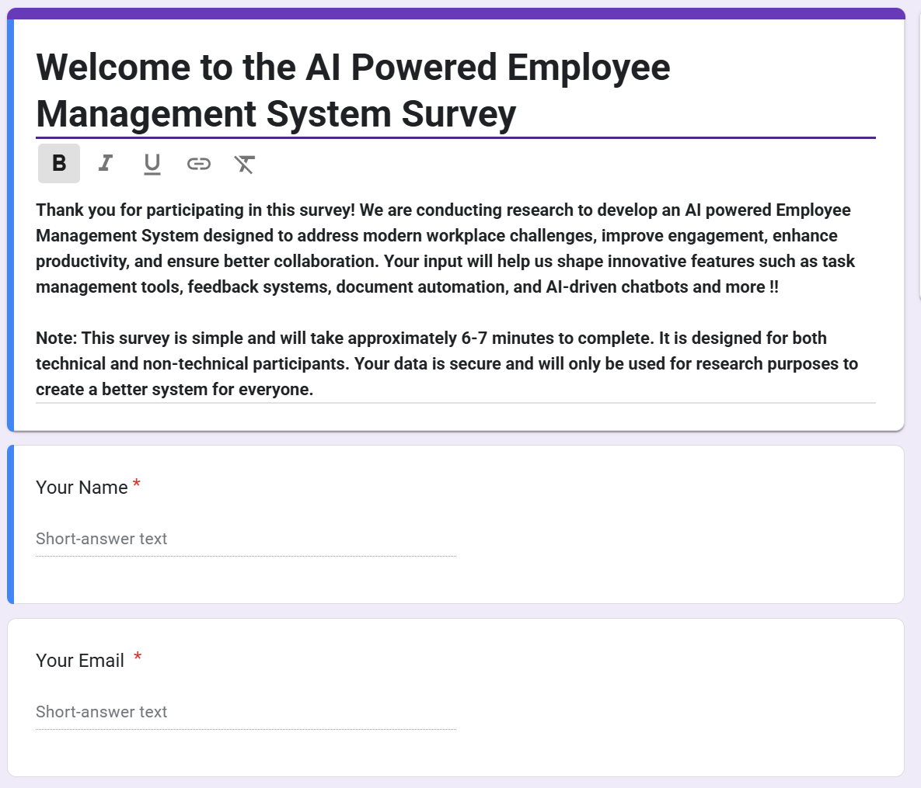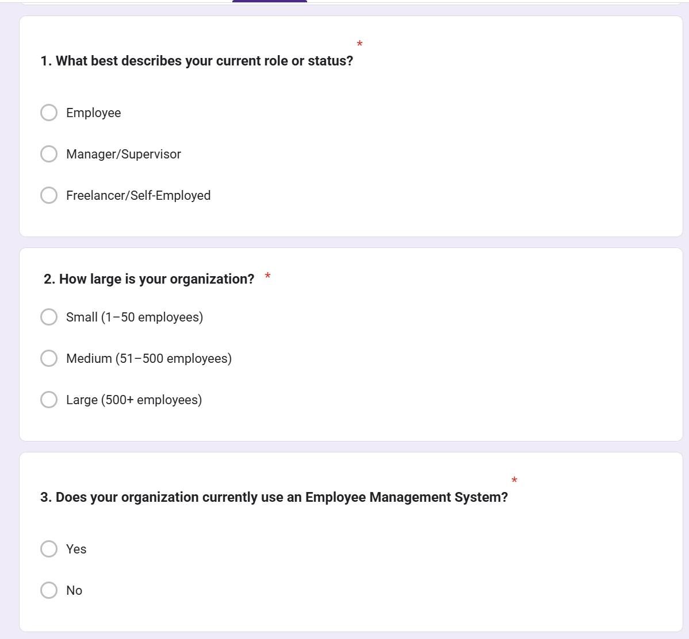

Figure 172 Screenshot of survey part 2

Figure 173 Screenshot of survey part 1

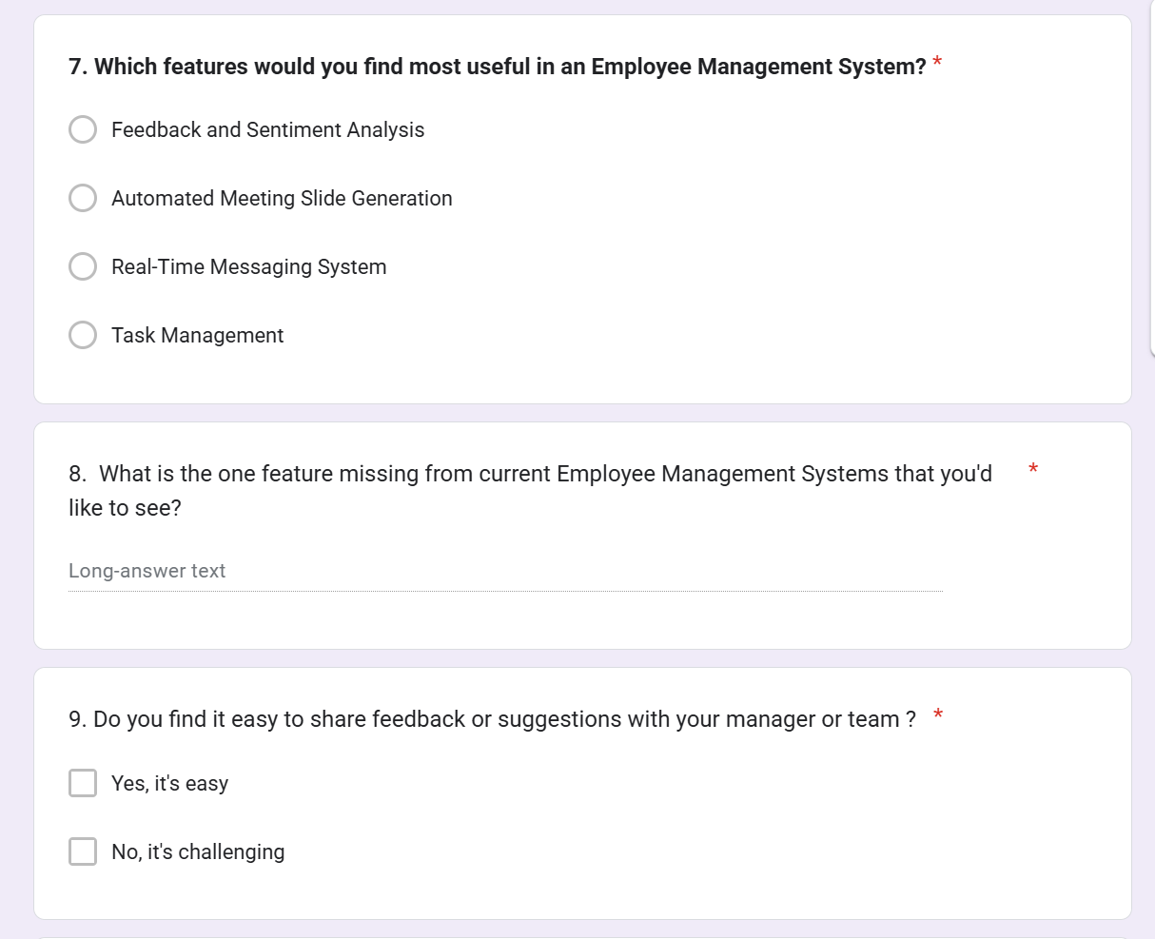

Figure 174 Screenshot of survey part 3

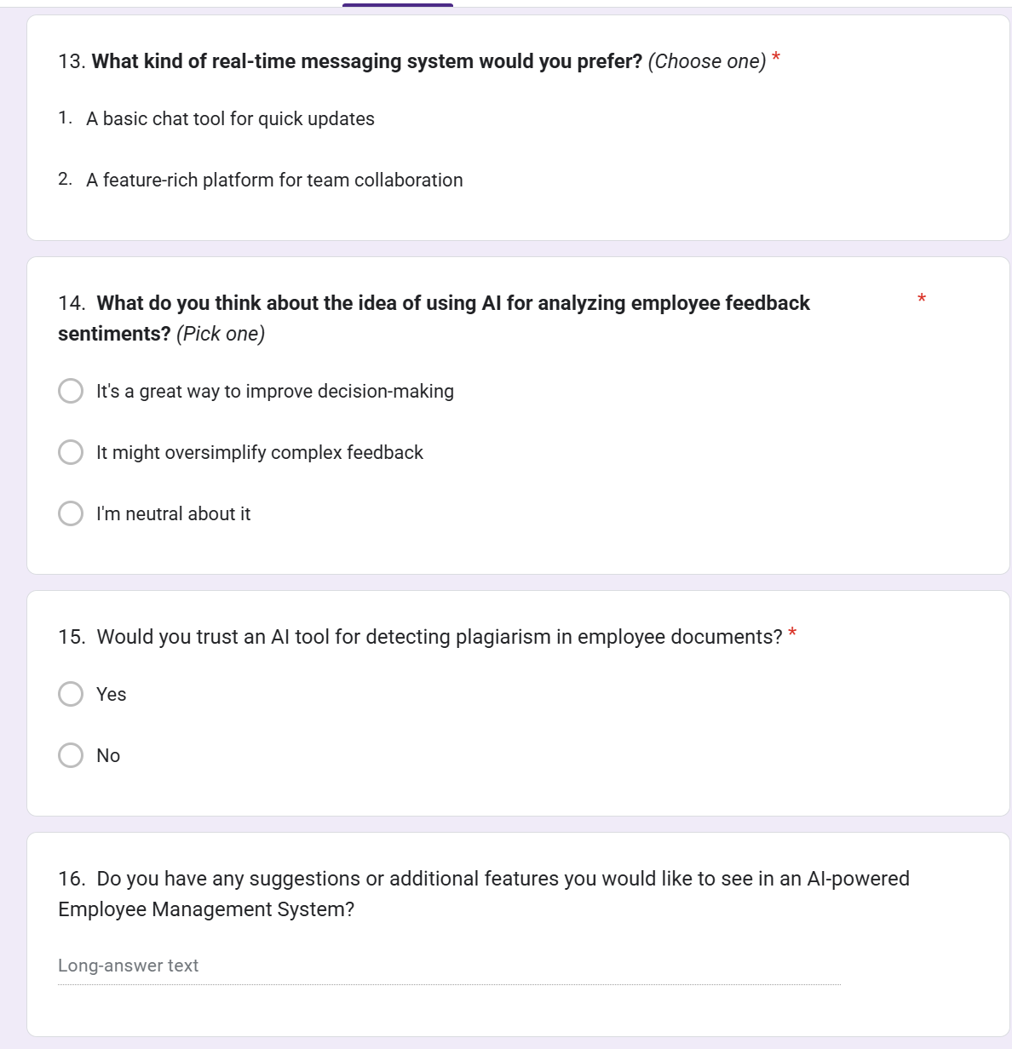

Figure 175 Screenshot of survey part 4

### **8.1.3 PRE-SURVEY RESULT**

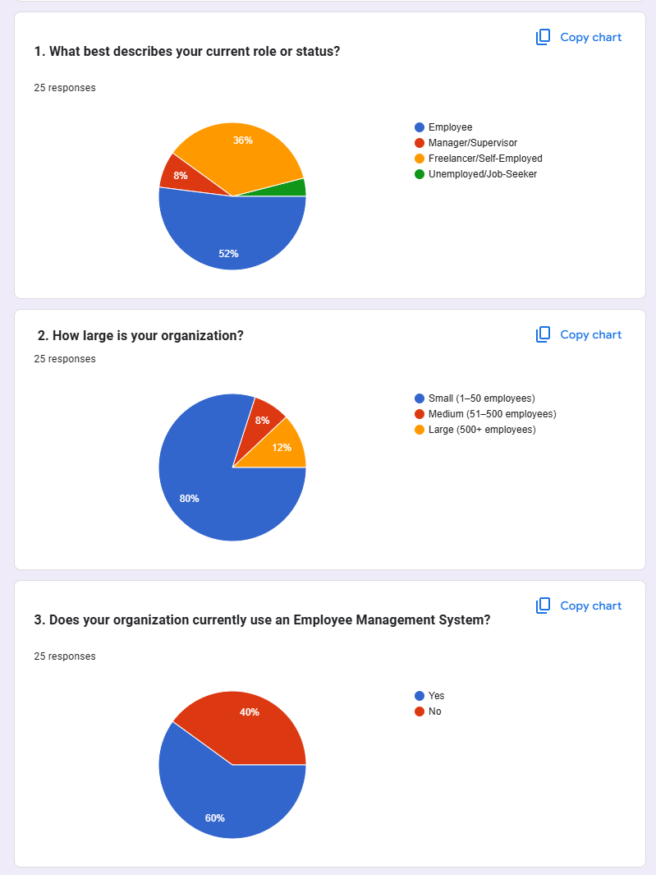

Figure 176 Survey result part 1

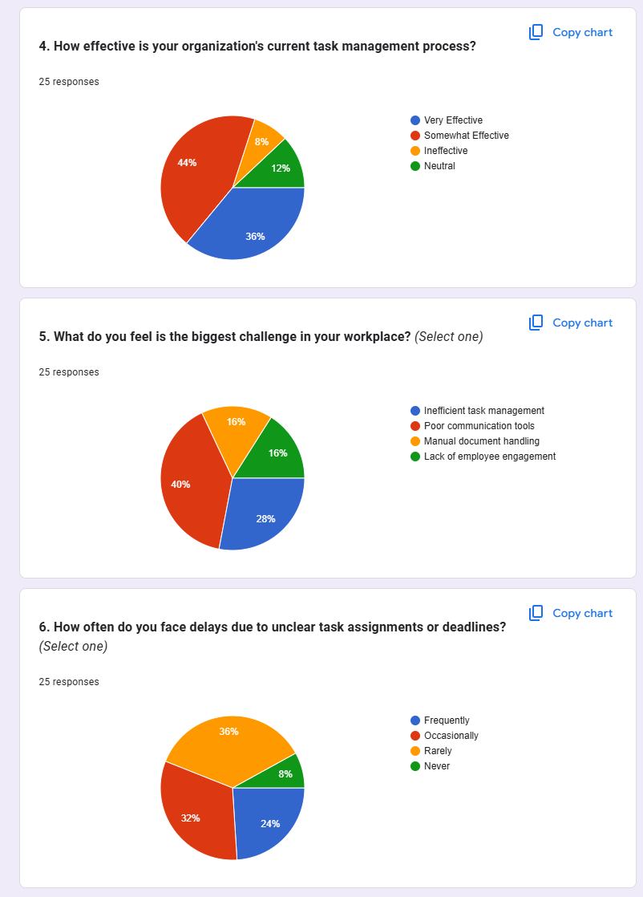

Figure 177 Survey result part 2

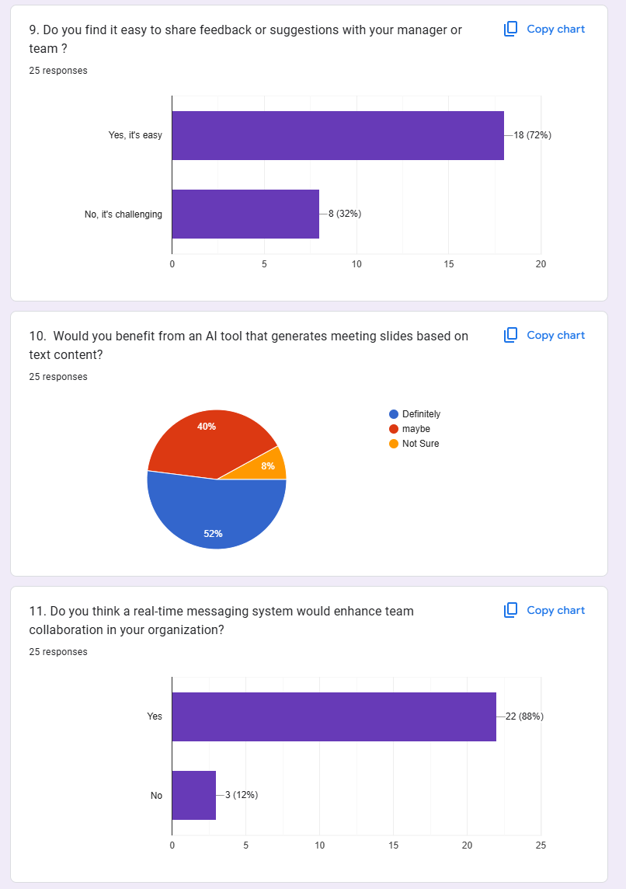

Figure 178 Survey result part 3

**Go Back**

## **8.2 APPENDIX B: LITERATURE REVIEW**

### **8.2.1 MEETING SLIDE GENERATION:**

There is an advanced meeting slide generation feature in my system which uses models like LLMs such as **GPT** and **Llama**. The system receives the text and passes them through these models to generate concise slides that are ready to be presented. This unique integration caters specially for the domain specific content generation, drastically minimizing the manual effort without compromising on the engagement and the structure of slides for employee’s presentation. This helps the users a lot by increasing productivity and reducing time to market in slide preparation. (Manju Appukuttan, 2016)

For this feature I go through the above research papers an article:

|  |  |
| --- | --- |
| **Research Topic** | **Link** |
| |  | | --- | |  |   *Automated Presentation Slide Generation from Research Papers using NLP and Deep Learning* | *[Read Journal](https://www.techrxiv.org/doi/full/10.36227/techrxiv.171561007.70987286/v1)* |
| *Automatic Presentation Slides Generation from Scientific Documents* | *[Access here:](https://ojs.aaai.org/index.php/AAAI/article/view/19943)* |
| [*Automatic Presentation Slide Generation Using LLMs*](https://scholarworks.sjsu.edu/cgi/viewcontent.cgi?article=8991&context=etd_theses) | [*Access here:*](https://scholarworks.sjsu.edu/etd_theses/5444/) |
| *Automatic slide generation from scientific papers based on multimodal learning* | [*Read Article:*](https://webthesis.biblio.polito.it/24617/) |

Table 72 Meeting slide research table

**Similarities:**

* The general idea of all the approaches (including mine) is to first extract some key points or summaries from the scientific papers to generate research presentation slides.
* All three of the methods, including mine, are designed to automate slide creation to some extent, limiting the need for manual operation and increasing efficiency.
* This technique is optimized for converting research papers or scholarly papers into slides with technical content.

**Differences:**

* Used better model BART, T5 Where other method used more traditional technique or task specific model which is less fine-tuned.
* Some techniques use a heuristic or rule-based approach however, my system relies on fine tuning of state-of-the-art transformer models which give higher flexibility and performance.
* My system, however, tries to be a complete approach, rather than multi-create approaches.

**Back:**

### **8.2.2 FEEDBACK SENTIMENT ANALYSIS:**

For my employee management system based on AI, I have created a sentiment analysis feature, for which I thoroughly researched to choose the most powerful models and techniques. I researched existing models like the **BERT** and **RoBERTa** which have shown their performance in the NLP related tasks. I have also tested different neural network architectures, such as **GRU, LSTM, BiLSTM, TextCNN** and RNN, to determine their suitability for processing sequential data and producing accurate results with additional benchmarks. (Batra et al., 2021)

Therefore, I will be working with **BERT** or **BiLSTM** for feedback sentiment analysis, Encoder only models such as **BERT** and **DistilBERT** are best suited for extracting contextual embeddings in addition to improving the accuracy of sentiment predictions.

For this feature I go through the above research papers an article:

|  |  |
| --- | --- |
| **Research Topic** | **Link** |
| |  | | --- | |  |   *Text based Sentiment Analysis using LSTM* | *[Read Journal](https://pdfs.semanticscholar.org/0027/d572e43d0c120d59e81c228f2a17b3b05006.pdf)* |
| *Text based Sentiment Analysis using GRU* | *[Access here:](https://www.researchgate.net/publication/364683014_Sentiment_Analysis_using_Modified_GRU)* |
| *Sentiment Analysis on social media using BERT & ROBERTA* | [*Access here:*](https://ieeexplore.ieee.org/abstract/document/10126206) |
| *Sentiment Analysis using Bert* | [*Read Article:*](https://aclanthology.org/W19-6120/) |

Table 73 Sentiment analysis research

**Similarities:**

* **Handling of Sequential Data:** All methods are capable of processing text data in an effective manner and sentiment analysis are done based on the sequential context.
* **Feature Extraction:** Models like **LSTM, GRU, BERT** and **RoBERTa** which can extract useful features from input text, helping sentiment prediction.
* **Data Driven Methods:** Both methods utilize deep learning architectures to capture squeeze patterns and dependencies in the data. At the end of all methods, this is where we want to be able to classify sentiments as either positive, negative, or neutral.
* **Ingesting Procedures:** All the methods require some preprocessing methods such as: tokenization, stop word removal, and handling balance dataset to have efficient results.

**Differences:**

**Model Architecture:**

* LSTM/GRU: Sequentially manage long-term dependencies with recurrent architecture.
* BERT/ Distil BERT: Use transformer architectures with attention to help them understand context.

**Training Time:**

* LSTM/GRU: Faster training on average due to simpler architectures.
* BERT/Distil BERT: Resource-heavy with multi-dimensional attention layers.

**Pre-training:**

* LSTM/GRU: Needs custom training or random initialization.
* BERT/Distil BERT: These are pre-trained on huge corpora great for transfer learning tasks.

**Contextual Understanding:**

* LSTM/GRU: Sequential processing with limited bidirectional context.
* BERT/Distil BERT: BERT is fully bidirectional and hence has access to both past and future context.

**Application Scope:**

* **LSTM/GRU**: Often used in smaller-scale or domain-specific sentiment analysis tasks.
* **BERT / Distil BERT**: Preferred for general-purpose, large-scale, and highly accurate sentiment analysis due to its adaptability and pre-trained capabilities.

### **8.2.3 DOCUMENTS SUMMARIZATION & QUERYING:**

In my system, I use **LangChain** for using fine-tuned large language models like GPT, Mistral, and **LLaMA**. With retrieval-augmented generation RAG approach, these pretrained models can successfully query the required documents. My task is, then, document summarization, where I generate brief and fluid insights from large amounts of data, utilizing these fine-tuned models. This approach focuses on enhancing efficiency and delivering precise results without the need for training from scratch.

For this feature I go through the above research papers an article:

|  |  |
| --- | --- |
| **Research Topic** | **Link** |
| *Text summarization using unsupervised deep learning* | *[Read Journal](https://www.sciencedirect.com/science/article/abs/pii/S0957417416305486)* |
| *Text summarization using LLM Langchain* | *[Access here:](https://papers.ssrn.com/sol3/papers.cfm?abstract_id=4888165)* |
| *Text Summarization with Pretrained Encoders* | *[Access here:](https://arxiv.org/abs/1908.08345)* |
| *Text Summarization Approaches Using Machine Learning & LSTM* | [*Read Article:*](https://revistageintec.net/old/wp-content/uploads/2022/03/2526.pdf) |
| *Text Summarization with Neural Networks* | [*Read Article:*](https://digital.library.txst.edu/server/api/core/bitstreams/960b9ba1-5a77-45d4-9110-d14ee46b0a1a/content) |

Table 74 Document summarization research topic

**Similarities:**

* All methods, like LLM with Lang Chain and deep learning for a simple text summarization, have the same purpose of text summarization.
* **Summary:** Both Lang Chain and the others rely on NLP techniques for extracting interesting information and putting in a human-readable format.
* **Processing Large Text:** In the same way that LLMs rely on neural networks and pre-trained encoders to process large text datasets and determine relevant content for summarization.
* **Automation:** All techniques facilitate automation of the summarization process thereby reducing manual work and increasing efficiency.
* **Applications:** They can be applied in many fields, such as for research papers, news articles, technical documentation, etc.

**Differences:**

* **Model Type**: The type of models that LangChain uses, which are fine-tuned LLMs Like GPT, Mistral, LLaMA as well as unsupervised methods relying on clustering or a similarity-based methods and neural network methods using models like LSTMs, CNNs.
* **Flexibility:** It provides huge flexibility with RAG to query your documents from LangChain with LLMs which is not the case in its other approaches like unsupervised learning or LSTM-based summaries.
* **Data Dependency:** Unsupervised learning techniques are independent of supervised data, unlike LLMs and neural networks that depend on the availability of labeled or fine-tuned datasets for performance.
* **Complexity:** Implementation using LLMs in Lang Chain is made sufficiently easy for developers by pre-trained pipelines, whereas machine learning-based approaches such as LSTM or encoders require users to develop custom architecture and perform hyperparameter tuning.

**Go Back:**

## **8.3 APPENDIX C: HIGH LEVEL USE CASE DIAGRAM:**

A **use case diagram** at a high level that show the interaction of user (actor) to that system. Here is what it might look like:

**Components:**

* Participants: Shown as stick men. These are the users or systems who are interacting with the system.
* Use Cases: Displayed inside ovals. They are actions or functions which the system offers.
* System Boundaries: Shown as a rectangle. It summarizes all use cases in the system

1. **Login:**

|  |  |
| --- | --- |
| Use Cases | Login |
| **Actors** | Employee, Manager |
| **Description** | The end-user logs on securely with previously registered credentials. Employees can login to access personal user dashboard while managers log into access functionality for team and project management. |

Table 75 High level login

**2. Generate Notes or Summary:**

|  |  |
| --- | --- |
| Use Cases | Generate Notes or Summary |
| **Actors** | Employee |
| **Description** | Employees can upload files like meeting minutes or project files, and the system will, in turn, providing summaries or notes by AI to help with productivity and keeping schedules in order. |

Table 76 High level Genrate summary

**3. Create Tasks:**

|  |  |
| --- | --- |
| Use Cases | Create Tasks |
| **Actors** | Manager |
| **Description** | The manager will assign tasks to employees from respective departments, be able to view progress and monitor the timely completion of deliverable and optional manager can also view tasks reports. |

Table 77 High level creates tasks

**4. Create Posts:**

|  |  |
| --- | --- |
| Use Cases | **Create Posts** |
| **Actors** | Employee |
| **Description** | Employees will be able to create **posts** that will be visible to department members, who can like and comment on them, in the system. Only the **author** of a post can **edit** or **delete** it. |

Table 78 High level Create posts

**5. Chat Assistant:**

|  |  |
| --- | --- |
| Use Cases | **Chat Assistant** |
| **Actors** | Employee |
| **Description** | The AI-powered chat assistant provides real-time chat communications between each employee. |

Table 79 High level chat assistant

**6. View Tasks:**

|  |  |
| --- | --- |
| Use Cases | **View Tasks** |
| **Actors** | Employee |
| **Description** | Employees can see all tasks assigned to them by the manager. They can submit tasks which are approved by an employee. |

Table 80 High level View Tasks

**7. Document Query:**

|  |  |
| --- | --- |
| Use Cases | **Document Query** |
| **Actors** | Employee |
| **Description** | Documents can be uploaded by employees and queried over where the documents should be uploaded. |

Table 81 High level document query

**8. Meeting Slide Generation**

|  |  |
| --- | --- |
| Use Cases | **Meeting Slide Generation** |
| **Actors** | Employee |
| **Description** | Employees upload raw content for presentations, and the system uses AI to generate professional meeting slides, reducing preparation time and effort. |

Table 82 High level Meeting slide

**9. Submit Support feedback**

|  |  |
| --- | --- |
| Use Cases | **Submit Support feedback** |
| **Actors** | Employee |
| **Description** | Employees submits feedback which is then passed to sentiment model and with score of that feedback with class it is saved into databases. |

Table 83 High level feedback

**10. Announcement:**

|  |  |
| --- | --- |
| Use Cases | **Announcement** |
| **Actors** | Employee, managers |
| **Description** | In this system, **managers** can **create announcements**, set a **priority** and **date**, and employees can **view** the announcements based on their **priority** and **date**, with the latest announcements being shown first. |

Table 84 High level announcement

**11. Registered hired employees:**

|  |  |
| --- | --- |
| Use Cases | **Registered hired employees** |
| **Actors** | Manager |
| **Description** | Manager get recruited employees and then sent all details with login id pass pin to those employees through form where employees get through that email. |

Table 85 High level registered hired employee

**12. Send Hired candidate to manager:**

|  |  |
| --- | --- |
| Use Cases | **Send Hired candidate to manage** |
| **Actors** | HR |
| **Description** | HR recruit employees and then all recruited employees sent to manager for onboarding process. |

Table 86 High level sends hired candidate to manager

**Go Back:**

## **8.4 APPENDIX D: EXTENDED USE CASE DIAGRAM:**

**1. Login:**

|  |  |
| --- | --- |
| Use Cases | **Login** |
| **Actors** | Employee, managers |
| **Description** | Employees and Managers sign in with their already saved credentials. They are provided access to their own dashboard and Managers get access to manage their team. |
| **Typical Course of Events** | |
| **Actor Action** | **System Response** |
| 1. The user inputs their email, and password. | 2. The credentials get validated by the system. |
| 3. The user clicks the login button. | 4. The user login system authenticates the user and grants access based on his role (Employee or Manager). |
| 5. After logging in, the users are redirected to their respective dashboard. | 6. The system provides access to the appropriate functionalities. |

Table 87 Extended Login use case

**Alternative Courses:**

|  |  |
| --- | --- |
| **Condition** | **Response** |
| **Line 1:** The user enters incorrect login credentials. | **Use Case Ends:** System shows the error message and asks the user to enter their credentials again. |
| **Line 2:** The user is not authenticated in the system because of a system error. | **Use Case Ends:** In the system the user gets a technical issue message and the error is logged |

Table 88 Alternative login use case

1. **Generate Notes or Summary:**

|  |  |
| --- | --- |
| **Use Cases** | **Generate Notes or Summary** |
| **Actors** | Employee |
| **Description** | Employees upload their files (meeting minutes, project files), and the system generates AI-based summaries or notes, which improves productivity and keeps schedules organized. |
| **Typical Course of Events** | |
| **Actor Action** | **System Response** |
| 1. The employee uploads a file (meeting minutes, project file). | 2. This checks each file and calls a process to start processing file. |
| 3. The employee uploads the file for summarization. | 4. The file gets processed by the system and a summary or notes are generated. |
| 5. The employee reads the generated summary | 6. The summary gets stored in the system, and the employee can download it or share it. |

Table 89 Extended use cases for Generate summary

**Alternative Courses:**

|  |  |
| --- | --- |
| **Condition** | **Response** |
| **Line 1**: Employee uploads an unsupported file type | **Use Case Ends**: The system Error message showing the user to upload a valid file format. |
| **Line 2**: The File contents too large for processing. | **Use Case Ends**: The system returns an error message that it could not process the file. |

Table 90 Alternative extended use case diagram for document summary

1. **Create Tasks:**

|  |  |
| --- | --- |
| **Use Cases** | **Create Tasks** |
| **Actors** | Manager |
| **Description** | The Manager is responsible for assigning tasks to employees, setting deadlines and monitoring progress. The manager can create task reports as well. |
| **Typical Course of Events** | |
| **Actor Action** | **System Response** |
| 1. The manager enters all the task details and assigns employees also views all reports. | 2. The system validates task data and saves tasks in the database and displays tasks to employees. |
| 3. The manager sees status. | 4. The system updates the status of each task and allows the manager to create reports. |

Table 91 Create tasks extended use case

**Alternative Courses:**

|  |  |
| --- | --- |
| **Condition** | **Response** |
| **Line 1:** Uncomplete task info given by the manager (e.g. missing deadline). | **Use Case Ends:** The system requests that the manager fill in the missing fields and resubmit the task. |

Table 92 Alternative extended use case for create tasks

1. **Create Posts:**

|  |  |
| --- | --- |
| **Use Cases** | **Mark Attendance** |
| **Actors** | Employee |
| **Description** | Employees create posts and only appears to the members of that department. Posts can be liked, commented; only the author can edit or delete his post. |
| **Typical Course of Events** | |
| **Actor Action** | **System Response** |
| 1. The employee create a post with text. | 2. The post content is validated by the system, and it is saved. |
| 3. The post is made visible to department members. | 4. In the type of post that the members can like, comment. |
| 5. The author can edit or remove the post. | 6. The system proceeds to update the post or hides it in the way the author previously asked it. |

Table 94 Create posts extended use case

**Alternative Courses:**

|  |  |
| --- | --- |
| **Condition** | **Response** |
| **Line 1:** This process consists of the employee posting a message that are either incomplete or invalid. | **Use Case Ends:** The system requests the employee to fix the content of the post. |
| **Line 2:** The system fails to load or display the post to department members. | **Use Case Ends:** The system throws an error, and the post cannot be seen by the target group. |

Table 95 Alternative use case for Create posts

1. **Chat Assistant:**

|  |  |
| --- | --- |
| **Use Cases** | **Chat Assistant** |
| **Actors** | Employee |
| **Description** | The chat assistant provides real-time chat communications between employees. |
| **Typical Course of Events** | |
| **Actor Action** | **System Response** |
| 1. The employee opens the chat assistant UI. | 2. The system will show the chat UI along with the link to the employee account |
| 3. A message or query is sent from an employee | 4. Other people can see that message and can send a reply in real time. |
| 5. The employee interacts with the other person as needed. | 6. The system continues to provide real-time responses until the session ends. |

Table 96 Extended use case for chat assistant

**Alternative Courses:**

|  |  |
| --- | --- |
| **Condition** | **Response** |
| **Line 1:** The system will fail to connect WebSocket for real time communications. | **Use Case Ends:** The system takes an time for sending message. |

Table 97 Alternative use case for chat assistant

1. **Document Query:**

|  |  |
| --- | --- |
| **Use Cases** | **Document Query** |
| **Actors** | Employee |
| **Description** | Employees can upload a document and get summarized content and get Query response produced by LLM AI models and stored properly out of each other. |
| **Typical Course of Events** | |
| **Actor Action** | **System Response** |
| 1. The employee uploads a document. | 2. The system checks the type and size of the file. |
| 3. The employee enters a query after uploading documents in related text fields. | 4. The system provides Query response generated by language models. |
| 5. The employee validates where to upload documents. | 6. The document is uploaded and saved to its location by the system. |

Table 98 Extended use cases diagram for Document query

**Alternative Courses:**

|  |  |
| --- | --- |
| **Condition** | **Response** |
| **Line 1:** Unsupported document type | **Use Case Ends:** The system asked to upload a readable file type |

Table 99 Alternative use cases diagram for Document query

1. **Meeting Slide Generation:**

|  |  |
| --- | --- |
| **Use Cases** | **Meeting Slide Generation** |
| **Actors** | Employee |
| **Description** | It allows employees to upload raw content for presentations, and the tool utilizes AI to create polished meeting slides, which saves time and effort spent on meeting preparations. |
| **Typical Course of Events** | |
| **Actor Action** | **System Response** |
| 1. An employee uploads content (like text, images) raw data for a presentation. | 2. The system processes the content and analyzes key text points. |
| 3. The employee selects slide themes and fonts. | 4. The system generates slides based on user preferences. |
| 5. The employee reviews the generated slides. | 6. The system allows the employee to download slides. |

Table 100 Extended use cases diagram for Meeting slides

**Alternative Courses:**

|  |  |
| --- | --- |
| **Condition** | **Response** |
| **Line 1:** The content uploaded is in an unsupported format. | **Use Case Ends:** The system asks the employee to upload a valid format. |
| **Line 2:** The employee doesn’t select a style or theme. | **Use Case Ends:** Default slides are created by the system upon the content. |

Table 101 Alternative use cases diagram for Meeting slides

1. **Support Sentiment Analysis:**

|  |  |
| --- | --- |
| **Use Cases** | **Meeting Slide Generation** |
| **Actors** | Employee |
| **Description** | Managers go to feedback sections and then see all anonymous feedback and calculate sentiment score. |
| **Typical Course of Events** | |
| **Actor Action** | **System Response** |
| 1. The manager clicks on the calculated score button in feedback. | 2. The system processes the data and applies **sentiment analysis algorithms.** |
| 3. The manager analyzes all the sentiment analysis results. | 4. The system provides insights into sentiments like positive, negative and neutral. |
| 5. The manager uses the insights for creating decisions improving things which lacks. | 6. The system stores the analysis for future references. |

Table 102 Extended use cases diagram for sentiment analysis

**Alternative Courses:**

|  |  |
| --- | --- |
| **Condition** | **Response** |
| **Line 1:** The sentiment analysis yields no significant results. | **Use Case Ends:**  The system informs the manager of insufficient data and suggests additional data for analysis. |

Table 103 Alternative use cases diagram for sentiment analysis

1. **Announcement:**

|  |  |
| --- | --- |
| **Use Cases** | **Announcement** |
| **Actors** | Employee, Manager |
| **Description** | The managers create the announcements by providing the announcements along with priority and date then the employees view the announcements based on their priority and date where the announcements with the latest date will be displayed first. |
| **Typical Course of Events** | |
| **Actor Action** | **System Response** |
| 1. The manager creates a new announcement by setting priority and date. | 2. The announcement details get validated by the system, and the announcement is stored. |
| 3. The employee sees all the list of announcements. | 4. The system displays the announcements in order of priority and date, with the latest ones on top. |
| 5. The employee clicks on an announcement to view more details. | 6. The system shows the full details of the selected announcement. |

Table 104 Extended use cases diagram for Announcement

**Alternative Courses:**

|  |  |
| --- | --- |
| **Condition** | **Response** |
| **Line 1:** The manager does not set a priority or date. | **Use Case Ends:** The system prompts the manager to provide priority and date before submitting the announcement. |
| **Line 3:** The employee doesn’t have access to view announcements. | **Use Case Ends:**  The system returns an access error, prompting the employee to contact the administrator. |

Table 105 Alternative use cases diagram for Announcement

1. **View Tasks:**

|  |  |
| --- | --- |
| **Use Cases** | **View Tasks** |
| **Actors** | Employee |
| **Description** | **Employees** can **View tasks created and assigned by manager** in which he can also submit tasks, and he sees all his tasks assigned with proper deadline and status. |
| **Typical Course of Events** | |
| **Actor Action** | **System Response** |
| 1. Employee logs in and navigates to the task’s sections. | 2. The system first checks the user and then displays all tasks assigned to them. |
| 3. The employee sees all the list of Tasks with deadlines and status. | 4. The system fetches and displays detailed things about those tasks. |
| 5. The employee submits the tasks and automatically status will be updated to submitted. | 6. The system validates the updates and saves new status to submitted |
| 7. Upon manager confirmation / approval for that task tasks status is updated to completed. | 8. The system updates the new changes and update status too. |

Table 106 Extended use cases diagram for view tasks

**Alternative Courses:**

|  |  |
| --- | --- |
| **Condition** | **Response** |
| **Line 1:** The employee has no tasks assigned. | **Use Case Ends:** The system displays no tasks message. |

Table 107 Alternative use cases diagram for view tasks

## **8.5 APPENDIX E: POST-SURVEY RESULT**

Here is the final post survey done regarding how individuals utilize the **Worksphere** App. The app simplifies employees beginning work and document handling using AI. The system supports activities such as uploading of meeting slides, document summarization, responding to questions from PDF (RAG system), analysis of the feeling of feedback, and establishing a channel for communication within the app (post & comment). I have attached some figures for the survey which I have carried out and the responses I get from users, especially employees, which are given below:

The survey was conducted online through Google Forms. This provided the participants with limited time to test the app.

* We received a total of 70 responses, so we had plenty of user input.
* Many of the respondents believed the system to be highly beneficial in facilitating workplaces, particularly in the task and paperwork needs of firms.

**8.5.1 SAMPLE OF FILLED PRE-SURVEY FORMS:**

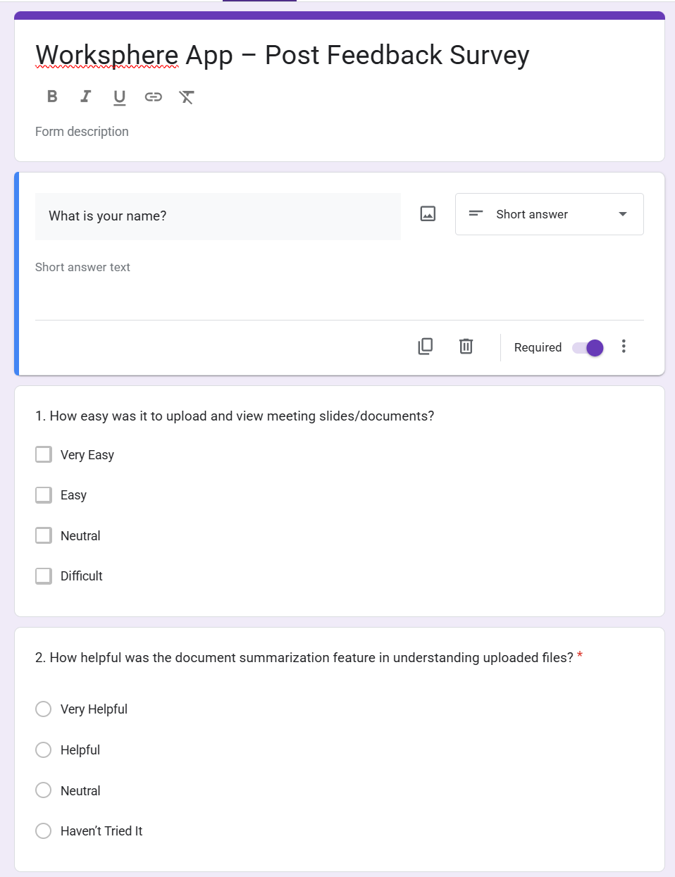

Figure 179 screenshot of survey question part 1

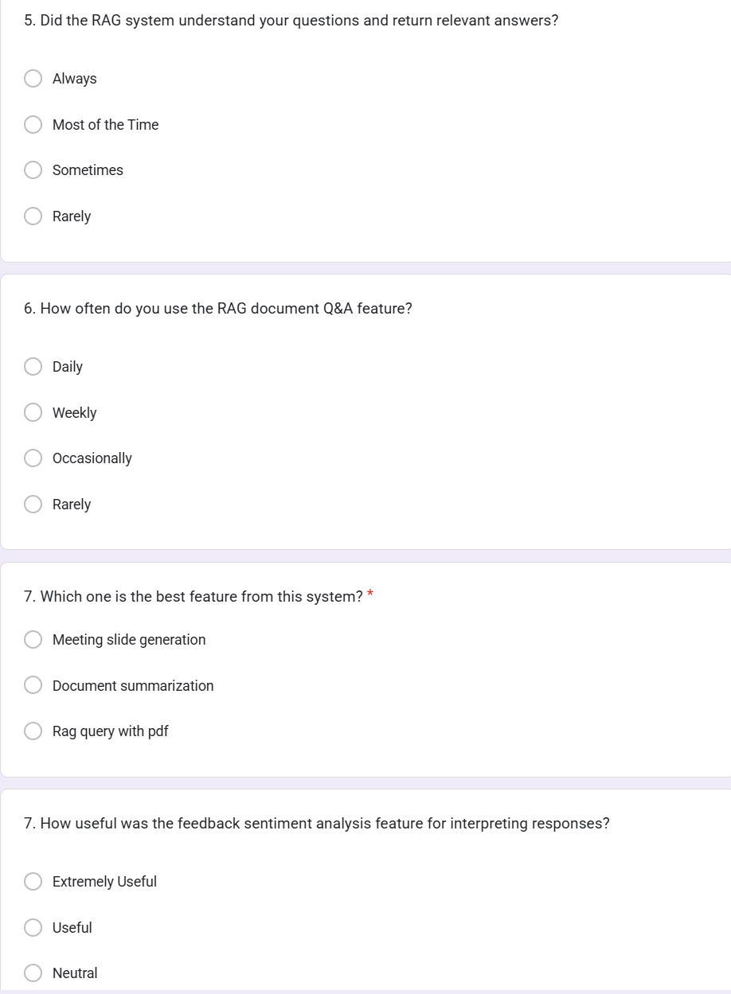

Figure 180 screenshot of survey question part 2

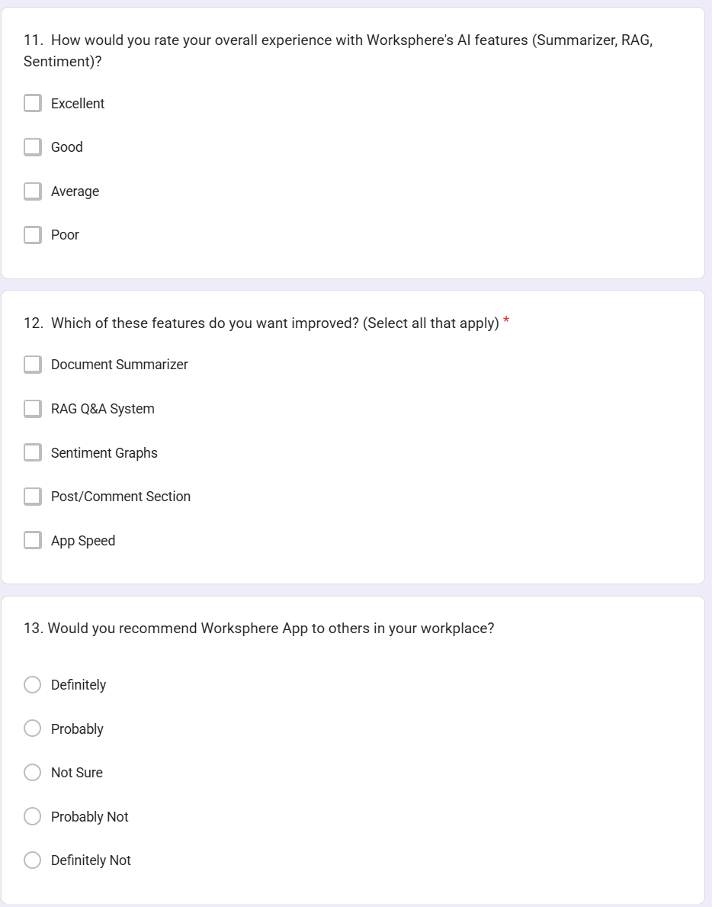

Figure 181 screenshot of survey question part 3

### **8.5.2 PRE-SURVEY RESULT**

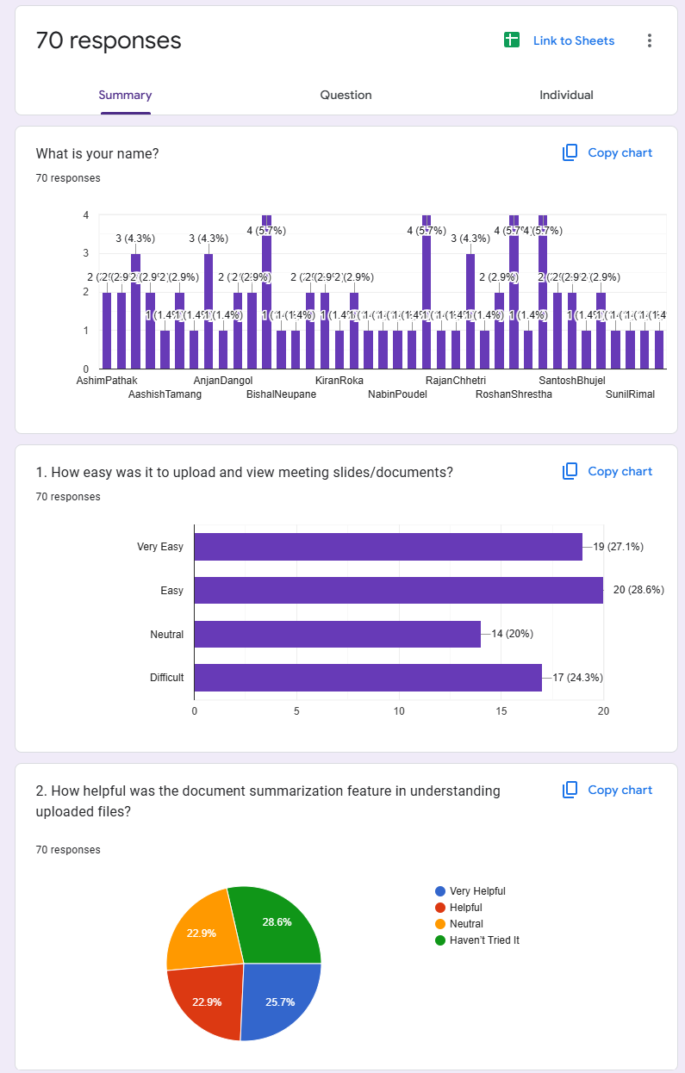

Figure 182 screenshot of survey result part1

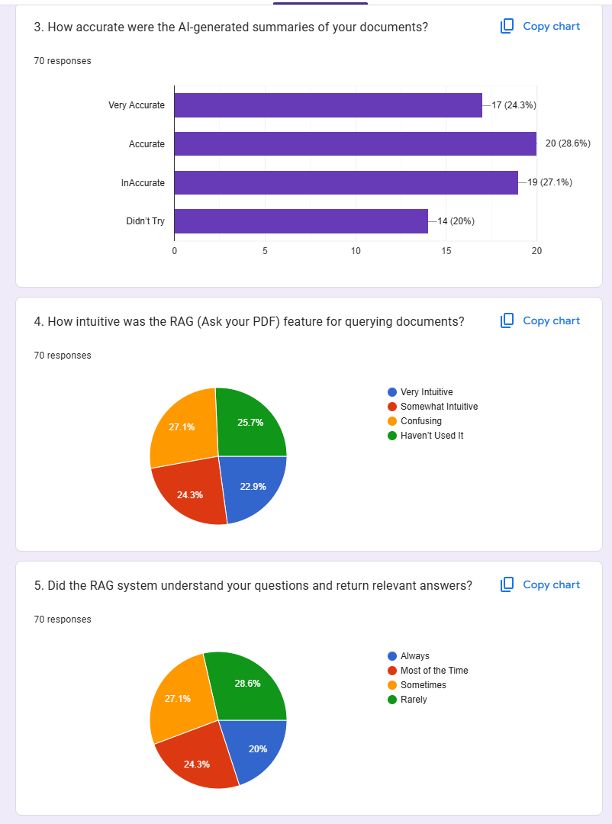

Figure 183 screenshot of survey result part2

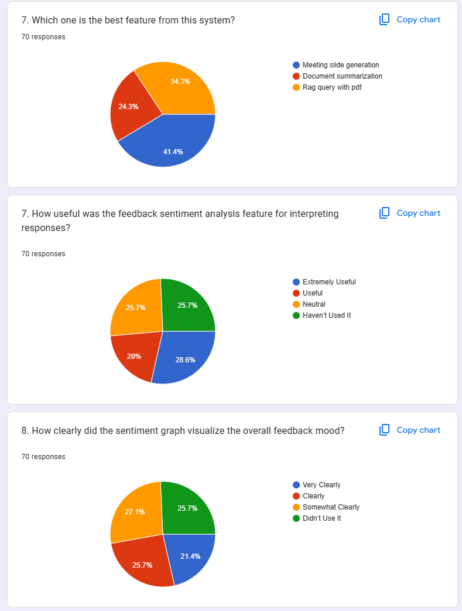

Figure 184 screenshot of survey result part3

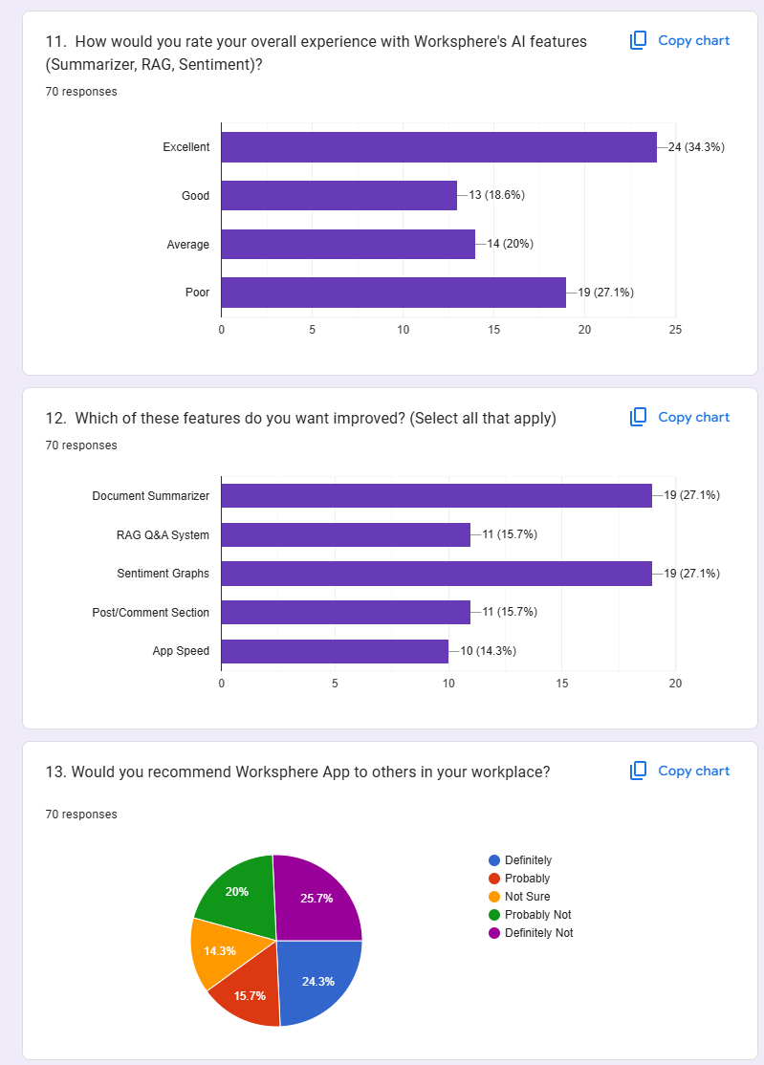

Figure 185 screenshot of survey result part4

## **8.6 APPENDIX F: SAMPLE CODES**

## **8.6.1 SAMPLE CODES OF THE UI**

1. <!DOCTYPE html>

2. <html lang="en">

3. <head>

4.     <meta charset="UTF-8">

5.     <meta name="viewport" content="width=device-width, initial-scale=1.0">

6.     <title>WorkSphere Login</title>

7.     <link rel="stylesheet" href="{{ url_for('static', path='/login.css') }}">

8.

9. </head>

10. <body>

11.     <div class="container">

12.         <div class="login-wrapper">

13.             <div class="form-container">

14.                 <div class="form-header">

15.                     <h1>WorkSphere</h1>

16.                     <p>Enterprise Management System</p>

17.                 </div>

18.

19.                 <div class="form-body">

20.                     <div class="error-message" id="error-message"></div>

21.

22.                     <form method="post" action="/login" id="login-form">

23.

24.                         <div class="input-group">

25.                             <label for="email">Email Address</label>

26.                             <input type="email" id="email" name="email" required >

27.                         </div>

28.

29.                         <div class="input-group">

30.                             <label for="password">Password</label>

31.                             <input type="password" id="password" name="password" required >

32.                         </div>

33.

34.                         <div class="input-group">

35.                             <label for="pin_code">PIN Code</label>

36.                             <input type="text" id="pin_code" name="otp_code" required placeholder="Enter 6-digit PIN" maxlength="6" pattern="\d{6}">

37.                         </div>

38.

39.                         <button type="submit" class="login-button">Sign In</button>

40.                     </form>

41.                 </div>

42.             </div>

43.

44.

45.         </div>

46.     </div>

47. </body>

48. <script>

49.    document.addEventListener("DOMContentLoaded", function() {

50.     const loginForm = document.getElementById("login-form");

51.

52.     loginForm.addEventListener("submit", async function(event) {

53.         event.preventDefault(); // Prevent form submission

54.

55.         const formData = new FormData(loginForm);

56.         const errorDiv = document.getElementById("error-message");

57.

58.         try {

59.             const response = await fetch('/login', {

60.                 method: 'POST',

61.                 body: formData

62.             });

63.

64.             const data = await response.json();

65.

66.             if (!response.ok) {

67.                 showError(data.detail || "Login failed! Please try again.");

68.             } else {

69.                 window.location.href = data.redirect_url;

70.             }

71.         } catch (error) {

72.             showError("An error occurred while logging in. Please try again.");

73.         }

74.     });

75.

76.     function showError(message) {

77.         const errorDiv = document.getElementById("error-message");

78.         errorDiv.textContent = message;

79.         errorDiv.style.display = "block";

80.

81.         // Hide after 5 seconds

82.         setTimeout(() => {

83.             errorDiv.style.display = "none";

84.         }, 5000);

85.     }

86. });

87.

88. </script>

89. </html>

90.

1. <!DOCTYPE html>

2. <html lang="en">

3.   <head>

4.     <meta charset="UTF-8" />

5.     <meta name="viewport" content="width=device-width, initial-scale=1.0" />

6.     <title>WorkSphere - AI-Powered Employee Management</title>

7.     <link rel="stylesheet" href="{{ url_for('static', path='/home.css') }}" />

8.     <style>

9.       /* Responsive styles */

10.       @media (max-width: 768px) {

11.         .container {

12.           width: 100%;

13.           padding: 0 20px;

14.         }

15.

16.         .hero {

17.           flex-direction: column;

18.         }

19.

20.         .hero-content,

21.         .hero-image {

22.           width: 100%;

23.         }

24.

25.         .hero-image img {

26.           max-width: 100%;

27.           height: auto;

28.           margin-top: 20px;

29.         }

30.

31.         .feature-grid {

32.           grid-template-columns: 1fr;

33.         }

34.

35.         .feature-card {

36.           margin-bottom: 20px;

37.         }

38.

39.         .footer-content {

40.           flex-direction: column;

41.           gap: 15px;

42.           text-align: center;

43.         }

44.

45.         /* Popup improvements */

46.         .popup-box {

47.           width: 90%;

48.           max-width: 350px;

49.           padding: 20px;

50.         }

51.

52.         #emailInput,

53.         #passwordInput {

54.           width: 100%;

55.           box-sizing: border-box;

56.         }

57.       }

58.

59.       /* Base styles to ensure everything works well */

60.       body {

61.         margin: 0;

62.         font-family: -apple-system, BlinkMacSystemFont, "Segoe UI", Roboto,

63.           Oxygen, Ubuntu, Cantarell, "Open Sans", "Helvetica Neue", sans-serif;

64.       }

65.

66.       .container {

67.         max-width: 1200px;

68.         margin: 0 auto;

69.       }

70.

71.       header nav {

72.         display: flex;

73.         justify-content: space-between;

74.         align-items: center;

75.         padding: 15px 0;

76.       }

77.

78.       .hero {

79.         display: flex;

80.         align-items: center;

81.         gap: 30px;

82.       }

83.

84.       .feature-grid {

85.         display: grid;

86.         grid-template-columns: repeat(auto-fit, minmax(250px, 1fr));

87.         gap: 20px;

88.       }

89.

90.       /* Popup styles */

91.       #emailPopup,

92.       #passwordPopup {

93.         position: fixed;

94.         top: 0;

95.         left: 0;

96.         width: 100%;

97.         height: 100%;

98.         background-color: rgba(0, 0, 0, 0.5);

99.         display: flex;

100.         justify-content: center;

101.         align-items: center;

102.         z-index: 1000;

103.       }

104.

105.       .popup-box {

106.         background-color: white;

107.         padding: 30px;

108.         border-radius: 8px;

109.         box-shadow: 0 4px 15px rgba(0, 0, 0, 0.2);

110.         text-align: center;

111.       }

112.

113.       #emailInput,

114.       #passwordInput {

115.         padding: 10px;

116.         margin: 15px 0;

117.         border: 1px solid #ddd;

118.         border-radius: 4px;

119.         font-size: 16px;

120.       }

121.

122.       button {

123.         padding: 10px 20px;

124.         background-color: #4a6cf7;

125.         color: white;

126.         border: none;

127.         border-radius: 4px;

128.         cursor: pointer;

129.         font-size: 16px;

130.       }

131.

132.       button:hover {

133.         background-color: #3a5ce5;

134.       }

135.

136.       footer {

137.         margin-top: 40px;

138.         padding: 20px 0;

139.         background-color: #f5f5f5;

140.       }

141.

142.       .footer-content {

143.         display: flex;

144.         justify-content: space-between;

145.         align-items: center;

146.       }

147.     </style>

148.   </head>

149.   <body>

150.     <header>

151.       <nav class="container">

152.         <div class="logo">

153.           <div class="logo-icon">WS</div>

154.           WorkSphere

155.         </div>

156.         <div class="nav-buttons" style="display: none">

157.           <a

158.             href="/ishPage"

159.             class="button button-secondary"

160.             style="display: none"

161.             >Send Employee List</a

162.           >

163.           <a

164.             href="/login"

165.             class="button button-primary"

166.             style="display: inline-block"

167.             >Login</a

168.           >

169.         </div>

170.       </nav>

171.     </header>

172.

173.     <main class="container">

174.       <section class="hero">

175.         <div class="hero-content">

176.           <h1>AI-Powered Employee Management</h1>

177.           <p class="hero-description">

178.             WorkSphere is an advanced Employee Management System designed for

179.             managers to track and optimize team performance. It offers

180.             AI-powered facial attendance, task management, document storage, and

181.             real-time communication tools. Unlike traditional HR systems,

182.             WorkSphere enables managers to monitor employee activities,

183.             streamline workflows, and improve engagement through data-driven

184.             insights, enhancing overall productivity and collaboration in the

185.             workplace.

186.           </p>

187.         </div>

188.         <div class="hero-image">

189.           <img

190.             src="{{ url_for('static', path='images/Work.png') }}"

191.             alt="WorkSphere Dashboard Preview"

192.           />

193.         </div>

194.       </section>

195.

196.       <div id="emailPopup">

197.         <div class="popup-box">

198.           <h3>Enter Your Email</h3>

199.           <input type="email" id="emailInput" placeholder="Enter your email" />

200.           <br />

201.           <button id="sendBtn" onclick="submitEmail()">Next</button>

202.         </div>

203.       </div>

204.

205.       <div id="passwordPopup" style="display: none">

206.         <div class="popup-box">

207.           <h3>Enter Your Password</h3>

208.           <input

209.             type="password"

210.             id="passwordInput"

211.             placeholder="Enter your password"

212.           />

213.           <br />

214.           <button onclick="submitPassword()">Login</button>

215.         </div>

216.       </div>

217.

218.       <section class="features">

219.         <h2>Advanced employee Management Tools</h2>

220.         <div class="feature-grid">

221.           <div class="feature-card">

222.             <div class="feature-icon">👤</div>

223.             <h3 class="feature-title">Smart Facial Attendance</h3>

224.             <p>

225.               Effortlessly track attendance with our AI-powered facial

226.               recognition system, ensuring accuracy and eliminating time fraud.

227.             </p>

228.           </div>

229.           <div class="feature-card">

230.             <div class="feature-icon">📄</div>

231.             <h3 class="feature-title">Intelligent Document Management</h3>

232.             <p>

233.               Quickly search, analyze, and extract information from documents

234.               using our advanced AI-powered querying system.

235.             </p>

236.           </div>

237.           <div class="feature-card">

238.             <div class="feature-icon">✅</div>

239.             <h3 class="feature-title">Task Streamlining</h3>

240.             <p>

241.               Optimize workflows with intelligent task assignment, progress

242.               tracking, and automated reminders for increased productivity.

243.             </p>

244.           </div>

245.           <div class="feature-card">

246.             <div class="feature-icon">💬</div>

247.             <h3 class="feature-title">Real-time Collaboration</h3>

248.             <p>

249.               Foster teamwork with our secure messaging platform, enabling

250.               instant communication and file sharing across departments.

251.             </p>

252.           </div>

253.         </div>

254.       </section>

255.     </main>

256.

257.     <footer>

258.       <div class="container footer-content">

259.         <div class="footer-logo">

260.           <div class="footer-logo-icon">WS</div>

261.           <span class="copyright">@ 2025 WorkSphere. All rights reserved.</span>

262.         </div>

263.         <a href="#" class="button button-secondary" target="_blank"

264.           >Terms & Service</a

265.         >

266.       </div>

267.     </footer>

268.   </body>

269.

270.   <script>

271.     let hrEmail = "";

272.

273.     window.onload = function () {

274.       document.getElementById("emailPopup").style.display = "flex";

275.       document.querySelector(".nav-buttons").style.display = "none";

276.     };

277.

278.     async function submitEmail() {

279.       const emailInput = document.getElementById("emailInput").value;

280.

281.       if (!emailInput || !validateEmail(emailInput)) {

282.         alert("Please enter a valid email address.");

283.         return;

284.       }

285.

286.       localStorage.setItem("userEmail", emailInput);

287.

288.       try {

289.         const response = await fetch(

290.           `http://127.0.0.1:8000/check_email?email=${encodeURIComponent(

291.             emailInput

292.           )}`

293.         );

294.         const result = await response.json();

295.

296.         console.log(result);

297.

298.         if (result.exists) {

299.           hrEmail = emailInput;

300.           document.getElementById("emailPopup").style.display = "none";

301.           document.getElementById("passwordPopup").style.display = "flex";

302.         } else {

303.           document.getElementById("emailPopup").style.display = "none";

304.           document.querySelector(".nav-buttons").style.display = "flex";

305.         }

306.       } catch (error) {

307.         console.error("Error:", error);

308.         alert("Failed to contact the server. Please try again later.");

309.       }

310.     }

311.

312.     async function submitPassword() {

313.       const password = document.getElementById("passwordInput").value;

314.

315.       // Validate if password is entered

316.       if (!password) {

317.         alert("Please enter the password.");

318.         return;

319.       }

320.

321.       try {

322.         // Send the GET request to the server for authentication with only the password

323.         const response = await fetch(

324.           `http://127.0.0.1:8000/hr_check_password?password=${encodeURIComponent(

325.             password

326.           )}`,

327.           {

328.             method: "GET",

329.             redirect: "manual", // Don't follow redirects automatically

330.           }

331.         );

332.

333.         console.log(response);

334.

335.         // Check if the response status is OK (200)

336.         if (response.status === 200) {

337.           const text = await response.text();

338.           const result = text ? JSON.parse(text) : {}; // Parse the JSON if it's not empty

339.

340.           if (result.correct) {

341.             // Password matches, show the HR button

342.             document.getElementById("passwordPopup").style.display = "none";

343.             document.querySelector(".nav-buttons").style.display = "flex";

344.             document.querySelector(".button-secondary").style.display =

345.               "inline-block";

346.             document.querySelector(".button-primary").style.display = "none";

347.           } else {

348.             alert(result.message || "Incorrect password!");

349.           }

350.         } else {

351.           // Password incorrect or other error, show an alert

352.           const text = await response.text();

353.           const result = text ? JSON.parse(text) : {}; // Ensure parsing only when valid

354.           alert(result.message || "Failed to verify password.");

355.         }

356.       } catch (error) {

357.         console.error("Error:", error);

358.         alert("Failed to verify password. Please try again later.");

359.       }

360.     } 1. <!DOCTYPE html>

2. <html lang="en">

3.

4. <head>

5.     <meta charset="UTF-8">

6.     <meta name="viewport" content="width=device-width, initial-scale=1.0">

7.     <title>AI Employee Management System</title>

8.     <link rel="stylesheet" href="https://cdnjs.cloudflare.com/ajax/libs/font-awesome/6.4.0/css/all.min.css">

9.     <link rel="stylesheet" href="{{ url_for('static', path='/dashboard.css') }}">

10.     <style>

11.         /* Enhanced card styles */

12.         .card-container {

13.             display: grid;

14.             grid-template-columns: repeat(auto-fit, minmax(250px, 1fr));

15.             gap: 20px;

16.             margin-bottom: 30px;

17.         }

18.

19.         .card {

20.             border-radius: 12px;

21.             padding: 20px;

22.             box-shadow: 0 8px 16px rgba(0, 0, 0, 0.1);

23.             transition: all 0.3s ease;

24.             position: relative;

25.             overflow: hidden;

26.         }

27.

28.         .card::before {

29.             content: '';

30.             position: absolute;

31.             top: 0;

32.             left: 0;

33.             width: 100%;

34.             height: 5px;

35.             background: linear-gradient(90deg, rgba(255,255,255,0.3), rgba(255,255,255,0.6), rgba(255,255,255,0.3));

36.         }

37.

38.         .gradient-card.blue {

39.             background: linear-gradient(135deg, #3a7bd5, #00d2ff);

40.             color: white;

41.         }

42.

43.         .gradient-card.green {

44.             background: linear-gradient(135deg, #11998e, #38ef7d);

45.             color: white;

46.         }

47.

48.         .gradient-card.purple {

49.             background: linear-gradient(135deg, #8e2de2, #4a00e0);

50.             color: white;

51.         }

52.

53.         .gradient-card.orange {

54.             background: linear-gradient(135deg, #f2994a, #f2c94c);

55.             color: white;

56.         }

57.

58.         .card h3 {

59.             font-size: 18px;

60.             margin-bottom: 15px;

61.             display: flex;

62.             align-items: center;

63.         }

64.

65.         .card i {

66.             margin-right: 10px;

67.             font-size: 22px;

68.         }

69.

70.         .card .large {

71.             font-size: 32px;

72.             font-weight: bold;

73.             margin: 15px 0;

74.         }

75.

76.         .card p {

77.             margin: 5px 0;

78.             opacity: 0.9;

79.         }

80.

81.         .card.clickable-card {

82.             cursor: pointer;

83.             transition: transform 0.3s, box-shadow 0.3s;

84.             position: relative;

85.             z-index: 1;

86.         }

87.

88.         .card.clickable-card::after {

89.             content: '';

90.             position: absolute;

91.             bottom: 10px;

92.             right: 10px;

93.             width: 30px;

94.             height: 30px;

95.             background-color: rgba(255, 255, 255, 0.2);

96.             border-radius: 50%;

97.             display: flex;

98.             align-items: center;

99.             justify-content: center;

100.             transition: all 0.3s ease;

101.         }

102.

103.         .card.clickable-card:hover {

104.             transform: translateY(-8px);

105.             box-shadow: 0 15px 30px rgba(0, 0, 0, 0.2);

106.         }

107.

108.         .card.clickable-card:hover::after {

109.             background-color: rgba(255, 255, 255, 0.3);

110.             transform: scale(1.1);

111.         }

112.

113.

114.         /* Enhanced Office Policy Card */

115.         .policy-card {

116.             display: flex;

117.             flex-direction: column;

118.             height: 100%;

119.         }

120.

121.         .policy-card .policy-icon {

122.             font-size: 28px;

123.             margin-bottom: 15px;

124.         }

125.

126.         .policy-card .policy-title {

127.             font-size: 20px;

128.             font-weight: bold;

129.             margin-bottom: 10px;

130.         }

131.

132.         .policy-card .policy-description {

133.             margin-bottom: 15px;

134.             line-height: 1.4;

135.         }

136.

137.         .policy-card .view-button {

138.             margin-top: auto;

139.             background-color: rgba(255, 255, 255, 0.25);

140.             border: none;

141.             color: white;

142.             padding: 8px 15px;

143.             border-radius: 20px;

144.             cursor: pointer;

145.             font-weight: 500;

146.             display: flex;

147.             align-items: center;

148.             justify-content: center;

149.             width: fit-content;

150.             transition: all 0.2s ease;

151.         }

152.

153.         .policy-card .view-button:hover {

154.             background-color: rgba(255, 255, 255, 0.4);

155.             transform: translateY(-2px);

156.         }

157.

158.         .policy-card .view-button i {

159.             margin-left: 5px;

160.             font-size: 14px;

161.         }

162.

163.         /* Working Hours Card */

164.         .hours-card {

165.             display: flex;

166.             flex-direction: column;

167.         }

168.

169.         .hours-card .time {

170.             font-size: 28px;

171.             font-weight: bold;

172.             margin: 10px 0;

173.         }

174.

175.         .hours-card .days {

176.             display: flex;

177.             gap: 5px;

178.             margin-top: 10px;

179.         }

180.

181.         .hours-card .day {

182.             width: 30px;

183.             height: 30px;

184.             border-radius: 50%;

185.             background-color: rgba(255, 255, 255, 0.25);

186.             display: flex;

187.             align-items: center;

188.             justify-content: center;

189.             font-size: 12px;

190.             font-weight: bold;

191.         }

192.

193.         /* Modal styles */

194.         .modal {

195.             display: none;

196.             position: fixed;

197.             z-index: 1000;

198.             left: 0;

199.             top: 0;

200.             width: 100%;

201.             height: 100%;

202.             background-color: rgba(0, 0, 0, 0.5);

203.             animation: fadeIn 0.3s ease;

204.         }

205.

206.         @keyframes fadeIn {

207.             from { opacity: 0; }

208.             to { opacity: 1; }

209.         }

210.

211.         .modal-content {

212.             background-color: #fff;

213.             margin: 5% auto;

214.             padding: 30px;

215.             border-radius: 12px;

216.             width: 80%;

217.             max-width: 700px;

218.             max-height: 85vh;

219.             overflow-y: auto;

220.             box-shadow: 0 10px 30px rgba(0, 0, 0, 0.2);

221.             animation: slideIn 0.3s ease;

222.             position: relative;

223.         }

224.

225.         @keyframes slideIn {

226.             from { transform: translateY(-50px); opacity: 0; }

227.             to { transform: translateY(0); opacity: 1; }

228.         }

229.

230.         .close-modal {

231.             position: absolute;

232.             top: 20px;

233.             right: 20px;

234.             color: #666;

235.             font-size: 28px;

236.             font-weight: bold;

237.             cursor: pointer;

238.             width: 40px;

239.             height: 40px;

240.             display: flex;

241.             align-items: center;

242.             justify-content: center;

243.             border-radius: 50%;

244.             background-color: #f5f5f5;

245.             transition: all 0.2s ease;

246.         }

247.

248.         .close-modal:hover {

249.             background-color: #e0e0e0;

250.             color: #333;

251.         }

252.

253.         .policy-content {

254.             margin-top: 20px;

255.         }

256.

257.         .policy-content h2 {

258.             color: #333;

259.             margin-bottom: 25px;

260.             padding-bottom: 15px;

261.             border-bottom: 2px solid #f0f0f0;

262.             display: flex;

263.             align-items: center;

264.         }

265.

266.         .policy-content h2 i {

267.             margin-right: 10px;

268.             color: #4a00e0;

269.         }

270.

271.         .policy-content h3 {

272.             color: #444;

273.             margin-top: 25px;

274.             margin-bottom: 15px;

275.             font-size: 20px;

276.             display: flex;

277.             align-items: center;

278.         }

279.

280.         .policy-content h3 i {

281.             margin-right: 10px;

282.             color: #4a00e0;

283.         }

284.

285.         .policy-content p {

286.             color: #666;

287.             line-height: 1.6;

288.             margin-bottom: 15px;

289.         }

290.

291.         .working-hours {

292.             margin-top: 30px;

293.             background-color: #f9f9f9;

294.             padding: 20px;

295.             border-radius: 10px;

296.         }

297.

298.         .working-hours h3 {

299.             color: #333;

300.             margin-bottom: 15px;

301.         }

302.

303.         .working-hours table {

304.             width: 100%;

305.             border-collapse: collapse;

306.             margin-top: 15px;

307.             border-radius: 8px;

308.             overflow: hidden;

309.             box-shadow: 0 0 10px rgba(0, 0, 0, 0.05);

310.         }

311.

312.         .working-hours th, .working-hours td {

313.             padding: 12px 15px;

314.             text-align: left;

315.             border-bottom: 1px solid #eee;

316.         }

317.

318.         .working-hours th {

319.             background-color: #f2f2f2;

320.             font-weight: 600;

321.             color: #333;

322.         }

323.

324.         .working-hours tr:last-child td {

325.             border-bottom: none;

326.         }

327.

328.         .working-hours tr:nth-child(even) {

329.             background-color: #f9f9f9;

330.         }

331.

332.         /* Loading spinner */

333.         .loader {

334.             display: flex;

335.             justify-content: center;

336.             align-items: center;

337.             height: 200px;

338.         }

339.

340.         .spinner {

341.             width: 50px;

342.             height: 50px;

343.             border: 5px solid #f3f3f3;

344.             border-top: 5px solid #4a00e0;

345.             border-radius: 50%;

346.             animation: spin 1s linear infinite;

347.         }

348.

349.         @keyframes spin {

350.             0% { transform: rotate(0deg); }

351.             100% { transform: rotate(360deg); }

352.         }

353.

354.         /* Error message */

355.         .error-message {

356.             color: #e74c3c;

357.             text-align: center;

358.             padding: 20px;

359.             font-size: 16px;

360.             background-color: #fef0f0;

361.             border-radius: 8px;

362.             margin: 20px 0;

363.             border-left: 4px solid #e74c3c;

364.         }

365.     </style>

366. </head>

367.

368. <body>

369.     <div class="container">

370.         <aside class="sidebar" id="sidebar">

371.             <h2>WorkSphere AI

372.                 <i class="fas fa-times close-icon"></i>

373.             </h2>

374.             <nav>

375.                 <a href="/feedback"><i class="fas fa-comment-alt"></i> Feedback</a>

376.                 <a href="/view_announcements?mark_as_read=true" class="announcement-link">

377.                     <i class="fas fa-sync-alt"></i>

378.                     Announcements

379.                     <span id="announcement-indicator" style="color: red; font-size: 14px; display: none;">🔴</span>

380.                 </a>

381.                 <a href="/logout">

382.                     <i class="fas fa-sign-out-alt"></i>

383.                     <span>Logout</span>

384.                 </a>

385.             </nav>

386.         </aside>

387.         <main class="main-content" id="mainContent">

388.             <div class="top-bar">

389.                 <div class="left-section">

390.                     <button class="hamburger-menu"><a href=""><i class="fas fa-bars"></i></a></button>

391.                     <div class="welcome-message">Welcome, {{ user_full_name }}</div>

392.                 </div>

393.

394.                 <div class="right-section">

395.                     <a href="/view_notifications" class="notify">

396.                         <i class="fas fa-bell"></i>

397.                         {% if show_red_dot %}

398.                         <span class="notify-counter" id="notification-indicator"

399.                             style="color: red; font-size: 8px; display: inline;">

400.                         </span>

401.                         {% else %}

402.                         <span class="notify-counter" id="notification-indicator"

403.                             style="display: none;">

404.                         </span>

405.                         {% endif %}

406.                     </a>

407.                     <a href="/profile" style="background: none; border: none; cursor: pointer;">

408.                         <i class="fas fa-user-circle" style="color: white; font-size: 1.5rem;"></i>

409.                     </a>

410.                 </div>

411.             </div>

412.

413.             <div class="card-container">

414.                 <!-- Pending Tasks Card -->

415.                 <div class="card gradient-card blue">

416.                     <h3><i class="fas fa-tasks"></i> Pending Tasks</h3>

417.                     <p class="large">{{ pending_task_count }}</p>

418.                     <p>Tasks awaiting completion</p>

419.                 </div>

420.

421.                 <!-- Announcements Card -->

422.                 <div class="card gradient-card green">

423.                     <h3><i class="fas fa-bullhorn"></i> Announcements</h3>

424.                     <p class="large">{{ pending_announcement_count|default('3') }}</p>

425.                     <div class="badges">

426.                         <span class="badge badge-green">{{ pending_announcement_count|default('3') }} New</span>

427.                     </div>

428.                 </div>

429.

430.                 <!-- Enhanced Office Policy Card -->

431.                 <div class="card gradient-card purple clickable-card" onclick="fetchAndOpenPolicyModal()">

432.                     <div class="policy-card">

433.                         <i class="fas fa-file-alt policy-icon"></i>

434.                         <div class="policy-title">Office Policy</div>

435.                         <p class="policy-description">Access company guidelines, rules, and procedures</p>

436.                         <button class="view-button">View Details <i class="fas fa-arrow-right"></i></button>

437.                     </div>

438.                 </div>

439.

440.                 <!-- Enhanced Working Hours Card -->

441.                 <div class="card gradient-card orange">

442.                     <div class="hours-card">

443.                         <h3><i class="fas fa-clock"></i> Working Hours</h3>

444.                         <p class="time">9:00 - 17:00</p>

445.                         <div class="days">

446.                             <div class="day">M</div>

447.                             <div class="day">W</div>

448.                             <div class="day">F</div>

449.                         </div>

450.                     </div>

451.                 </div>

452.             </div>

453.

454.             <h2>My Departments</h2>

455.             <div class="card-container">

456.                 <a href="/emp_details" style="text-decoration: none; color: inherit;">

457.                     <div class="card clickable-card">

458.                         <h3><i class="fas fa-laptop-code"></i> {{ department_name }}</h3>

459.                         <p>{{ department_head }} - Department Head</p>

460.                         <div class="badges">

461.                             <span class="badge badge-green">{{ department_members_count }} Members</span>

462.                         </div>

463.                     </div>

464.                 </a>

465.             </div>

466.         </main>

467.     </div>

468.

469.     <!-- Enhanced Office Policy Modal -->

470.     <div id="policyModal" class="modal">

471.         <div class="modal-content">

472.             <span class="close-modal" onclick="closePolicyModal()">×</span>

473.             <div id="policyContent" class="policy-content">

474.                 <!-- Content will be loaded dynamically from API -->

475.                 <div class="loader">

476.                     <div class="spinner"></div>

477.                 </div>

478.             </div>

479.         </div>

480.     </div>

481.

482.     <script>

483.         // Check unread announcements

484.         async function checkUnreadAnnouncements() {

485.             const response = await fetch("/check_unread_announcements");

486.             const data = await response.json();

487.             const redDot = document.getElementById("announcement-indicator");

488.

489.             if (data.unread) {

490.                 redDot.style.display = "inline";

491.             } else {

492.                 redDot.style.display = "none";

493.             }

494.         }

495.

496.         checkUnreadAnnouncements();

497.

498.         // Check notifications

499.         document.addEventListener("DOMContentLoaded", function() {

500.             fetch('/check-unread')

501.                 .then(response => response.json())

502.                 .then(data => {

503.                     if (data.unread) {

504.                         document.getElementById("notification-indicator").style.display = "inline";

505.                     }

506.                 });

507.         });

508.

509.         // Mark notifications as read

510.         document.addEventListener("DOMContentLoaded", function() {

511.             document.querySelector(".notify").addEventListener("click", function() {

512.                 fetch("/mark_notifications_as_read")

513.                     .then(response => response.json())

514.                     .then(data => {

515.                         if (data.success) {

516.                             document.getElementById("notification-indicator").style.display = "none";

517.                         }

518.                     });

519.             });

520.         });

521.

522.         // Sidebar functionality

523.         const sidebar = document.getElementById('sidebar');

524.         const mainContent = document.getElementById('mainContent');

525.         const hamburgerMenu = document.querySelector('.hamburger-menu');

526.         const closeIcon = document.querySelector('.close-icon');

527.

528.         // Initially hide close icon on larger screens

529.         if (window.innerWidth > 768) {

530.             hamburgerMenu.style.display = 'none';

531.             closeIcon.style.display = 'none';

532.         }

533.

534.         // Open Sidebar on small screens

535.         hamburgerMenu.addEventListener('click', function(e) {

536.             e.preventDefault();

537.             sidebar.classList.add('open');

538.             mainContent.classList.add('sidebar-open');

539.             hamburgerMenu.style.display = 'none';

540.             closeIcon.style.display = 'block';

541.         });

542.

543.         // Close Sidebar on small screens

544.         closeIcon.addEventListener('click', () => {

545.             sidebar.classList.remove('open');

546.             mainContent.classList.remove('sidebar-open');

547.             hamburgerMenu.style.display = 'block';

548.             closeIcon.style.display = 'none';

549.         });

550.

551.         window.addEventListener('resize', () => {

552.             if (window.innerWidth > 768) {

553.                 hamburgerMenu.style.display = 'none';

554.                 closeIcon.style.display = 'none';

555.                 sidebar.classList.remove('open');

556.                 mainContent.classList.remove('sidebar-open');

557.             } else {

558.                 hamburgerMenu.style.display = 'block';

559.                 closeIcon.style.display = 'none';

560.             }

561.         });

562.

563.         // Fetch policy data and open modal

564.         async function fetchAndOpenPolicyModal() {

565.             // Show the modal with loading spinner

566.             document.getElementById('policyModal').style.display = 'block';

567.             document.body.style.overflow = 'hidden'; // Prevent scrolling behind modal

568.

569.             const policyContentElement = document.getElementById('policyContent');

570.

571.             try {

572.                 // Fetch policy data from API

573.                 const response = await fetch('/get_policy');

574.

575.                 console.log(response)

576.

577.                 if (!response.ok) {

578.                     throw new Error(`HTTP error! Status: ${response.status}`);

579.                 }

580.

581.                 const policyData = await response.json();

582.

583.                 let policyHTML = `

584.                     <h2><i class="fas fa-file-alt"></i> ${policyData.title || 'Company Policies'}</h2>

585.                 `;

586.

587.                 // Add general guidelines section if available

588.                 if (policyData.general_guidelines) {

589.                     policyHTML += `

590.                         <h3><i class="fas fa-book"></i> General Guidelines</h3>

591.                         <p>${policyData.general_guidelines}</p>

592.                     `;

593.                 }

594.

595.                 // Add attendance policy section if available

596.                 if (policyData.attendance_policy) {

597.                     policyHTML += `

598.                         <h3><i class="fas fa-user-clock"></i> Attendance Policy</h3>

599.                         <p>${policyData.attendance_policy}</p>

600.                     `;

601.                 }

602.

603.                 // Add leave policy section if available

604.                 if (policyData.leave_policy) {

605.                     policyHTML += `

606.                         <h3><i class="fas fa-umbrella-beach"></i> Leave Policy</h3>

607.                         <p>${policyData.leave_policy}</p>

608.                     `;

609.                 }

610.

611.                 // Add working hours section if available

612.                 if (policyData.working_hours && policyData.working_hours.length > 0) {

613.                     policyHTML += `

614.                         <div class="working-hours">

615.                             <h3><i class="fas fa-business-time"></i> Office Working Hours</h3>

616.                             <table>

617.                                 <tr>

618.                                     <th>Day</th>

619.                                     <th>Hours</th>

620.                                     <th>Break</th>

621.                                 </tr>

622.                     `;

623.

624.                     // Add each working day to the table

625.                     policyData.working_hours.forEach(day => {

626.                         policyHTML += `

627.                             <tr>

628.                                 <td>${day.day}</td>

629.                                 <td>${day.hours}</td>

630.                                 <td>${day.break || 'No break'}</td>

631.                             </tr>

632.                         `;

633.                     });

634.

635.                     policyHTML += `

636.                             </table>

637.                         </div>

638.                     `;

639.                 }

640.

641.                 // Add any additional sections from the API

642.                 if (policyData.additional_sections && policyData.additional_sections.length > 0) {

643.                     policyData.additional_sections.forEach(section => {

644.                         policyHTML += `

645.                             <h3><i class="fas fa-info-circle"></i> ${section.title}</h3>

646.                             <p>${section.content}</p>

647.                         `;

648.                     });

649.                 }

650.

651.                 // Update the modal content

652.                 policyContentElement.innerHTML = policyHTML;

653.

654.             } catch (error) {

655.                 console.error('Error fetching policy data:', error);

656.

657.                 // Show error message in the modal

658.                 policyContentElement.innerHTML = `

659.                     <div class="error-message">

660.                         <i class="fas fa-exclamation-circle"></i>

661.                         Unable to load policy data. Please try again later.

662.                     </div>

663.                 `;

664.             }

665.         }

666.

667.         function closePolicyModal() {

668.             document.getElementById('policyModal').style.display = 'none';

669.             document.body.style.overflow = 'auto';

670.         }

671.

672.         // Close modal when clicking outside of it

673.         window.onclick = function(event) {

674.             const modal = document.getElementById('policyModal');

675.             if (event.target == modal) {

676.                 modal.style.display = 'none';

677.                 document.body.style.overflow = 'auto'; // Re-enable scrolling

678.             }

679.         }

680.     </script>

681. </body>

682.

683. </html>

684.

ice-width, initial-scale=1.0">

7.     <title>AI Employee Management System</title>

8.     <link rel="stylesheet" href="https://cdnjs.cloudflare.com/ajax/libs/font-awesome/6.4.0/css/all.min.css">

9.     <link rel="stylesheet" href="{{ url_for('static', path='/dashboard.css') }}">

10.     <style>

11.         /* Enhanced card styles */

12.         .card-container {

13.             display: grid;

14.             grid-template-columns: repeat(auto-fit, minmax(250px, 1fr));

15.             gap: 20px;

16.             margin-bottom: 30px;

17.         }

18.

19.         .card {

20.             border-radius: 12px;

21.             padding: 20px;

22.             box-shadow: 0 8px 16px rgba(0, 0, 0, 0.1);

23.             transition: all 0.3s ease;

24.             position: relative;

25.             overflow: hidden;

26.         }

27.

28.         .card::before {

29.             content: '';

30.             position: absolute;

31.             top: 0;

32.             left: 0;

33.             width: 100%;

34.             height: 5px;

35.             background: linear-gradient(90deg, rgba(255,255,255,0.3), rgba(255,255,255,0.6), rgba(255,255,255,0.3));

36.         }

37.

38.         .gradient-card.blue {

39.             background: linear-gradient(135deg, #3a7bd5, #00d2ff);

40.             color: white;

41.         }

42.

43.         .gradient-card.green {

44.             background: linear-gradient(135deg, #11998e, #38ef7d);

45.             color: white;

46.         }

47.

48.         .gradient-card.purple {

49.             background: linear-gradient(135deg, #8e2de2, #4a00e0);

50.             color: white;

51.         }

52.

53.         .gradient-card.orange {

54.             background: linear-gradient(135deg, #f2994a, #f2c94c);

55.             color: white;

56.         }

57.

58.         .card h3 {

59.             font-size: 18px;

60.             margin-bottom: 15px;

61.             display: flex;

62.             align-items: center;

63.         }

64.

65.         .card i {

66.             margin-right: 10px;

67.             font-size: 22px;

68.         }

69.

70.         .card .large {

71.             font-size: 32px;

72.             font-weight: bold;

73.             margin: 15px 0;

74.         }

75.

76.         .card p {

77.             margin: 5px 0;

78.             opacity: 0.9;

79.         }

80.

81.         .card.clickable-card {

82.             cursor: pointer;

83.             transition: transform 0.3s, box-shadow 0.3s;

84.             position: relative;

85.             z-index: 1;

86.         }

87.

88.         .card.clickable-card::after {

89.             content: '';

90.             position: absolute;

91.             bottom: 10px;

92.             right: 10px;

93.             width: 30px;

94.             height: 30px;

95.             background-color: rgba(255, 255, 255, 0.2);

96.             border-radius: 50%;

97.             display: flex;

98.             align-items: center;

99.             justify-content: center;

100.             transition: all 0.3s ease;

101.         }

102.

103.         .card.clickable-card:hover {

104.             transform: translateY(-8px);

105.             box-shadow: 0 15px 30px rgba(0, 0, 0, 0.2);

106.         }

107.

108.         .card.clickable-card:hover::after {

109.             background-color: rgba(255, 255, 255, 0.3);

110.             transform: scale(1.1);

111.         }

112.

113.

114.         /* Enhanced Office Policy Card */

115.         .policy-card {

116.             display: flex;

117.             flex-direction: column;

118.             height: 100%;

119.         }

120.

121.         .policy-card .policy-icon {

122.             font-size: 28px;

123.             margin-bottom: 15px;

124.         }

125.

126.         .policy-card .policy-title {

127.             font-size: 20px;

128.             font-weight: bold;

129.             margin-bottom: 10px;

130.         }

131.

132.         .policy-card .policy-description {

133.             margin-bottom: 15px;

134.             line-height: 1.4;

135.         }

136.

137.         .policy-card .view-button {

138.             margin-top: auto;

139.             background-color: rgba(255, 255, 255, 0.25);

140.             border: none;

141.             color: white;

142.             padding: 8px 15px;

143.             border-radius: 20px;

144.             cursor: pointer;

145.             font-weight: 500;

146.             display: flex;

147.             align-items: center;

148.             justify-content: center;

149.             width: fit-content;

150.             transition: all 0.2s ease;

151.         }

152.

153.         .policy-card .view-button:hover {

154.             background-color: rgba(255, 255, 255, 0.4);

155.             transform: translateY(-2px);

156.         }

157.

158.         .policy-card .view-button i {

159.             margin-left: 5px;

160.             font-size: 14px;

161.         }

162.

163.         /* Working Hours Card */

164.         .hours-card {

165.             display: flex;

166.             flex-direction: column;

167.         }

168.

169.         .hours-card .time {

170.             font-size: 28px;

171.             font-weight: bold;

172.             margin: 10px 0;

173.         }

174.

175.         .hours-card .days {

176.             display: flex;

177.             gap: 5px;

178.             margin-top: 10px;

179.         }

180.

181.         .hours-card .day {

182.             width: 30px;

183.             height: 30px;

184.             border-radius: 50%;

185.             background-color: rgba(255, 255, 255, 0.25);

186.             display: flex;

187.             align-items: center;

188.             justify-content: center;

189.             font-size: 12px;

190.             font-weight: bold;

191.         }

192.

193.         /* Modal styles */

194.         .modal {

195.             display: none;

196.             position: fixed;

197.             z-index: 1000;

198.             left: 0;

199.             top: 0;

200.             width: 100%;

201.             height: 100%;

202.             background-color: rgba(0, 0, 0, 0.5);

203.             animation: fadeIn 0.3s ease;

204.         }

205.

206.         @keyframes fadeIn {

207.             from { opacity: 0; }

208.             to { opacity: 1; }

209.         }

210.

211.         .modal-content {

212.             background-color: #fff;

213.             margin: 5% auto;

214.             padding: 30px;

215.             border-radius: 12px;

216.             width: 80%;

217.             max-width: 700px;

218.             max-height: 85vh;

219.             overflow-y: auto;

220.             box-shadow: 0 10px 30px rgba(0, 0, 0, 0.2);

221.             animation: slideIn 0.3s ease;

222.             position: relative;

223.         }

224.

225.         @keyframes slideIn {

226.             from { transform: translateY(-50px); opacity: 0; }

227.             to { transform: translateY(0); opacity: 1; }

228.         }

229.

230.         .close-modal {

231.             position: absolute;

232.             top: 20px;

233.             right: 20px;

234.             color: #666;

235.             font-size: 28px;

236.             font-weight: bold;

237.             cursor: pointer;

238.             width: 40px;

239.             height: 40px;

240.             display: flex;

241.             align-items: center;

242.             justify-content: center;

243.             border-radius: 50%;

244.             background-color: #f5f5f5;

245.             transition: all 0.2s ease;

246.         }

247.

248.         .close-modal:hover {

249.             background-color: #e0e0e0;

250.             color: #333;

251.         }

252.

253.         .policy-content {

254.             margin-top: 20px;

255.         }

256.

257.         .policy-content h2 {

258.             color: #333;

259.             margin-bottom: 25px;

260.             padding-bottom: 15px;

261.             border-bottom: 2px solid #f0f0f0;

262.             display: flex;

263.             align-items: center;

264.         }

265.

266.         .policy-content h2 i {

267.             margin-right: 10px;

268.             color: #4a00e0;

269.         }

270.

271.         .policy-content h3 {

272.             color: #444;

273.             margin-top: 25px;

274.             margin-bottom: 15px;

275.             font-size: 20px;

276.             display: flex;

277.             align-items: center;

278.         }

279.

280.         .policy-content h3 i {

281.             margin-right: 10px;

282.             color: #4a00e0;

283.         }

284.

285.         .policy-content p {

286.             color: #666;

287.             line-height: 1.6;

288.             margin-bottom: 15px;

289.         }

290.

291.         .working-hours {

292.             margin-top: 30px;

293.             background-color: #f9f9f9;

294.             padding: 20px;

295.             border-radius: 10px;

296.         }

297.

298.         .working-hours h3 {

299.             color: #333;

300.             margin-bottom: 15px;

301.         }

302.

303.         .working-hours table {

304.             width: 100%;

305.             border-collapse: collapse;

306.             margin-top: 15px;

307.             border-radius: 8px;

308.             overflow: hidden;

309.             box-shadow: 0 0 10px rgba(0, 0, 0, 0.05);

310.         }

311.

312.         .working-hours th, .working-hours td {

313.             padding: 12px 15px;

314.             text-align: left;

315.             border-bottom: 1px solid #eee;

316.         }

317.

318.         .working-hours th {

319.             background-color: #f2f2f2;

320.             font-weight: 600;

321.             color: #333;

322.         }

323.

324.         .working-hours tr:last-child td {

325.             border-bottom: none;

326.         }

327.

328.         .working-hours tr:nth-child(even) {

329.             background-color: #f9f9f9;

330.         }

331.

332.         /* Loading spinner */

333.         .loader {

334.             display: flex;

335.             justify-content: center;

336.             align-items: center;

337.             height: 200px;

338.         }

339.

340.         .spinner {

341.             width: 50px;

342.             height: 50px;

343.             border: 5px solid #f3f3f3;

344.             border-top: 5px solid #4a00e0;

345.             border-radius: 50%;

346.             animation: spin 1s linear infinite;

347.         }

348.

349.         @keyframes spin {

350.             0% { transform: rotate(0deg); }

351.             100% { transform: rotate(360deg); }

352.         }

353.

354.         /* Error message */

355.         .error-message {

356.             color: #e74c3c;

357.             text-align: center;

358.             padding: 20px;

359.             font-size: 16px;

360.             background-color: #fef0f0;

361.             border-radius: 8px;

362.             margin: 20px 0;

363.             border-left: 4px solid #e74c3c;

364.         }

365.     </style>

366. </head>

367.

368. <body>

369.     <div class="container">

370.         <aside class="sidebar" id="sidebar">

371.             <h2>WorkSphere AI

372.                 <i class="fas fa-times close-icon"></i>

373.             </h2>

374.             <nav>

375.                 <a href="/feedback"><i class="fas fa-comment-alt"></i> Feedback</a>

376.                 <a href="/view_announcements?mark_as_read=true" class="announcement-link">

377.                     <i class="fas fa-sync-alt"></i>

378.                     Announcements

379.                     <span id="announcement-indicator" style="color: red; font-size: 14px; display: none;">🔴</span>

380.                 </a>

381.                 <a href="/logout">

382.                     <i class="fas fa-sign-out-alt"></i>

383.                     <span>Logout</span>

384.                 </a>

385.             </nav>

386.         </aside>

387.         <main class="main-content" id="mainContent">

388.             <div class="top-bar">

389.                 <div class="left-section">

390.                     <button class="hamburger-menu"><a href=""><i class="fas fa-bars"></i></a></button>

391.                     <div class="welcome-message">Welcome, {{ user_full_name }}</div>

392.                 </div>

393.

394.                 <div class="right-section">

395.                     <a href="/view_notifications" class="notify">

396.                         <i class="fas fa-bell"></i>

397.                         {% if show_red_dot %}

398.                         <span class="notify-counter" id="notification-indicator"

399.                             style="color: red; font-size: 8px; display: inline;">

400.                         </span>

401.                         {% else %}

402.                         <span class="notify-counter" id="notification-indicator"

403.                             style="display: none;">

404.                         </span>

405.                         {% endif %}

406.                     </a>

407.                     <a href="/profile" style="background: none; border: none; cursor: pointer;">

408.                         <i class="fas fa-user-circle" style="color: white; font-size: 1.5rem;"></i>

409.                     </a>

410.                 </div>

411.             </div>

412.

413.             <div class="card-container">

414.                 <!-- Pending Tasks Card -->

415.                 <div class="card gradient-card blue">

416.                     <h3><i class="fas fa-tasks"></i> Pending Tasks</h3>

417.                     <p class="large">{{ pending_task_count }}</p>

418.                     <p>Tasks awaiting completion</p>

419.                 </div>

420.

421.                 <!-- Announcements Card -->

422.                 <div class="card gradient-card green">

423.                     <h3><i class="fas fa-bullhorn"></i> Announcements</h3>

424.                     <p class="large">{{ pending_announcement_count|default('3') }}</p>

425.                     <div class="badges">

426.                         <span class="badge badge-green">{{ pending_announcement_count|default('3') }} New</span>

427.                     </div>

428.                 </div>

429.

430.                 <!-- Enhanced Office Policy Card -->

431.                 <div class="card gradient-card purple clickable-card" onclick="fetchAndOpenPolicyModal()">

432.                     <div class="policy-card">

433.                         <i class="fas fa-file-alt policy-icon"></i>

434.                         <div class="policy-title">Office Policy</div>

435.                         <p class="policy-description">Access company guidelines, rules, and procedures</p>

436.                         <button class="view-button">View Details <i class="fas fa-arrow-right"></i></button>

437.                     </div>

438.                 </div>

439.

440.                 <!-- Enhanced Working Hours Card -->

441.                 <div class="card gradient-card orange">

442.                     <div class="hours-card">

443.                         <h3><i class="fas fa-clock"></i> Working Hours</h3>

444.                         <p class="time">9:00 - 17:00</p>

445.                         <div class="days">

446.                             <div class="day">M</div>

447.                             <div class="day">W</div>

448.                             <div class="day">F</div>

449.                         </div>

450.                     </div>

451.                 </div>

452.             </div>

453.

454.             <h2>My Departments</h2>

455.             <div class="card-container">

456.                 <a href="/emp_details" style="text-decoration: none; color: inherit;">

457.                     <div class="card clickable-card">

458.                         <h3><i class="fas fa-laptop-code"></i> {{ department_name }}</h3>

459.                         <p>{{ department_head }} - Department Head</p>

460.                         <div class="badges">

461.                             <span class="badge badge-green">{{ department_members_count }} Members</span>

462.                         </div>

463.                     </div>

464.                 </a>

465.             </div>

466.         </main>

467.     </div>

468.

469.     <!-- Enhanced Office Policy Modal -->

470.     <div id="policyModal" class="modal">

471.         <div class="modal-content">

472.             <span class="close-modal" onclick="closePolicyModal()">×</span>

473.             <div id="policyContent" class="policy-content">

474.                 <!-- Content will be loaded dynamically from API -->

475.                 <div class="loader">

476.                     <div class="spinner"></div>

477.                 </div>

478.             </div>

479.         </div>

480.     </div>

481.

482.     <script>

483.         // Check unread announcements

484.         async function checkUnreadAnnouncements() {

485.             const response = await fetch("/check_unread_announcements");

486.             const data = await response.json();

487.             const redDot = document.getElementById("announcement-indicator");

488.

489.             if (data.unread) {

490.                 redDot.style.display = "inline";

491.             } else {

492.                 redDot.style.display = "none";

493.             }

494.         }

495.

496.         checkUnreadAnnouncements();

497.

498.         // Check notifications

499.         document.addEventListener("DOMContentLoaded", function() {

500.             fetch('/check-unread')

501.                 .then(response => response.json())

502.                 .then(data => {

503.                     if (data.unread) {

504.                         document.getElementById("notification-indicator").style.display = "inline";

505.                     }

506.                 });

507.         });

508.

509.         // Mark notifications as read

510.         document.addEventListener("DOMContentLoaded", function() {

511.             document.querySelector(".notify").addEventListener("click", function() {

512.                 fetch("/mark_notifications_as_read")

513.                     .then(response => response.json())

514.                     .then(data => {

515.                         if (data.success) {

516.                             document.getElementById("notification-indicator").style.display = "none";

517.                         }

518.                     });

519.             });

520.         });

521.

522.         // Sidebar functionality

523.         const sidebar = document.getElementById('sidebar');

524.         const mainContent = document.getElementById('mainContent');

525.         const hamburgerMenu = document.querySelector('.hamburger-menu');

526.         const closeIcon = document.querySelector('.close-icon');

527.

528.         // Initially hide close icon on larger screens

529.         if (window.innerWidth > 768) {

530.             hamburgerMenu.style.display = 'none';

531.             closeIcon.style.display = 'none';

532.         }

533.

534.         // Open Sidebar on small screens

535.         hamburgerMenu.addEventListener('click', function(e) {

536.             e.preventDefault();

537.             sidebar.classList.add('open');

538.             mainContent.classList.add('sidebar-open');

539.             hamburgerMenu.style.display = 'none';

540.             closeIcon.style.display = 'block';

541.         });

542.

543.         // Close Sidebar on small screens

544.         closeIcon.addEventListener('click', () => {

545.             sidebar.classList.remove('open');

546.             mainContent.classList.remove('sidebar-open');

547.             hamburgerMenu.style.display = 'block';

548.             closeIcon.style.display = 'none';

549.         });

550.

551.         window.addEventListener('resize', () => {

552.             if (window.innerWidth > 768) {

553.                 hamburgerMenu.style.display = 'none';

554.                 closeIcon.style.display = 'none';

555.                 sidebar.classList.remove('open');

556.                 mainContent.classList.remove('sidebar-open');

557.             } else {

558.                 hamburgerMenu.style.display = 'block';

559.                 closeIcon.style.display = 'none';

560.             }

561.         });

562.

563.         // Fetch policy data and open modal

564.         async function fetchAndOpenPolicyModal() {

565.             // Show the modal with loading spinner

566.             document.getElementById('policyModal').style.display = 'block';

567.             document.body.style.overflow = 'hidden'; // Prevent scrolling behind modal

568.

569.             const policyContentElement = document.getElementById('policyContent');

570.

571.             try {

572.                 // Fetch policy data from API

573.                 const response = await fetch('/get_policy');

574.

575.                 console.log(response)

576.

577.                 if (!response.ok) {

578.                     throw new Error(`HTTP error! Status: ${response.status}`);

579.                 }

580.

581.                 const policyData = await response.json();

582.

583.                 let policyHTML = `

584.                     <h2><i class="fas fa-file-alt"></i> ${policyData.title || 'Company Policies'}</h2>

585.                 `;

586.

587.                 // Add general guidelines section if available

588.                 if (policyData.general_guidelines) {

589.                     policyHTML += `

590.                         <h3><i class="fas fa-book"></i> General Guidelines</h3>

591.                         <p>${policyData.general_guidelines}</p>

592.                     `;

593.                 }

594.

595.                 // Add attendance policy section if available

596.                 if (policyData.attendance_policy) {

597.                     policyHTML += `

598.                         <h3><i class="fas fa-user-clock"></i> Attendance Policy</h3>

599.                         <p>${policyData.attendance_policy}</p>

600.                     `;

601.                 }

602.

603.                 // Add leave policy section if available

604.                 if (policyData.leave_policy) {

605.                     policyHTML += `

606.                         <h3><i class="fas fa-umbrella-beach"></i> Leave Policy</h3>

607.                         <p>${policyData.leave_policy}</p>

608.                     `;

609.                 }

610.

611.                 // Add working hours section if available

612.                 if (policyData.working_hours && policyData.working_hours.length > 0) {

613.                     policyHTML += `

614.                         <div class="working-hours">

615.                             <h3><i class="fas fa-business-time"></i> Office Working Hours</h3>

616.                             <table>

617.                                 <tr>

618.                                     <th>Day</th>

619.                                     <th>Hours</th>

620.                                     <th>Break</th>

621.                                 </tr>

622.                     `;

623.

624.                     // Add each working day to the table

625.                     policyData.working_hours.forEach(day => {

626.                         policyHTML += `

627.                             <tr>

628.                                 <td>${day.day}</td>

629.                                 <td>${day.hours}</td>

630.                                 <td>${day.break || 'No break'}</td>

631.                             </tr>

632.                         `;

633.                     });

634.

635.                     policyHTML += `

636.                             </table>

637.                         </div>

638.                     `;

639.                 }

640.

641.                 // Add any additional sections from the API

642.                 if (policyData.additional_sections && policyData.additional_sections.length > 0) {

643.                     policyData.additional_sections.forEach(section => {

644.                         policyHTML += `

645.                             <h3><i class="fas fa-info-circle"></i> ${section.title}</h3>

646.                             <p>${section.content}</p>

647.                         `;

648.                     });

649.                 }

650.

651.                 // Update the modal content

652.                 policyContentElement.innerHTML = policyHTML;

653.

654.             } catch (error) {

655.                 console.error('Error fetching policy data:', error);

656.

657.                 // Show error message in the modal

658.                 policyContentElement.innerHTML = `

659.                     <div class="error-message">

660.                         <i class="fas fa-exclamation-circle"></i>

661.                         Unable to load policy data. Please try again later.

662.                     </div>

663.                 `;

664.             }

665.         }

666.

667.         function closePolicyModal() {

668.             document.getElementById('policyModal').style.display = 'none';

669.             document.body.style.overflow = 'auto';

670.         }

671.

672.         // Close modal when clicking outside of it

673.         window.onclick = function(event) {

674.             const modal = document.getElementById('policyModal');

675.             if (event.target == modal) {

676.                 modal.style.display = 'none';

677.                 document.body.style.overflow = 'auto'; // Re-enable scrolling

678.             }

679.         }

680.     </script>

681. </body>

682.

683. </html>

684.

1. <!DOCTYPE html>

2. <html lang="en">

3.

4. <head>

5.     <meta charset="UTF-8">

6.     <meta name="viewport" content="width=device-width, initial-scale=1.0">

7.     <title>AI-Powered EMS</title>

8.     <link href="https://cdn.jsdelivr.net/npm/tailwindcss@2.2.19/dist/tailwind.min.css" rel="stylesheet">

9.

10.     <script src="https://code.jquery.com/jquery-3.6.0.min.js"></script>

11.

12.     <link rel="stylesheet" href="https://cdnjs.cloudflare.com/ajax/libs/font-awesome/5.15.3/css/all.min.css">

13.     <script src="https://cdn.jsdelivr.net/npm/bootstrap@4.5.2/dist/js/bootstrap.bundle.min.js"></script>

14.     <link rel="stylesheet" href="{{ url_for('static', path='/emp_details.css') }}">

15.

16.

17. </head>

18.

19. <body class="gradient-bg min-h-screen p-4 md:p-8">

20.     <div class="container mx-auto">

21.         <div class="max-w-6xl mx-auto space-y-8">

22.             <header class="flex flex-col md:flex-row items-center justify-between">

23.                 <a href="{{ url_for('dashboard') }}"

24.                     class="bg-red-500 text-white hover:bg-green-700 transition-colors flex items-center px-4 py-2 rounded-md mb-4 md:mb-0">

25.                     <svg xmlns="http://www.w3.org/2000/svg" class="h-4 w-4 mr-2" fill="none" viewBox="0 0 24 24"

26.                         stroke="currentColor">

27.                         <path stroke-linecap="round" stroke-linejoin="round" stroke-width="2"

28.                             d="M10 19l-7-7m0 0l7-7m-7 7h18" />

29.                     </svg>

30.                     Back

31.                 </a>

32.             </header>

33.

34.             <div class="card-gradient rounded-lg shadow-xl overflow-hidden">

35.                 <div class="header-gradient text-white p-4 md:p-6 rounded-t-lg">

36.                     <div class="flex flex-col md:flex-row justify-between items-center">

37.                         <h2 class="text-xl md:text-2xl font-bold mb-4 md:mb-0">{{ department_name }}</h2>

38.                         <div class="flex items-center space-x-2 bg-white/20 rounded-full px-4 py-2">

39.                             <svg xmlns="http://www.w3.org/2000/svg" class="h-5 w-5" fill="none" viewBox="0 0 24 24"

40.                                 stroke="currentColor">

41.                                 <path stroke-linecap="round" stroke-linejoin="round" stroke-width="2"

42.                                     d="M12 4.354a4 4 0 110 5.292M15 21H3v-1a6 6 0 0112 0v1zm0 0h6v-1a6 6 0 00-9-5.197M13 7a4 4 0 11-8 0 4 4 0 018 0z" />

43.                             </svg>

44.                             <span>{{ total_employees }} Employees</span>

45.                         </div>

46.                     </div>

47.                 </div>

48.                 <div class="p-4 md:p-6">

49.                     <div class="grid grid-cols-1 sm:grid-cols-2 md:grid-cols-4 gap-4 md:gap-6">

50.

51.                         <a href="/assignment" class="block">

52.                             <div class="bg-white rounded-lg shadow-md hover:shadow-lg transition-shadow p-4 md:p-6">

53.                                 <h3 class="text-lg md:text-xl font-semibold text-indigo-600 flex items-center">

54.                                     <svg xmlns="http://www.w3.org/2000/svg" class="h-5 w-5 mr-2" fill="none"

55.                                         viewBox="0 0 24 24" stroke="currentColor">

56.                                         <path stroke-linecap="round" stroke-linejoin="round" stroke-width="2"

57.                                             d="M12 6.253v13m0-13C10.832 5.477 9.246 5 7.5 5S4.168 5.477 3 6.253v13C4.168 18.477 5.754 18 7.5 18s3.332.477 4.5 1.253m0-13C13.168 5.477 14.754 5 16.5 5c1.747 0 3.332.477 4.5 1.253v13C19.832 18.477 18.247 18 16.5 18c-1.746 0-3.332.477-4.5 1.253" />

58.                                     </svg>

59.                                     Tasks

60.                                 </h3>

61.                                 <p class="text-sm text-gray-600 mt-2">View and submit your Tasks </p>

62.                             </div>

63.                         </a>

64.

65.                         <a href="/feed" class="chat-link">

66.                             <div class="chat-card">

67.                               <span class="counter" id="unread-count">2</span>

68.                               <h3 class="chat-title">

69.                                 <svg xmlns="http://www.w3.org/2000/svg" class="chat-icon" fill="none" viewBox="0 0 24 24" stroke="currentColor">

70.                                   <path stroke-linecap="round" stroke-linejoin="round" stroke-width="2"

71.                                     d="M8 12h.01M12 12h.01M16 12h.01M21 12c0 4.418-4.03 8-9 8a9.863 9.863 0 01-4.255-.949L3 20l1.395-3.72C3.512 15.042 3 13.574 3 12c0-4.418 4.03-8 9-8s9 3.582 9 8z" />

72.                                 </svg>

73.                                 Chat

74.                               </h3>

75.                               <p class="chat-description">Communicate with your colleagues</p>

76.                             </div>

77.                           </a>

78.

79.                         <a href="/employee-details" class="block">

80.                             <div class="bg-white rounded-lg shadow-md hover:shadow-lg transition-shadow p-4 md:p-6">

81.                                 <h3 class="text-lg md:text-xl font-semibold text-indigo-600 flex items-center">

82.                                     <svg xmlns="http://www.w3.org/2000/svg" class="h-5 w-5 mr-2" fill="none"

83.                                         viewBox="0 0 24 24" stroke="currentColor">

84.                                         <path stroke-linecap="round" stroke-linejoin="round" stroke-width="2"

85.                                             d="M17 20h5v-2a3 3 0 00-5.356-1.857M17 20H7m10 0v-2c0-.656-.126-1.283-.356-1.857M7 20H2v-2a3 3 0 015.356-1.857M7 20v-2c0-.656.126-1.283.356-1.857m0 0a5.002 5.002 0 019.288 0M15 7a3 3 0 11-6 0 3 3 0 016 0zm6 3a2 2 0 11-4 0 2 2 0 014 0zM7 10a2 2 0 11-4 0 2 2 0 014 0z" />

86.                                     </svg>

87.                                     Employees

88.                                 </h3>

89.                                 <p class="text-sm text-gray-600 mt-2">View employee information and roles</p>

90.                             </div>

91.                         </a>

92.

93.                         <a href="/summary" class="block">

94.                             <div class="bg-white rounded-lg shadow-md hover:shadow-lg transition-shadow p-4 md:p-6">

95.                                 <h3 class="text-lg md:text-xl font-semibold text-indigo-600 flex items-center">

96.                                     <svg xmlns="http://www.w3.org/2000/svg" class="h-5 w-5 mr-2" fill="none"

97.                                         viewBox="0 0 24 24" stroke="currentColor">

98.                                         <path stroke-linecap="round" stroke-linejoin="round" stroke-width="2"

99.                                             d="M9 17v5m0 0H5a2 2 0 01-2-2v-3m6 0h6a2 2 0 002-2V7m0 5h.01M21 12h-6m0 0l3 3m-3-3l3-3" />

100.                                     </svg>

101.                                     Generate Summary

102.                                 </h3>

103.                                 <p class="text-sm text-gray-600 mt-2">Upload and Get summary from documents</p>

104.                             </div>

105.                         </a>

106.

107.                         <a href="/slider" class="block">

108.                             <div class="bg-white rounded-lg shadow-md hover:shadow-lg transition-shadow p-4 md:p-6">

109.                                 <h3 class="text-lg md:text-xl font-semibold text-indigo-600 flex items-center">

110.                                     <svg xmlns="http://www.w3.org/2000/svg" class="h-5 w-5 mr-2" fill="none"

111.                                         viewBox="0 0 24 24" stroke="currentColor">

112.                                         <path stroke-linecap="round" stroke-linejoin="round" stroke-width="2"

113.                                             d="M8 2h8a2 2 0 012 2v16a2 2 0 01-2 2H8a2 2 0 01-2-2V4a2 2 0 012-2zm2 6h4m-4 4h4m-4 4h4M6 8h12M6 12h12M6 16h12"/>

114.                                         <polygon points="14,11 19,14 14,17" fill="currentColor"/>

115.                                     </svg>

116.                                     Generate Slide

117.                                 </h3>

118.                                 <p class="text-sm text-gray-600 mt-2">Generate Your presentation slide</p>

119.                             </div>

120.                         </a>

121.

122.                         <a href="/rag" class="block">

123.                             <div class="bg-white rounded-lg shadow-md hover:shadow-lg transition-shadow p-4 md:p-6">

124.                                 <h3 class="text-lg md:text-xl font-semibold text-indigo-600 flex items-center">

125.                                     <svg xmlns="http://www.w3.org/2000/svg" class="h-5 w-5 mr-2" fill="none"

126.                                         viewBox="0 0 24 24" stroke="currentColor">

127.                                         <path stroke-linecap="round" stroke-linejoin="round" stroke-width="2"

128.                                             d="M8 2h8a2 2 0 012 2v16a2 2 0 01-2 2H8a2 2 0 01-2-2V4a2 2 0 012-2zm2 6h4m-4 4h4m-4 4h4M6 8h12M6 12h12M6 16h12"/>

129.                                         <polygon points="14,11 19,14 14,17" fill="currentColor"/>

130.                                     </svg>

131.                                     Rag Query

132.                                 </h3>

133.                                 <p class="text-sm text-gray-600 mt-2">Query Your document</p>

134.                             </div>

135.                         </a>

136.

137.

138.                     </div>

139.                 </div>

140.             </div>

141.

142.             <div class="card-gradient rounded-lg shadow-xl overflow-hidden">

143.

144.             {% if message %}

145.                 <div class="alert custom-alert alert-dismissible fade show" role="alert">

146.                     <strong>{{ message }}</strong>

147.                     <button type="button" class="close" data-dismiss="alert" aria-label="Close">

148.                         <span aria-hidden="true">×</span>

149.                     </button>

150.                 </div>

151.             {% endif %}

152.

153.                 <div class="p-4 md:p-6">

154.                     <h2 class="text-xl md:text-2xl font-bold text-indigo-800 mb-6">All Posts</h2>

155.                     <div class="space-y-6">

156.                         <div class="bg-white rounded-lg shadow-md p-4 md:p-6">

157.                             <h3 class="text-lg md:text-xl font-semibold text-indigo-600 mb-4">Create Post</h3>

158.

159.

160.                 <form method="post" action="/posts/">

161.                     <input type="text" name="title" placeholder="Post Title"

162.                         class="w-full p-3 border border-gray-300 rounded-md focus:outline-none focus:ring-2 focus:ring-indigo-500 mb-4" required>

163.

164.                     <textarea name="content" placeholder="Write your post here..."

165.                             class="w-full min-h-[100px] p-3 border border-gray-300 rounded-md focus:outline-none focus:ring-2 focus:ring-indigo-500 mb-4" required></textarea>

166.

167.                     <div class="flex flex-col sm:flex-row justify-between mt-4">

168.                         <button type="submit" class="btn-gradient text-white px-4 py-2 rounded-md w-full sm:w-auto">Create Post</button>

169.                     </div>

170.                 </form>

171.             </div>

172.

173.             <div class="space-y-6">

174.                 {% for post in posts %}

175.                 <div class="post-container post-container--enhanced rounded-lg shadow-md p-6">

176.                     <div class="post-container__header mb-4 flex items-center">

177.

178.                         <span class="avatar">{{ post.initials }}</span>

179.

180.                         <div>

181.                             <h3 class="post-title post-title--large text-lg md:text-xl font-semibold text-indigo-600">{{ post.title }}</h3>

182.                             <p class="post-creator text-sm text-gray-500">by <span class="font-medium text-indigo-500">{{ post.full_name }}</span></p>

183.                         </div>

184.                     </div>

185.

186.                     <p class="post-content post-content--main text-gray-700 mb-4">{{ post.content }}</p>

187.

188.                     <div class="post-date post-date--styled mb-4">

189.                         <span class="post-date__label font-medium">Post Date:</span>

190.                         <span class="post-date__value text-indigo-500">{{ post.created_date }}</span>

191.                     </div>

192.

193.                     <!-- Post actions (Edit, Delete, Like) -->

194.

195.                     <div class="post-actions flex flex-col sm:flex-row justify-between items-center mb-4">

196.                         <div class="post-actions__edit-delete flex space-x-2 mb-2 sm:mb-0">

197.                             <!-- Show Edit and Delete buttons only for the author -->

198.                             {% if user_id == post.user_id %}

199.                                 <a href="{{ url_for('post_edit_page', post_id=post.post_id) }}" class="post-actions__edit">

200.                                     <button class="btn-outline btn-outline--edit px-3 py-1 rounded-md flex items-center hover:bg-indigo-100 transition duration-300">

201.                                         <svg xmlns="http://www.w3.org/2000/svg" class="h-4 w-4 mr-1" fill="none" viewBox="0 0 24 24" stroke="currentColor">

202.                                             <path stroke-linecap="round" stroke-linejoin="round" stroke-width="2" d="M11 5H6a2 2 0 00-2 2v11a2 2 0 002 2h11a2 2 0 002-2v-5m-1.414-9.414a2 2 0 112.828 2.828L11.828 15H9v-2.828l8.586-8.586z" />

203.                                         </svg>

204.                                         Edit

205.                                     </button>

206.                                 </a>

207.

208.                                 <a href="/post/delete/{{ post.post_id }}" class="post-actions__delete">

209.                                     <button class="btn-outline btn-outline--delete px-3 py-1 rounded-md flex items-center hover:bg-red-100 transition duration-300">

210.                                         <svg xmlns="http://www.w3.org/2000/svg" class="h-4 w-4 mr-1" fill="none" viewBox="0 0 24 24" stroke="currentColor">

211.                                             <path stroke-linecap="round" stroke-linejoin="round" stroke-width="2" d="M19 7l-.867 12.142A2 2 0 0116.138 21H7.862a2 2 0 01-1.995-1.858L5 7m5 4v6m4-6v6m1-10V4a1 1 0 00-1-1h-4a1 1 0 00-1 1v3M4 7h16" />

212.                                         </svg>

213.                                         Delete

214.                                     </button>

215.                                 </a>

216.                             {% endif %}

217.                         </div>

218.

219.                         <div class="post-actions__stats flex items-center space-x-4">

220.                             <span class="post-actions__comments text-sm text-gray-500">{{ post.comments|length }} comments</span>

221.                             <span id="like-count-{{ post.post_id }}" class="post-actions__likes text-sm text-gray-500">{{ post.likes }} likes</span>

222.                             <button

223.                                 id="like-button-{{ post.post_id }}"

224.                                 class="fb-like-button fb-like-button--custom flex items-center space-x-1 {{ 'bg-blue-500 text-white' if post.is_liked else 'text-gray-500' }}"

225.                                 aria-label="Like"

226.                                 onclick="toggleLike(this, '{{ post.post_id }}')"

227.                                 data-liked="{{ is_liked|lower }}">

228.                                 <svg

229.                                     xmlns="http://www.w3.org/2000/svg"

230.                                     class="h-4 w-4"

231.                                     fill="none"

232.                                     viewBox="0 0 24 24"

233.                                     stroke="currentColor">

234.                                     <path

235.                                         stroke-linecap="round"

236.                                         stroke-linejoin="round"

237.                                         stroke-width="2"

238.                                         d="M14 10h4.764a2 2 0 011.789 2.894l-3.5 7A2 2 0 0115.263 21h-4.017c-.163 0-.326-.02-.485-.06L7 20m7-10V5a2 2 0 00-2-2h-.095c-.5 0-.905.405-.905.905 0 .714-.211 1.412-.608 2.006L7 11v9m7-10h-2M7 20H5a2 2 0 01-2-2v-6a2 2 0 012-2h2.5" />

239.                                 </svg>

240.                                 <span class="like-text">{{ "Liked" if post.is_liked else "Like" }}</span>

241.                             </button>

242.                         </div>

243.                     </div>

244.

245.

246.                     <div class="post-comments">

247.                         <h4 class="post-comments__title">Comments</h4>

248.

249.                         <ul class="post-comments__list">

250.                             {% for comment in comments_by_post[post.post_id] %}

251.                             <li class="comment">

252.                                 <div class="avatar">{{ comment.initials }}</div>

253.                                 <div class="comment__content">

254.                                     <p class="comment__text">{{ comment.content }}</p>

255.                                     <div class="comment__meta">

256.                                         <span class="comment__author">{{ comment.full_name }}</span>

257.                                         <span class="comment__date">{{ comment.comment_date }}</span>

258.                                     </div>

259.                                 </div>

260.                             </li>

261.                             {% endfor %}

262.                         </ul>

263.

264.                         <form action="/comments/" method="post" class="comment-form">

265.                             <input

266.                                 type="text"

267.                                 name="content"

268.                                 placeholder="Add a comment..."

269.                                 class="comment-form__input"

270.                                 required>

271.

272.                             <input type="hidden" name="post_id" value="{{ post.post_id }}">

273.

274.                             <button

275.                                 type="submit"

276.                                 class="comment-form__submit">

277.                                 Add Comment

278.                             </button>

279.                         </form>

280.                     </div>

281.

282.                 </div>

283.

284.

285.                 {% else %}

286.                 <p>No posts available.</p>

287.                 {% endfor %}

288.             </div>

289.

290.

291.             <!-- <div class="space-y-6">

292.                 {% for post in posts %}

293.                 <div class="post-gradient rounded-lg shadow-md p-4 md:p-6">

294.                     <h3 class="text-lg md:text-xl font-semibold text-indigo-600 mb-4">{{ post.title }}</h3>

295.                     <p class="text-gray-700 mb-4">{{ post.content }}</p>

296.

297.                     <div class="flex flex-col sm:flex-row justify-between items-center">

298.                         <div class="flex space-x-2 mb-2 sm:mb-0">

299.                             <a href="{{ url_for('post_edit_page', post_id=post.post_id) }}">

300.                                 <button class="btn-outline px-3 py-1 rounded-md flex items-center">

301.                                     <svg xmlns="http://www.w3.org/2000/svg" class="h-4 w-4 mr-1" fill="none" viewBox="0 0 24 24" stroke="currentColor">

302.                                         <path stroke-linecap="round" stroke-linejoin="round" stroke-width="2" d="M11 5H6a2 2 0 00-2 2v11a2 2 0 002 2h11a2 2 0 002-2v-5m-1.414-9.414a2 2 0 112.828 2.828L11.828 15H9v-2.828l8.586-8.586z" />

303.                                     </svg>

304.                                     Edit

305.                                 </button>

306.                             </a>

307.

308.

309.                             <a href="/post/delete/{{ post.post_id }}" class="btn-outline px-3 py-1 rounded-md flex items-center">

310.                                 <svg xmlns="http://www.w3.org/2000/svg" class="h-4 w-4 mr-1" fill="none" viewBox="0 0 24 24" stroke="currentColor">

311.                                     <path stroke-linecap="round" stroke-linejoin="round" stroke-width="2" d="M19 7l-.867 12.142A2 2 0 0116.138 21H7.862a2 2 0 01-1.995-1.858L5 7m5 4v6m4-6v6m1-10V4a1 1 0 00-1-1h-4a1 1 0 00-1 1v3M4 7h16" />

312.                                 </svg>

313.                                 Delete

314.                             </a>

315.

316.

317.                         </div>

318.                         <a href="/post/like/{{ post.post_id }}" class="btn-outline px-3 py-1 rounded-md flex items-center">

319.                             <svg xmlns="http://www.w3.org/2000/svg" class="h-4 w-4 mr-1" fill="none" viewBox="0 0 24 24" stroke="currentColor">

320.                                 <path stroke-linecap="round" stroke-linejoin="round" stroke-width="2" d="M14 10h4.764a2 2 0 011.789 2.894l-3.5 7A2 2 0 0115.263 21h-4.017c-.163 0-.326-.02-.485-.06L7 20m7-10V5a2 2 0 00-2-2h-.095c-.5 0-.905.405-.905.905 0 .714-.211 1.412-.608 2.006L7 11v9m7-10h-2M7 20H5a2 2 0 01-2-2v-6a2 2 0 012-2h2.5" />

321.                             </svg>

322.                             Like ({{ post.likes_count }})

323.                         </a>

324.

325.

326.                     <div class="mt-4">

327.                         <h4 class="text-lg font-semibold text-indigo-600 mb-2">Comments</h4>

328.                         <ul class="space-y-2">

329.                             {% for comment in post.comments %}

330.                             <li class="bg-gray-100 p-2 rounded">

331.                                 <p>"{{ comment.text }}" - {{ comment.user.name }}</p>

332.                                 <span class="text-sm text-gray-500">Posted on: {{ comment.created_at }}</span>

333.                             </li>

334.                             {% endfor %}

335.                         </ul>

336.                         <div class="mt-2">

337.                             <input type="text" placeholder="Add a comment..." class="w-full p-2 border border-gray-300 rounded-md">

338.                             <button class="mt-2 btn-gradient text-white px-3 py-1 rounded-md">Add Comment</button>

339.                         </div>

340.                     </div>

341.                 </div>

342.                 {% else %}

343.                 <p>No posts available.</p>

344.                 {% endfor %}

345.             </div>

346.

347.

348.

349.         </div> -->

350.

351.                 </div>

352.             </div>

353.         </div>

354.     </div>

355. </body>

356. <script>

357.

358.    async function fetchUnreadCount() {

359.         const response = await fetch('/total_unread', {

360.             method: 'GET',

361.             headers: {

362.                 'Authorization': `Bearer ${document.cookie.access_token}`

363.             }

364.         });

365.         const data = await response.json();

366.         const unreadCount = data.total_unread;

367.         document.getElementById("unread-count").textContent = unreadCount;

368.     }

369.

370.     // Call fetchUnreadCount initially

371.     fetchUnreadCount();

372.

373.     // WebSocket connection to listen for real-time updates

374.     const socket = new WebSocket("ws://127.0.0.1:8000/ws/{{ user_id }}");

375.

376.     socket.onmessage = function(event) {

377.         const message = JSON.parse(event.data);

378.         if (message.type === "new_message") {

379.             // Fetch unread count again after receiving a new message

380.             fetchUnreadCount();

381.         }

382.     };

383.

384. function getRandomColor() {

385.             const hue = Math.floor(Math.random() * 360);

386.             return `hsl(${hue}, 70%, 50%)`;

387.         }

388.

389.         function setAvatarColors() {

390.             const avatars = document.querySelectorAll('.avatar');

391.             avatars.forEach(avatar => {

392.                 avatar.style.backgroundColor = getRandomColor();

393.             });

394.         }

395.

396.         // Set initial colors

397.         setAvatarColors();

398.

399.         // Optionally, set new colors every time the page is loaded

400.         window.addEventListener('load', setAvatarColors);

401.

402.  async function toggleLike(button, postId) {

403.     const isLiked = button.getAttribute("data-liked") === "true"; // Check current like state

404.     const likeCountSpan = document.getElementById(`like-count-${postId}`);

405.

406.     try {

407.         // Send a request to toggle the like state (like/unlike)

408.         const response = await fetch(`/post/${isLiked ? "unlike" : "like"}/${postId}`, {

409.             method: "POST",

410.             headers: {

411.                 "Content-Type": "application/json",

412.             },

413.         });

414.

415.         if (response.ok) {

416.             const data = await response.json();  // Get the new like count from the response

417.

418.             // Update like count in UI

419.             likeCountSpan.textContent = `${data.likes} likes`;

420.

421.             // Toggle the button's state and appearance

422.             if (isLiked) {

423.                 button.setAttribute("data-liked", "false"); // Mark as unliked

424.                 button.querySelector(".like-text").textContent = "Like"; // Change button text

425.                 // button.classList.remove("bg-blue-500", "text-white"); // Remove 'liked' styles

426.                 // button.classList.add("text-gray-500"); // Change to default like style

427.             } else {

428.                 button.setAttribute("data-liked", "true"); // Mark as liked

429.                 button.querySelector(".like-text").textContent = "Liked"; // Change button text

430.                 // button.classList.add("bg-blue-500", "text-white"); // Add 'liked' styles

431.                 // button.classList.remove("text-gray-500"); // Remove default like style

432.             }

433.         } else {

434.             console.error("Error toggling like/unlike");

435.         }

436.     } catch (error) {

437.         console.error("Error while toggling like:", error);

438.     }

439. }

440.

441. </script>

442. </html>

443.

1. <!DOCTYPE html>

2. <html lang="en">

3. <head>

4.     <meta charset="UTF-8" />

5.     <meta name="viewport" content="width=device-width, initial-scale=1.0" />

6.     <link

7.       rel="stylesheet"

8.       href="https://cdnjs.cloudflare.com/ajax/libs/font-awesome/5.15.3/css/all.min.css"

9.     />

10.     <title>Enhanced AI Notes Generation</title>

11.     <link rel="stylesheet" href="{{ url_for('static', path='/summarize.css') }}">

12.

13. </head>

14. <!DOCTYPE html>

15. <html lang="en">

16. <head>

17.     <meta charset="UTF-8" />

18.     <meta name="viewport" content="width=device-width, initial-scale=1.0" />

19.     <link

20.       rel="stylesheet"

21.       href="https://cdnjs.cloudflare.com/ajax/libs/font-awesome/5.15.3/css/all.min.css"

22.     />

23.     <title>Enhanced AI Notes Generation</title>

24.     <link rel="stylesheet" href="{{ url_for('static', path='/summarize.css') }}">

25. </head>

26. <body>

27.     <div class="container">

28.         <header class="header">

29.             <a href="/emp_details" class="back-btn">

30.                 <i class="fas fa-arrow-left"></i> Back to Dashboard

31.             </a>

32.             <h1 class="title">AI Document Summarization</h1>

33.         </header>

34.

35.         <div class="action-buttons">

36.           <form id="uploadForm" enctype="multipart/form-data">

37.             <label for="file-input" class="btn btn-choose">

38.                 📄 Choose a file

39.                 <input

40.                     type="file"

41.                     id="file-input"

42.                     hidden

43.                     accept=".txt,.doc,.docx,.pdf"

44.                     name="file"

45.                     required

46.                 />

47.             </label>

48.           </form>

49.

50.           <input type="hidden" id="file-path">

51.

52.             <a

53.                 href="#"

54.                 class="btn btn-summarize"

55.                 id="summarizeBtn"

56.                 style="pointer-events: none; opacity: 0.6; cursor: not-allowed;"

57.             >

58.                 📝 Summarize Text

59.             </a>

60.         </div>

61.

62.         <p>{{ full_name }}</p>

63.

64.         <div id="file-name"></div>

65.

66.         <div class="content-area">

67.             <div class="content-label">File Contents:</div>

68.             <textarea

69.                 class="textarea"

70.                 id="content-area"

71.                 placeholder="Files summarization will appear here...

72.

73. • Support for multiple file formats

74. • Easy to copy and edit

75. • Download as text file

76. • Clear with one click"

77.                 readonly

78.             >{{ summary if summary else '' }}</textarea>

79.         </div>

80.

81.         <div class="bottom-buttons">

82.             <button class="btn btn-download" id="download-btn">

83.                 ⬇️ Download Notes

84.             </button>

85.             <button class="btn btn-clear" id="clear-btn">🗑️ Clear All</button>

86.         </div>

87.     </div>

88.

89.     <script>

90.       const contentArea = document.getElementById("content-area");

91.       const downloadBtn = document.getElementById("download-btn");

92.       const clearBtn = document.getElementById("clear-btn");

93.       const fileInput = document.getElementById("file-input");

94.       const fileName = document.getElementById("file-name");

95.       const summarizeBtn = document.getElementById('summarizeBtn');

96.

97.       // Load saved summary and file name from localStorage on page load

98.       window.addEventListener('load', () => {

99.           const savedSummary = localStorage.getItem('savedSummary');

100.           const savedFileName = localStorage.getItem('savedFileName');

101.

102.           if (savedSummary) {

103.               contentArea.value = savedSummary;

104.           }

105.           if (savedFileName) {

106.               fileName.textContent = `Selected file: ${savedFileName}`;

107.               fileInput.value = ''; // Reset file input to avoid browser restrictions

108.           }

109.       });

110.

111.       // File input change handler

112.       fileInput.addEventListener('change', async function (event) {

113.           const fileInput = event.target;

114.           const file = fileInput.files[0];

115.

116.           if (!file) return;

117.

118.           const formData = new FormData();

119.           formData.append('file', file);

120.

121.           try {

122.               const response = await fetch('/upload-file', {

123.                   method: 'POST',

124.                   body: formData,

125.               });

126.

127.               if (response.ok) {

128.                   const data = await response.json();

129.                   const filePath = data.file_path;

130.

131.                   // Update hidden input with the file path

132.                   document.getElementById('file-path').value = filePath;

133.

134.                   // Enable the summarize button and redirect to summarize page

135.                   summarizeBtn.href = `/summarize?file_path=${filePath}`;

136.                   summarizeBtn.style.pointerEvents = 'auto';

137.                   summarizeBtn.style.opacity = '1';

138.                   summarizeBtn.style.cursor = 'pointer';

139.

140.                   // Save the file name to localStorage

141.                   localStorage.setItem('savedFileName', file.name);

142.                   fileName.textContent = `Selected file: ${file.name}`;

143.               } else {

144.                   summarizeBtn.style.pointerEvents = 'none'; // Keep disabled if error

145.               }

146.           } catch (error) {

147.               summarizeBtn.style.pointerEvents = 'none'; // Keep disabled on failure

148.           }

149.       });

150.

151.       // Summarize button click handler

152.       summarizeBtn.addEventListener('click', async (event) => {

153.           event.preventDefault(); // Prevent default link behavior

154.

155.           const filePath = document.getElementById('file-path').value;

156.           if (!filePath) return;

157.

158.           // Show "Generating summary, please wait..." message

159.           contentArea.value = "Generating summary, please wait...";

160.

161.           try {

162.               const response = await fetch(`/summarize?file_path=${filePath}`);

163.               if (response.ok) {

164.                   const data = await response.json();

165.                   contentArea.value = data.summary; // Update textarea with the generated summary

166.

167.                   // Save the summary to localStorage

168.                   localStorage.setItem('savedSummary', data.summary);

169.               } else {

170.                   contentArea.value = "Error generating summary. Please try again.";

171.               }

172.           } catch (error) {

173.               contentArea.value = "An error occurred. Please check your connection and try again.";

174.           }

175.       });

176.

177.       // Download Handler

178.       downloadBtn.addEventListener("click", () => {

179.           if (contentArea.value) {

180.               const blob = new Blob([contentArea.value], { type: "text/plain" });

181.               const url = window.URL.createObjectURL(blob);

182.               const a = document.createElement("a");

183.               a.href = url;

184.               a.download = "ai_notes.txt";

185.               document.body.appendChild(a);

186.               a.click();

187.               window.URL.revokeObjectURL(url);

188.               document.body.removeChild(a);

189.

190.               // Add success animation

191.               downloadBtn.style.transform = "scale(0.95)";

192.               setTimeout(() => {

193.                   downloadBtn.style.transform = "scale(1)";

194.               }, 200);

195.           }

196.       });

197.

198.       // Clear Handler

199.       clearBtn.addEventListener("click", () => {

200.           contentArea.value = "";

201.           fileName.textContent = "";

202.           contentArea.style.borderColor = "#ff4b4b";

203.           setTimeout(() => {

204.               contentArea.style.borderColor = "#e0e0e0";

205.           }, 1000);

206.

207.           // Clear the saved summary and file name from localStorage

208.           localStorage.removeItem('savedSummary');

209.           localStorage.removeItem('savedFileName');

210.       });

211.   </script>

212. </body>

213. </html>

214. </body>

215. </html>

216.

217.

1. <!DOCTYPE html>

2. <html lang="en">

3. <head>

4.     <meta charset="UTF-8">

5.     <meta name="viewport" content="width=device-width, initial-scale=1.0">

6.     <title>Enhanced AI PDF Chat Interface</title>

7.     <link href="https://fonts.googleapis.com/css2?family=Inter:wght@300;400;500;600&display=swap" rel="stylesheet">

8.     <link rel="stylesheet" href="{{ url_for('static', path='/rag.css') }}">

9.     <style>

10.         :root {

11.             --primary-color: #4f46e5;

12.             --secondary-color: #818cf8;

13.             --bg-color: #f9fafb;

14.             --text-color: #1f2937;

15.             --light-gray: #e5e7eb;

16.             --border-radius: 8px;

17.             --shadow: 0 4px 6px -1px rgba(0, 0, 0, 0.1), 0 2px 4px -1px rgba(0, 0, 0, 0.06);

18.         }

19.

20.         * {

21.             margin: 0;

22.             padding: 0;

23.             box-sizing: border-box;

24.             font-family: 'Inter', sans-serif;

25.         }

26.

27.         body {

28.             background-color: var(--bg-color);

29.             color: var(--text-color);

30.             line-height: 1.5;

31.         }

32.

33.         .container {

34.             display: flex;

35.             min-height: 100vh;

36.         }

37.

38.         .sidebar {

39.             width: 280px;

40.             background-color: white;

41.             border-right: 1px solid var(--light-gray);

42.             padding: 1.5rem;

43.         }

44.

45.         .upload-section {

46.             margin-bottom: 1.5rem;

47.         }

48.

49.         .upload-button {

50.             display: flex;

51.             align-items: center;

52.             justify-content: center;

53.             gap: 8px;

54.             background-color: var(--primary-color);

55.             color: white;

56.             padding: 0.75rem 1rem;

57.             border-radius: var(--border-radius);

58.             cursor: pointer;

59.             font-weight: 500;

60.             transition: background-color 0.3s;

61.         }

62.

63.         .upload-button:hover {

64.             background-color: var(--secondary-color);

65.         }

66.

67.         .upload-button svg {

68.             width: 20px;

69.             height: 20px;

70.         }

71.

72.         .uploaded-files {

73.             display: flex;

74.             flex-direction: column;

75.             gap: 0.75rem;

76.         }

77.

78.         .file-item {

79.             display: flex;

80.             align-items: center;

81.             gap: 8px;

82.             padding: 0.75rem;

83.             background-color: #f3f4f6;

84.             border-radius: var(--border-radius);

85.             font-size: 0.875rem;

86.         }

87.

88.         .file-item svg {

89.             width: 16px;

90.             height: 16px;

91.             color: var(--primary-color);

92.         }

93.

94.         .main-content {

95.             flex: 1;

96.             display: flex;

97.             flex-direction: column;

98.             max-width: calc(100% - 280px);

99.         }

100.

101.         .header {

102.             display: flex;

103.             justify-content: space-between;

104.             align-items: center;

105.             padding: 1.5rem;

106.             border-bottom: 1px solid var(--light-gray);

107.             background-color: white;

108.         }

109.

110.         .header h1 {

111.             font-size: 1.5rem;

112.             font-weight: 600;

113.         }

114.

115.         .back-button {

116.             display: flex;

117.             align-items: center;

118.             gap: 8px;

119.             color: var(--text-color);

120.             text-decoration: none;

121.             font-size: 0.875rem;

122.             transition: color 0.3s;

123.         }

124.

125.         .back-button:hover {

126.             color: var(--primary-color);

127.         }

128.

129.         .back-button svg {

130.             width: 18px;

131.             height: 18px;

132.         }

133.

134.         .chat-section {

135.             flex: 1;

136.             padding: 1.5rem;

137.             overflow-y: auto;

138.             display: flex;

139.             flex-direction: column;

140.             gap: 1rem;

141.         }

142.

143.         .message {

144.             padding: 1rem;

145.             border-radius: var(--border-radius);

146.             max-width: 80%;

147.             box-shadow: var(--shadow);

148.         }

149.

150.         .user-message {

151.             background-color: var(--primary-color);

152.             color: white;

153.             align-self: flex-end;

154.         }

155.

156.         .ai-message {

157.             background-color: white;

158.             align-self: flex-start;

159.         }

160.

161.         .loading {

162.             position: relative;

163.         }

164.

165.         .loading:after {

166.             content: '...';

167.             animation: dots 1.5s steps(5, end) infinite;

168.         }

169.

170.         @keyframes dots {

171.             0%, 20% { content: '.'; }

172.             40% { content: '..'; }

173.             60%, 100% { content: '...'; }

174.         }

175.

176.         .input-section {

177.             display: flex;

178.             gap: 0.5rem;

179.             padding: 1rem 1.5rem;

180.             background-color: white;

181.             border-top: 1px solid var(--light-gray);

182.         }

183.

184.         .input-field {

185.             flex: 1;

186.             padding: 0.75rem 1rem;

187.             border: 1px solid var(--light-gray);

188.             border-radius: var(--border-radius);

189.             font-size: 1rem;

190.             outline: none;

191.             transition: border-color 0.3s;

192.         }

193.

194.         .input-field:focus {

195.             border-color: var(--primary-color);

196.         }

197.

198.         .submit-button {

199.             background-color: var(--primary-color);

200.             color: white;

201.             border: none;

202.             padding: 0.75rem 1.5rem;

203.             border-radius: var(--border-radius);

204.             font-weight: 500;

205.             cursor: pointer;

206.             transition: background-color 0.3s;

207.         }

208.

209.         .submit-button:hover {

210.             background-color: var(--secondary-color);

211.         }

212.

213.         /* Responsive adjustments */

214.         @media (max-width: 768px) {

215.             .container {

216.                 flex-direction: column;

217.             }

218.

219.             .sidebar {

220.                 width: 100%;

221.                 border-right: none;

222.                 border-bottom: 1px solid var(--light-gray);

223.             }

224.

225.             .main-content {

226.                 max-width: 100%;

227.             }

228.         }

229.     </style>

230. </head>

231. <body>

232.     <div class="container">

233.         <div class="sidebar">

234.             <div class="upload-section">

235.                 <input type="file" id="file-upload" hidden multiple accept=".pdf">

236.                 <label for="file-upload" class="upload-button">

237.                     <svg xmlns="http://www.w3.org/2000/svg" viewBox="0 0 24 24" fill="none" stroke="currentColor" stroke-width="2" stroke-linecap="round" stroke-linejoin="round">

238.                         <path d="M21 15v4a2 2 0 0 1-2 2H5a2 2 0 0 1-2-2v-4"></path>

239.                         <polyline points="17 8 12 3 7 8"></polyline>

240.                         <line x1="12" y1="3" x2="12" y2="15"></line>

241.                     </svg>

242.                     Upload PDF

243.                 </label>

244.             </div>

245.             <div class="uploaded-files" id="uploaded-files">

246.                 <!-- Uploaded files will appear here -->

247.             </div>

248.         </div>

249.         <div class="main-content">

250.             <div class="header">

251.                 <h1>AI PDF Chat Interface</h1>

252.                 <a href="/emp_details" class="back-button">

253.                     <svg xmlns="http://www.w3.org/2000/svg" viewBox="0 0 24 24" fill="none" stroke="currentColor" stroke-width="2" stroke-linecap="round" stroke-linejoin="round">

254.                         <path d="M19 12H5M12 19l-7-7 7-7"/>

255.                     </svg>

256.                     Back to Dashboard

257.                 </a>

258.             </div>

259.             <div class="chat-section" id="chat-section">

260.                 <div class="message ai-message">

261.                     Hello! I'm ready to assist you with your PDF documents. What would you like to know?

262.                 </div>

263.             </div>

264.             <div class="input-section">

265.                 <input type="text" class="input-field" id="user-input" placeholder="Type your message here...">

266.                 <button class="submit-button" id="send-button">Send</button>

267.             </div>

268.         </div>

269.     </div>

270.     <script>

271.         document.getElementById('send-button').addEventListener('click', sendMessage);

272.         document.getElementById('user-input').addEventListener('keypress', function(e) {

273.             if (e.key === 'Enter') {

274.                 sendMessage();

275.             }

276.         });

277.

278.         let uploadedFilePath = "";  // Store uploaded file path

279.         let chatHistory = [];

280.

281.         async function sendMessage() {

282.             const userInput = document.getElementById('user-input');

283.             const fileInput = document.getElementById('file-upload');

284.             const question = userInput.value.trim();

285.

286.             if (!question && fileInput.files.length === 0 && !uploadedFilePath) {

287.                 alert("Please enter a question or upload a file.");

288.                 return;

289.             }

290.

291.             // Clear input field immediately

292.             userInput.value = "";

293.

294.             // Add user message to chat

295.             addMessage("user", question || "Uploaded File");

296.

297.             // Show loading indicator

298.             const loadingMessage = addMessage("ai", "Thinking...");

299.             loadingMessage.classList.add("loading");

300.

301.             const formData = new FormData();

302.             formData.append("question", question);

303.

304.             // If user uploads a new file, send it and update `uploadedFilePath`

305.             if (fileInput.files.length > 0) {

306.                 formData.append("file", fileInput.files[0]);

307.             } else if (uploadedFilePath) {

308.                 // If no new file, send existing file path

309.                 formData.append("file_path", uploadedFilePath);

310.             }

311.

312.             try {

313.                 const response = await fetch("/upload-rag-file", {

314.                     method: "POST",

315.                     body: formData,

316.                     credentials: "include"

317.                 });

318.

319.                 const result = await response.json();

320.

321.                 if (response.ok) {

322.                     // Remove loading message

323.                     loadingMessage.remove();

324.

325.                     // Display AI response

326.                     addMessage("ai", result.ai_response || "AI processed the request successfully.");

327.

328.                     // Save uploaded file path for reuse

329.                     if (result.file_path) {

330.                         uploadedFilePath = result.file_path;

331.                     }

332.

333.                     // Store and display chat history

334.                     chatHistory = result.chat_history;

335.                     displayChatHistory();

336.                 } else {

337.                     loadingMessage.remove();

338.                     addMessage("ai", "Error: " + result.detail);

339.                 }

340.             } catch (error) {

341.                 console.error("Upload failed", error);

342.                 loadingMessage.remove();

343.                 addMessage("ai", "Upload failed. Please try again.");

344.             }

345.

346.             // Clear file input but keep the stored file path

347.             fileInput.value = "";

348.         }

349.

350.         function addMessage(sender, text) {

351.             const chatSection = document.getElementById('chat-section');

352.             const messageDiv = document.createElement('div');

353.             messageDiv.className = `message ${sender}-message`;

354.             messageDiv.textContent = text;

355.             chatSection.appendChild(messageDiv);

356.             chatSection.scrollTop = chatSection.scrollHeight;

357.             return messageDiv;

358.         }

359.

360.         function displayChatHistory() {

361.             const chatSection = document.getElementById('chat-section');

362.             chatSection.innerHTML = "";

363.

364.             chatHistory.forEach(chat => {

365.                 addMessage("user", chat.question);

366.                 addMessage("ai", chat.response);

367.             });

368.         }

369.

370.         document.getElementById('file-upload').addEventListener('change', function(event) {

371.             const files = event.target.files;

372.             const uploadedFilesContainer = document.getElementById('uploaded-files');

373.             uploadedFilesContainer.innerHTML = '';

374.

375.             for (let i = 0; i < files.length; i++) {

376.                 const file = files[i];

377.                 const fileItem = document.createElement('div');

378.                 fileItem.className = 'file-item';

379.                 fileItem.innerHTML = `

380.                     <svg xmlns="http://www.w3.org/2000/svg" viewBox="0 0 24 24">

381.                         <path d="M14 2H6a2 2 0 0 0-2 2v16a2 2 0 0 0 2 2h12a2 2 0 0 0 2-2V8l-6-6zm4 18H6V4h7v5h5v11z"/>

382.                     </svg>

383.                     ${file.name}

384.                 `;

385.                 uploadedFilesContainer.appendChild(fileItem);

386.             }

387.         });

388.     </script>

389. </body>

390. </html>

391.

1. <!DOCTYPE html>

2. <html lang="en">

3. <head>

4.     <meta charset="UTF-8">

5.     <meta name="viewport" content="width=device-width, initial-scale=1.0">

6.     <title>Employee Feedback Form</title>

7.     <link rel="stylesheet" href="https://cdnjs.cloudflare.com/ajax/libs/font-awesome/6.4.0/css/all.min.css">

8.     <script src="https://cdn.jsdelivr.net/npm/bootstrap@4.5.2/dist/js/bootstrap.bundle.min.js"></script>

9.     <link rel="stylesheet" href="{{ url_for('static', path='/feedback.css') }}">

10.

11.

12. </head>

13. <body>

14.     <div class="container">

15.         <div class="form-container">

16.             <div class="form-header">

17.                 <button class="back-button">

18.                     <a href="{{ url_for('dashboard') }}" aria-label="Go back to dashboard">

19.                         <i class="fas fa-arrow-left"></i> Back

20.                     </a>

21.                 </button>

22.                 <h1 class="form-title">Employee Feedback Form</h1>

23.             </div>

24.

25.             {% if message %}

26.             <div class="alert custom-alert alert-dismissible fade show {{ message_type }}" role="alert" id="messageAlert">

27.                 <strong>{{ message }}</strong>

28.                 <button type="button" class="close" data-dismiss="alert" aria-label="Close" onclick="closeAlert()">

29.                     <span aria-hidden="true">×</span>

30.                 </button>

31.             </div>

32.         {% endif %}

33.

34.

35.             <div class="form-content">

36.                 <form action="/submit-feedback" method="post">

37.                     <div class="form-group">

38.                         <label for="feedbackType">Feedback Type:</label>

39.                         <select id="feedbackType" name="feedbackType" required>

40.                             <option value="">Select Feedback Type</option>

41.                             <option value="suggestion">Suggestion</option>

42.                             <option value="complaint">Complaint</option>

43.                             <option value="appreciation">Appreciation</option>

44.                             <option value="other">Other</option>

45.                         </select>

46.                     </div>

47.                     <div class="form-group">

48.                         <label for="message">Feedback Message:</label>

49.                         <textarea id="message" name="message" required></textarea>

50.                     </div>

51.                     <button type="submit" class="submit-btn">Submit Feedback</button>

52.                 </form>

53.

54.                 <div id="messageContainer" class="message" style="display: none;"></div>

55.             </div>

56.         </div>

57.     </div>

58.

59.

60. </body>

61. <script>

62.     function closeAlert() {

63.         var alertElement = document.getElementById("messageAlert");

64.         alertElement.style.display = 'none';  // Hide the alert

65.     }

66. </script>

67.

68. </html>

69.

1. <!DOCTYPE html>

2. <html lang="en">

3.   <head>

4.     <meta charset="UTF-8" />

5.     <meta name="viewport" content="width=device-width, initial-scale=1.0" />

6.     <title>Manager Dashboard</title>

7.     <link

8.       href="https://fonts.googleapis.com/css2?family=Inter:wght@400;500;600;700&display=swap"

9.       rel="stylesheet"

10.     />

11.     <link

12.       rel="stylesheet"

13.       href="https://cdnjs.cloudflare.com/ajax/libs/font-awesome/6.4.0/css/all.min.css"

14.     />

15.     <link rel="stylesheet" href="{{ url_for('static', path='/dash.css') }}" />

16.     <style>

17.       /* Base styles - these will apply if your dash.css doesn't have them */

18.       body {

19.         font-family: "Inter", sans-serif;

20.         margin: 0;

21.         padding: 0;

22.         display: flex;

23.         min-height: 100vh;

24.       }

25.

26.       .sidebar {

27.         background-color: #2c3e50;

28.         color: white;

29.         width: 250px;

30.         padding: 20px 0;

31.         height: 100vh;

32.         position: fixed;

33.         overflow-y: auto;

34.       }

35.

36.       .sidebar h2 {

37.         padding: 0 20px;

38.         margin-bottom: 30px;

39.       }

40.

41.       .sidebar nav {

42.         display: flex;

43.         flex-direction: column;

44.       }

45.

46.       .sidebar nav a {

47.         color: white;

48.         text-decoration: none;

49.         padding: 12px 20px;

50.         display: flex;

51.         align-items: center;

52.         transition: background-color 0.3s;

53.       }

54.

55.       .sidebar nav a i {

56.         margin-right: 10px;

57.         width: 20px;

58.         text-align: center;

59.       }

60.

61.       .sidebar nav a:hover {

62.         background-color: #34495e;

63.       }

64.

65.       .main-content {

66.         flex: 1;

67.         margin-left: 250px;

68.         padding: 20px;

69.       }

70.

71.       .header {

72.         display: flex;

73.         justify-content: space-between;

74.         align-items: center;

75.         margin-bottom: 30px;

76.       }

77.

78.       .search-bar {

79.         display: flex;

80.       }

81.

82.       .search-bar input {

83.         padding: 8px 12px;

84.         border: 1px solid #ddd;

85.         border-radius: 4px 0 0 4px;

86.         width: 250px;

87.       }

88.

89.       .search-bar button {

90.         background-color: #3498db;

91.         color: white;

92.         border: none;

93.         padding: 8px 12px;

94.         border-radius: 0 4px 4px 0;

95.         cursor: pointer;

96.       }

97.

98.       /* Make stat cards wider and fill their sides */

99.       .stats-grid {

100.         display: grid;

101.         grid-template-columns: 1fr 1fr;

102.         gap: 30px;

103.         margin-bottom: 40px;

104.         width: 100%;

105.       }

106.

107.       .stat-card {

108.         background-color: white;

109.         border-radius: 10px;

110.         padding: 25px;

111.         box-shadow: 0 4px 15px rgba(0, 0, 0, 0.1);

112.         height: 120px;

113.         display: flex;

114.         flex-direction: column;

115.         justify-content: center;

116.         width: 100%;

117.         box-sizing: border-box;

118.       }

119.

120.       .stat-card h3 {

121.         margin-top: 0;

122.         color: #7f8c8d;

123.         font-size: 18px;

124.         font-weight: 500;

125.         margin-bottom: 10px;

126.       }

127.

128.       .stat-card p {

129.         margin-bottom: 0;

130.         font-size: 42px;

131.         font-weight: 600;

132.         color: #2c3e50;

133.       }

134.

135.       .employee-table {

136.         background-color: white;

137.         border-radius: 8px;

138.         padding: 20px;

139.         box-shadow: 0 2px 10px rgba(0, 0, 0, 0.1);

140.       }

141.

142.       table {

143.         width: 100%;

144.         border-collapse: collapse;

145.       }

146.

147.       table th,

148.       table td {

149.         padding: 12px 15px;

150.         text-align: left;

151.         border-bottom: 1px solid #ddd;

152.       }

153.

154.       table th {

155.         font-weight: 600;

156.         color: #7f8c8d;

157.       }

158.

159.       table td a {

160.         color: #3498db;

161.         text-decoration: none;

162.       }

163.

164.       .chat-employee {

165.         position: relative;

166.       }

167.

168.       .chat-counter {

169.         position: absolute;

170.         top: 8px;

171.         right: 15px;

172.         background-color: #e74c3c;

173.         color: white;

174.         border-radius: 50%;

175.         width: 20px;

176.         height: 20px;

177.         display: flex;

178.         align-items: center;

179.         justify-content: center;

180.         font-size: 12px;

181.       }

182.

183.       /* Hide close button by default */

184.       .close-menu {

185.         display: none;

186.       }

187.

188.       /* Responsive styles */

189.       @media screen and (max-width: 768px) {

190.         body {

191.           display: block;

192.         }

193.

194.         .sidebar {

195.           position: fixed;

196.           left: -100%;

197.           top: 0;

198.           height: 100%;

199.           width: 100%;

200.           max-width: 300px;

201.           z-index: 1000;

202.           transition: left 0.3s ease;

203.           overflow-y: auto;

204.         }

205.

206.         .sidebar.active {

207.           left: 0;

208.         }

209.

210.         .sidebar nav {

211.           flex-direction: column;

212.           padding-top: 50px; /* Space for the close button */

213.         }

214.

215.         .sidebar nav a {

216.           padding: 15px 20px;

217.           width: 100%;

218.           box-sizing: border-box;

219.           display: flex;

220.           flex-direction: row;

221.           align-items: center;

222.           border-bottom: 1px solid rgba(255, 255, 255, 0.1);

223.         }

224.

225.         .sidebar nav a i {

226.           margin-right: 15px;

227.           font-size: 18px;

228.         }

229.

230.         .sidebar nav a span {

231.           flex: 1;

232.         }

233.

234.         .main-content {

235.           width: 100%;

236.           margin-left: 0;

237.           padding: 15px;

238.           box-sizing: border-box;

239.         }

240.

241.         .header {

242.           flex-direction: column;

243.           align-items: flex-start;

244.           padding: 15px 0;

245.           margin-top: 30px; /* Space for the hamburger menu */

246.         }

247.

248.         .search-bar {

249.           width: 100%;

250.           margin-top: 15px;

251.         }

252.

253.         .search-bar input {

254.           width: calc(100% - 50px);

255.         }

256.

257.         .stats-grid {

258.           grid-template-columns: 1fr;

259.           gap: 20px;

260.         }

261.

262.         .stat-card {

263.           height: 100px;

264.         }

265.

266.         .employee-table {

267.           overflow-x: auto;

268.           padding: 15px;

269.         }

270.

271.         /* Hamburger menu */

272.         .menu-toggle {

273.           display: block;

274.           position: fixed;

275.           top: 15px;

276.           left: 15px;

277.           z-index: 999;

278.           background: none;

279.           border: none;

280.           font-size: 24px;

281.           cursor: pointer;

282.           color: #333;

283.           padding: 5px;

284.         }

285.

286.         /* Close button - only show on mobile when sidebar is active */

287.         .close-menu {

288.           position: absolute;

289.           top: 15px;

290.           right: 15px;

291.           background: none;

292.           border: none;

293.           font-size: 24px;

294.           cursor: pointer;

295.           color: #fff;

296.           z-index: 1001;

297.           padding: 5px;

298.           display: none;

299.         }

300.

301.         .sidebar.active .close-menu {

302.           display: block;

303.         }

304.

305.         /* Overlay */

306.         .sidebar-overlay {

307.           display: none;

308.           position: fixed;

309.           top: 0;

310.           left: 0;

311.           width: 100%;

312.           height: 100%;

313.           background-color: rgba(0, 0, 0, 0.5);

314.           z-index: 998;

315.         }

316.

317.         .sidebar-overlay.active {

318.           display: block;

319.         }

320.

321.         /* Chat counter positioning */

322.         .chat-counter {

323.           right: 20px;

324.         }

325.       }

326.

327.       /* Extra small devices */

328.       @media screen and (max-width: 480px) {

329.         .sidebar {

330.           max-width: 100%;

331.         }

332.

333.         .header h1 {

334.           font-size: 24px;

335.         }

336.

337.         table th,

338.         table td {

339.           padding: 10px;

340.           font-size: 14px;

341.         }

342.       }

343.     </style>

344.   </head>

345.   <body>

346.     <!-- Hamburger menu button -->

347.     <button class="menu-toggle" id="menuToggle">

348.       <i class="fas fa-bars"></i>

349.     </button>

350.

351.     <!-- Overlay for sidebar -->

352.     <div class="sidebar-overlay" id="sidebarOverlay"></div>

353.

354.     <aside class="sidebar">

355.       <!-- Close button -->

356.       <button class="close-menu" id="closeMenu">

357.         <i class="fas fa-times"></i>

358.       </button>

359.

360.       <h2>WorkSphere</h2>

361.       <nav>

362.         <a href="{{ url_for('register_employee_page') }}">

363.           <i class="fas fa-users"></i>

364.           <span>Onboard Employees</span>

365.         </a>

366.

367.         <a href="{{ url_for('assign_task') }}">

368.           <i class="fas fa-tasks"></i>

369.           <span>Tasks</span>

370.         </a>

371.

372.         <a href="{{ url_for('render_sentiments_page') }}">

373.           <i class="fas fa-comments"></i>

374.           <span>Evaluations</span>

375.         </a>

376.

377.         <a href="/announcements">

378.           <i class="fas fa-bullhorn"></i>

379.           <span>Announce</span>

380.         </a>

381.

382.         <a href="/feed" class="chat-employee">

383.           <i class="fas fa-comments"></i>

384.           <span>Chat with Employees</span>

385.           <div class="chat-counter" id="unread-count">2</div>

386.         </a>

387.

388.         <a href="/policy">

389.           <i class="fas fa-bullhorn"></i>

390.           <span>Company Policy</span>

391.         </a>

392.

393.         <a href="/logout">

394.           <i class="fas fa-sign-out-alt"></i>

395.           <span>Logout</span>

396.         </a>

397.       </nav>

398.     </aside>

399.     <main class="main-content">

400.       <header class="header">

401.         <h1>Manager Dashboard</h1>

402.

403.         <div class="search-bar">

404.           <input type="search" placeholder="Search employees..." />

405.           <button><i class="fas fa-search"></i></button>

406.         </div>

407.

408.       </header>

409.       <section class="stats-grid">

410.         <div class="stat-card">

411.           <h3>Total Employees</h3>

412.           <p>{{ total_employees }}</p>

413.         </div>

414.         <div class="stat-card">

415.           <h3>Departments</h3>

416.           <p>{{ total_departments }}</p>

417.         </div>

418.       </section>

419.       <section class="employee-table">

420.         <table>

421.           <thead>

422.             <tr>

423.               <th>Name</th>

424.               <th>Department</th>

425.               <th>Position</th>

426.             </tr>

427.           </thead>

428.           <tbody>

429.             {% for employee in employees %}

430.             <tr>

431.               <td>

432.                 <a href="/tracking.html?user_id={{ employee.user_id }}"

433.                   >{{ employee.name }}</a

434.                 >

435.               </td>

436.               <td>{{ employee.department }}</td>

437.               <td>{{ employee.position }}</td>

438.             </tr>

439.             {% endfor %}

440.           </tbody>

441.         </table>

442.       </section>

443.     </main>

444.

445.     <script>

446.       // Sidebar toggle functionality

447.       const menuToggle = document.getElementById("menuToggle");

448.       const closeMenu = document.getElementById("closeMenu");

449.       const sidebar = document.querySelector(".sidebar");

450.       const overlay = document.getElementById("sidebarOverlay");

451.

452.       menuToggle.addEventListener("click", () => {

453.         sidebar.classList.add("active");

454.         overlay.classList.add("active");

455.         document.body.style.overflow = "hidden"; // Prevent scrolling when sidebar is open

456.       });

457.

458.       closeMenu.addEventListener("click", () => {

459.         sidebar.classList.remove("active");

460.         overlay.classList.remove("active");

461.         document.body.style.overflow = ""; // Restore scrolling

462.       });

463.

464.       overlay.addEventListener("click", () => {

465.         sidebar.classList.remove("active");

466.         overlay.classList.remove("active");

467.         document.body.style.overflow = ""; // Restore scrolling

468.       });

469.

470.       // Employee search functionality

471. document.addEventListener('DOMContentLoaded', function() {

472.   // Select the search elements

473.   const searchInput = document.querySelector('.search-bar input');

474.   const searchButton = document.querySelector('.search-bar button');

475.   const employeeTable = document.querySelector('table');

476.

477.   // Function to filter employees based on search input

478.   function filterEmployees() {

479.     const searchTerm = searchInput.value.toLowerCase().trim();

480.     const rows = employeeTable.querySelectorAll('tbody tr');

481.

482.     rows.forEach(row => {

483.       // Get the employee name from the first column

484.       const nameCell = row.querySelector('td:first-child');

485.       const employeeName = nameCell.textContent.toLowerCase();

486.

487.       // Show or hide the row based on search match

488.       if (employeeName.includes(searchTerm)) {

489.         row.style.display = '';

490.       } else {

491.         row.style.display = 'none';

492.       }

493.     });

494.   }

495.

496.   // Add event listeners for search

497.   searchInput.addEventListener('input', filterEmployees);

498.   searchButton.addEventListener('click', filterEmployees);

499.

500.   // Also trigger search on Enter key

501.   searchInput.addEventListener('keypress', function(e) {

502.     if (e.key === 'Enter') {

503.       filterEmployees();

504.     }

505.   });

506. });

507.

508.       // Close sidebar when clicking a menu item on mobile

509.       const navLinks = document.querySelectorAll(".sidebar nav a");

510.       navLinks.forEach((link) => {

511.         link.addEventListener("click", () => {

512.           if (window.innerWidth <= 768) {

513.             sidebar.classList.remove("active");

514.             overlay.classList.remove("active");

515.             document.body.style.overflow = "";

516.           }

517.         });

518.       });

519.

520.       // Check window size on resize

521.       window.addEventListener("resize", () => {

522.         if (window.innerWidth > 768) {

523.           sidebar.classList.remove("active");

524.           overlay.classList.remove("active");

525.           document.body.style.overflow = "";

526.         }

527.       });

528.

529.       // Original script

530.       async function fetchUnreadCount() {

531.         try {

532.           const response = await fetch("/total_unread", {

533.             method: "GET",

534.             headers: {

535.               Authorization: `Bearer ${document.cookie.access_token}`,

536.             },

537.           });

538.           const data = await response.json();

539.           const unreadCount = data.total_unread;

540.           document.getElementById("unread-count").textContent = unreadCount;

541.         } catch (error) {

542.           console.error("Error fetching unread count:", error);

543.         }

544.       }

545.

546.       // Call fetchUnreadCount initially

547.       fetchUnreadCount();

548.

549.       // WebSocket connection to listen for real-time updates

550.       try {

551.         const socket = new WebSocket("ws://127.0.0.1:8000/ws/{{ user_id }}");

552.

553.         socket.onmessage = function (event) {

554.           const message = JSON.parse(event.data);

555.           if (message.type === "new_message") {

556.             fetchUnreadCount();

557.           }

558.         };

559.

560.         socket.onerror = function (error) {

561.           console.error("WebSocket error:", error);

562.         };

563.       } catch (error) {

564.         console.error("WebSocket connection error:", error);

565.       }

566.     </script>

567.   </body>

568. </html>

569.

## **8.6.2 SAMPLE CODE FOR THE AUTOMATION SCRIPT**

1. def test_save_employee():

2.     payload = {

3.         "fullname": "Roshan Thapa",

4.         "email": "roshnithapaa@gmail.com",

5.         "phone": "9812345678",

6.         "position": "Software Engineer",

7.         "department": "Engineering",

8.         "password": "securepass123"

9.     }

10.

11.     response = requests.post(ENDPOINT + "/save-employee", data=payload, allow_redirects=False)

12.

13.     print("Status Code:", response.status_code)

14.     print("Response Text:", response.text)

15.

16.     assert response.status_code in [200, 201, 303]

17.

1. def test_login_password():

2.     payload = {

3.         "email": "roshnithapaa@gmail.com",

4.         "password": "wrongpassword",

5.         "otp_code": "099882"

6.     }

7.

8.     response = requests.post(ENDPOINT + "/login", data=payload)

9.

10.     assert response.status_code == 200 or response.status_code == 401

11.     assert "Incorrect password employee" in response.text

12.

## **8.7 APPENDIX G: DESIGNS:**

### **8.7.1 GANTT CHART:**

The updated Gantt chart contains some important changes and improvements that would help with tracking the project accordingly. It includes Updated interim report submissions dates that are important, which ensure timely execution of the task. The new version now incorporates tasks like UML diagram creation and other key activities, making it more detailed.

In the Gantt chart, these phases are ordered such that the research and planning lead to the development and reviews, respectively. This timeline is adjusted in relation to time usage and the efficiency of resources learned so far.

In short, this revised Gantt chart now gives a far more succinct and comprehensive look into the project to help us stay right on schedule and meet deadlines more efficiently. (Geraldi and Lechter)

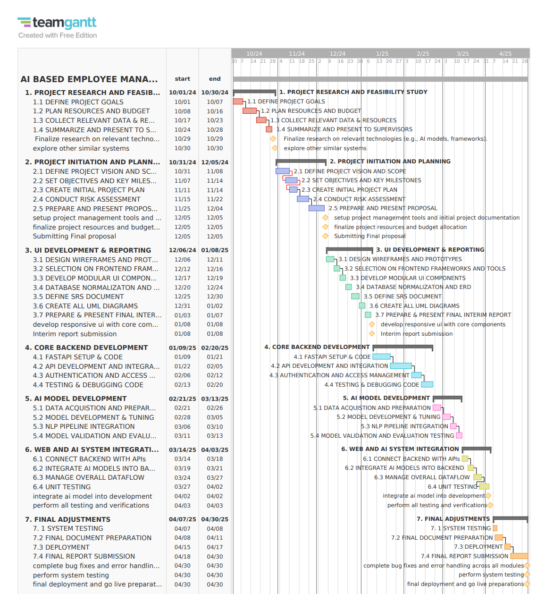

Figure 186 Gantt chart

### **8.7.2 WORK BREAKDOWN STRUCTURE:**

The WBS is the same as was initially planned, since all activities and deliverables planned up to the interim submission milestone have been realized. (Globerson)

**These include:**

**Initial Research and Planning:**

* Definition of project goals
* Planning and budgehigh level
* ting resources
* Research into relevant technologies and exploration of similar systems

**Interim Development Phase:**

* Design prototypes and wireframes for UI/UX design
* Selection of frontend frameworks and tools
* UI modular component development for the interface.
* Normalization of the database and creation of the ERD
* Documentation of SRS
* Preparation of the UML diagrams for the system

As all the tasks planned till this phase have been completed as scheduled, the WBS shall be updated only after identifying the next set of deliverables beyond the interim submission phase so that the work completed thus far aligns with the project plan, and any changes post that can be incorporated in a structured manner.

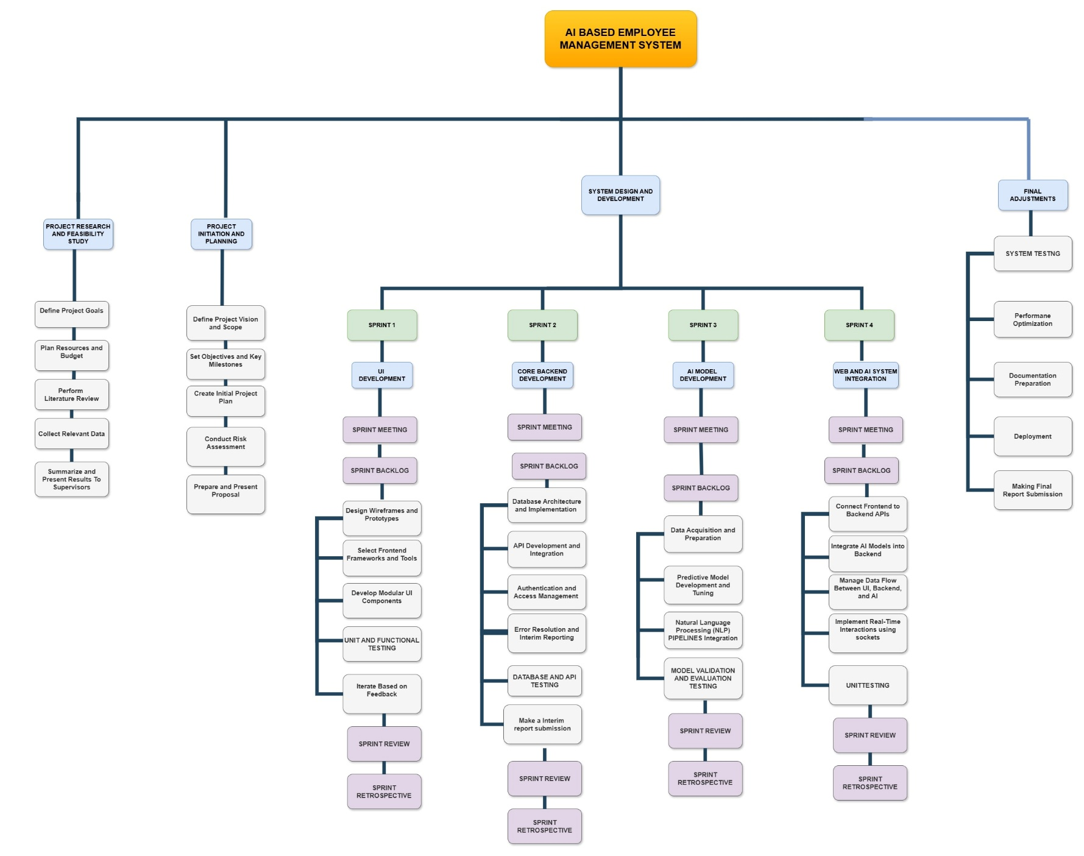

Figure 187 Work Breakdown Structure

**Go Back**

**FUNCTIONAL REQUIREMENTS:**

Functional requirements (FRs) specify what functions, operations, or behaviors that a software system must have to satisfy the needs and expectations from its users.

The system should perform the functionality, these are the high-level user goals, and then we can provide functional requirements specifications, detailing how users will use the system to achieve those goals.

1. **User Registration and Login**
   * HR sends recruited employee details to managers through email.
   * The Manager sees the recruited employees sent by HR into his Gmail account and then manager sends those details to respected employees with their login details.
   * Employee enters that login details to get into their personal employee dashboard.
2. **Task Management**
   * Managers can create and assign tasks to employees.
   * Employees can view assigned tasks on their personal dashboards.
   * Tasks must include details such as task title, description and deadlines.
   * Employees after submission tasks automatically status will get updated to submitted.
   * Manager view that submitted tasks and then he can approve and removed tasks after that approved is displayed in tasks status.
3. **Interactive Post System**
   * Employees can create posts visible to their department or organization wide.
   * Posts should allow interactions such as **likes** and **comments**.
4. **Meeting Slide Generation**
   * Employees can input text content to automatically generate meeting slides.
5. **Document Querying and Summarization**
   * Employees can upload documents to query specific information.
   * The system provides AI-generated summaries for lengthy documents.
6. **Feedback and Sentiment Analysis**
   * Employees can submit anonymous feedback.
   * Managers can view aggregated feedback along with AI generated sentiment analysis reports.

**NON-FUNCTIONAL REQUIREMENTS:**

1. **Performance**

* The system should support up to 100 concurrent users with response times under 3 seconds for most operations.
* Task creation and document querying processes should be completed within 5 seconds.

1. **Scalability**

* The system must be scalable to handle increased users, data storage, and document uploads as the organization grows.

1. **Security**

* Employee and organizational data must be encrypted during storage and transmission.
* Multi-factor authentication (PIN-based activation and password) must be enforced.
* Role-based access control should ensure only authorized users can access sensitive data.

1. **Usability**

* The system interface should be user-friendly, with clear navigation and accessible for employees of all technical skill levels.
* Feedback and assistance features should be intuitive and easy to use.

1. **Reliability and Availability**

* The system must achieve 99.9% uptime to ensure uninterrupted service.
* Automated backups should run daily to protect against data loss.

1. **Compliance**

* The system should adhere to local and global data protection regulations such as GDPR and Nepalese cyber laws.

1. **Maintainability**

* The system should have well-documented code and modular architecture for easy updates and bug fixes.
* The AI tools integrated should allow for periodic updates without affecting other functionalities.

## **8.8 APPENDIX H: SCREENSHOTS OF THE SYSTEM**

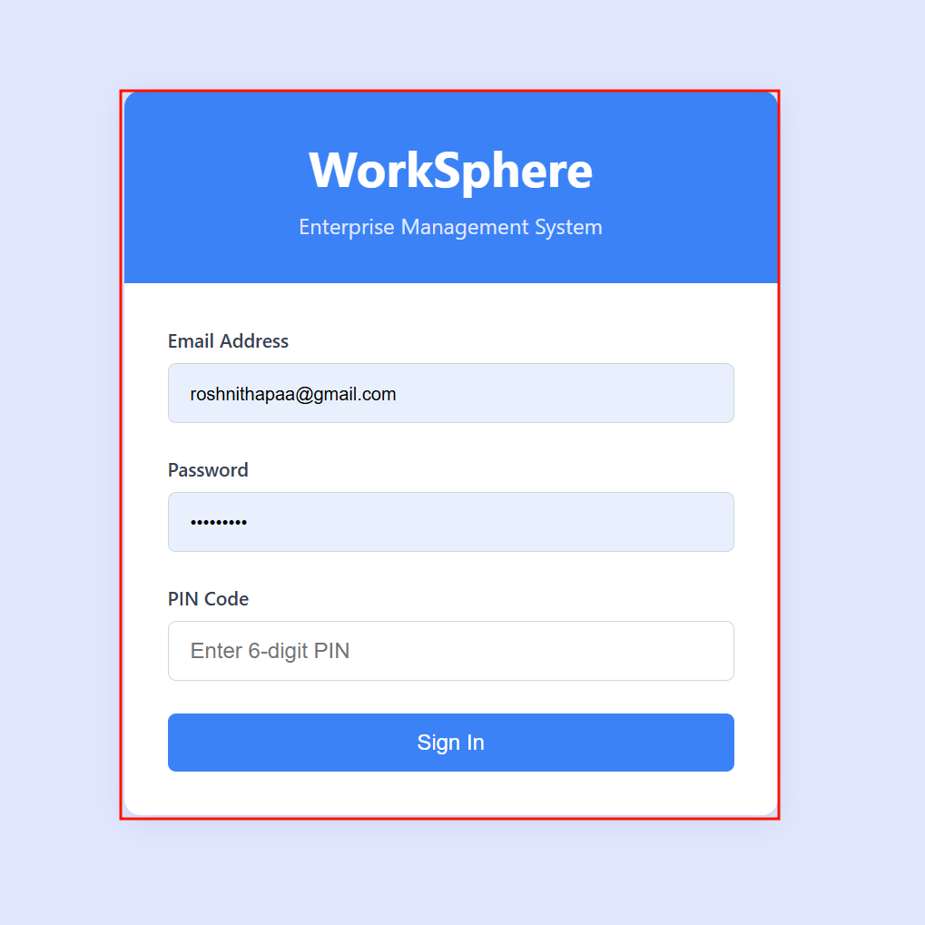

Figure 188 Login UI

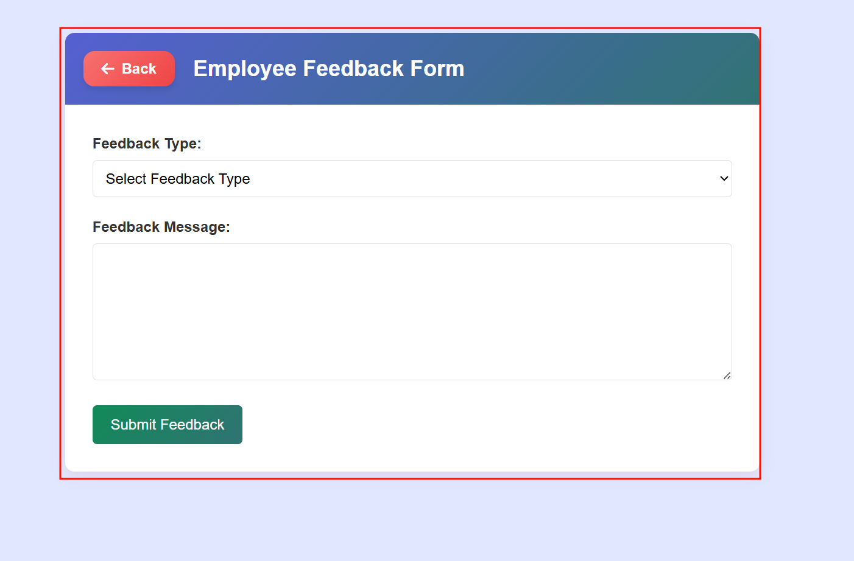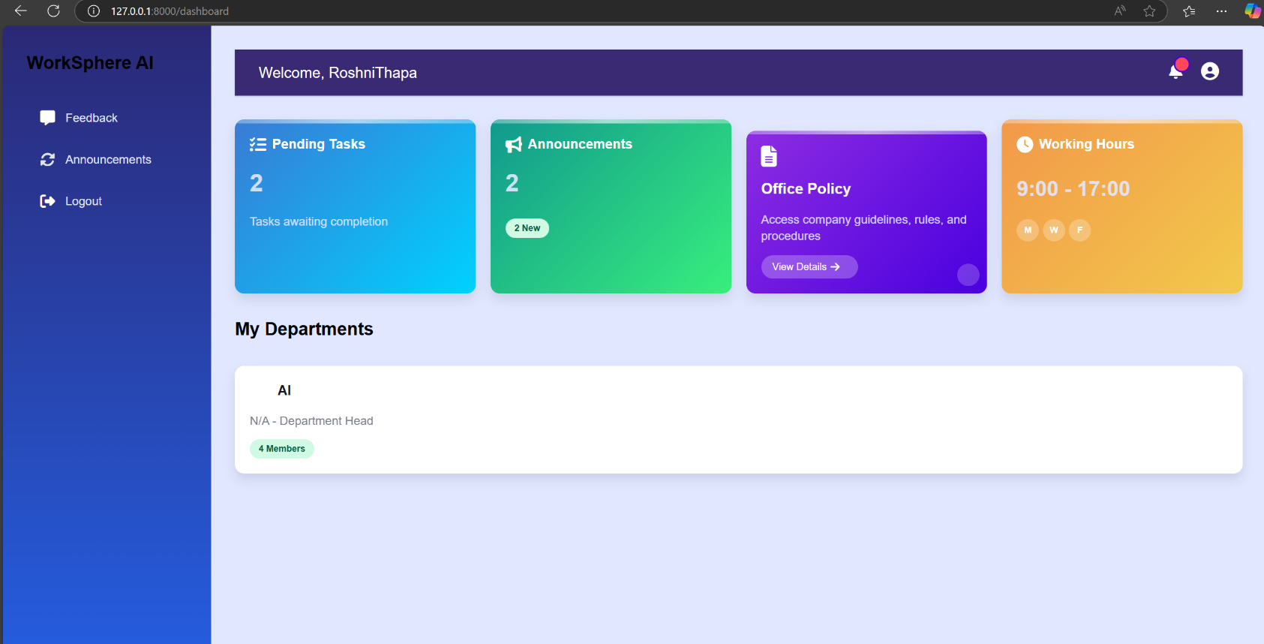

Figure 189 Feedback page UI

Figure 190 Employee dashboard UI

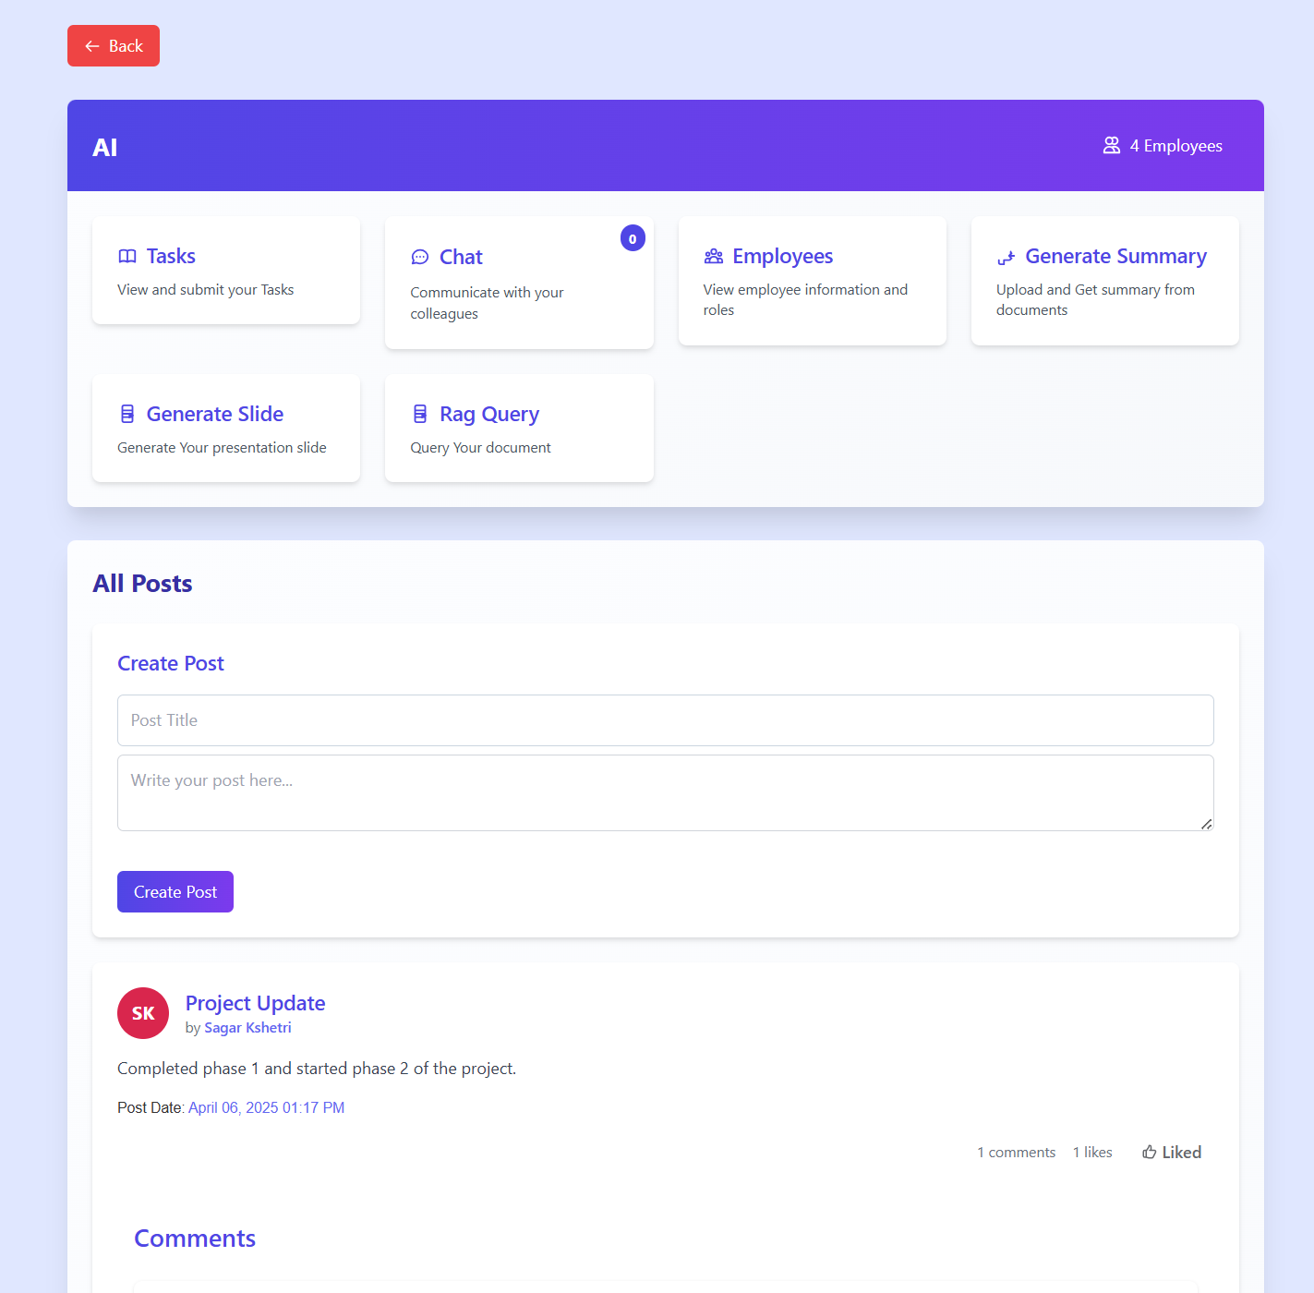

Figure 191 Employee details page UI

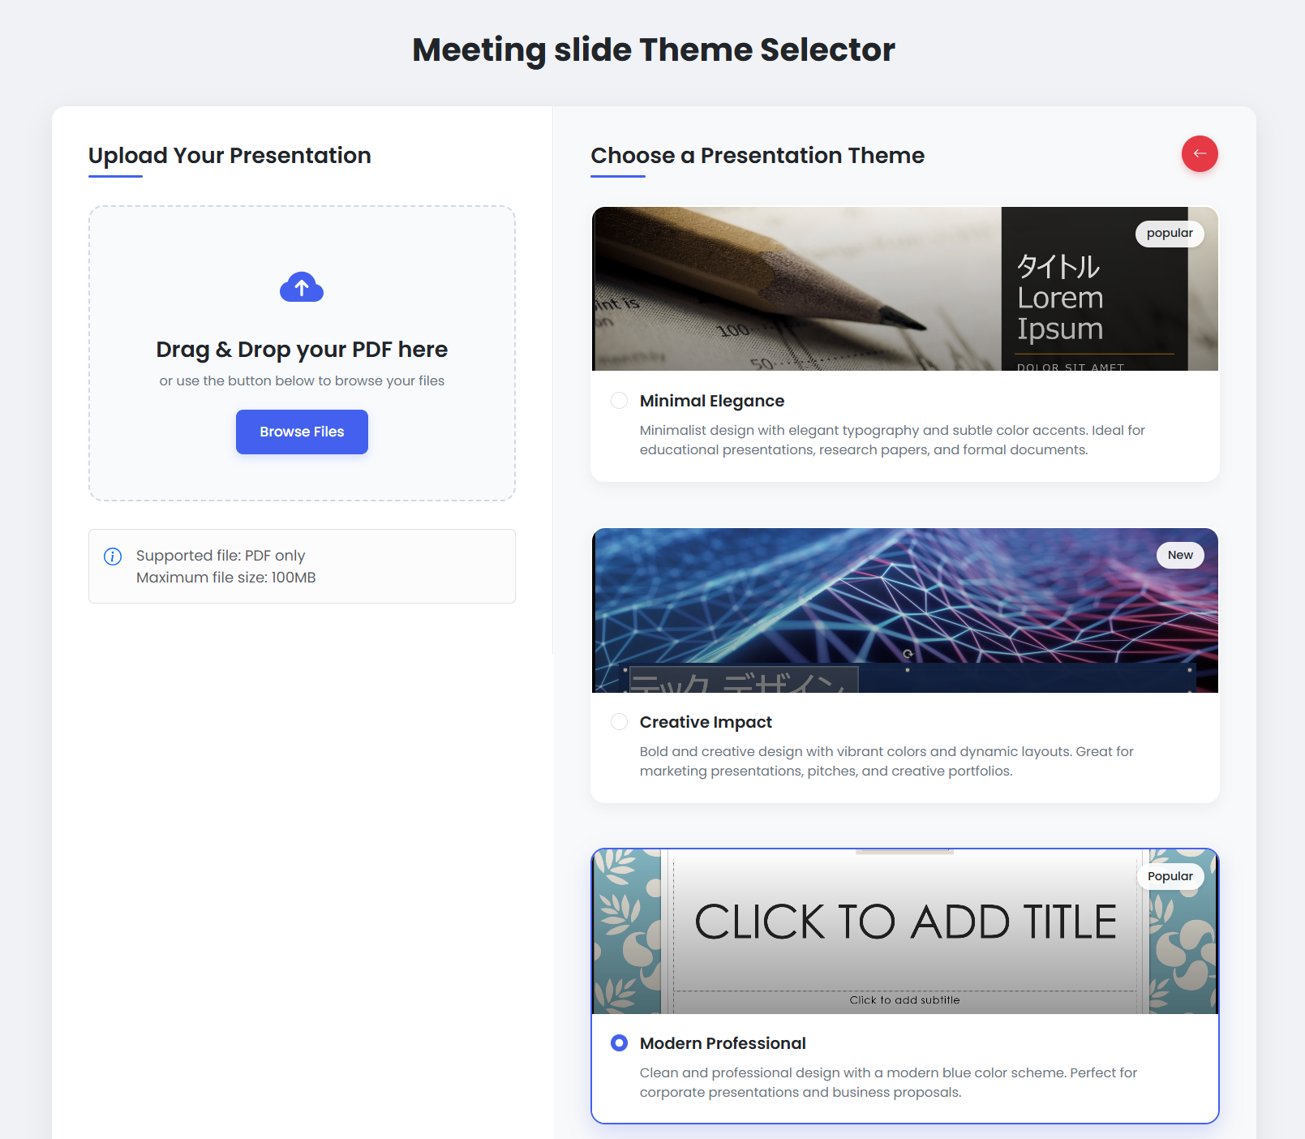

Figure 192 Meeting slide page UI

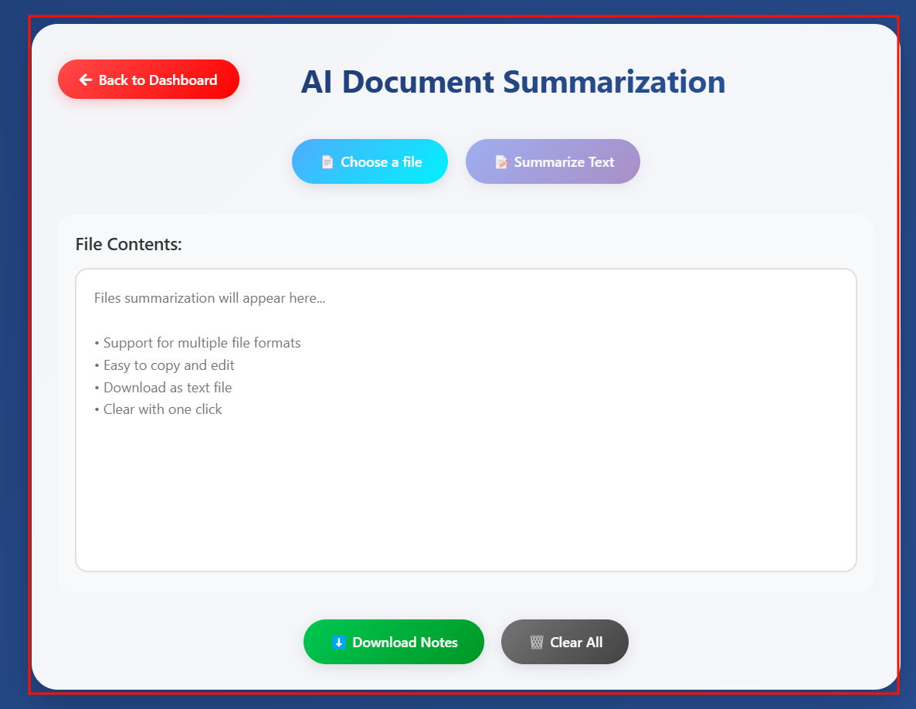

Figure 193 Document summarization page UI

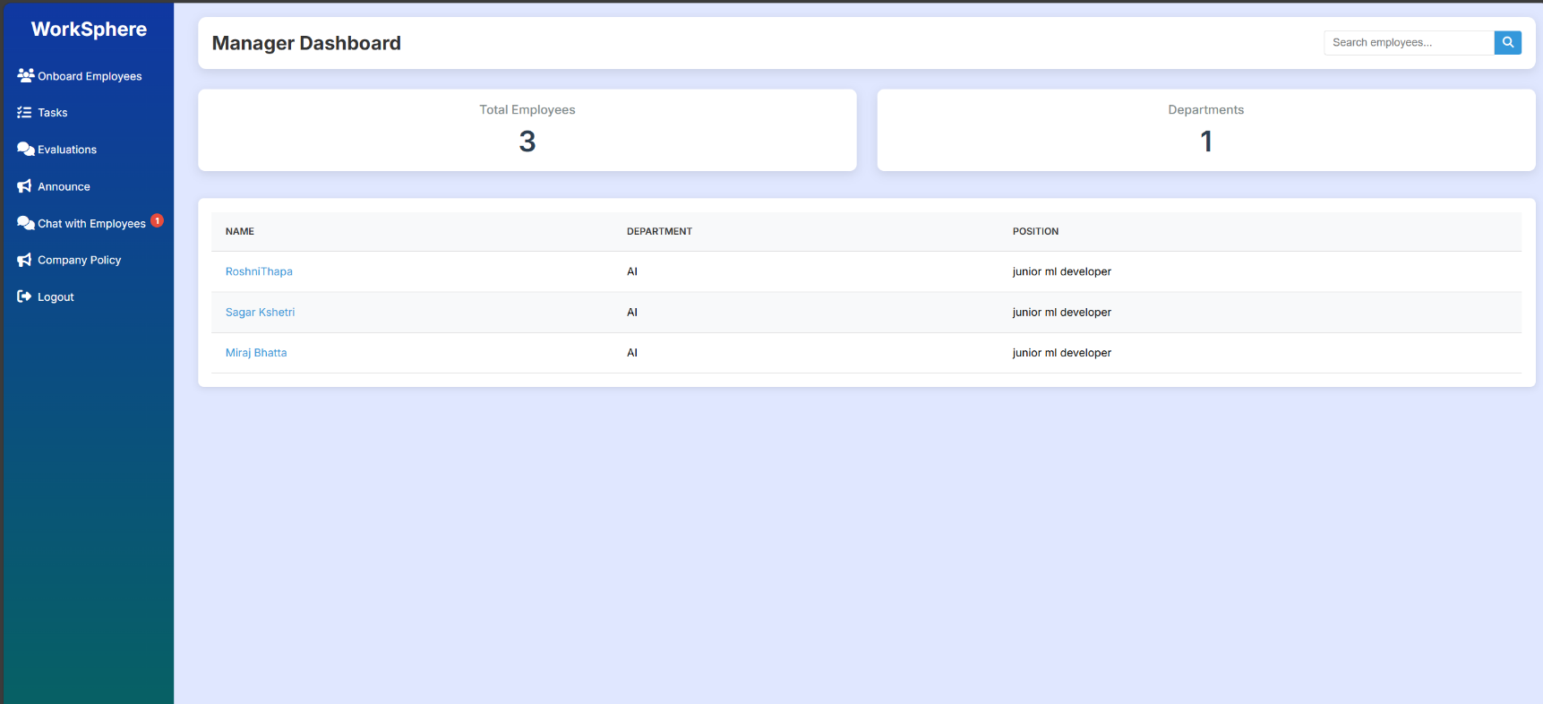

Figure 194 Manager dashboard page UI

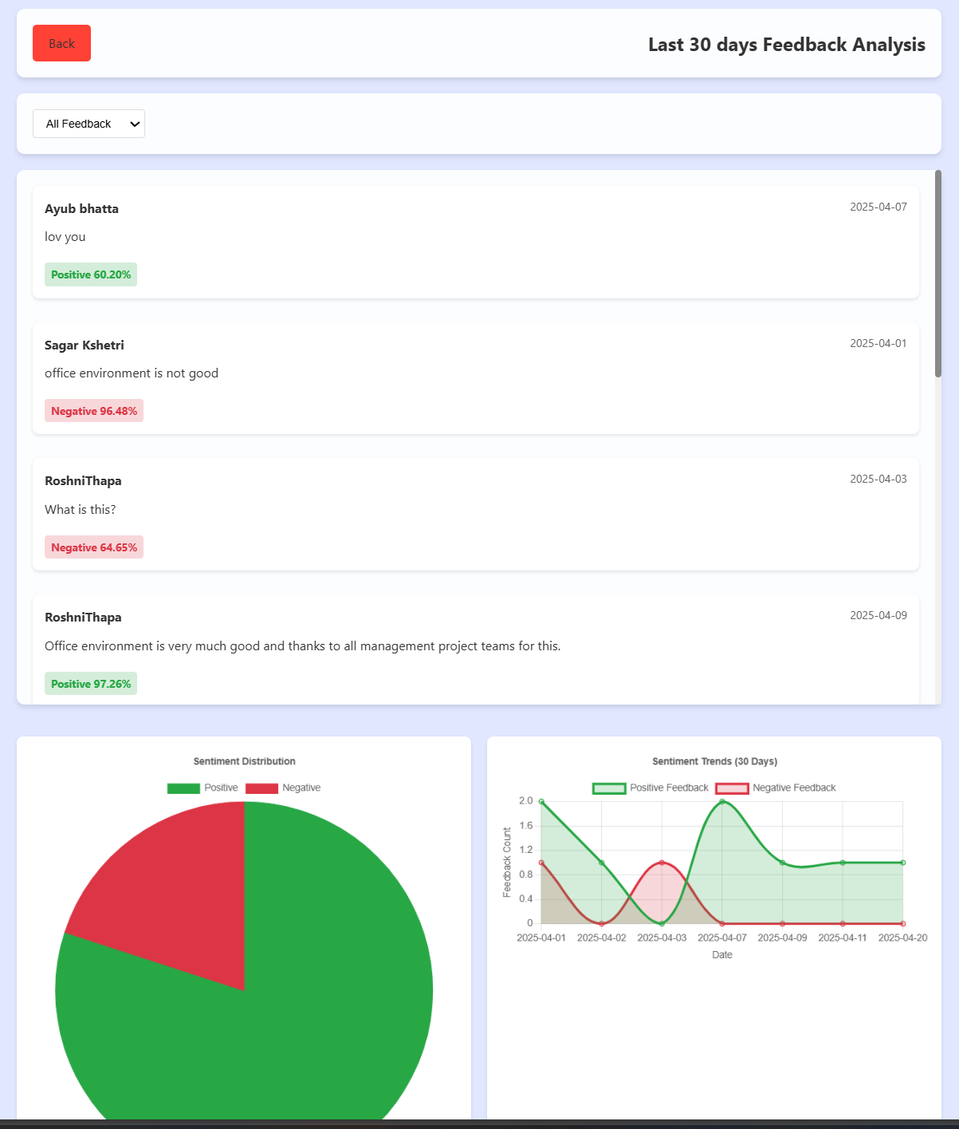

Figure 195 Sentiment feedback page UI

## **8.9 APPENDIX I: USER FEEDBACK FORM**

### **8.9.1 USER FEEDBACK FORM**

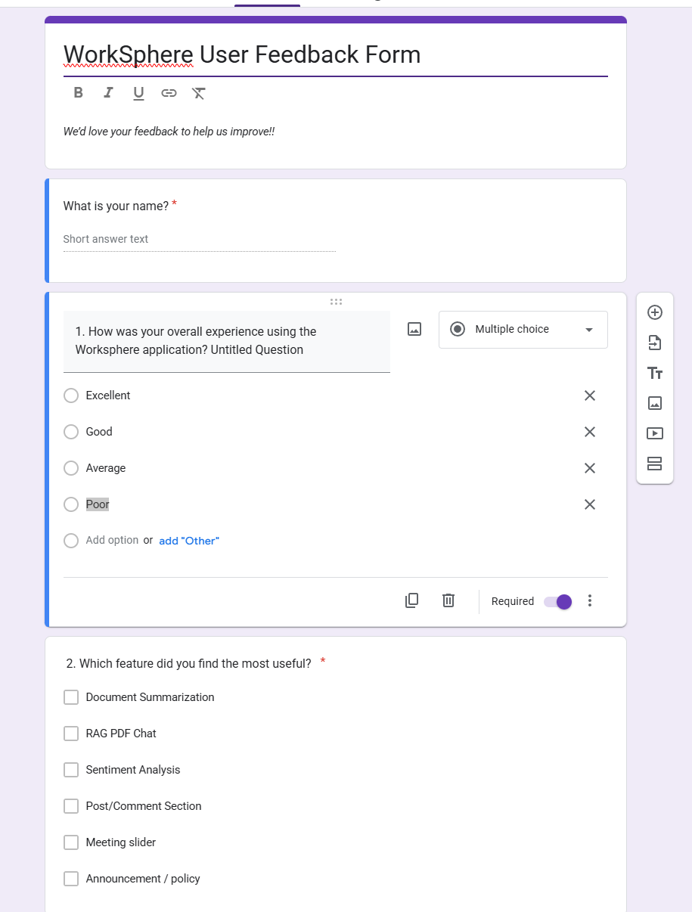

Figure screenshot of feedback part 1

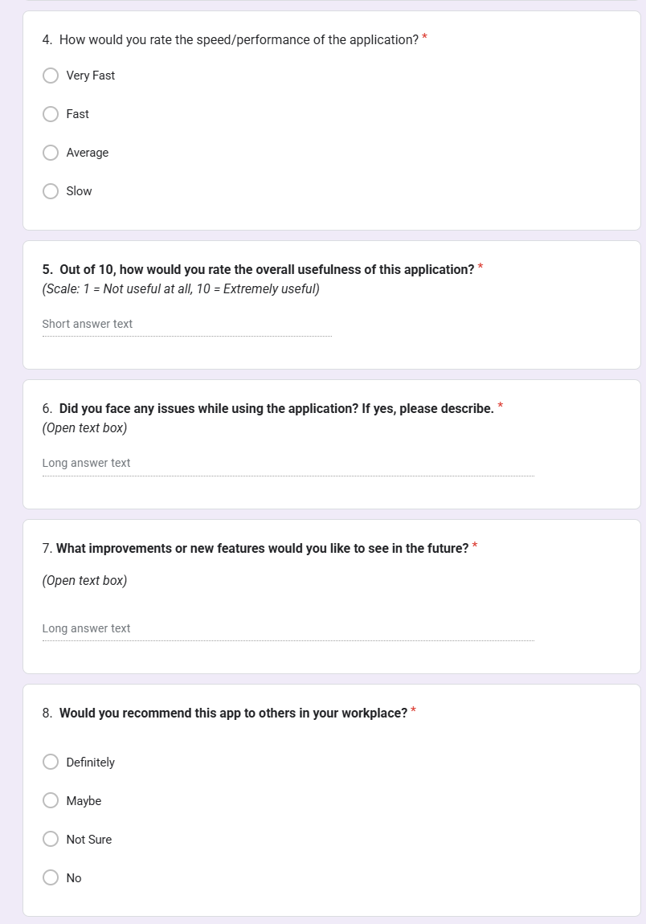

Figure screenshot of feedback part 2

### **8.9.2 RESULT OF FILLED USER FEEDBACK FORMS**

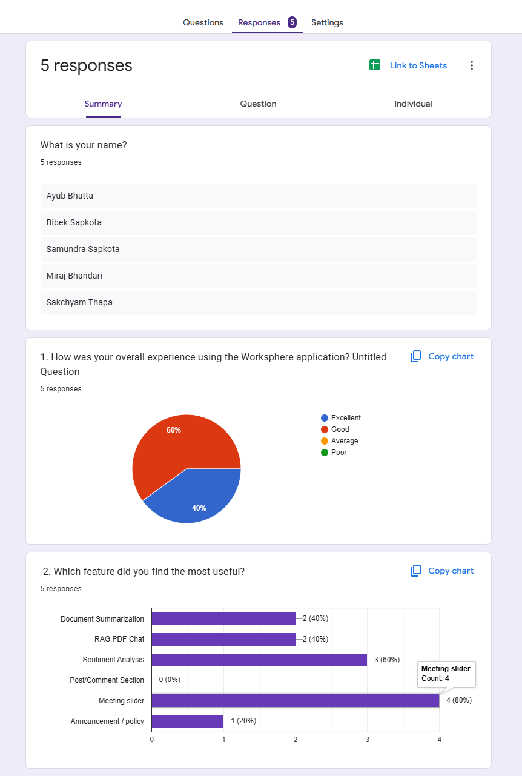

Figure screenshot of result part 1

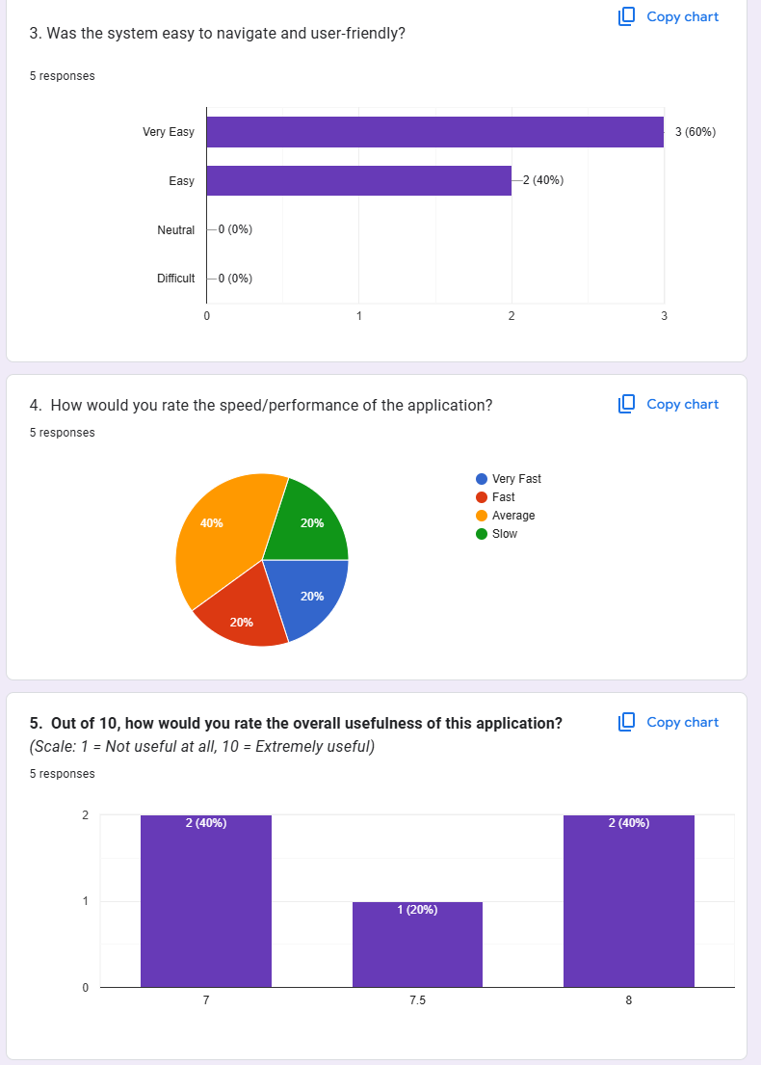

Figure screenshot of result part 2

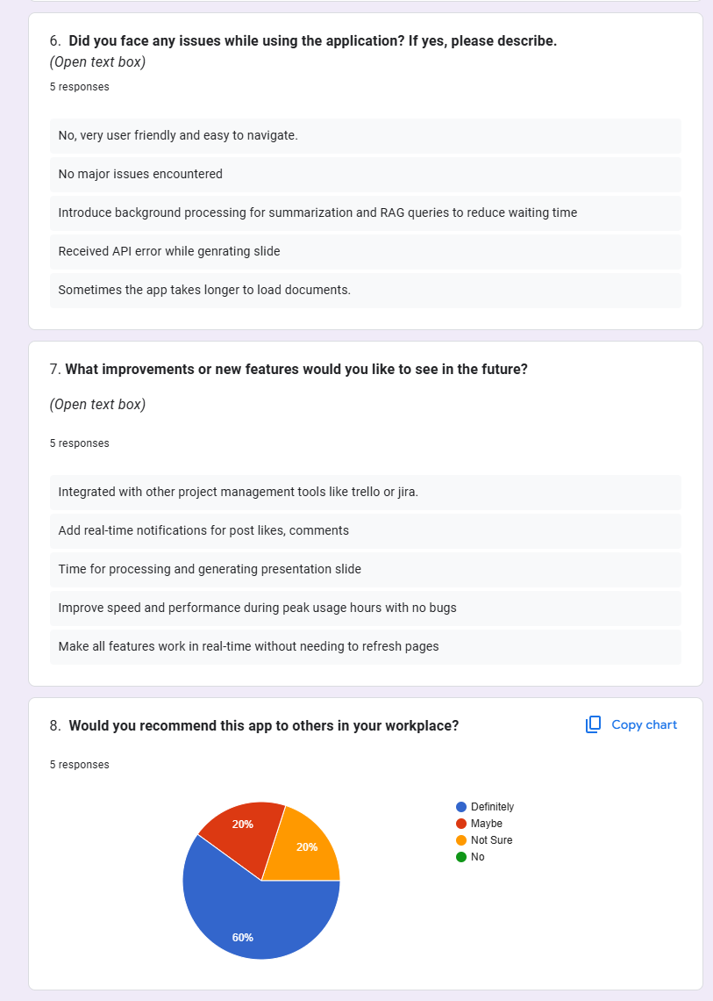

Figure screenshot of result part 3

**User Feedback Summary:**

I uploaded my application to AWS and distributed a test and review link to a small group of early adopters. To date, 5 users have tried the app and have posted feedback. The feedback has been extremely positive, and all have made useful suggestions. The feedback has allowed areas that are lacking improvement to be discovered and affirm areas of the app that are correct.